Supplementary information

Miscibility and Ternary Diagram of Aqueous Polyvinyl alcohols with Different Degrees of Saponification

Junhyuk Kim^{1,‡}, Shohei Ishikawa^{2,‡,}*, Mitsuru Naito³, Xiang Li⁴, Ung-il Chung¹, and Takamasa Sakai^{2,}*

¹Department of Bioengineering, Graduate School of Engineering, The University of Tokyo, 7-3-1 Hongo, Bunkyo-ku, Tokyo 113-8656, Japan
²Department of Chemistry & Biotechnology, School of Engineering, The University of Tokyo, Tokyo 113-8656, Japan
³Department of Materials Engineering, Graduate School of Engineering, The University of Tokyo, 7-3-1, Hongo, Bunkyo-ku, Tokyo 113-8656, Japan
⁴Faculty of Advanced Life Science, Hokkaido University, Sapporo 001–0021, Japan

‡These authors contributed equally to this work.
*Corresponding authors:
(S.I.) ishikawa@gel.t.u-tokyo.ac.jp
(T.S.) sakai@gel.t.u-tokyo.ac.jp

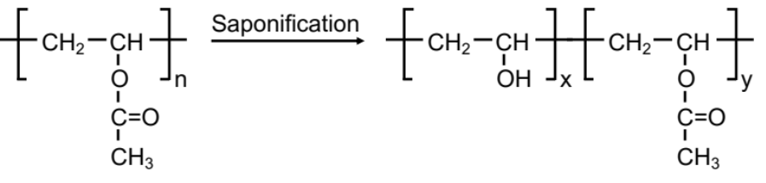
Figure S1. Chemical structure of PVAs. The degree of polymerization is 550, shown as n. The DSs are 74, 82, 88, and 98 mol%, implying that the ratios of x and y are 74:26, 82:18, 88:12, and 98:2, respectively.

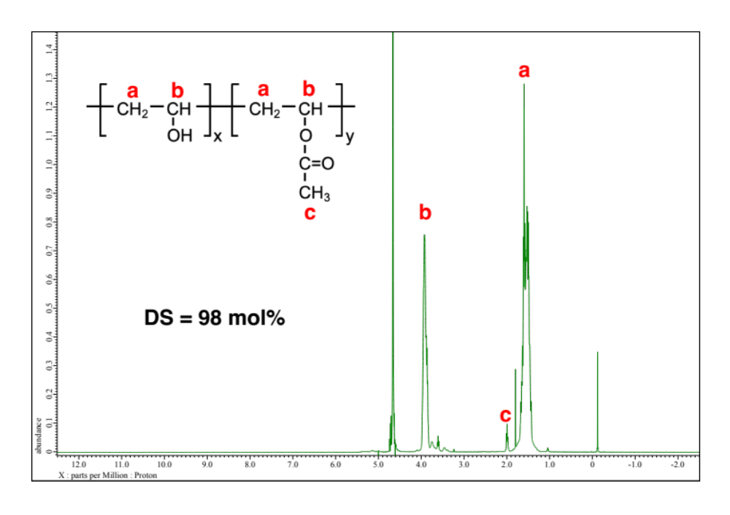
Figure S2. ¹H-NMR spectra of PVA98. a = δ 1.60 (m, 2H, CH₂), b = δ 3.92 (m, 1H, CH), c = δ 2.00 (m, 3H, CH₃).

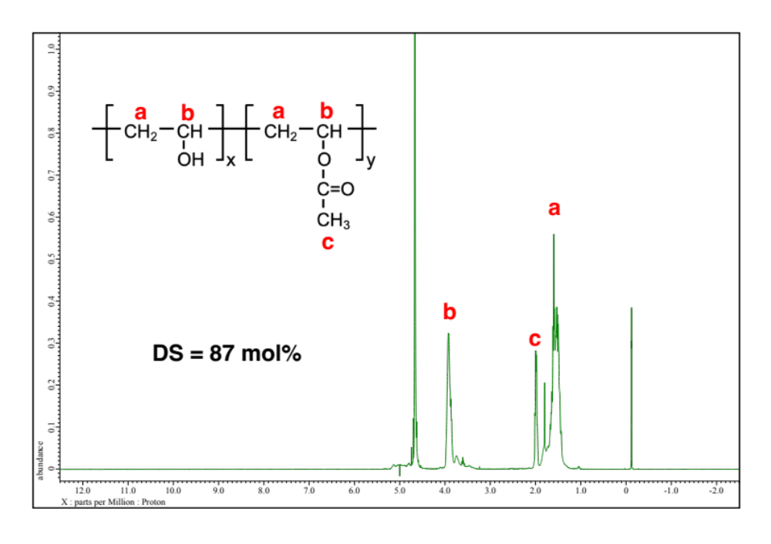
Figure S3. ¹H-NMR spectra of PVA88. a = δ 1.60 (m, 2H, CH₂), b = δ 3.92 (m, 1H, CH), c = δ 2.00 (m, 3H, CH₃).

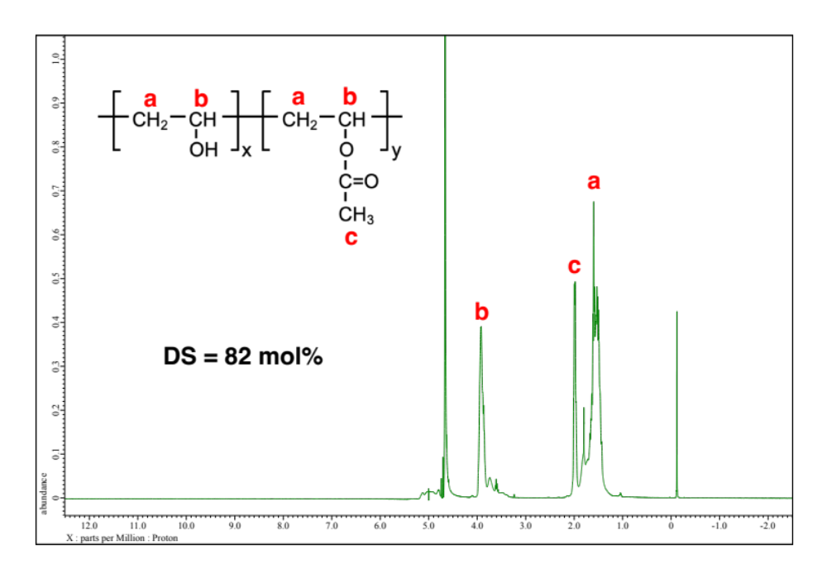
Figure S4. ¹H-NMR spectra of PVA82. a = δ 1.60 (m, 2H, CH₂), b = δ 3.92 (m, 1H, CH), c = δ 2.00 (m, 3H, CH₃).

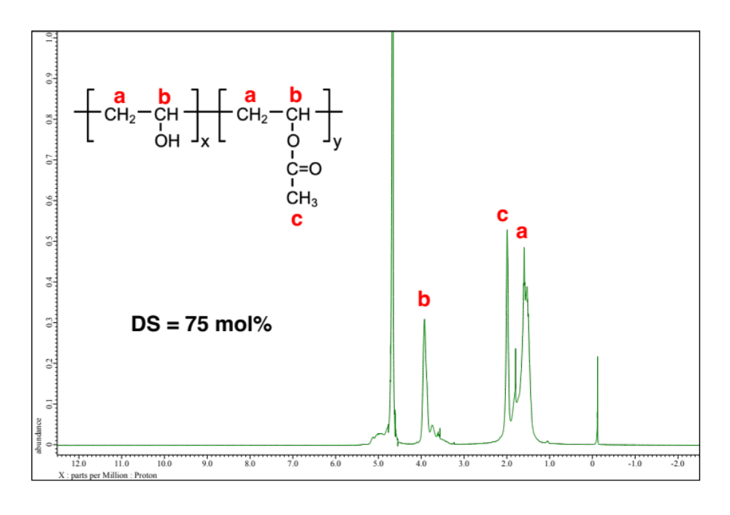
Figure S5. ¹H-NMR spectra of PVA74. a = δ 1.60 (m, 2H, CH₂), b = δ 3.92 (m, 1H, CH), c = δ 2.00 (m, 3H, CH₃).

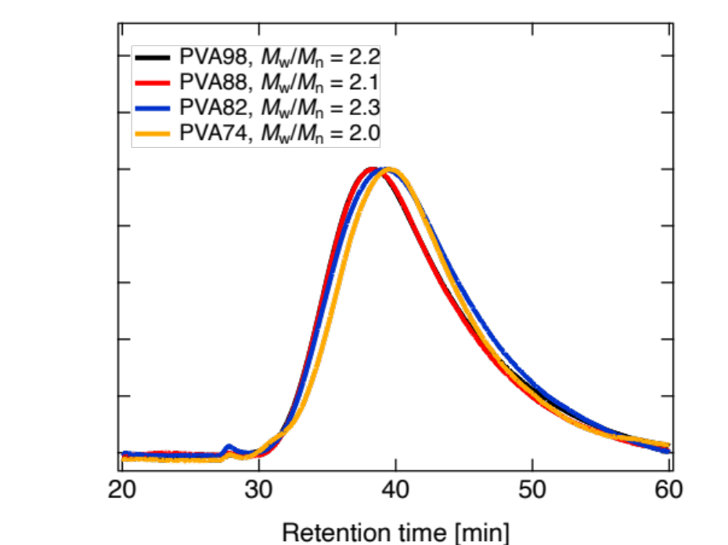
Figure S6. GPC trace of PVA98 (black), PVA88 (red), PVA82 (blue), and PVA74 (orange). These traces were normalized so that the elution curves had the same peak intensity.

