Supplementary Information
Phase I randomized, observer-blinded, placebo-controlled study of a SARS-CoV-2 mRNA vaccine PTX-COVID19-B
Natalia-Martin Orozco^{1*}, Noah Vale², Alan Mihic², Talya Amor², Lawrence Reiter¹, Yuko Arita¹, Reuben Samson^{3,4}, Queenie Hu⁴, Anne-Claude Gingras^{3,4}, Bradley Thomas Sorenson¹, Eric Gates Marcusson¹, Piyush Patel¹
- Providence Therapeutics Holdings. 8832 Blackfoot Trail SE, Ste 120, Calgary, AB, T2J 3J1, Canada
- Centricity Research. 2291 Kipling Avenue, Unit 117B, Toronto, ON, M9W 4L6, Canada
- Department of Molecular Genetics, University of Toronto. 1 King's College Cir, Rm 4396, Toronto, ON, M5S 1A8, Canada
- Lunenfeld-Tanenbaum Research Institute at Mount Sinai Hospital, Sinai Health System, 600 University Ave, Toronto, ON M5G 1X5, Canada
*Corresponding Author: Natalia Martin Orozco, PhD
Email: natalia@providencetherapeutics.com
Phone: 647 554 8436

SUPPLEMENTARY NOTE

We would like to thank the Providence Therapeutics Team that contributed to the manufacturing of the vaccine.
Nathalie Fabbri, Florian Gossart, Karitza Fuenmayor, Rajesh Krishnan, Aula Al Muslim, Richard Tran, Joseph Bteich, Aisha Yusuf, Priya Rajesh, Jordan Schwartz, Jared Davis

We would like to thank the Sunnybrook Research Institute Team that supported our manufacturing of the vaccine.
Nickett Donaldson, Crystal Bourne, and Rod Engeland

SUPPLEMENTARY FIGURES

Supplementary Figure S1. Human Convalescent sera antibody titers by MSD

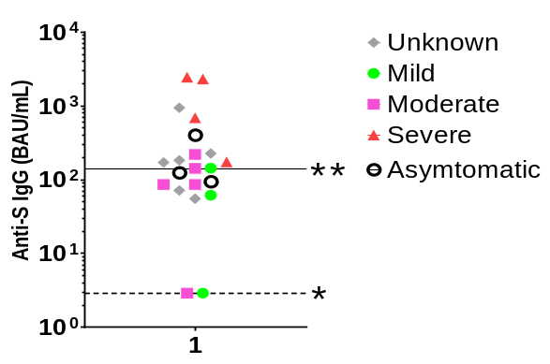
HCS
Anti-Spike
Anti-RBD
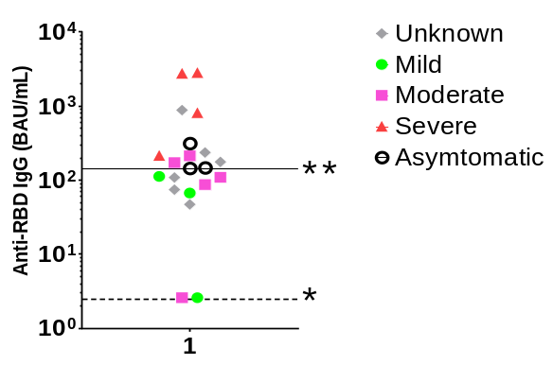
HCS
HCS

Human Convalescence Serum or HCS was obtained from donors that had COVID-19. The severity of their disease was obtained and graph with the titers of antibodies against RBD and SPIKE. The serum donors had a COVID-19 positive diagnostic but no information on patient demographic or time of infection was provided.

Supplementary Figure S2. Correlation between ELISA and MSD assays for detection of anti-S antibodies
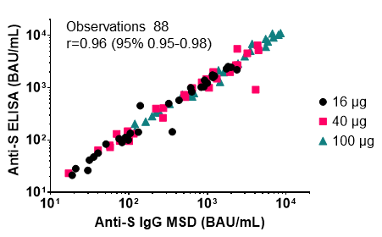
Detection of anti-S antibodies from participants vaccinated with PTX-COVID19 was determined by ELISA and multiplex MSD. Both determinations were calibrated with the WHO standard and results from both assays have a good correlation (r=0.96).

Supplementary Figure S3. Correlation of anti-S IgG and neutralizing antibody response
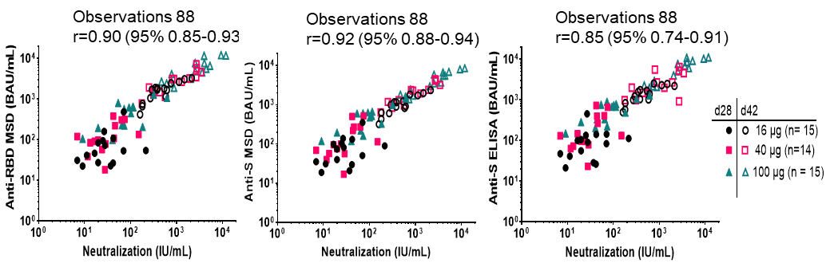
Titers of total IgG antibodies against RBD and Spike determined by MSD or ELISA correlate with neutralization titers specially at mid and high dose on day 42 (Open symbols)

Supplementary Figure S4. ACE2:Spike Blocking antibody titers and correlation of blocking antibody titers with neutralizing antibody response
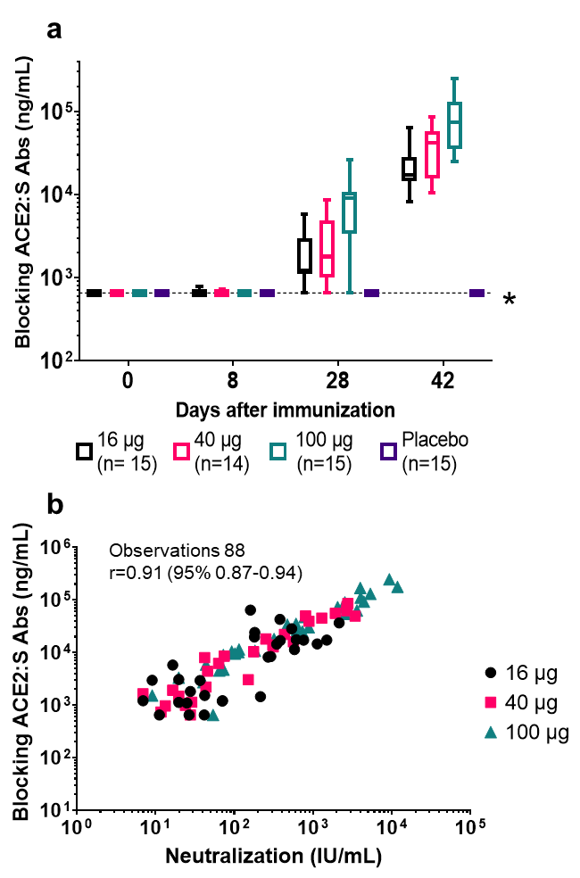
- Detection of neutralizing activity from the sera of participants vaccinated with PTX-COVID-19-B was determined by ACE2:S blocking assay. Neutralization activity was evident at day 28 after the first immunization and increased by day 42 in all cohorts.
- The neutralization activity determined by ACE2:S blocking assay correlates to the neutralization activity determined pVNA assay.

Supplementary Figure S5. Correlation of pseudovirus neutralization assays, lentivirus vs. rVSV
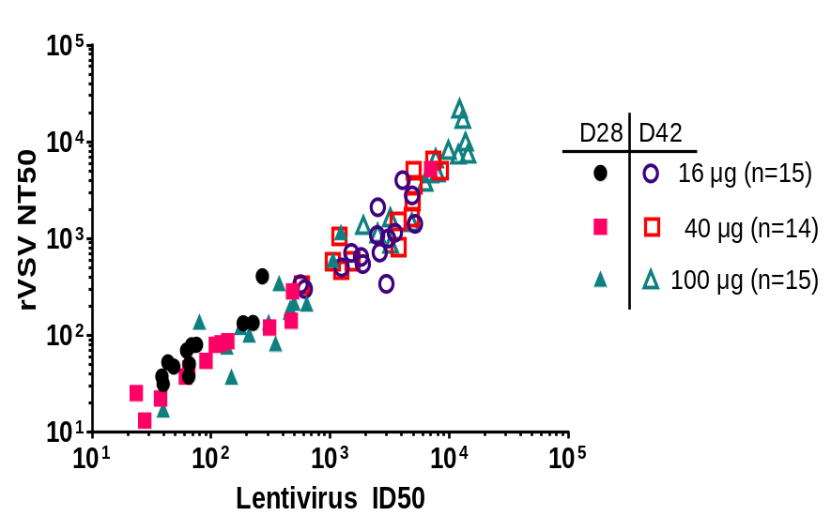
Observations 88
r=0.87 (95% 0.80-0.91)
Detection of neutralization activity pVNA from participants vaccinated with PTX-COVID19 was determined by two methods, one method used rVSV expressing ancestral S protein and was performed at Nexelis; the second method used lentivirus expressing G614 S variant and was performed at Mount Sinai Hospital. Both assays have a very good correlation (r=0.87).

Supplementary Figure S6. Vaccine Regimens and Schedule of Key Trial Assessments
A | Vaccine Regimens  Vaccine Groups | No. of Participants |  |  |  |  |  |  | Day 1 |  |  |  |  |  | Day 28
 |  | Randomized (PTX-COVID19-B: placebo) |  | Randomized Sentinel (PTX-COVID19-B: placebo) |  |  |  |  | PTX-COVID19-B |  |  |  |  |  | PTX-COVID19-B
 | Cohort 1 | 11:4 |  | 4:1 |  |  |  |  | 16 μg or placebo |  |  |  |  |  | 16 μg or placebo
 | Cohort 2 | 11:4 |  | 4:1 |  |  |  |  | 40 μg or placebo |  |  |  |  |  | 40 μg or placebo
 | Cohort 3 | 11:4 |  | 4:1 |  |  |  |  | 100 μg or placebo |  |  |  |  |  | 100 μg or placebo
B | Key Trial Assessments
 | Procedure | Screening | Day
 |  |  | 1 |  | 2 | 8 |  | 28 |  | 29 |  | 42 |  | 90 |  | 180 |  | 395
 | NP swab for COVID-19 via RT-PCR | X |  |  |  |  |  | X
 | Blood samples for immunogenicity analysis (antibodies IgG, IgA, neutralization) | X |  |  |  | X |  | X |  |  |  | X |  | X |  | X |  | X
 | Vaccine administration |  | X |  |  |  |  | X
 | Post-vaccination assessment (approximately 1 hour post vaccination, includes arm check and vital signs) |  | X |  |  |  |  | X
 | Medically attended AE assessments
 | Unsolicited AE assessments
 | Solicited AEs |  | X |  | X |  |  | X |  | X
 | Assessments of NOCD, AESIs (including COVID-19 cases for enhanced disease), and PIMMCs
 | Serious adverse event assessments
Shown are the planned randomization and associated vaccine regimens administered in the trial (Panel A), along with the timing of key trial assessments (Panel B).

SUPPLEMENTARY TABLES

Supplementary Table S1. FDA Toxicity Grading Scale for Solicited Local and Systemic Reactions
 | Mild (Grade 1) | Moderate (Grade 2) | Severe (Grade 3) | Potentially Life Threatening (Grade 4)
Local Reaction to Injectable Product
Pain | Does not interfere with activity | Repeated use of non-narcotic pain reliever > 24 hours or interferes with activity | Any use of narcotic pain reliever or prevents daily activity | Emergency room (ER) visit or hospitalization
Erythema/ Rednessª | 2.5 - 5 cm | 5.1 - 10 cm | > 10 cm | Necrosis or exfoliative dermatitis
Induration^{b} | 2.5 - 5 cm and does not interfere with activity | 5.1 - 10 cm or interferes with activity | > 10 cm or prevents daily activity | Necrosis
Swelling^{b} | 2.5 - 5 cm and does not interfere with activity | 5.1 - 10 cm or interferes with activity | > 10 cm or prevents daily activity | Necrosis
Systemic (General)
Fever^{c} (°C)  (°F) | 38.0 – 38.4  100.4 – 101.1 | 38.5 – 38.9  101.2 – 102.0 | 39.0 – 40  102.1 – 104 | > 40  > 104
Nausea | No interference with activity or 1 – 2 episodes/24 hours | Some interference with activity or > 2 episodes/24 hours | Prevents daily activity, requires outpatient IV hydration | ER visit or hospitalization for hypotensive shock
Headache | No interference with activity | Repeated use of nonnarcotic pain reliever > 24 hours or some interference with activity | Significant; any use of narcotic pain reliever or prevents daily activity | ER visit or hospitalization
Fatigue | No interference with activity | Some interference with activity | Significant; prevents daily activity | ER visit or hospitalization
Muscle pain | No interference with activity | Some interference with activity | Significant; prevents daily activity | ER visit or hospitalization
Joint pain | No interference with activity | Some interference with activity | Significant; prevents daily activity | ER visit or hospitalization
Chills | No interference with activity | Some interference with activity | Significant; prevents daily activity | ER visit or hospitalization
Feverish | No interference with activity | Some interference with activity | Significant; prevents daily activity | ER visit or hospitalization
Rash (not at injection site) | No interference with activity | Some interference with activity | Significant; prevents daily activity | ER visit or hospitalization
ª In addition to grading the measured local reaction at the greatest single diameter, the measurement should be recorded as a continuous variable.
^{b} Induration/Swelling should be evaluated and graded using the functional scale as well as the actual measurement.
^{c} Oral temperature; no recent hot or cold beverages or smoking.
The intensity of a solicited adverse event was graded according to the FDA Guidance for Industry: Toxicity Grading Scale for Healthy Adult and Adolescent Volunteers Enrolled in Preventive Vaccine Clinical Trials (September 2007). The grading scale comprises 4 levels: mild (Grade 1), moderate (Grade 2), severe (Grade 3), and potentially life-threatening (Grade 4). The scale was adapted for the protocol.
Reference: Food and Drug Administration. Guidance for industry: Toxicity grading scale for healthy adult and adolescent volunteers enrolled in preventive vaccine clinical trials. US Department of Health and Human Services, Food and Drug Administration, Center for Biologics Evaluation and Research. September 2007. https://www.fda.gov/media/73679/download

Supplementary Table S2. DAIDS Adverse Events Intensity Assessment
Grade | Intensity | Definition
Grade 1 | Mild | Symptoms causing no or minimal interference with usual social and functional activities with intervention not indicated.
Grade 2 | Moderate | Symptoms causing greater than minimal interference with usual social and functional activities with intervention indicated.
Grade 3 | Severe | Symptoms causing inability to perform usual social and functional activities with intervention or hospitalization indicated.
Grade 4 | Potentially Life-Threatening | Symptoms causing inability to perform basic self-care functions with intervention indicated to prevent permanent impairment, persistent disability, or death.
Grade 5 |  | Any adverse event where the outcome is death
For those adverse events that are not covered in the FDA Guidance for Industry (see Table 1) the rating scale from DAIDS (Table for Grading the Severity of Adult and Pediatric Adverse Events, Version 2.1) was used.
Reference: Division of AIDS (DAIDS) Table for Grading the Severity of Adult and Pediatric Adverse Events. Corrected Version 2.1. Division of AIDS, National Institute of Allergy and Infectious Diseases, National Institutes of Health, US Department of Health and Human Services. July 2017. https://rsc.niaid.nih.gov/sites/default/files/daidsgradingcorrectedv21.pdf

