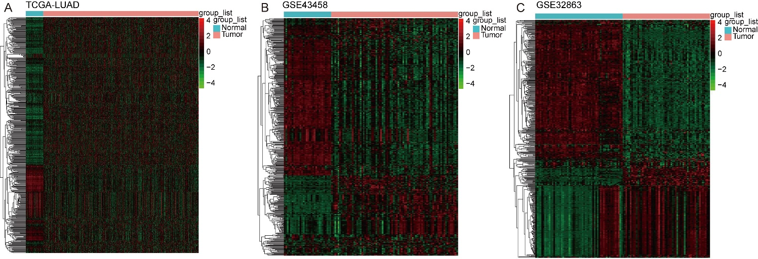
Figure S1 The heatmap of DEGs between cancer group and paracancerous sample in TCGA-LUAD dataset. (A) GSE43458 dataset (B) and GSE32863 dataset (C) The heatmap was plotted using the pheatmap (Version 1.0.12, https://cran.r-project.org/web/packages/pheatmap/index.html).

