Mitochondrial impairment but not peripheral inflammation predicts greater Gulf War illness severity
Beatrice A. Golomb, MD, PhD¹*, Roel Sanchez Baez, MD¹,², Jan M. Schilling, MD³, Mehul Dhanani, BS^{3,4}, McKenzie J. Fannon, BS³, Brinton K. Berg, BA¹, Bruce J Miller, BS¹, Pam R Taub, MD⁵ and Hemal H. Patel, PhD³
- Department of Medicine, University of California, San Diego, La Jolla, CA 92093, U.S.A.
- Current Affiliation: San Ysidro Health Center, San Diego, CA 92114, U.S.A.
- VA San Diego Healthcare System and Department of Anesthesiology, University of California, San Diego, San Diego, CA 92161, U.S.A.
- Current Affiliation: Avidity Biosciences, San Diego, CA 92121, U.S.A.
- Division of Cardiovascular Medicine, Department of Medicine, University of California, San Diego, San Diego, CA 92037, U.S.A.
*Corresponding Author:
Beatrice Alexandra Golomb, MD, PhD
Department of Medicine
UC San Diego School of Medicine
9500 Gilman Drive #0995
La Jolla, CA 92093-0995 U.S.A
Email: bgolomb@ucsd.edu

Supplement Table 1. All mitochondrial assessments by case-control status.
 | Total Sample (N=36)  Mean  (SD) | Unpaired Analysis |  |  |  | Paired Analysis |  |  |  | Description
 | Total Sample (N=36)  Mean  (SD) | VGWI  (n=19)  Mean  (SD) | Controls  (n=17)  Mean  (SD) | Difference  Mean | P* | VGWI  (n=19)  Mean  (SD) | Controls  (n=17)  Mean  (SD) | Difference  Mean  (SD) | P* | Description
FAO  Oct&G&M  Leak | 7.37  (8.91) | 6.69  (7.31) | 8.14  (10.7) | 1.45 | 0.66 | 8.57  (6.73) | 10.2  (12.2) | 1.66  (15.1) | 0.74 | Determined by using fatty acids as the fuel source with complex I substrates malate/glutamate in the absence of ADP to assess leak.
 |  |  |  |  | 0.33 | 8.57  (6.73) | 10.2  (12.2) | 1.66  (15.1) | 0.37
CI&FAO  G&M  OXPHOS | 24.1  (12.5) | 25.2  (9.11) | 22.8  (15.8) | -2.35 | 0.62 | 24.1  (8.96) | 28.2  (14.1) | 4.12  (16.7) | 0.45 | Determined by using fatty acids as the fuel source with complex I substrates malate/glutamate with ADP to drive respiration.
 |  |  |  |  | 0.31 | 24.1  (8.96) | 28.2  (14.1) | 4.12  (16.7) | 0.23
CI&FAO  G&M&P  OXPHOS | 34.5  (20.3) | 34.2  (16.7) | 35.0  (24.4) | 0.77 | 0.92 | 27.8  (14.8) | 41.9  (24.6) | 14.1  (30.1) | 0.17 | Determined by using fatty acids as the fuel source with complex I substrates malate, glutamate, and pyruvate with ADP to drive respiration.
 |  |  |  |  | 0.46 | 27.8  (14.8) | 41.9  (24.6) | 14.1  (30.1) | 0.087
CI&CII&  FAO  CI/  CII  OXPHOS | 56.4  (27.1) | 50.7  (24.0) | 62.9  (29.8) | 12.2 | 0.23 | 46.0  (23.7) | 72.1  (29.6) | 26.1  (33.6) | 0.037 | Determined by using fatty acids as the fuel source with complex I and II substrates malate, glutamate, pyruvate, and succinate with ADP to drive respiration.
 |  |  |  |  | 0.11 | 46.0  (23.7) | 72.1  (29.6) | 26.1  (33.6) | 0.018
FAO  MaxUC | 82.7  (36.1) | 74.8  (29.5) | 91.9  (41.7) | 17.1 | 0.20 | 67.6  (26.7) | 102.1  (45.5) | 34.4  (47.9) | 0.049 | Determined by using fatty acids as the fuel source with FCCP as an uncoupler.
 |  |  |  |  | 0.10 | 67.6  (26.7) | 102.1  (45.5) | 34.4  (47.9) | 0.025
CII&FAO  ETS | 49.4  (18.1) | 44.8  (13.7) | 54.9  (21.6) | 10.1 | 0.14 | 45.2  (15.5) | 59.1  (22.4) | 13.8  (24.1) | 0.10 | Determined by using fatty acids as the fuel source with rotenone to inhibit complex I to look at complex II respiration.
 |  |  |  |  | 0.068 | 45.2  (15.5) | 59.1  (22.4) | 13.8  (24.1) | 0.051
FAO  ROX | -5.35  (7.76) | -4.13  (4.94) | -6.75  (10.1) | -2.62 | 0.37 | -2.30  (4.38) | -6.33  (11.8) | -4.03  (12.8) | 0.35 | Determined by using fatty acids as the fuel source with antimycin A to inhibit complex III to look at residual oxygen consumption.
 |  |  |  |  | 0.18 | -2.30  (4.38) | -6.33  (11.8) | -4.03  (12.8) | 0.17
CI  G&M  Leak | 9.28  (11.5) | 8.51  (11.7) | 10.3  (11.6) | 1.74 | 0.68 | 7.05  (9.69) | 10.4  (10.5) | 3.32  (14.6) | 0.47 | Determined by using basal MiRO5 media with complex I substrates malate/glutamate in the absence of ADP to assess leak.
 |  |  |  |  | 0.34 | 7.05  (9.69) | 10.4  (10.5) | 3.32  (14.6) | 0.23
CI  G&M  OXPHOS | 36.0  (22.2) | 31.8  (14.2) | 41.4  (29.3) | 9.54 | 0.23 | 33.0  (13.0) | 49.2  (27.3) | 16.3  (30.8) | 0.11 | Determined by using basal MiRO5 media with complex I substrates malate/glutamate with ADP to drive respiration.
 |  |  |  |  | 0.12 | 33.0  (13.0) | 49.2  (27.3) | 16.3  (30.8) | 0.055
CI  G&M&P  OXPHOS | 32.9  (23.6) | 36.9  (22.1) | 27.7  (25.3) | -9.23 | 0.28 | 36.8  (27.0) | 30.4  (28.0) | -6.41  (35.7) | 0.56 | Determined by using basal MiRO5 media with complex I substrates malate, glutamate, and pyruvate with ADP to drive respiration.
 |  |  |  |  | 0.14 | 36.8  (27.0) | 30.4  (28.0) | -6.41  (35.7) | 0.28
CI&CII  OXPHOS | 56.2  (22.8) | 51.1  (22.8) | 62.7  (21.8) | 11.6 | 0.15 | 49.0  (19.8) | 64.8  (24.0) | 15.8  (35.0) | 0.17 | Determined by using basal MiRO5 media with complex I and II substrates malate, glutamate, pyruvate, and succinate with ADP to drive respiration.
 |  |  |  |  | 0.077 | 49.0  (19.8) | 64.8  (24.0) | 15.8  (35.0) | 0.083
CI  MaxUC | 85.6  (28.6) | 79.5  (25.3) | 93.6  (31.4) | 14.1 | 0.17 | 79.4  (24.4) | 95.2  (34.5) | 15.8  (42.1) | 0.24 | Determined by using basal MiRO5 media with FCCP as an uncoupler.
 |  |  |  |  | 0.085 | 79.4  (24.4) | 95.2  (34.5) | 15.8  (42.1) | 0.12
CII  ETS | 47.3  (20.0) | 44.2  (16.9) | 51.2  (23.4) | 6.98 | 0.33 | 45.0  (15.4) | 48.4  (25.6) | 3.36  (31.5) | 0.73 | Determined by using basal MiRO5 media with rotenone to inhibit complex I to look at complex II respiration.
 |  |  |  |  | 0.17 | 45.0  (15.4) | 48.4  (25.6) | 3.36  (31.5) | 0.37
CI  ROX | -3.52  (6.84) | -2.17  (6.25) | -5.25  (7.41) | -3.08 | 0.21 | -1.06  (6.78) | -6.20  (7.59) | -5.14  (10.6) | 0.14 | Determined by using basal MiRO5 media with antimycin A to inhibit complex III to look at residual oxygen consumption.
 |  |  |  |  | 0.11 | -1.06  (6.78) | -6.20  (7.59) | -5.14  (10.6) | 0.069
ROT  Bleak | 1.40  (6.81) | 0.41  (6.48) | 2.63  (7.25) | 2.22 | 0.39 | 0.88  (7.48) | 0.81  (6.51) | -0.07  (9.09) | 0.98 | Determined by using basal MiRO5 media with rotenone to inhibit complex I in the absence of ADP to assess baseline leak.
 |  |  |  |  | 0.20 | 0.88  (7.48) | 0.81  (6.51) | -0.07  (9.09) | 0.49
CII  Leak | 17.8  (17.3) | 14.6  (15.5) | 21.6  (19.2) | 7.0 | 0.29 | 19.1  (18.2) | 17.5  (10.9) | -1.60  (23.7) | 0.84 | Determined by using basal MiRO5 media with complex II substrate succinate in the absence of ADP to assess leak.
 |  |  |  |  | 0.14 | 19.1  (18.2) | 17.5  (10.9) | -1.60  (23.7) | 0.42
CII  OXPHOS | 70.3  (28.0) | 62.0  (14.6) | 80.5  (36.8) | 18.6 | 0.075 | 64.2  (14.4) | 73.3  (28.4) | 9.06  (36.1) | 0.45 | Determined by using basal MiRO5 media with complex II substrate succinate with ADP to drive respiration.
 |  |  |  |  | 0.038 | 64.2  (14.4) | 73.3  (28.4) | 9.06  (36.1) | 0.22
CII  MaxUC | 78.4  (30.8) | 69.8  (23.5) | 88.9  (36.1) | 19.1 | 0.098 | 74.7  (14.3) | 79.6  (24.3) | 4.90  (30.4) | 0.62 | Determined by using basal MiRO5 media with FCCP as an uncoupler.
 |  |  |  |  | 0.049 | 74.7  (14.3) | 79.6  (24.3) | 4.90  (30.4) | 0.31
CII  ROX | -6.38  (18.6) | -3.07  (9.04) | -10.5  (25.9) | -7.38 | 0.29 | -3.12  (10.7) | -14.5  (28.1) | -11.41  (30.38) | 0.27 | Determined by using basal MiRO5 media with antimycin A to inhibit complex III to look residual oxygen consumption.
 |  |  |  |  | 0.15 | -3.12  (10.7) | -14.5  (28.1) | -11.41  (30.38) | 0.13
* Two sided p-values are complemented by one-sided p-values (grayed out) to make more apparent trends in the expected/predicted direction. One-sided p-values have some support from prior evidence of elevated hsCRP and depressed mitochondrial function in VGWI. Subtracting mean values for cases from mean values for controls does not always yield the differences presented here because values are rounded to three significant digits. MiRO5 (with 110mM D-sucrose), C (complex), FAO (fatty acid oxidation), ADP (adenosine diphosphate), P (pyruvate), M (malate), G (glutamate), S (succinate), Oct (octanoylcarnitine), OXPHOS (oxygen consumption in the ADP-activated state), MaxUC (maximum uncoupled state), FCCP (carbonilcyanide p-trifluoromethoxyphenylhydrazone, an uncoupling agent), ETS (respiratory capacity of electron transfer system), ROX (residual oxygen consumption), B (baseline). Values for respiration are pmolO₂*s⁻¹/mg tissue. Three protocols were employed to secure the data, each reflected in PMID: 27060259.

Supplement Table 2a. Pairwise correlations and corresponding p-values for CI&CIIOXPHOS and symptoms in controls
Controls
(n=14)
 | r | P | Sign
Aches/pains | 0.062 | 0.83 | -
Joint pain | 0.67 | 0.0092 | -
Muscle pain | -0.18 | 0.54 | +
Headache
Tiredness | 0.13 | 0.66 | -
Sleep problems | 0.14 | 0.63 | -
Low energy
Muscle weakness
Post-exertion fatigue | -0.25 | 0.39 | +
Irritability | -0.045 | 0.88 | +
Impatience | -0.018 | 0.95 | +
Anxiety | -0.21 | 0.48 | +
Need to recheck | -0.21 | 0.48 | +
Word/name recall | -0.018 | 0.95 | +
Concentration problems
Difficulty remembering | -0.018 | 0.95 | +
Reading difficulty
Cold limbs
Dry skin
Ringing in ears | -0.018 | 0.95 | +
r = Pearson’s correlation coefficient. CI&CIIOXPHOS was secured for 14 of the 17 controls. Bolded
p-values are significant.
The sign is designated as + for relations in the predicted direction and - for relations in
the opposite direction. Cells are grayed out for symptoms that were inadequately represented in
controls to allow for calculation of a correlation coefficient.

Supplement Table 2b. Pairwise correlations and corresponding p-values for hsCRP and symptoms
Controls
(n=17)
 | R | P | Sign
Aches/pains | -0.24 | 0.34 | -
Joint pain | -0.14 | 0.59 | -
Muscle pain | 0.20 | 0.45 | +
Headache | -0.12 | 0.64 | -
Tiredness | 0.54 | 0.026 | +
Sleep problems | 0.81 | 0.0001 | +
Low energy
Muscle weakness
Post-exertion fatigue | -0.10 | 0.70 | -
Irritability | -0.093 | 0.72 | -
Impatience | -0.082 | 0.75 | -
Anxiety | -0.11 | 0.67 | -
Need to recheck | 0.38 | 0.13 | +
Word/name recall | -0.15 | 0.58 | -
Concentration problems
Difficulty remembering | -0.082 | 0.75 | -
Reading difficulty
Cold limbs
Dry skin | -0.12 | 0.64 | -
Ringing in ears | -0.13 | 0.61 | -
r = Pearson’s correlation coefficient. Bolded p-values are significant. The sign is designated as + for relations in the predicted direction and - for relations in the opposite direction. Cells are grayed out for symptoms that were inadequately represented in controls to allow for calculation of a correlation coefficient. We hypothesize that the relation of sleep problems and tiredness to hsCRP in controls is driven by the relation of these to sleep apnea. Sleep apnea relates to obesity/weight gain (bidirectionally), and adipose sites produce inflammatory mediators. In addition, sleep apnea (via reoxygenation injury) promotes oxidative stress, a driver of apoptosis and thereby inflammation.

Supplement Figure 1. GWI severity vs. CI&CIIOXPHOS: Total sample
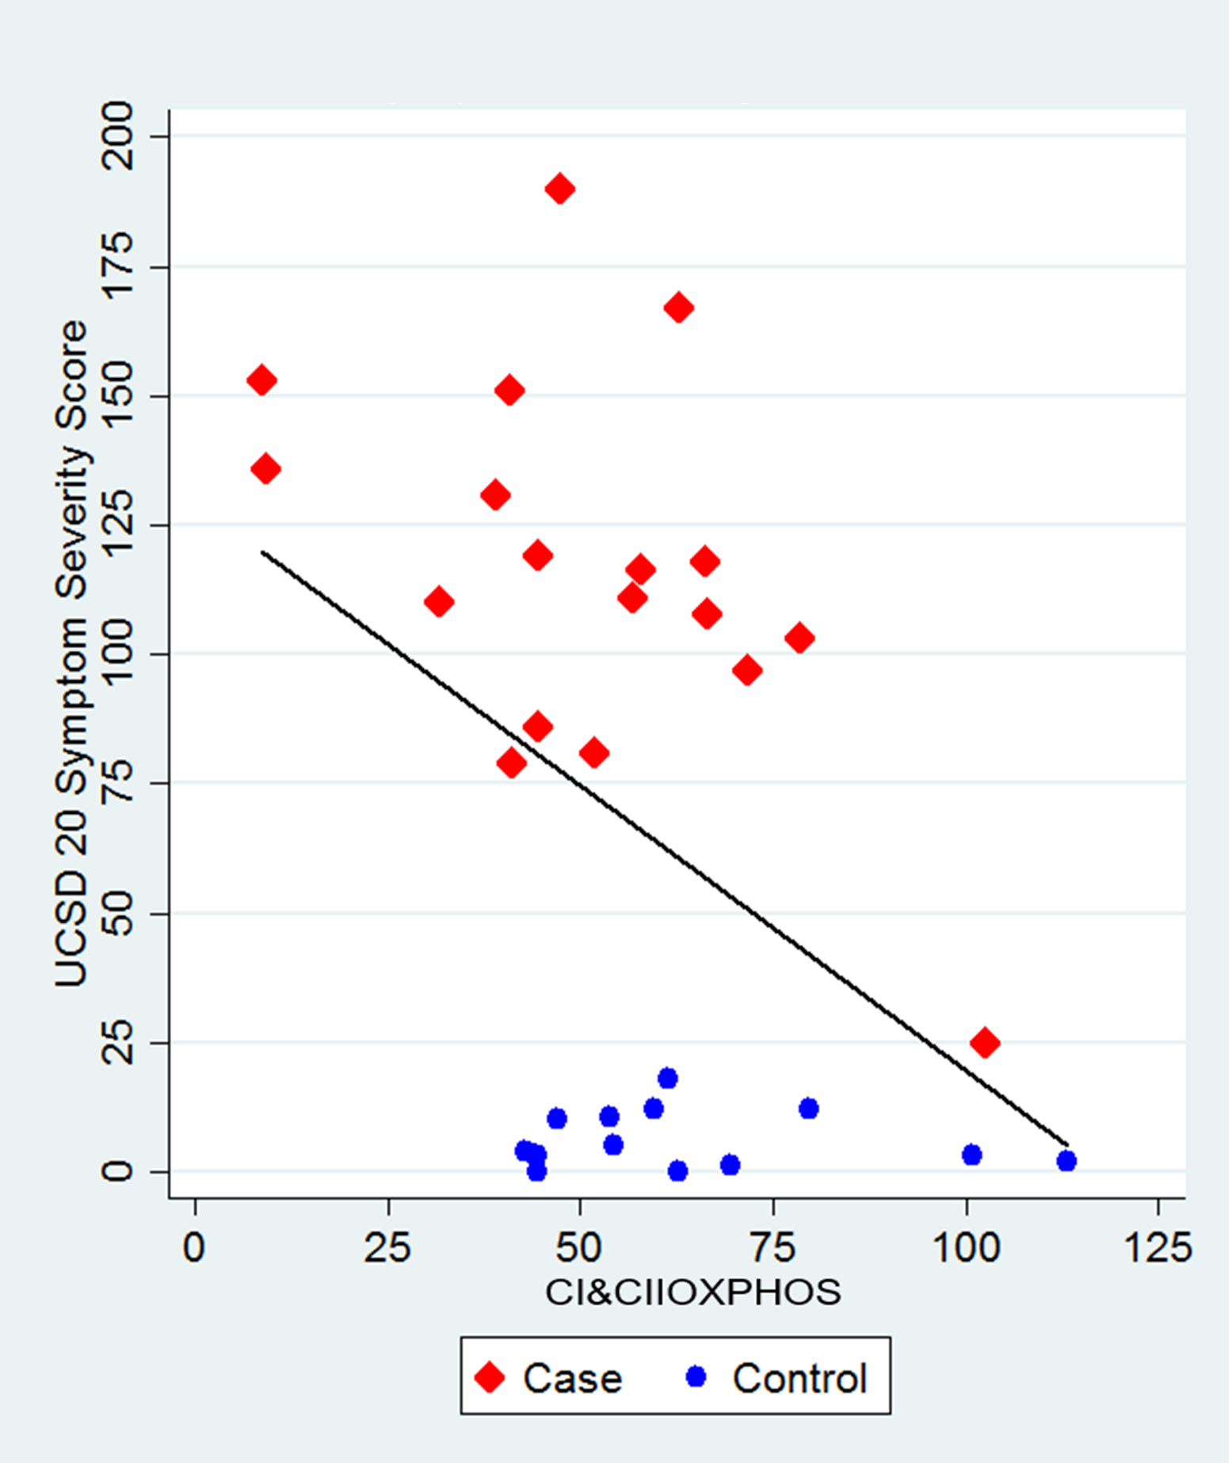
Combined Gulf War illness (case) and healthy control participants: greater symptom severity (y-axis) is tied to lower CI&CIIOXPHOS (mitochondrial function marker).

Supplement Figure 2. GWI severity vs. CI&CIIOXPHOS: GWI cases separately
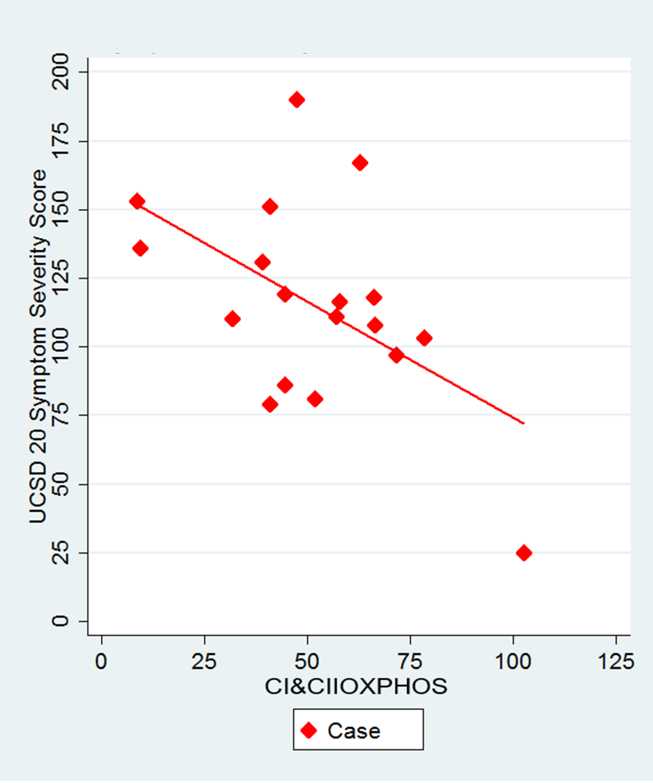
Gulf War illness cases separately: Greater symptom severity (y-axis) is tied to lower CI&CIIOXPHOS (mitochondrial function marker).

