Supplementary appendix

Table S1. Schematic presentation of sample size selection
Indicators | Bangladesh  (N=7,902) | Pakistan  (N=4,227) | Nepal  (N=2,379)
Total listed children in DHS surveys | 8,759 | 12,708 | 5,038
Children after excluding dead children | 8,402 | 11,989 | 4,861
Children after excluding absence for height and weight measurement | 7,902 | 4,227 | 2,379

Table S2. Classification of children with severe anthropometric failure
Group name | Description | Severe Wasting | Severe Stunting | Severe Underweight
A | No severe failure | No | No | No
B | Severe wasting only | Yes | No | No
C | Severe wasting and severe underweight | Yes | No | Yes
D | Severe wasting, severe stunting and severe underweight | Yes | Yes | Yes
E | Severe stunting and severe underweight | No | Yes | Yes
F | Severe stunting only | No | Yes | No
G | Severe underweight only | No | No | Yes

Table S3. Measurements of independent variables
Variable | Description | Measurement | Scale of measurement
Mothers’ age (in years) | Age of mothers at the time of data collection | 15-19, 20-24, 25-29, 30-34, 35-39, ≥ 40 | Discrete, categorial
Parents’ education | Parental educational status. Accomplishment of at least five years of schooling (primary level, class 1 to 5) refers educated. No (0 years of schooling) schooling year refers uneducated. | Both parents were uneducated, only father was uneducated, only mother was uneducated, both parents were educated | Categorical
Mother’s income-earning status | Mother engaged in economic activity at the time of data collection | Not working,  Currently working | Binary
Underweight mother | Mother with <18.5 kg/m² of body mass index refers to underweight, and ≥18.5 kg/m² refers to healthy or not underweight | No, Yes | Binary
Mothers received antenatal care | At least one medical surveillance and review performed during pregnancy for the early detection of possible complications of pregnancy | No, Yes | Binary
Mothers received postnatal care | At least one postnatal care is the individualized care provided to meet the needs of a mother and her baby following childbirth | No, Yes | Binary
Mother’s attitudes toward wife-beating | Respondents are asked if they agree that a husband is justified in hitting or beating his wife under each of the following five circumstances: she burns the food, she argues with him, she goes out without telling him, she neglects the children, and she refuses to have sex with him. If respondents answer “yes” in at least one circumstance, they are considered to have attitudes justifying wife beating. | Not justified, Justified | Binary
Mothers’ decision-making autonomy | In the BDHS surveys, a woman’s decision-making power is assessed on the following three themes: 1) a woman who usually decides on her healthcare 2) a woman who usually decides on large household purchases and 3) a woman who usually decides on visits to family or relatives. The response options were as follows: (a) respondent alone, (b) respondent and husband/partner, (c) respondent and another person, (d) husband/partner alone, (e) someone else, (f) other. For each question, a value of 1 was assigned for inability in decision-making if the responses were d, e, or f and 0 for otherwise if the responses were a, b, or c. The values were then added, resulting in a score from 0 to 3. The Cronbach’s α for the instruments was 0·79, indicating high internal consistency. | Not participated, Participated | Binary
Source of water | Improved: piped into dwelling, piped to yard/plot, public tap/standpipe, piped to neighbour, tube well or borehole, protected well, protected spring, rainwater, tanker truck, cart with small tank, bottled water; unimproved: unprotected well, unprotected spring, surface water (river, dam, lake, pond, stream, canal, irrigation channel), other | Improved, unimproved | Binary
Type of toilet facility | Improved: flush - to piped sewer system, flush - to septic tank, flush - to pit latrine, flush - don't know where, pit latrine - ventilated improved pit, pit latrine - with slab, composting toilet; unimproved: flush - to somewhere else, pit latrine - without slab / open pit, bucket toilet, hanging toilet/latrine, other | Improved, unimproved | Binary
Cooking fuel | Solid fuel includes coal, lignite, charcoal, wood, straw / shrubs / grass, agricultural crop and animal dung; Clean fuel includes electricity, natural gas, processed gas, biogas, kerosene | Clean fuel, Solid fuel | Binary
Mass media exposure | Mass media exposure through television, radio and newspaper/magazine has been defined as exposure to at least one media that exposes to at least once a week | No, Yes | Binary
Wealth index | Wealth index in the DHS surveys is calculated, by the DHS authority, based on information on household characteristics and assets using principal component analysis. Then households are classified into quintiles based on the values of the wealth index, where households with lower values of the index is considered as poorest and vice-versa | Poorest, poorer, middle, richer, richest | Categorical
Children’s age (in months) | Age of the children at the time of data collection | 0-11 months, 12-23 months, 24-35 months, 36-47 months, 48-59 months | Categorical
Sex of child | Sex differential of children | Male, Female | Binary
Birth order | Birth order is the chronological order of sibling births in a family | One, two, three, four and above | Categorical
Low birth weight | Children were <2.5 kg of weight during birth. Approximately 75% mothers can correctly report their baby's size at birth, therefore mother’s recall is a valid proxy measure of birth weight. | No, Yes, Not weighted | Categorical
Recent morbidity status | Children had at least cough, fever or diarrhea before 2 weeks of the survey | No, Yes | Binary

Table S4. Compare background characteristics of included and excluded children
Characteristics | Bangladesh  (N=7,902) |  | Pakistan  (N=4,227) |  | Nepal  (N=2,379)
 | Complete cases  (N=4,617) | Excluded cases  (N=3,358) | Complete cases  (N=2,673) | Excluded cases  (N=1,554) | Complete cases  (N=1,919) | Excluded cases  (N=460)
Maternal age (years) | p <0.001 |  | p <0.001 |  | p= 0.094
≤24 | 2,412 (53.1) | 1,326 (39.5) | 639 (23.9) | 368 (23.7) | 826 (43.1) | 201 (43.7)
25-29 | 1,190 (26.2) | 1,020 (30.4) | 782 (29.3) | 557 (35.8) | 609 (31.7) | 164 (35.6)
30-34 | 675 (14.8) | 651 (19.4) | 656 (24.5) | 394 (25.4) | 303 (15.8) | 66 (14.4)
≥40 | 267 (5.9) | 361 (10.7) | 596 (22.3) | 235 (15.1) | 181 (9.4) | 29 (6.3)
Parents’ educational status | p =001 |  | p=0.026 |  | p <0.001
Uneducated parents | 149 (3.3) | 150 (4.6) | 605 (22.6) | 375 (24.9) | 193 (10.1) | 66 (14.9)
Only educated mother | 490 (10.8) | 393 (12.1) | 112 (4.2) | 69 (4.6) | 54 (2.8) | 22 (4.9)
Only educated father | 133 (2.9) | 115 (3.5) | 733 (27.4) | 444 (29.6) | 408 (21.3) | 119 (26.9)
Educated parents | 3,772 (83.0) | 2,577 (79.7) | 1,223 (45.8) | 614 (40.9) | 1,264 (65.8) | 236 (53.3)
Mother’s current working status | p <0.001 |  | p=0.826 |  | p= 0.016
Not working | 2,843 (62.6) | 1,858 (55.3) | 2,373 (88.8) | 1,374 (88.5) | 877 (45.7) | 239 (52.0)
Working | 1,701 (37.4) | 1,500 (44.7) | 300 (11.2) | 178 (11.5) | 1,042 (54.3) | 221 (48.0)
Underweight mother | p <0.001 |  | p=0.260 |  | p= 0.016
No | 3,813 (84.0) | 2,922 (87.0) | 2,456 (91.9) | 1,412 (90.9) | 1,595 (83.1) | 366 (79.6)
Yes | 731 (16.0) | 436 (13.0) | 217 (8.1) | 142 (9.1) | 324 (16.9) | 94 (20.4)
Mother received antenatal care | p=0.370 |  | p=0.001 |  | p= 0.012
No | 365 (8.0) | 14 (10.1) | 410 (15.3) | 38 (26.0) | 110 (5.7) | 5 (16.7)
Yes | 4,179 (92.0) | 124 (89.9) | 2,263 (84.7) | 108 (74.0) | 1,809 (94.3) | 25 (83.3)
Mother received postnatal care | p=0.298 |  | p=0.322 |  | p= 0.104
No | 1,512 (33.3) | 50 (37.6) | 1,964 (73.5) | 98 (70.0) | 1,235 (64.4) | 15 (50.0)
Yes | 3,032 (66.7) | 83 (62.4) | 709 (26.5) | 42 (30.0) | 684 (35.6) | 15 (50.0)
Mothers attitude towards violence | p =0.365 |  | p₌0.526 |  | p= 0.349
Not justified | 3,737 (82.2) | 2,735 (81.4) | 1,376 (51.5) | 782 (50.4) | 1,369 (71.3) | 318 (69.1)
Justified | 807 (17.7) | 623 (18.6) | 1,296 (48.5) | 770 (49.6) | 550 (28.7) | 142 (30.9)
Mother’s decision-making autonomy | p <0.001 |  | p=0.188 |  | p <0.001
Not practiced | 696 (15.3) | 402 (12.4) | 1,223 (45.7) | 782 (50.4) | 687 (35.8) | 205 (46.3)
Practiced | 3,848 (84.7) | 2,832 (87.6) | 1,450 (54.3) | 782 (52.0) | 1,232 (64.2) | 238 (53.7)
Source of drinking water | p <0.001 |  | p=0.268 |  | p= 0.626
Improved | 3,868 (85.1) | 2,999 (89.3) | 2,292 (85.8) | 1,351 (86.9) | 1,682 (87.6) | 407 (88.5)
Unimproved | 676 (14.9) | 359 (10.7) | 381 (14.2) | 203 (13.1) | 237 (12.4) | 53 (11.5)
Fuel used in cooking | p=0.004 |  | p=0.252 |  | p= 0.001
Gas and liquid | 1,370 (30.1) | 910 (27.2) | 1,204 (45.0) | 670 (43.1) | 549 (28.6) | 97 (29.1)
Solid waste | 3,174 (69.8) | 2,442 (72.8) | 1,469 (55.0) | 884 (56.9) | 1,370 (71.4) | 363 (78.9)
Type of toilet facility | p= 0.034 |  | p=0.023 |  | p= 0.003
Improved | 2,534 (55.8) | 1,953 (58.2) | 2,105 (78.8) | 1,176 (75.7) | 1,473 (76.8) | 323 (70.2)
Unimproved | 2,010 (44.2) | 1,405 (41.8) | 568 (21.2) | 378 (24.3) | 446 (23.2) | 137 (29.8)
Mass media exposure | p=0.800 |  | p=0.268 |  | p= 0.001
No | 1,641 (36.1) | 1,222 (36.4) | 1,036 (38.7) | 626 (40.4) | 398 (20.7) | 128 (27.8)
Yes | 2,903 (63.9) | 2,136 (63.6) | 1,637 (61.3) | 40.4 (59.6) | 1,521 (79.3) | 332 (72.2)
Wealth index | p=0.604 |  | p=0.016 |  | p= 0.011
Poorest | 991 (21.8) | 776 (23.1) | 550 (20.6) | 355 (22.8) | 464 (24.2) | 133 (28.9)
Poorer | 933 (20.5) | 664 (19.8) | 656 (24.5) | 395 (25.4) | 420 (21.9) | 94 (20.5)
Middle | 828 (18.2) | 602 (17.9) | 504 (18.9) | 302 (19.4) | 401 (20.9) | 110 (23.9)
Richer | 913 (20.1) | 652 (19.4) | 469 (17.6) | 277 (17.8) | 391 (20.4) | 87 (18.9)
Richest | 897 (19.4) | 664 (19.8) | 494 (18.5) | 225 (14.5) | 243 (12.6) | 36 (7.8)
Place of residence | p=0.266 |  | p=0.497 |  | p= 0.004
Urban | 1,526 (33.6) | 1,168 (34.8) | 1,229 (46.0) | 696 (44.8) | 1,105 (57.5) | 231 (50.2)
Rural | 3,018 (66.4) | 2,190 (65.2) | 1,444 (54.0) | 858 (55.2) | 814 (42.4) | 229 (49.8)
Age of children | p<0.001 |  | p<0.001 |  | p<0.001
0-11 months | 1,665 (36.6) | 64 (1.9) | 800 (29.9) | 58 (3.7) | 466 (24.3) | 7 (1.5)
12-23 months | 1,544 (34.0) | 80 (2.4) | 718 (26.9) | 110 (7.1) | 494 (25.7) | 17 (3.7)
24-35 months | 1,333 (29.2) | 193 (5.7) | 522 (19.5) | 324 (20.9) | 379 (19.8) | 84 (18.3)
36-47 months | 2 (0.04) | 1,461 (43.5) | 368 (13.8) | 487 (31.3) | 330 (17.2) | 151 (32.8)
48-59 months |  | 1,560 (46.5) | 265 (9.9) | 575 (37.0) | 250 (13.0) | 201 (43.7)
Sex of children | p= 0.684 |  | p= 0.445 |  | p<0.001
Male | 2,381 (37.8) | 1,744 (51.9) | 1,369 (51.2) | 777 (50.0) | 1,038 (54.1) | 207 (45.0)
Female | 2,163 (47.6) | 1,614 (48.1) | 1,304 (48.8) | 777 (50.0) | 881 (45.9) | 253 (55.0)
Birth order | p= 0.294 |  | p<0.001 |  | p<0.001
First | 1,720 (37.9) | 1,299 (38.7) | 535 (20.0) | 512 (32.9) | 713 (37.2) | 223 (48.5)
Second | 1,502 (33.0) | 1,071 (31.9) | 582 (21.8) | 312 (20.1) | 585 (30.5) | 109 (23.7)
Third | 778 (17.1) | 549 (16.3) | 457 (17.1) | 260 (16.7) | 298 (15.5) | 65 (14.1)
Fourth and above | 544 (12.0) | 439 (13.1) | 1,099 (41.1) | 470 (30.2) | 323 (16.8) | 63 (13.7)
Low birth weight | p<0.001 |  | p<0.001 |  | p<0.001
No | 1,765 (38.8) | 94 (27.7) | 432 (16.2) | 187 (12.0) | 1,086 (56.6) | 205 (44.6)
Yes | 303 (6.7) | 35 (10.3) | 99 (3.7) | 38 (2.4) | 166 (8.6) | 31 (6.7)
Not weighted | 2,476 (54.5) | 210 (62.0) | 2,142 (80.1) | 1,327 (85.5) | 667 (34.8) | 224 (48.7)
Child morbidity | p<0.001 |  | p<0.001 |  | p<0.001
No | 2,205 (48.5) | 1,960 (48.4) | 1,076 (40.2) | 1,076 (40.2) | 1,262 (65.8) | 364 (79.1)
Yes | 2,339 (51.7) | 1,395 (41.6) | 1,597 (59.8) | 1,597 (59.8) | 657 (34.2) | 96 (20.9)
Little’s test for MCAR | p<0.001 |  | p=0.0002 |  | p<0.001
Note: MCAR denotes Missing Completely At Random,
p values were generated from chi-square test

Table S5 - Little’s test for Missing Completely at random and test for covariate-dependent missingness
Models† | Covariates | Bangladesh | Pakistan | Nepal
Models† | Covariates | p-values | p-values | p-values
Model 1 | No covariates | <0.001 | 0.0002 | <0.001
Model 2 | Age of child | 0.999 | 0.062 | 0.040
Model 3 | Age of child and place of residence | 0.998 | 0.063 | 0.112
Model 4 | Age of child, place of residence and wealth index | 0.999 | 0.930 | 0.461
Model 5 | Age of child, sex of child, place of residence and wealth index | 0.999 | 0.918 | 0.560
Note: †Models 2-5 were used to test the assumption

Figures

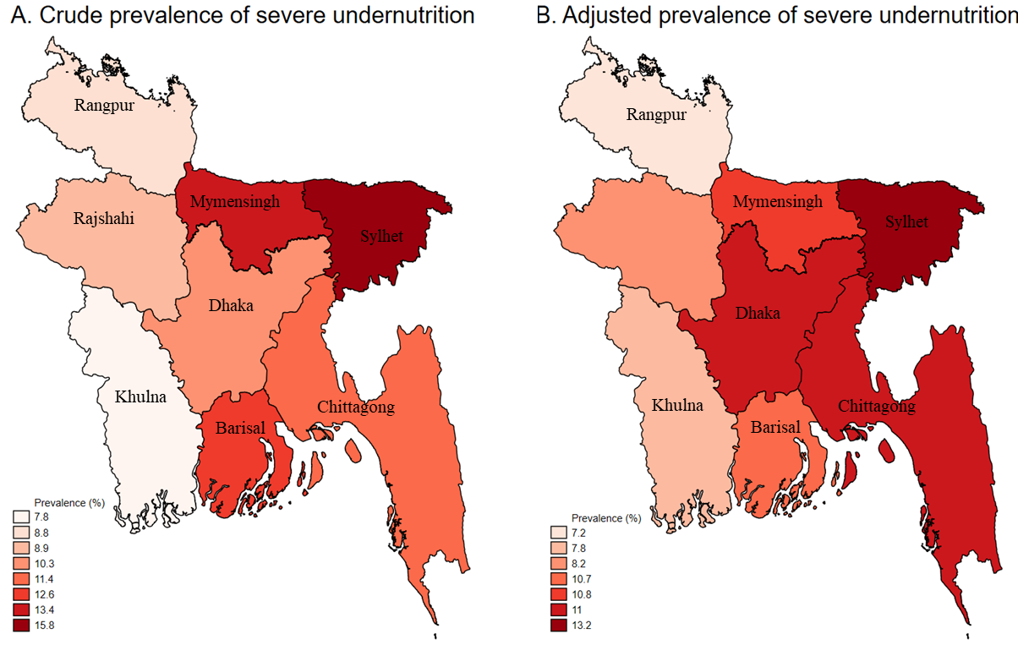
Supplementary Figure S1: Overall prevalence of severe undernutrition in Bangladesh.
Note: Prevalence was adjusted for the variables found significant in the regression model

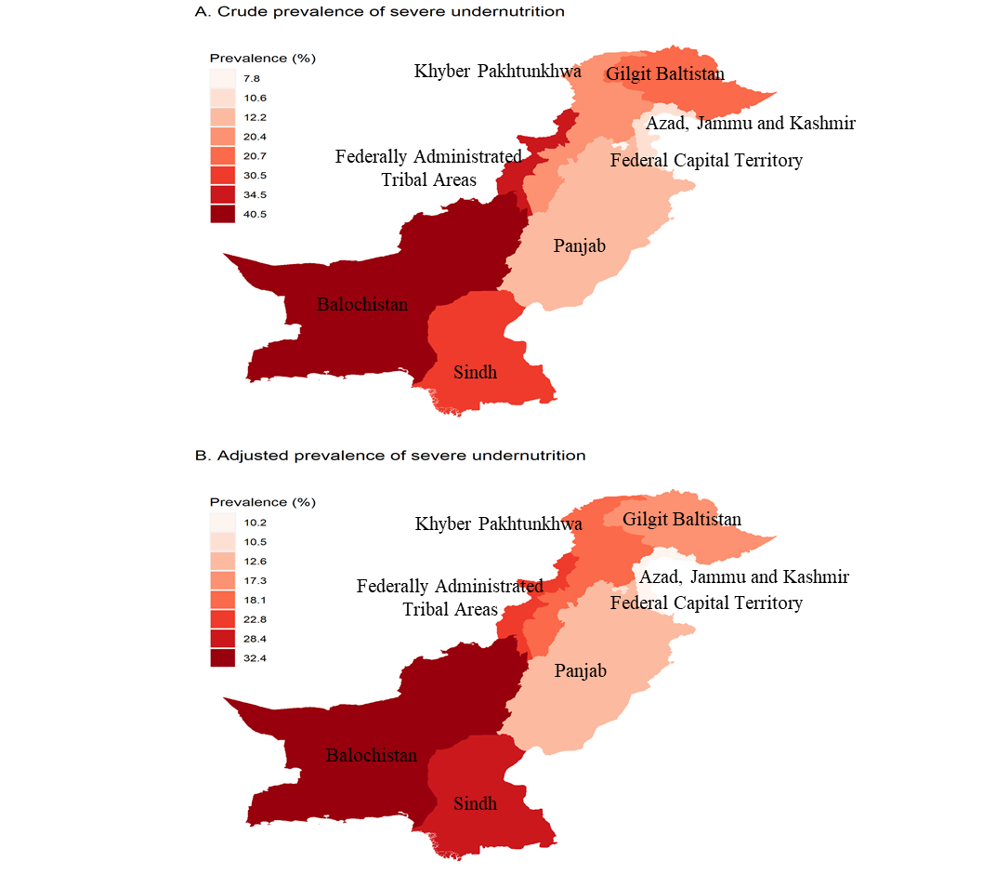
Supplementary Figure S2: Overall prevalence of severe undernutrition in Pakistan.
Note: Prevalence was adjusted for the variables found significant in the regression model

Supplementary Figure S3: Overall prevalence of severe undernutrition in Nepal.
Note: Prevalence was adjusted for the variables found significant in the regression model

