Quantifiable peptide library bridges the gap for proteomics based biomarker discovery and validation on breast cancer

Sung-Soo Kim^{1,2,†}, HyeonSeok Shin^{2,†}, Kyung-Geun Ahn¹, Young-Min Park¹, Min-Chul Kwon¹, Jae-Min Lim¹, Eun-Kyung Oh¹, Yumi Kim³, Seung-Man Han⁴ and Dong-Young Noh^{3,4**}

¹ Manufacturing and Technology Division, Bertis Inc., Hungdeok 1-ro, Giheung-gu, Yongin-si, Gyeonggi-do, Republic of Korea
² Bio Convergence Research Institute, Bertis Inc., Heungdeok 1-ro, Giheung-gu, Yongin-si, Gyeonggi-do, Republic of Korea
³ Department of Surgery, CHA Gangnam Medical Center, CHA University School of Medicine, Seoul, Republic of Korea
⁴ Bertis Inc., 172, Dolma-ro, Bundang-gu, Seongnam-si, Gyeonggi-do, Republic of Korea

Keywords: peptide library, Breast cancer, Serum biomarkers, Deep-learning, clinical proteomics, discovery, validation.
Financial support: This work was fully supported by Bertis Inc.

† These authors contributed equally to this work.
* Corresponding author:
Dong-Young Noh; Chief Executive Officer of Bertis Inc; 172, Dolma-ro, Bundang-gu, Seongnam-si, Gyeonggi-do 13605, Republic of Korea; (Email) dongyoung.noh@bertis.com (Tel) +82-10-5221-9688 (Fax) +82-31-693-8594; Professor emeritus of Seoul National University College of Medicine, 103 Daehak-ro, Seoul 03080, Republic of Korea.

Supplementary figure S1
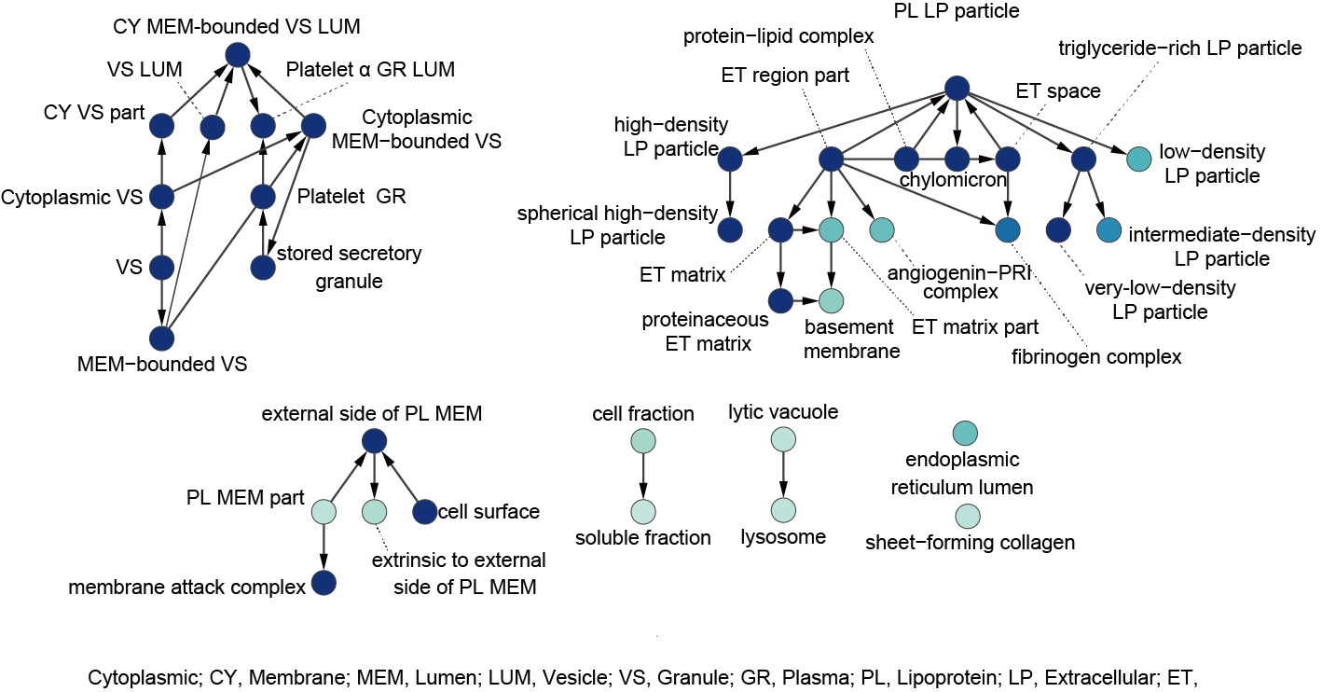
Supplementary figure S1 A GO functional enrichment network of the Pep-Quant library that satisfy a hypergeometric test with FDR correction of P < 0.05. The darker blue color indicates higher enrichment of the proteins to the function. Only the major function or cell components are shown by acronyms and the full GO names are shown in Supplementary Fig X. Acronyms: CY, cytoplasmic; MEM, membrane; Lum, lumen; VS, vesicle; GR, granule; PL, plasma; LP, lipoprotein; ET, extracellular.

Supplementary figure S2
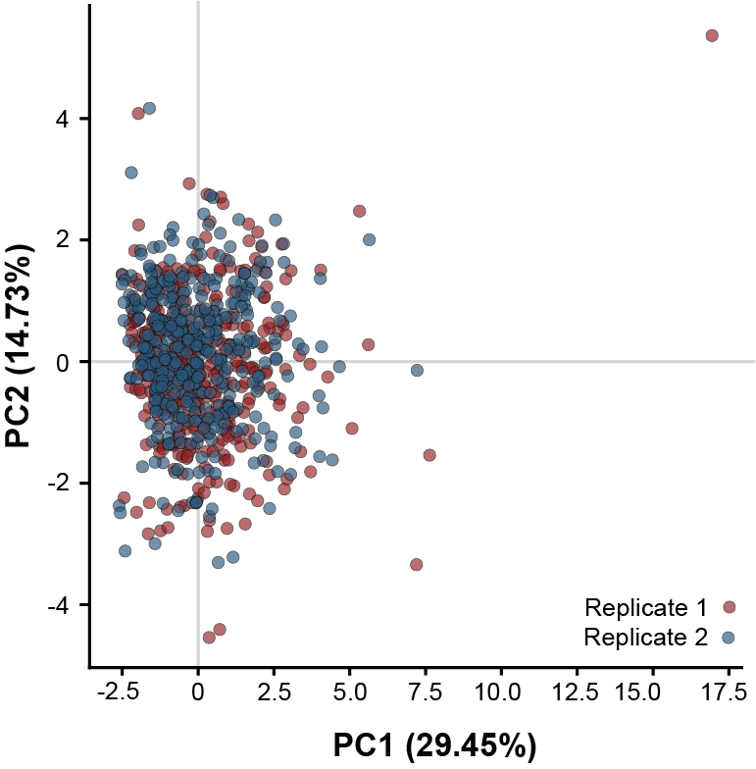
Supplementary figure S2 PCA plot of the replicates.

Supplementary figure S3
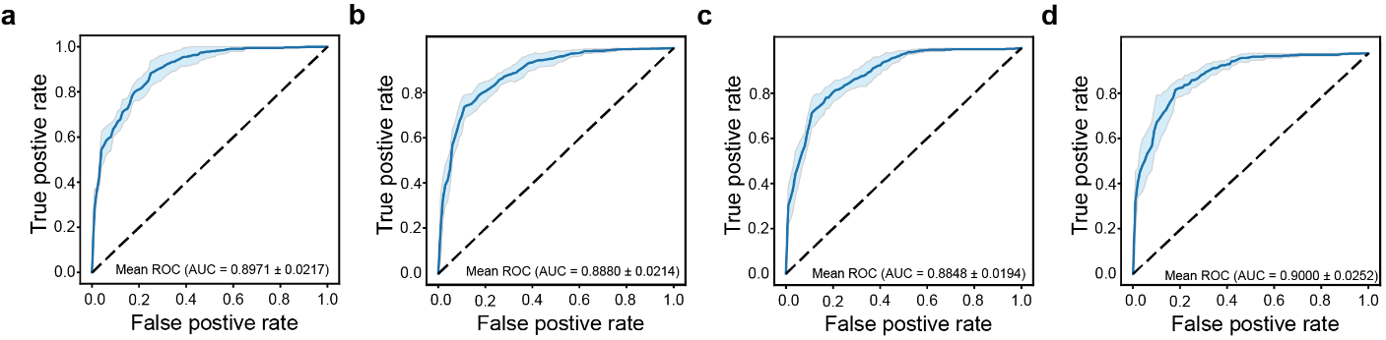
Supplementary Figure S3. Breast cancer prediction accuracy of different ML models. Area under the curve ROC graph for (A) logistic regression, (B) random forest (C), light GBM and (D) deep learning.

Supplementary figure S4
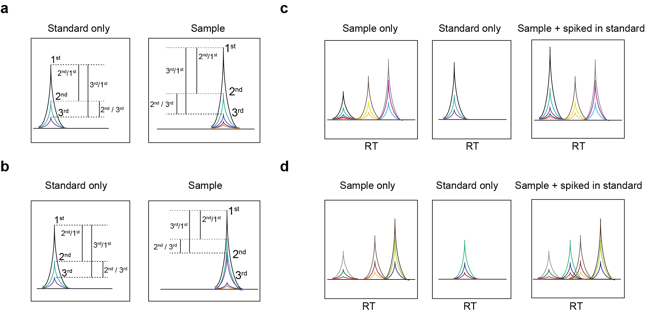
Supplementary figure S4 Schematic diagrams of the peptide identification process. Example of a comparison between the top three peaks of the standards and the samples that are (a) similar and (b) different. Example of a comparison between the standard, sample, and sample with spiked in standards to compare similarity in RT, top three peak ratio to determine a (c) quantifiable peptide and a (d) unquantifiable peptide.

Supplementary Table S1
Gene | Accession | Protein name | Sequence
FN1 | P02751 | Fibronectin | STTPDITGYR
FN1 | P02751 | Fibronectin | VDVIPVNLPGEHGQR
VWF | P04275 | von Willebrand factor | ILAGPAGDSNVVK
VWF | P04275 | von Willebrand factor | VTVFPIGIGDR
MMP9 | P14780 | Matrix metalloproteinase 9 | AVIDDAFAR
PRG4 | Q92954 | Proteoglycan 4 | AIGPSQTHTIR
PRG4 | Q92954 | Proteoglycan 4 | DQYYNIDVPSR
THBS1 | P07996 | Thrombospondin 1 | LVPNPDQK
APOC1 | P02654 | Apolipoprotein C1 | TPDVSSALDK
CHL1 | O00533 | Neural cell adhesion molecule L1 like | VIAVNEVGR
B2M | P61769 | Beta-2-microglobulin | IQVYSR
LYZ | P61626 | Lysozyme C | STDYGIFQINSR
CTSD | P07339 | Cathepsin D | VSTLPAITLK
PPBP | P02775 | Platelet basic protein | TTSGIHPK
C4BPA | P04003 | C4b-binding protein alpha chain | LSLEIEQLELQR
HBD | P02042 | Hemoglobin subunit delta | TAVNALWGK
lgals3bp | Q08380 | Galectin-3-binding protein | YSSDYFQAPSDYR
MASP1 | P48740 | Mannan-binding lectin serine protease 1 | SDFSNEER
APOF | Q13790 | Apolipoprotein F | SGVQQLIQYYQDQK
CPB2 | Q96IY4 | Carboxypeptidase B2 | YSFTIELR
VCAM1 | P19320 | Vascular cell adhesion protein 1 | SIDGAYTIR
GPLD1 | P80108 | Phosphatidylinositol-glycan-specific phospholipase D | GAVYVYFGSK
FCGBP | Q9Y6R7 | IgGFc-binding protein | GNPAVSYVR
LTF | P02788 | lactotransferrin | YYGYTGAFR
FCN2 | Q15485 | Ficolin-2 | VDGSVDFYR
PRDX6 | P30041 | Peroxiredoxin-6 | LSILYPATTGR
IGF1 | P05019 | Insulin-like growth factor1 | GFYFNKPTGYGSSSR
CLU | P10909 | Clusterin | TLLSNLEEAK
CHGA | P10645 | Chromogranin-A | ILSILR
PIGR | P01833 | Polymeric immunoglobulin receptor | VYTVDLGR

Supplementary Table S1 Biomarker candidates for breast cancer after the exploratory quantification with 50 breast cancer and 50 healthy control samples.

Supplementary Table S2
Gene | Protein | Sequence | Accession No.
APOC1 | Apolipoprotein C1 | TPDVSSALDK | P02654
CHL1 | Neural cell adhesion molecule L1 like | VIAVNEVGR | O00533
HBD | Hemoglobin subunit delta | TAVNALWGK | P02042
PIGR | Polymeric immunoglobulin receptor | VYTVDLGR | P01833
MMP9 | Matrix metalloproteinase-9 | AVIDDAFAR | P14780
PRDX6 | Peroxiredoxin-6 | LSILYPATTGR | P30041
THBS1 | Thrombospondin 1 | LVPNPDQK | P07996
FN1 | Fibronectin | STTPDITGYR | P02751
VWF | von Willebrand factor | ILAGPAGDSNVVK | P04275
MASP1 | Mannan-binding lectin serine protease 1 | SDFSNEER | P48740
PRG4 | Proteoglycan 4 | AIGPSQTHTIR | Q92954
CLU | Clusterin | TLLSNLEEAK | P10909
PPBP | Platelet basic protein | TTSGIHPK | P02775
C4BPA | C4b-binding protein alpha chain | LSLEIEQLELQR | P04003
FCGBP | IgGFc-binding protein | GNPAVSYVR | Q9Y6R7
LTF | lactotransferrin | YYGYTGAFR | P02788

Supplementary Table S2 Biomarker candidates for breast cancer after reproducibility check with larger cohort of 96 breast cancer and 95 healthy control samples.

Supplementary Table S3
Assay characteristic | APOC1 | CHL1 | CLU | PPBP | MMP9 | PRDX6 | PRG4 | FN1 | VWF
Lower Limit of  Quantification (ng/uL) | 0.0010 | 0.0008 | 0.0015 | 0.0187 | 0.0014 | 0.0015 | 0.0018 | 0.0026 | 0.0032
Linearity  (Correlation Coefficient) | 0.9996 | 0.9987 | 0.9987 | 0.9996 | 0.9990 | 0.9999 | 0.9997 | 0.9994 | 0.9993
Selectivity  (interference (%)) | 1.6933 | 7.6067 | 0.6483 | 1.7267 | 6.1833 | 0.0000 | 15.6567 | 1.4467 | 0.0000
Accuracy  (%) | 83.3 | 100.0 | 100.0 | 83.3 | 83.3 | 100.0 | 100.0 | 100.0 | 83.3
Precision intra-day  (CV*) | 0.0269 | 0.0361 | 0.0208 | 0.0606 | 0.0280 | 0.0146 | 0.0674 | 0.0289 | 0.0180
Precision inter-day  (CV) | 0.0515 | 0.0482 | 0.0460 | 0.0601 | 0.0622 | 0.0491 | 0.0483 | 0.0487 | 0.0420
Serum Stability in -80 ℃(CV) | 0.0244 | 0.0328 | 0.0247 | 0.0344 | 0.0440 | 0.1115 | 0.0348 | 0.0311 | 0.0460
Analyte Stability in 4 ℃  (CV) | 0.0313 | 0.0425 | 0.0235 | 0.0342 | 0.0624 | 0.1030 | 0.0425 | 0.0357 | 0.0531

Supplementary Table S3 MRM analytical performance evaluation results of nine markers
* CV indicate coefficient of variation

Supplementary Table S4
 | Sample category | Training set (70%) | Test set (30%) | Total  (100%)
Healthy controls | Age Total | 131 | 56 | 187
Healthy controls | Age 20-39 | 20 | 8
Healthy controls | Age 40-59 | 92 | 36
Healthy controls | Age 60-79 | 19 | 11
Healthy controls | Age 80+ | 0 | 0
Healthy controls | Unknown | 0 | 1
Breast cancer | Age Total | 150 | 65 | 215
Breast cancer | Age 20-39 | 3 | 3
Breast cancer | Age 40-59 | 82 | 35
Breast cancer | Age 60-79 | 51 | 19
Breast cancer | Age 80+ | 4 | 1
Breast cancer | Unknown | 10 | 7
Breast cancer | Stage Total | 150 | 65 | 215
Breast cancer | Stage 0 | 14 | 2
Breast cancer | Stage 1 | 33 | 22
Breast cancer | Stage 2 | 41 | 16
Breast cancer | Stage 3+ | 10 | 3
Breast cancer | unknown | 52 | 22
Other cancers | Other cancers total | 69 | 29 | 98
Other cancers | Ovarian | 14 | 6
Other cancers | Pancreas | 14 | 6
Other cancers | Thyroid | 14 | 6
Other cancers | Colon | 14 | 6
Other cancers | lung | 13 | 5
 | Total | 350 | 150 | 500

Supplementary Table S4 Number of samples used for training and testing the machine learning models

Supplementary Table S5
GO cellular component | Genes
very-low-density lipoprotein particle | APOC1
triglyceride-rich lipoprotein particle | APOC1
inclusion body | CLU
cytoplasmic vesicle part | FN1 PPBP
chylomicron | APOC1
spherical high-density lipoprotein particle | CLU
fibrinogen complex | FN1
aggresome | CLU
Weibel-Palade body | VWF
vesicle | VWF, FN1, PPBP, PRDX6
cytoplasmic vesicle | VWF, FN1, PPBP, PRDX6
membrane-bounded vesicle | VWF, FN1, PPBP, PRDX6
cytoplasmic membrane-bounded vesicle | VWF, FN1, PPBP, PRDX6
vesicle lumen | FN1, PPBP
cytoplasmic membrane-bounded vesicle lumen | FN1, PPBP
platelet alpha granule lumen | FN1, PPBP
plasma lipoprotein particle | APOC1, CLU
protein-lipid complex | APOC1, CLU
stored secretory granule | VWF, FN1, PPBP
high-density lipoprotein particle | APOC1, CLU
extracellular matrix | VWF, CHL1, FN1, MMP9
extracellular space | APOC1, FN1, PPBP, CLU, MMP9
proteinaceous extracellular matrix | VWF, CHL1, FN1, MMP9
platelet alpha granule | VWF, FN1, PPBP
extracellular region | VWF, CHL1, APOC1, FN1, PRG4, PPBP, CLU MMP9
extracellular region part | VWF, CHL1, APOC1, FN1, PPBP, CLU, MMP9

Supplementary Table S5 Cellular components associated with the nine biomarkers for breast cancer.

