Supplementary information

A novel strategy to characterize the pattern of β-lactam antibiotic-induced drug resistance in Acinetobacter baumannii.

Trae Hillyer^{#,1}, Bogdan M. Benin^{#,1}, Chuanqi Sun², Noah Aguirre¹, Belinda Willard³, Yuk Yin Sham⁴, Woo Shik Shin¹*

¹Department of Pharmaceutical Sciences, Northeast Ohio Medical University, Rootstown, OH USA
²Integrated Pharmaceutical Medicine Program, Northeast Ohio Medical University, Rootstown, OH USA
³Proteomics and Metabolomics Core, Lerner Research Institute, Cleveland Clinic, Cleveland, OH USA
⁴Department of Integrative Biology and Physiology, University of Minnesota, Minneapolis, MN USA

#Equal Contribution
*Corresponding author: Woo Shik Shin

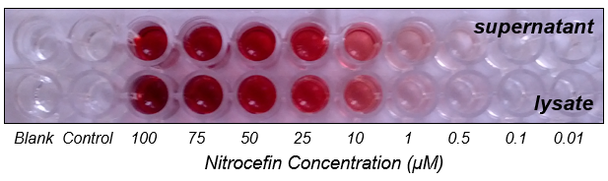
Supplementary Figure S1. Enzymatic activity of Ab19606 cell lysate and supernatant against Nitrocefin.

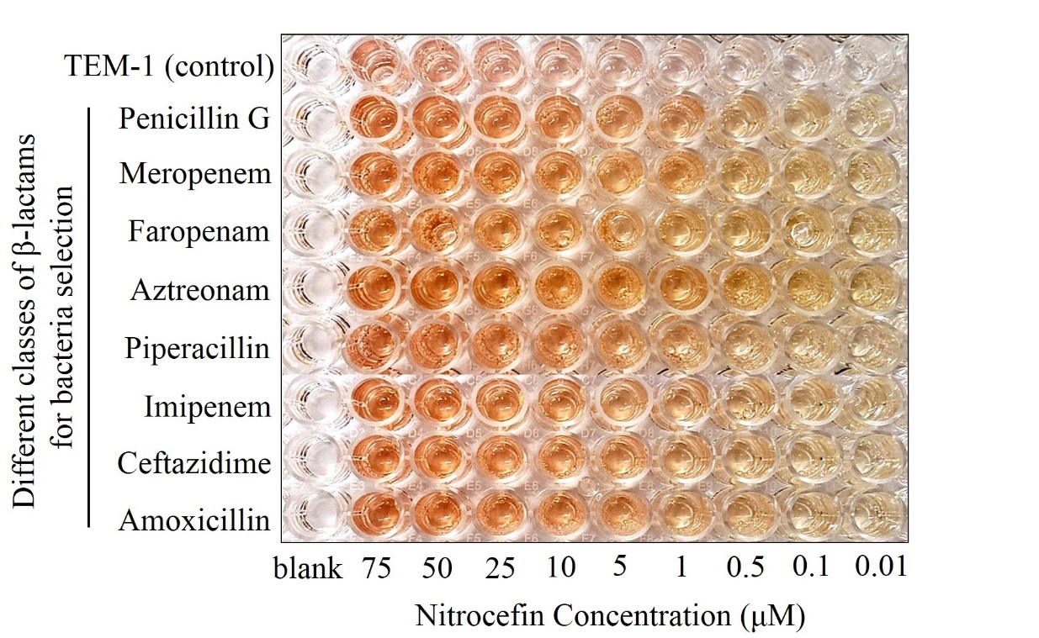
Supplementary Figure S2. Plate image for checking the enzymatic activity of β-lactam-selected Acinetobacter baumannii supernatant against nitrocefin substrate.

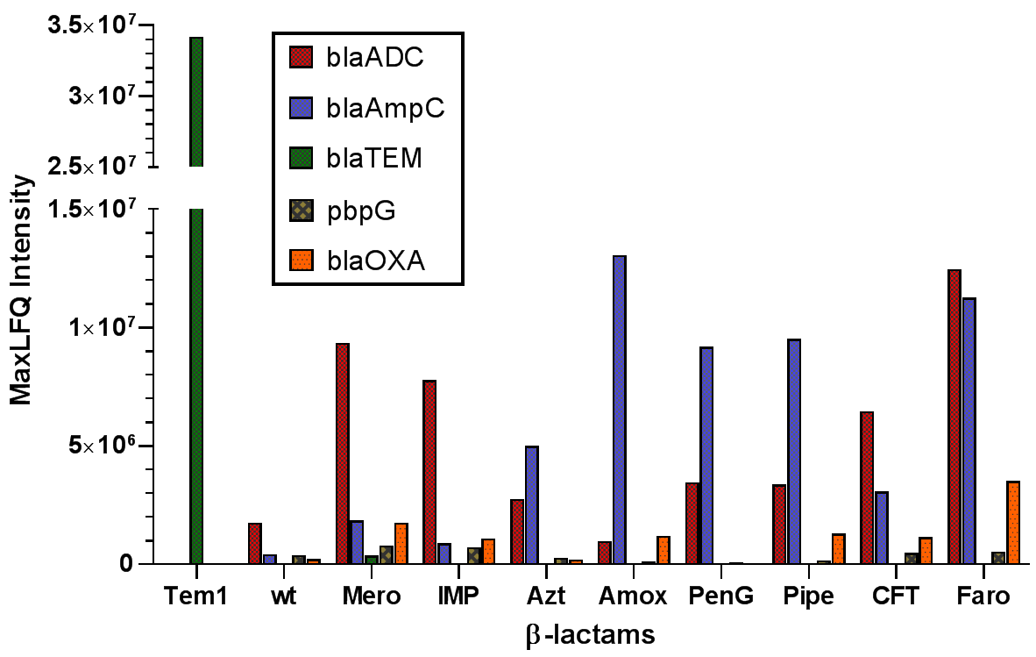

Supplementary Figure S3. Label free intensity (MaxLFQ) distribution of expressed β-lactamase across samples.

Supplementary Figure S4. Identified peptide sequences from proteomics analysis.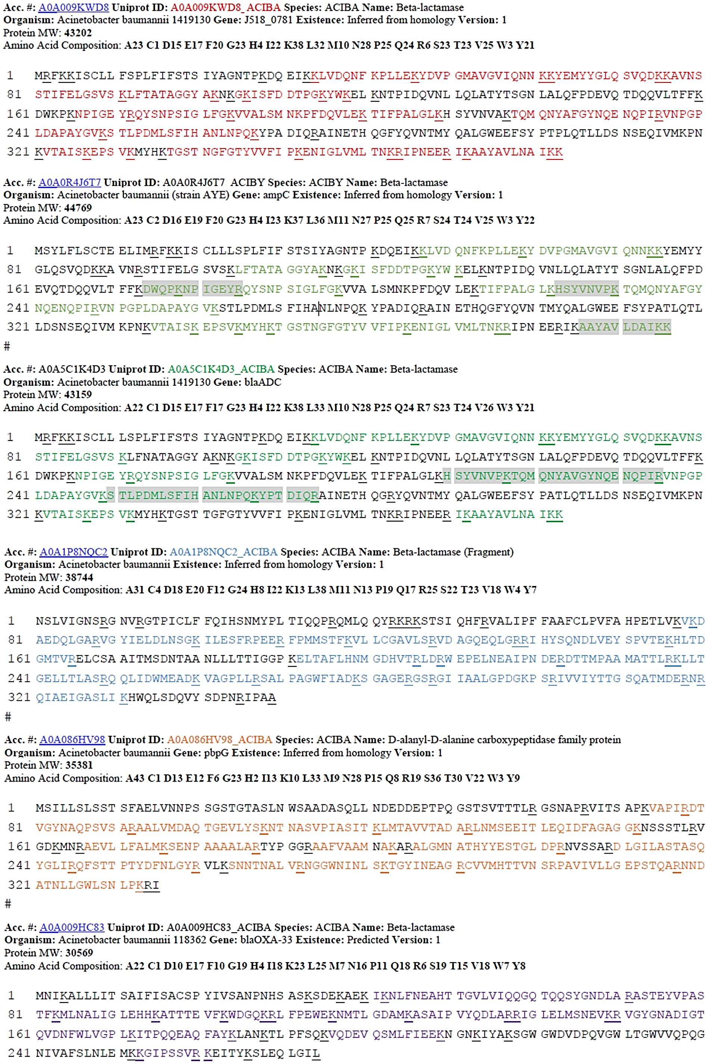
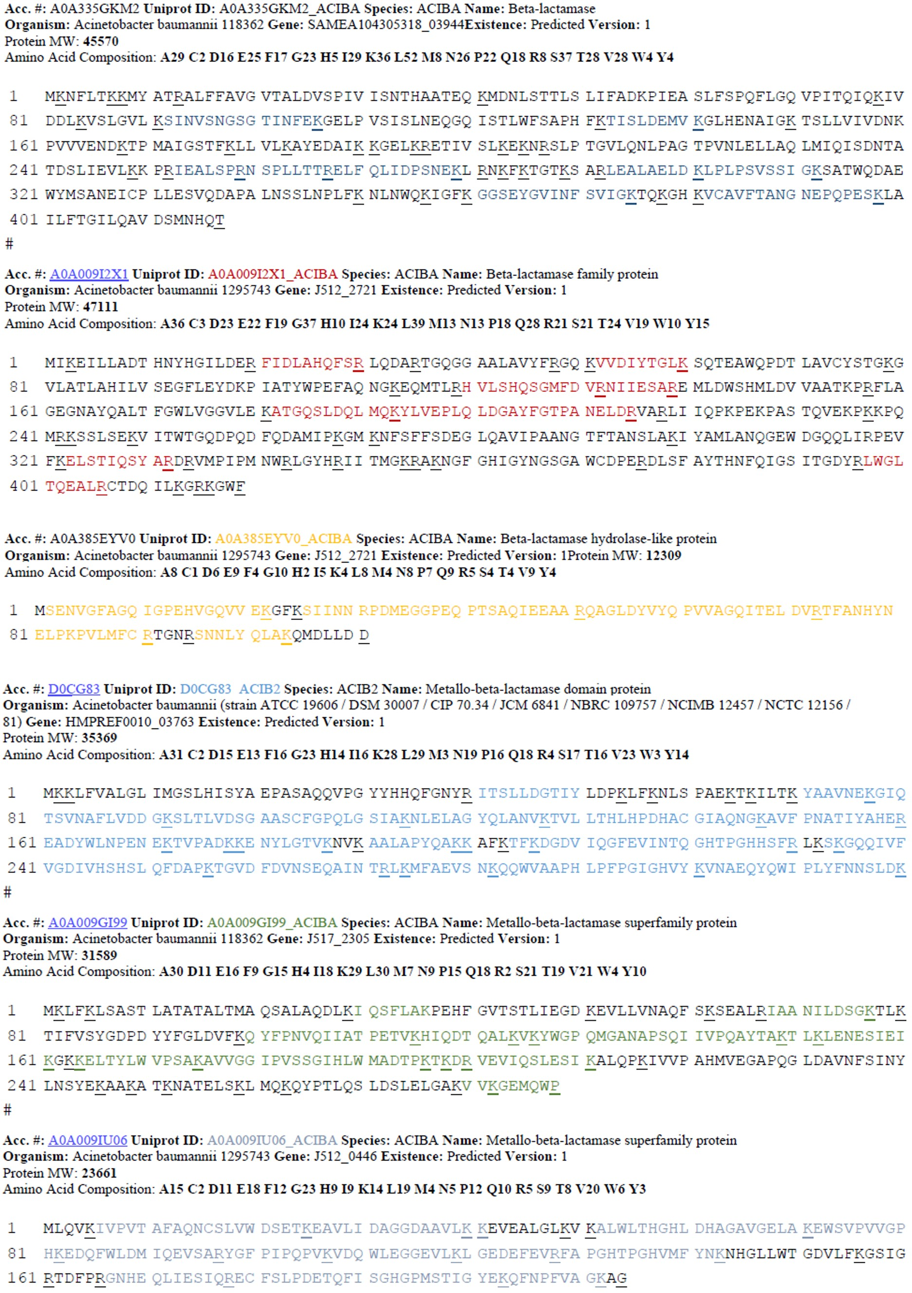
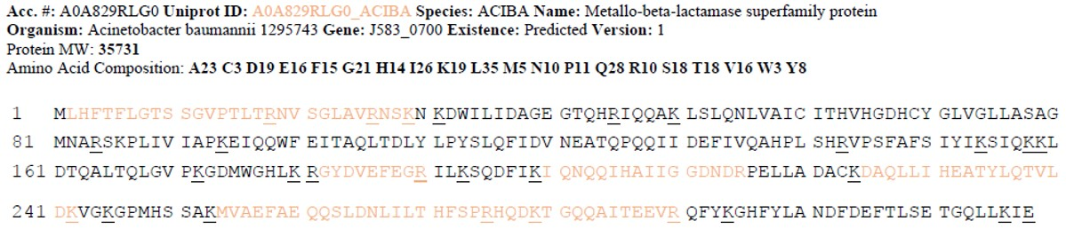

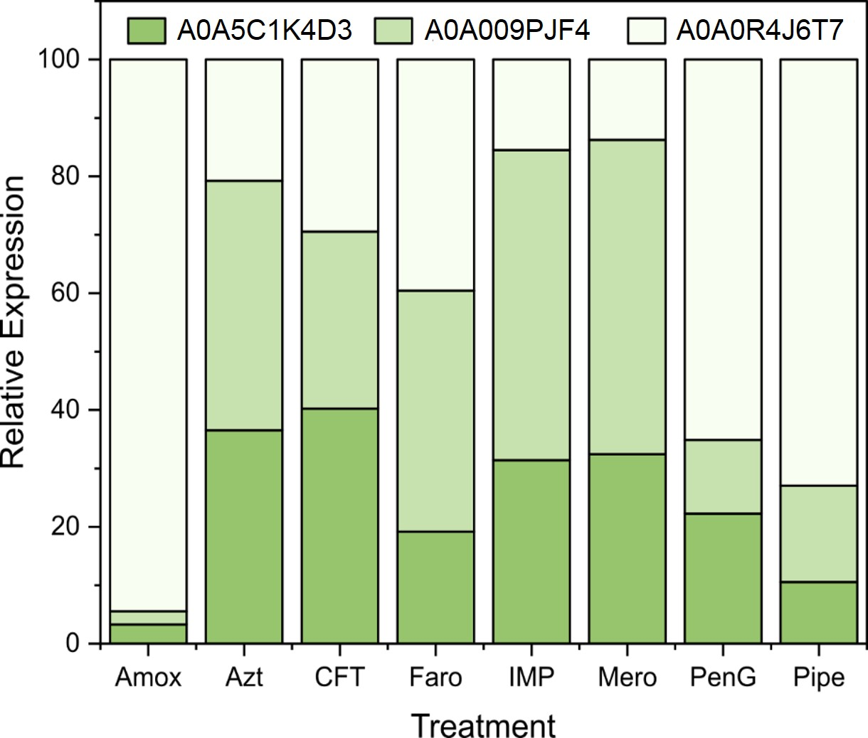

Supplementary Figure S5. Expanded comparison of relative Class C β-lactamase expression by Ab 19606 after treatment with various antibiotics.

