Induced Alpha And Beta Electroencephalographic Rhythms Covary With Single-Trial Speech Intelligibility In Competition

Vibha Viswanathan [1,*], Hari M. Bharadwaj [2], Michael G. Heinz [3], Barbara G. Shinn-Cunningham [1]

[1] Neuroscience Institute, Carnegie Mellon University, Pitttsburgh, PA 15213. [2] Department of Communication Science and Disorders, University of Pittsburgh, Pitttsburgh, PA 15260. [3] Department of Speech, Language, and Hearing Sciences, Purdue University, West Lafayette, IN 47907.

*Correspondence: vibhavis@andrew.cmu.edu

Supplementary Information

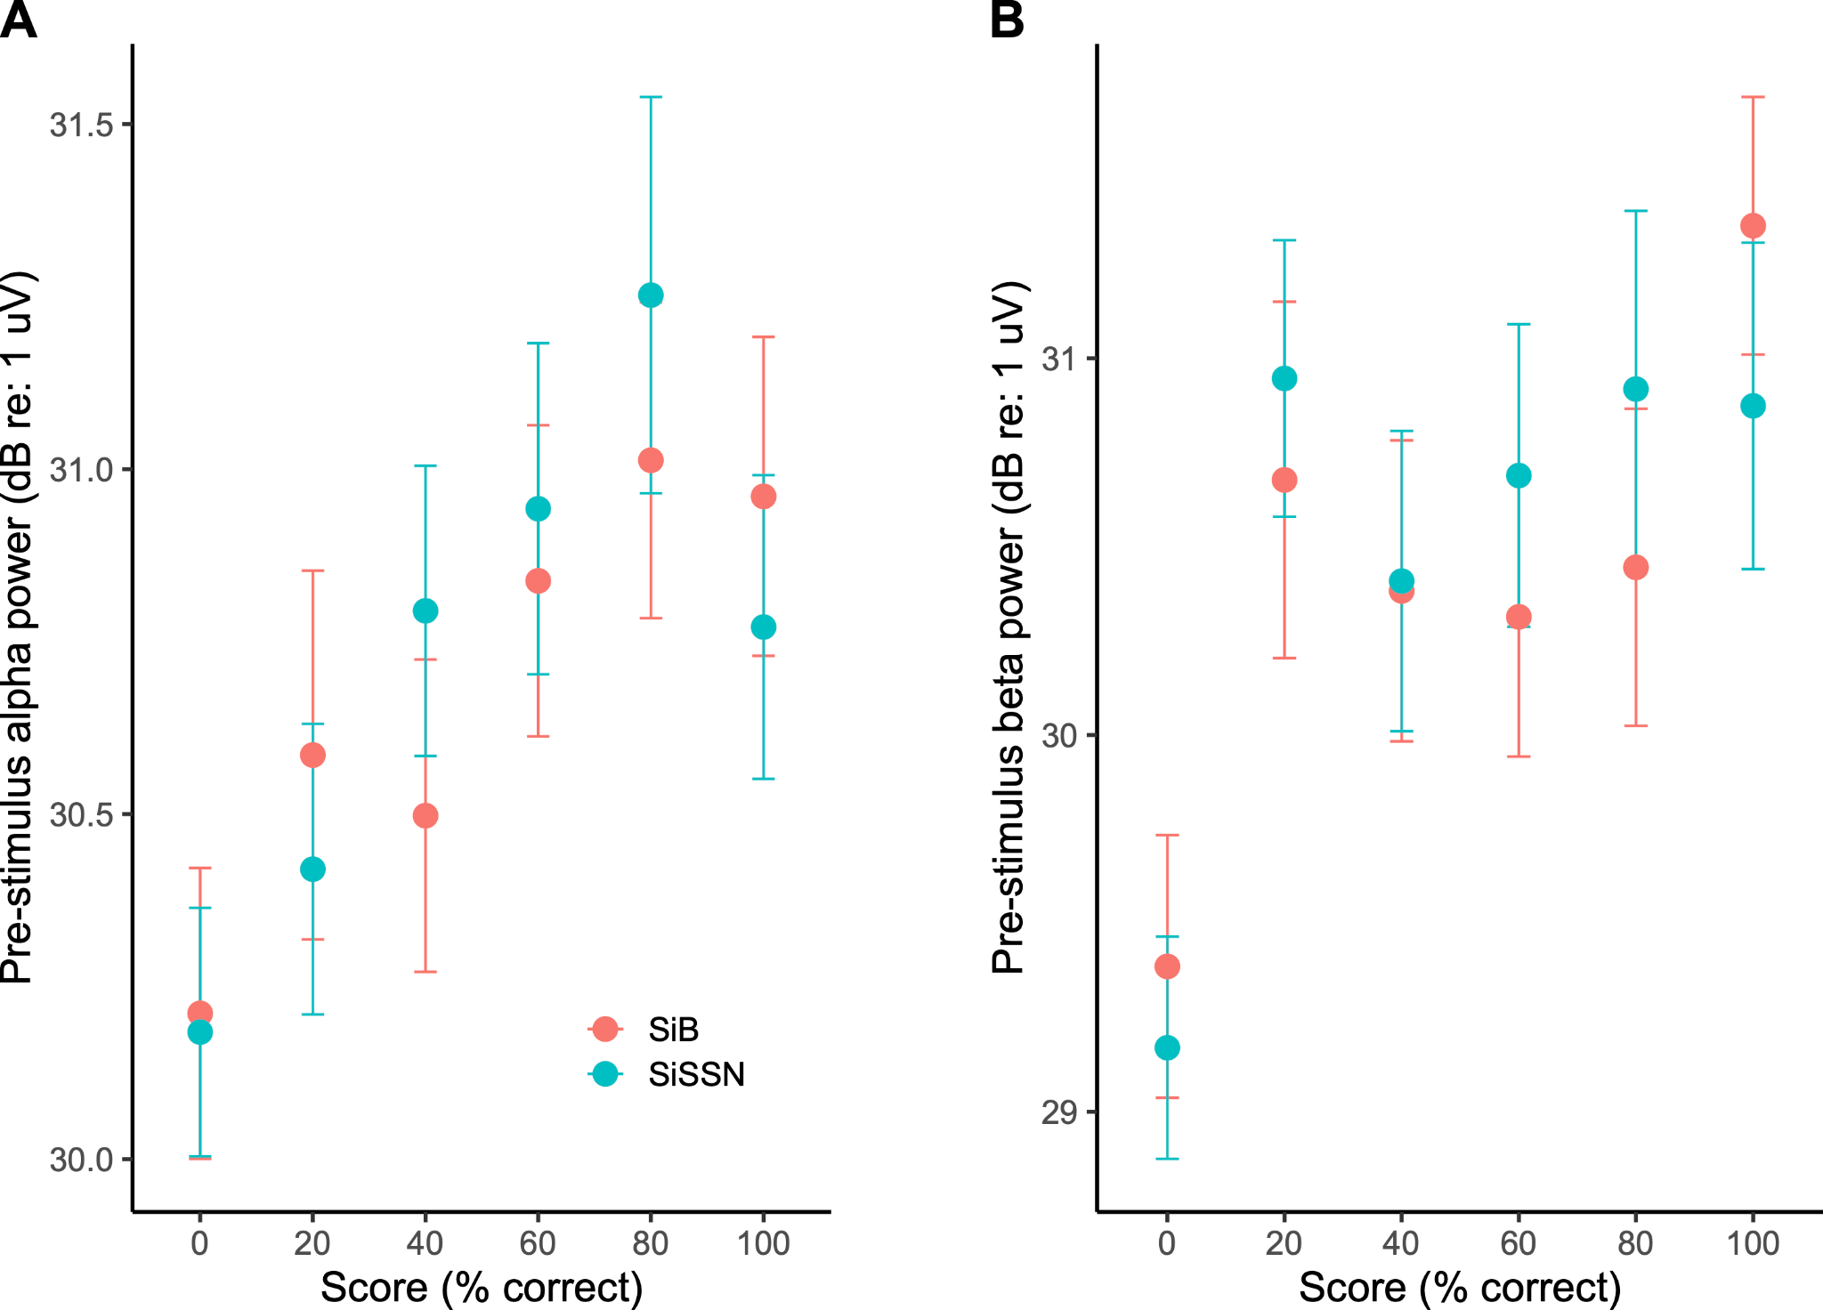
Supplementary Figure S1. Pre-stimulus alpha (A) and pre-stimulus beta (B) power [mean and standard error of the mean (STE)] versus percent-correct score in different trials across subjects. Data are shown separately for each experimental condition (SiB versus SiSSN).

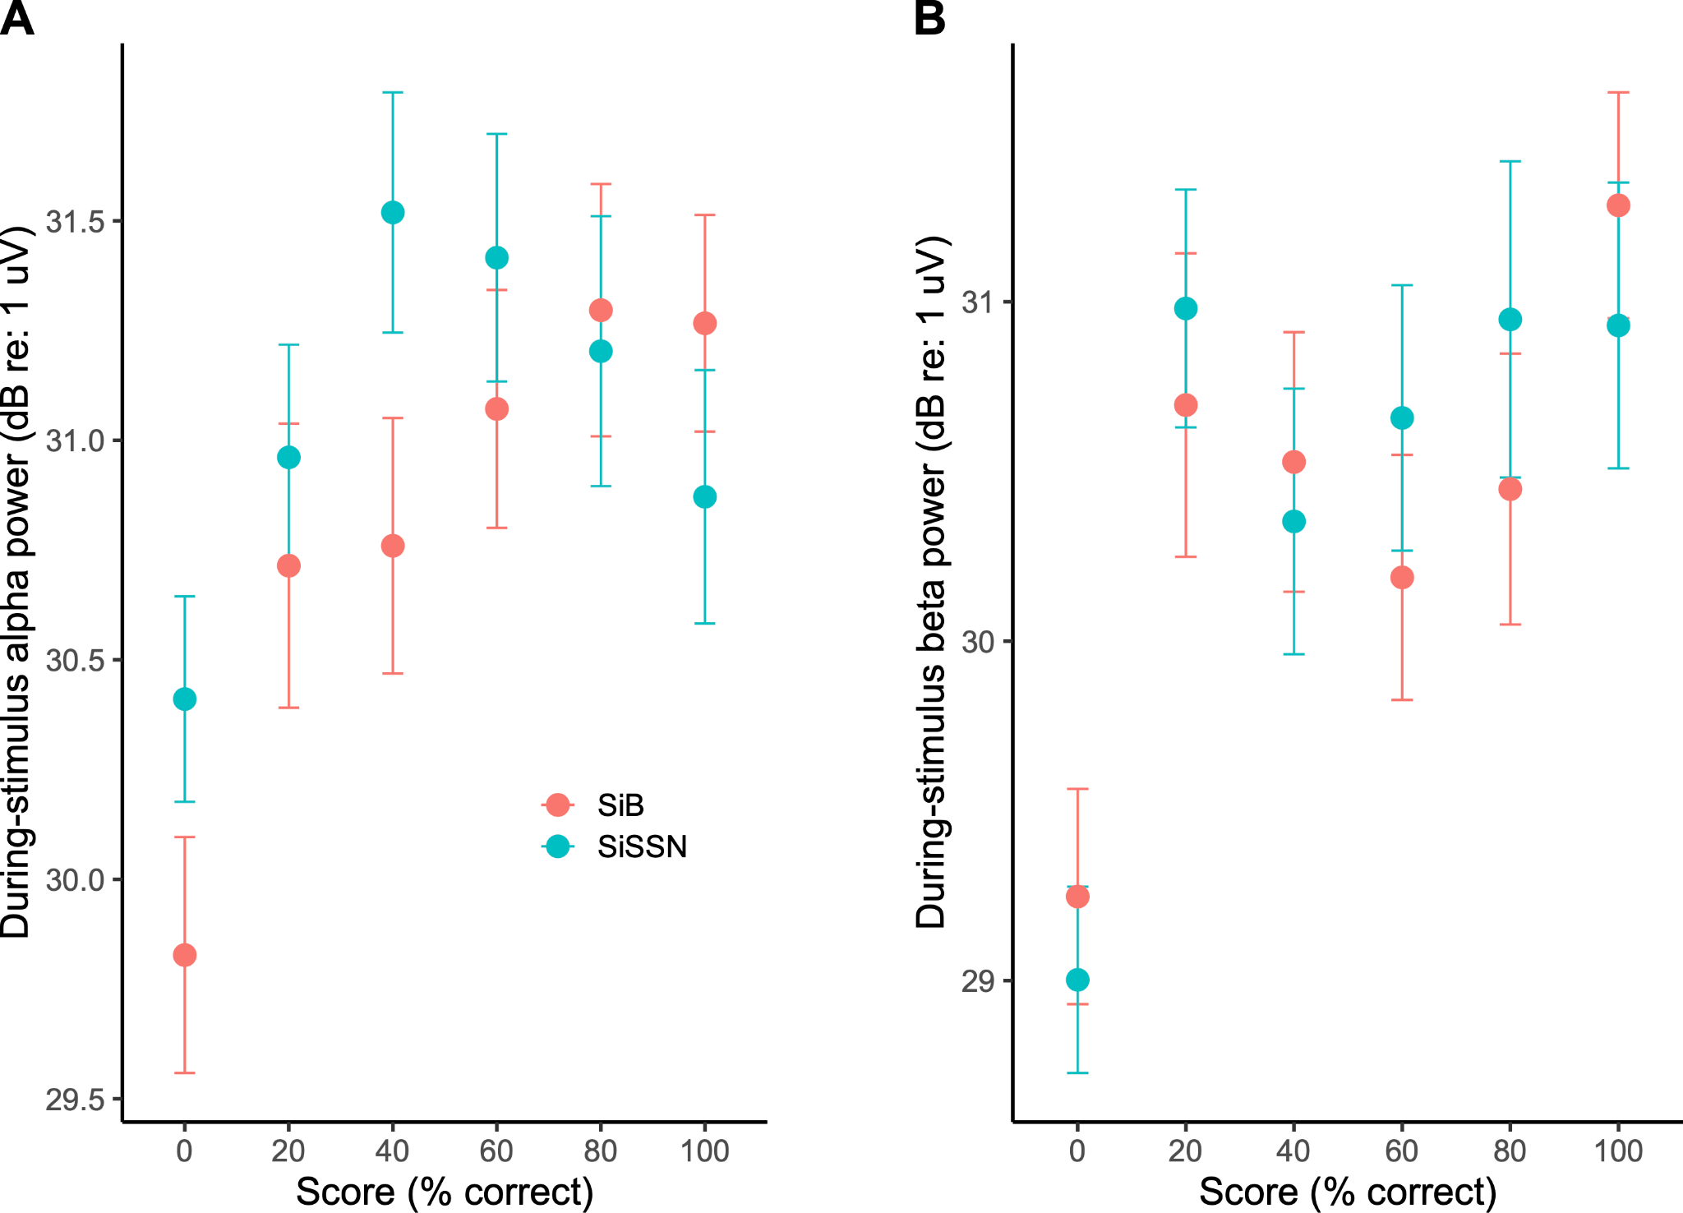
Supplementary Figure S2. During-stimulus alpha (A) and during-stimulus beta (B) power (mean and STE) versus percent-correct score in different trials across subjects. Data are shown separately for each experimental condition (SiB versus SiSSN).

Supplementary Table S1. Analysis of deviance table (Type II tests) for the multinomial linear regression analysis to test whether during-stimulus alpha power contributes additionally to predicting percent-correct score over the contribution of pre-stimulus alpha power alone, and vice-versa.
R code (uses the “nnet” package):
model <- multinom(formula = percentcorrect ~ duringstimulus_alpha + prestimulus_alpha + condition, data = data)
Anova(model)
 | Chi-square | Degree of freedom | Probability(>Chi-square)
duringstimulus_alpha | 13.912 | 5 | 0.01618
prestimulus_alpha | 9.933 | 5 | 0.07717
condition | 38.673 | 5 | 2.763e-07

Supplementary Table S2. Analysis of deviance table (Type II tests) for the multinomial linear regression analysis to test whether during-stimulus beta power contributes additionally to predicting percent-correct score over the contribution of pre-stimulus beta power alone, and vice-versa.
R code (uses the “nnet” package):
model <- multinom(formula = percentcorrect ~ duringstimulus_beta + prestimulus_beta + condition, data = data)
Anova(model)
 | Chi-square | Degree of freedom | Probability(>Chi-square)
duringstimulus_beta | 12.931 | 5 | 0.02404
prestimulus_beta | 4.089 | 5 | 0.53674
condition | 38.371 | 5 | 3.178e-07

