Data repurposing from digital home cage monitoring enlightens new perspectives on mouse motor behaviour and reduction principle

Supplementary Information
Availability of Data and Materials
The datasets used and/or analysed during the current study available from the corresponding author on reasonable request.

Supplementary Figures

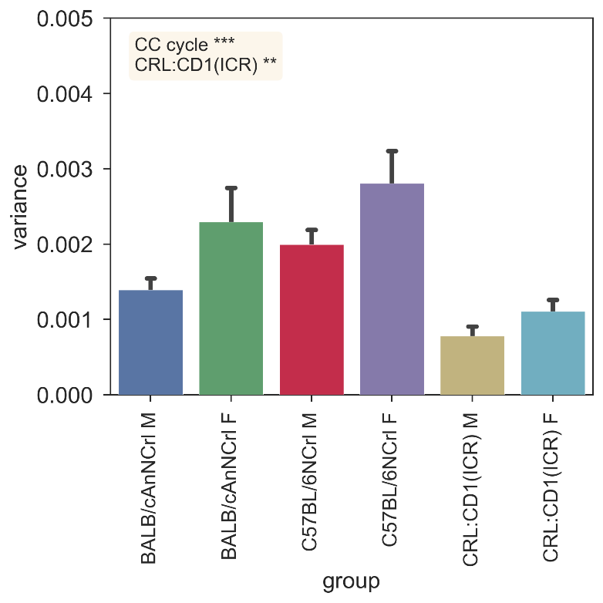
Supplementary Figure 1. Spatial activity variance across the first hour of cage-change. Average (± s.e.m.) Variance calculated over the activity values of the 12 electrodes. Significant fixed effects are reported (**p < 0.01, ***p < 0.001), with male C57BL/6NCRL used as reference (the model structure and relative statistical results are available in supplementary data materials).
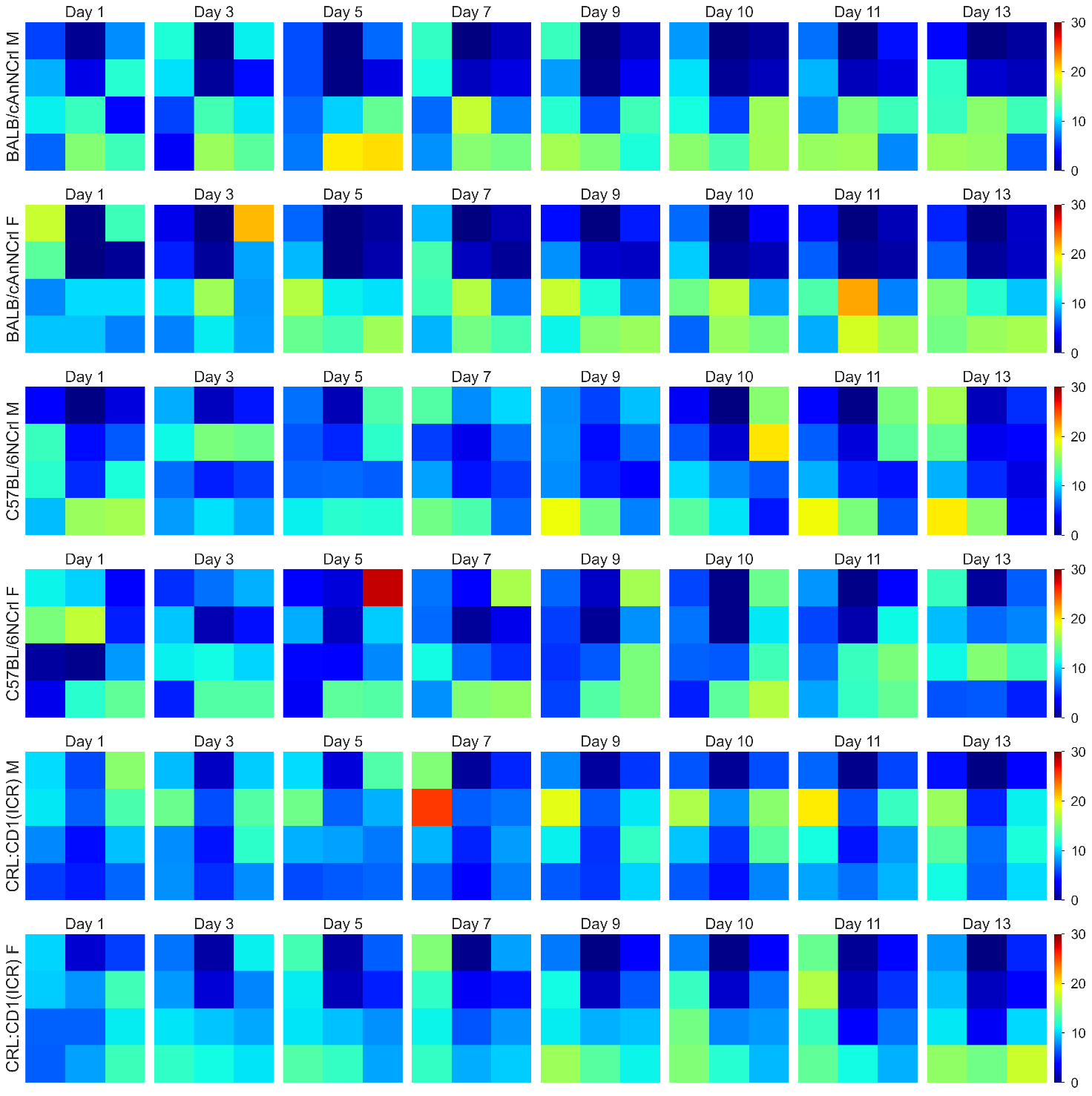
Supplementary Figure 2. Spatial activity heatmaps during the lights-on phase across days of a cage-change cycle. Average percentage of activity performed across the 12 electrodes (over the total activity performed on the DVC board), during the lights-on phase. The figure shows one example cage for each strain and sex, across multiple days of the first cage-change cycle. The rear half of the cage corresponds to the 6 electrodes in the top part of each heatmap, while the front half corresponds to the 6 bottom electrodes of each heatmap, as displayed in Figure 6.
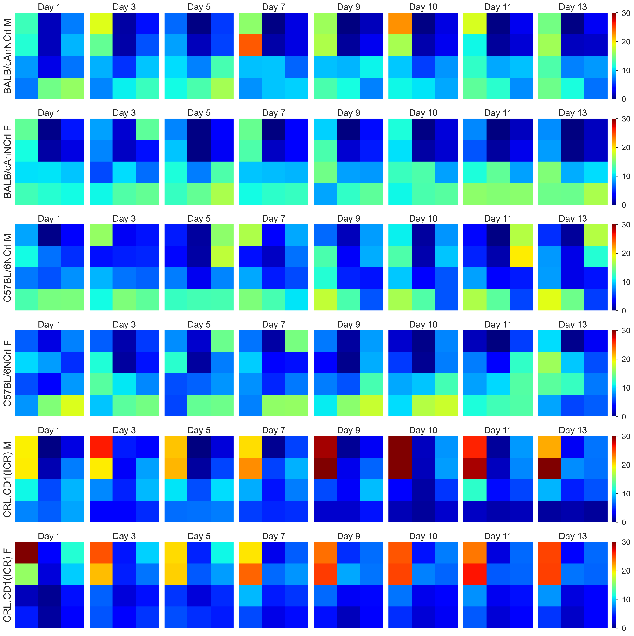
Supplementary Figure 3. Spatial activity heatmaps during the lights-off phase across days of a cage-change cycle. Average percentage of activity performed across the 12 electrodes (over the total activity performed on the DVC board), during the lights-off phase. The figure shows one example cage for each strain and sex, across multiple days of the first cage-change cycle. The rear half of the cage corresponds to the 6 electrodes in the top part of each heatmap, while the front half corresponds to the 6 bottom electrodes of each heatmap, as displayed in Figure 6.

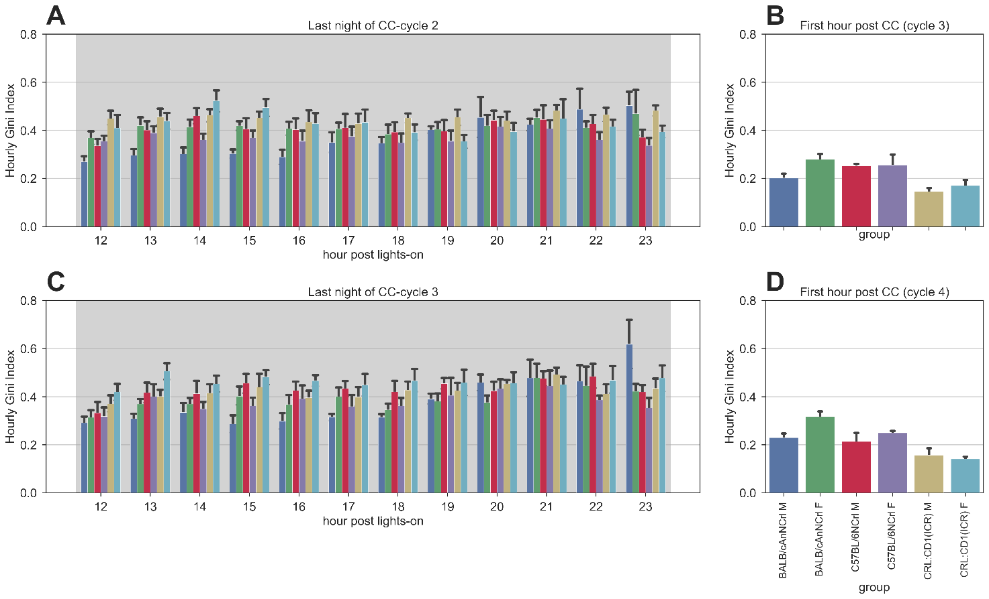
Supplementary Figure 4. Gini Index in-between the cage-change interval. A. Average (± s.e.m.) Gini Index of activity values of the 12 electrodes calculated for each hour of the night previous the cage-change, during the second cage-change cycle. B. Average (± s.e.m.) Gini Index of activity values of the 12 electrodes of the first hour of the third cage-change, following the night in 4A. C. Average (± s.e.m.) Gini Index of activity values of the 12 electrodes calculated for each hour of the night previous the cage-change, during the third cage-change cycle. D. Average (± s.e.m.) Gini Index of activity values of the 12 electrodes of the first hour of the fourth and last cage-change, following the night in 4C.

