Physiology of Saccharomyces cerevisiae during growth on industrial sugarcane molasses can be reproduced in a tailor-made defined synthetic medium
Kevy Pontes Eliodório^{1, ‡}; Gabriel Caetano de Gois e Cunha^{1, ‡}; Felipe Senne de Oliveira Lino²; Morten Otto Alexander Sommer³; Andreas Karoly Gombert⁴; Reinaldo Giudici¹; Thiago Olitta Basso^{1,*}

¹Department of Chemical Engineering, Escola Politécnica, Universidade de São Paulo, Av. Prof. Luciano Gualberto, 380, 05508-010, São Paulo, Brazil
² Nosh.bio GmbH, Schwarzschildstraβe 6, 12489 Berlin, Germany
³Novo Nordisk Foundation Center for Biosustainability, Technical University of Denmark, 2800, Kongens Lyngby, Denmark
⁴School of Food Engineering, University of Campinas, R. Monteiro Lobato 80, 13083-862, Campinas, Brazil

* Corresponding author
Email address: thiagobasso@usp.br (Basso, T.O.)
Postal address: Av. Professor Lineu Prestes 580, 05508-000, São Paulo - SP, Brazil
Telephone: + 55 11 30912260
‡both authors contributed equally to this work

Supplementary data
Figure S1 - Performance of S. cerevisiae Ethanol Red® in the synthetic molasses (Lino, Basso, and Sommer, 2018), in three industrial sugarcane molasses media, and in YP-sucrose (1% Yeast extract, 2% Peptone, and 18% Sucrose) in a scaled-down sugarcane biorefinery throughout five consecutive fermentation cycles [11]. The fermentations were performed in triplicates. Navy (Lino’s synthetic molasses); Red (Mol_A); Green (Mol_B); Purple (Mol_C); Light yellow (YP-sucrose). (A) Ethanol yield (as a percentage of theoretical maximum 0.511 g of ethanol.g of TRS⁻¹, %) (B) Glycerol concentrations (g.L⁻¹). (C) Biomass variation (%) is represented as the percentage of the first cycle initial wet yeast mass (accumulated variation). (D) Biomass variation (%) represented as percentage of the cycle initial wet yeast mass (cycle variation).

Figure S2 – Total reducing sugar content (%) of five sugarcane molasses samples (Mol_A, Mol_B, Mol_C, Mol_D, and Mol_E) and the semi-defined synthetic molasses proposed by Lino et al. [3]
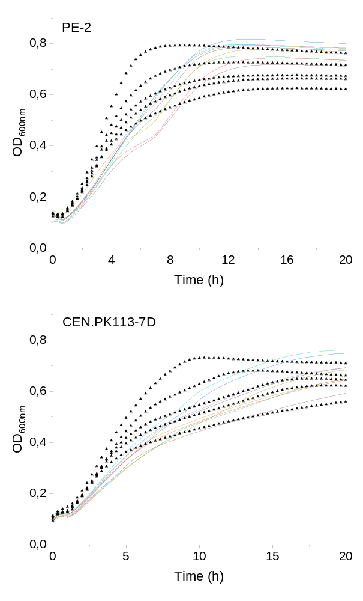
Figure S3 - Growth kinetics in molasses (black triangles) and modified versions of 1SMol with variations in ammonium and vitamin content (colored lines) for S. cerevisiae strains PE-2 and CEN.PK-113.7D

Table S1 - Compositional variations concerning 2SMolAA25 used in microplate assays to assess effect on yeast growth parameters with coded values in brackets.
Condition | Concentration ratio of 2SMol
Condition | Lower | Upper
2SMolAA25 | -
Inorganic nitrogen | 0 (-1) | 2 (+1)
Organic Acids | 0 (-1) | 2 (+1)
Trace elements | 0.1 (-1) | 10 (+1)
Vitamins | 0.1 (-1) | 2 (+1)
Mg & K | 0.2 (-1) | 2 (+1)
Calcium | 0 (-1) | 2 (+1)
Organic nitrogen | 0 (-1) | 0.5 (+1)
Phosphate | 0.5 (-1) | 2 (+1)
*The tested conditions are presented as the ratio between theses variations for each nutritional group and the composition of 2SMol containing 25% of amino acids (2SMolAA25)

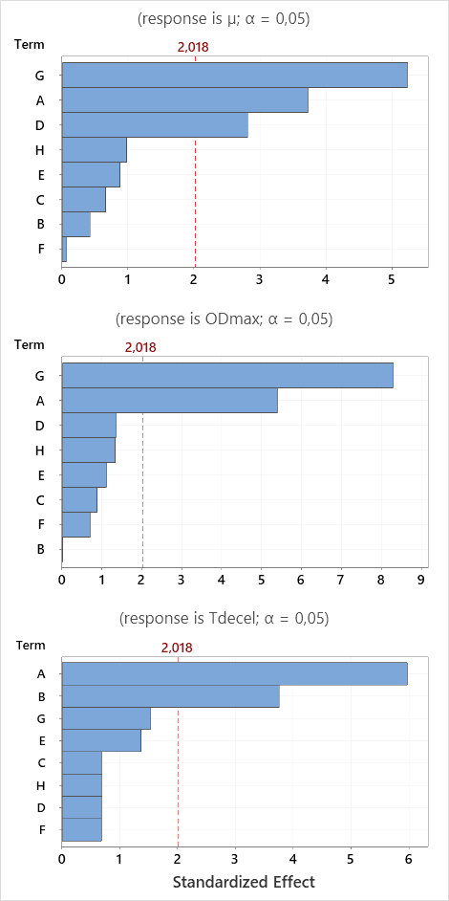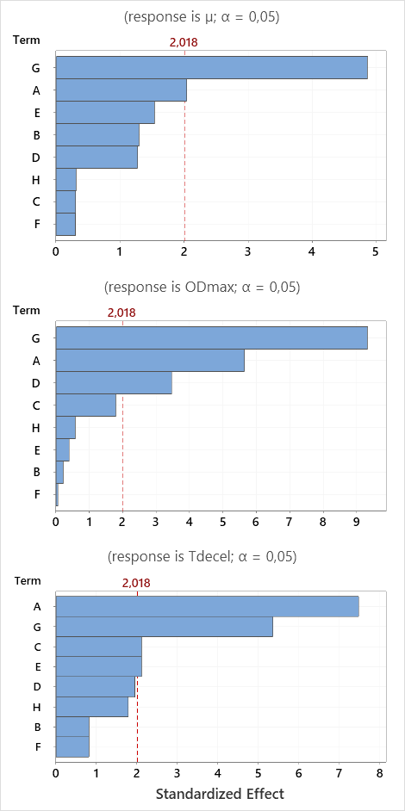

PE-2
CEN.PK113-7D
Figure S4 - Pareto chart of the standardized effects for CEN.PK113-7D and PE-2 in 2SMolAA25 with variations in the concentration of nutritional groups. (A) Inorganic nitrogen, (B) Organic acids, (C) Trace elements, (D) Vitamins, (E) Mg and K, (F) Calcium, (G) Organic nitrogen, and (H) Phosphate.

Table S2 - Growth parameters for S. cerevisiae strains PE-2 and CEN.PK113-7D using lower and higher levels of eight nutritional groups of 2SmolAA25.
PE-2
Parameter | µ (h⁻¹) |  | OD_{Max} |  | T_{decel} (h)
Level | Lower | Higher | Lower | Higher | Lower | Higher
2SMolAA25 | 0.416 |  | 0.823 |  | 12.22
Inorganic nitrogen | 0.428 | 0.4 | 0.812 | 0.688 | 8.22 | 13.33
Organic Acids | 0.432 | 0.414 | 0.796 | 0.8 | 10.67 | 10.11
Trace elements | 0.407 | 0.403 | 0.778 | 0.817 | 11.78 | 10.34
Vitamins | 0.393 | 0.411 | 0.736 | 0.812 | 13 | 11.67
Mg & K | 0.433 | 0.412 | 0.789 | 0.798 | 12 | 10.56
Calcium | 0.425 | 0.421 | 0.81 | 0.809 | 12.22 | 11.67
Organic nitrogen | 0.357 | 0.424 | 0.682 | 0.889 | 13.33 | 9.67
Phosphate | 0.419 | 0.415 | 0.787 | 0.8 | 11.56 | 12.78
Mol_B | 0.496 |  | 0.902 |  | 5.78
Mol-A | 0.426 |  | 0.682 |  | 8.56
Mol_D | 0.417 |  | 0.746 |  | 17.56
CEN.PK113-7D
Parameter | µ (h⁻¹) |  | OD_{Max} |  | T_{decel} (h)
Level | Lower | Higher | Lower | Higher | Lower | Higher
2SMolAA25 | 0.387 |  | 0.833 |  | 17
Inorganic nitrogen | 0.404 | 0.367 | 0.857 | 0.689 | 13.11 | 17
Organic Acids | 0.382 | 0.387 | 0.813 | 0.812 | 14.22 | 16.67
Trace elements | 0.367 | 0.373 | 0.852 | 0.825 | 16.11 | 16.56
Vitamins | 0.348 | 0.377 | 0.836 | 0.878 | 16.89 | 16.45
Mg & K | 0.388 | 0.379 | 0.84 | 0.806 | 16.89 | 16
Calcium | 0.384 | 0.385 | 0.818 | 0.84 | 16.89 | 16.45
Organic nitrogen | 0.335 | 0.388 | 0.638 | 0.896 | 17 | 16
Phosphate | 0.365 | 0.375 | 0.797 | 0.838 | 16.22 | 16.67
Mol_B | 0.390 |  | 0.827 |  | 10.78
Mol_A | 0.380 |  | 0.666 |  | 14.56
Mol_D | 0.370 |  | 0.716 |  | 26
* Standard deviations are not shown, given that they represented less than 8% of each mean value.

Table S3 - Investigated factors for the 3³ factorial design and their levels with coded values in brackets.
Investigated factors | Factor levels in % of 2SMol content
Organic nitrogen | 0 (-1) | 37,5 (0) | 75 (+1)
Inorganic nitrogen | 0 (-1) | 100 (0) | 200 (+1)
Vitamin | 0 (-1) | 100 (0) | 200 (+1)

Table S4 - Model coefficients for maximum specific growth rate (µ) obtained from the 3³ factorial design for yeast strains PE-2 and CEN.PK113-7D. (1) Organic nitrogen, (2) Inorganic nitrogen, (3) Vitamins.
Term | PE-2 |  |  |  | CEN.PK113-7D
Term | Coefficient | Standard Error | t-Value | p-Value | Coefficient | Standard Error | t-Value | p-Value
b₀ | 0.424 | 0.006 | 68.820 | 0.000 | 0.401 | 0.008 | 53.100 | 0.000
b₁ | 0.044 | 0.003 | 15.540 | 0.000 | 0.046 | 0.004 | 13.030 | 0.000
b₂ | 0.026 | 0.003 | 9.130 | 0.000 | 0.032 | 0.004 | 9.130 | 0.000
b₃ | 0.023 | 0.003 | 8.230 | 0.000 | 0.035 | 0.004 | 9.890 | 0.000
b₁₁ | -0.037 | 0.005 | -7.550 | 0.000 | -0.048 | 0.006 | -7.860 | 0.000
b₂₂ | -0.023 | 0.005 | -4.680 | 0.000 | -0.033 | 0.006 | -5.460 | 0.000
b₃₃ | -0.024 | 0.005 | -4.810 | 0.000 | -0.031 | 0.006 | -5.170 | 0.000
b₁₂ | -0.030 | 0.003 | -8.510 | 0.000 | -0.048 | 0.004 | -11.140 | 0.000
b₁₃ | 0.006 | 0.003 | 1.730 | 0.089 | 0.008 | 0.004 | 1.870 | 0.065
b₂₃ | 0.011 | 0.003 | 3.010 | 0.004 | 0.006 | 0.004 | 1.330 | 0.188
R² | 89.08% |  |  |  | 89.40%
R² adjusted | 87.69% |  |  |  | 88.05%
R² predicted | 85.57% |  |  |  | 86.34%

Table S5 - Model coefficients for maximum absorbance (OD_{max}) obtained from the 3³ factorial design for yeast strains PE-2 and CEN.PK113-7D. (1) Organic nitrogen, (2) Inorganic nitrogen, (3) Vitamins.
Term | PE-2 |  |  |  | CEN.PK113-7D
Term | Coefficient | Standard Error | t-Value | p-Value | Coefficient | Standard Error | t-Value | p-Value
b₀ | 0.914 | 0.017 | 55.310 | 0.000 | 0.903 | 0.021 | 44.040 | 0.000
b₁ | 0.159 | 0.008 | 20.840 | 0.000 | 0.167 | 0.009 | 17.580 | 0.000
b₂ | 0.076 | 0.008 | 9.890 | 0.000 | 0.074 | 0.009 | 7.840 | 0.000
b₃ | 0.032 | 0.008 | 4.230 | 0.000 | 0.044 | 0.009 | 4.650 | 0.000
b₁₁ | -0.081 | 0.013 | -6.100 | 0.000 | -0.056 | 0.016 | -3.400 | 0.001
b₂₂ | -0.042 | 0.013 | -3.160 | 0.002 | -0.055 | 0.016 | -3.370 | 0.001
b₃₃ | -0.017 | 0.013 | -1.280 | 0.205 | -0.006 | 0.016 | -0.360 | 0.722
b₁₂ | -0.066 | 0.009 | -7.060 | 0.000 | -0.103 | 0.012 | -8.840 | 0.000
b₁₃ | 0.034 | 0.009 | 3.640 | 0.001 | 0.029 | 0.012 | 2.480 | 0.016
b₂₃ | 0.014 | 0.009 | 1.450 | 0.150 | 0.016 | 0.012 | 1.370 | 0.176
R² | 90.34% |  |  |  | 82.35%
R² adjusted | 89.11% |  |  |  | 82.37%
R² predicted | 87.49% |  |  |  | 79.69%

Table S6 - Model coefficients for deceleration time (t_{decel}) obtained from the 3³ factorial design for yeast strains PE-2 and CEN.PK113-7D. (1) Organic nitrogen, (2) Inorganic nitrogen, (3) Vitamins.
Term | PE-2 |  |  |  | CEN.PK113-7D
Term | Coefficient | Standard Error | t-Value | p-Value | Coefficient | Standard Error | t-Value | p-Value
b₀ | 11.137 | 0.378 | 29.480 | 0.000 | 18.274 | 0.949 | 19.260 | 0.000
b₁ | -4.315 | 0.175 | -24.670 | 0.000 | -4.889 | 0.439 | -11.130 | 0.000
b₂ | -2.297 | 0.175 | -13.130 | 0.000 | -3.704 | 0.439 | -8.430 | 0.000
b₃ | -0.766 | 0.175 | -4.380 | 0.000 | -4.463 | 0.439 | -10.160 | 0.000
b₁₁ | 0.352 | 0.303 | 1.160 | 0.249 | 1.148 | 0.761 | 1.510 | 0.136
b₂₂ | 0.037 | 0.303 | 0.120 | 0.903 | -0.444 | 0.761 | -0.580 | 0.561
b₃₃ | 0.704 | 0.303 | 2.320 | 0.023 | 2.871 | 0.761 | 3.770 | 0.000
b₁₂ | 0.111 | 0.214 | 0.520 | 0.606 | 1.482 | 0.538 | 2.750 | 0.007
b₁₃ | -0.620 | 0.214 | -2.900 | 0.005 | -4.084 | 0.538 | -7.590 | 0.000
b₂₃ | -0.796 | 0.214 | -3.720 | 0.000 | -0.806 | 0.538 | -1.500 | 0.139
R² | 92.13% |  |  |  | 87.59%
R² adjusted | 91.12% |  |  |  | 86.02%
R² predicted | 89.60% |  |  |  | 84.04%

Figure S5 - Growth kinetics of S. cerevisiae strains CEN.PK 113-7D and PE-2 in: molasses (black lines, Mol_B solid, and Mol_D dashed) and modified versions of 2SMol [% of Organic nitrogen, Inorganic Nitrogen, vitamins in 2SMol]: [37.5, 100, 100] red line, [37.5, 200, 200] dark green, [37.5, 0, 200] light blue, [75, 100, 100] marine blue, [0, 200, 100] grey, [37.5, 100, 200] green, [37.5, 200, 100] light blue, [0, 100, 100] yellow, [0, 100, 200] pink

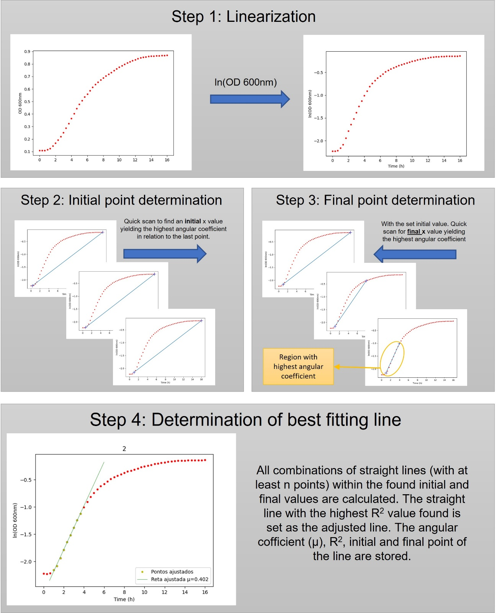
Figure S6 – Visual explanation of the algorithm used to calculate the steepest region in the ln(OD) versus time curves, and growth parameters (µ, OD_{max}, and t_{decel}).

