Supplementary Material
Supplemental Figure 1. Change in the MRC-ICU score by each ICU day.
Supplemental Figure 2. Hospital mortality by MRC-ICU, APACHE-II and SOFA score.
Supplemental Figure 3. Assessment of the interaction between medication regimen complexity and severity of illness for the training and testing sets.

Supplemental Figure 4. Metrics versus threshold plot.

Supplemental Figure 5. Calibration plot.

Supplemental Table 1. Line-item representation of the MRC-ICU score at 24 hours.
Supplemental Table 2. Univariate component analysis of the MRC-ICU score at 24 hours and risk for hospital mortality.

Supplemental Table 3. Evaluation of multiple logistic regression for hospital mortality with interaction terms between MRC-ICU, APACHE-II and SOFA scores.

Supplemental Table 4. Sensitivity, Specificity, Negative Predictive Value, and Positive Predictive Value for hospital mortality prediction models.

Supplemental Table 5. Results of DeLong’s Test for comparisons among AUROC curves for training and test sets.

Supplemental Table 6. Results of Negative Predictive Value (NPV) and Positive Predictive Value (PPV) threshold analyses.

Supplemental Figure 1. Change in the MRC-ICU score by each ICU day

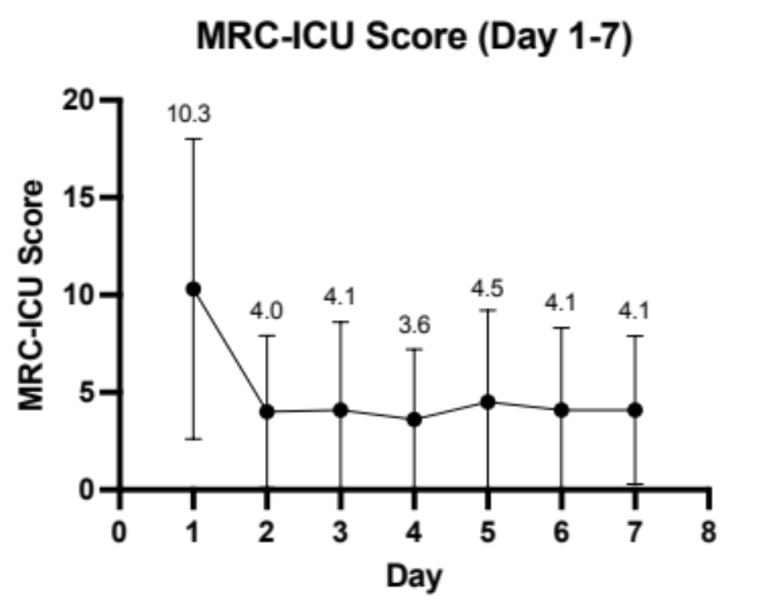
This figure represents the changes in mean MRC-ICU score (bars indicate standard deviation) over the first 7 days of the ICU stay.

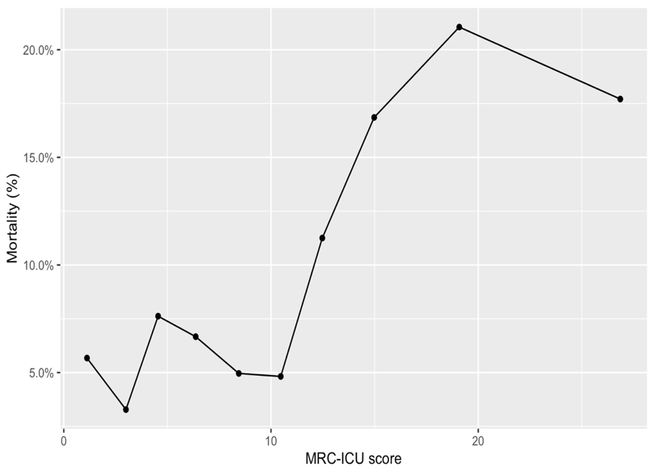
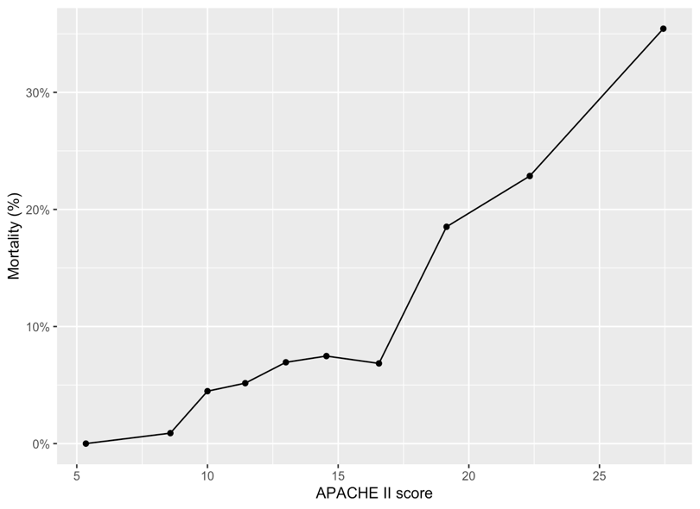
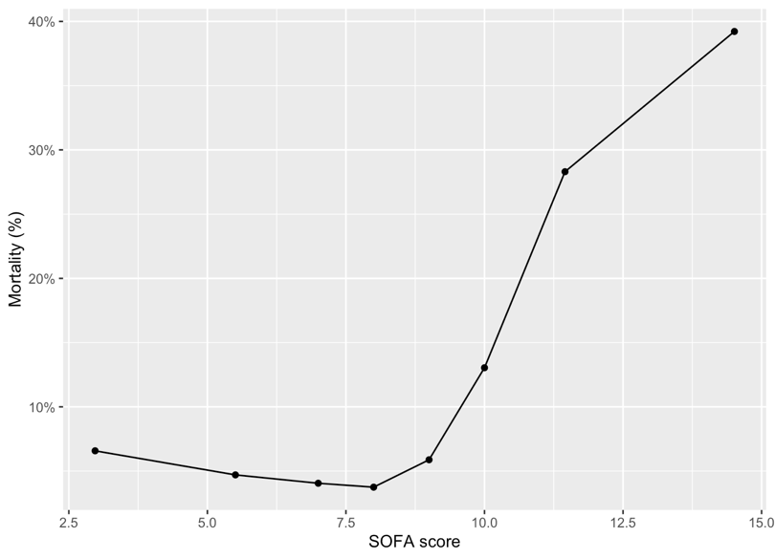
Supplemental Figure 2. Hospital mortality by MRC-ICU, APACHE-II and SOFA score

Supplemental Figure 3. Assessment of interaction between medication regimen complexity and severity of illness for the training and testing sets
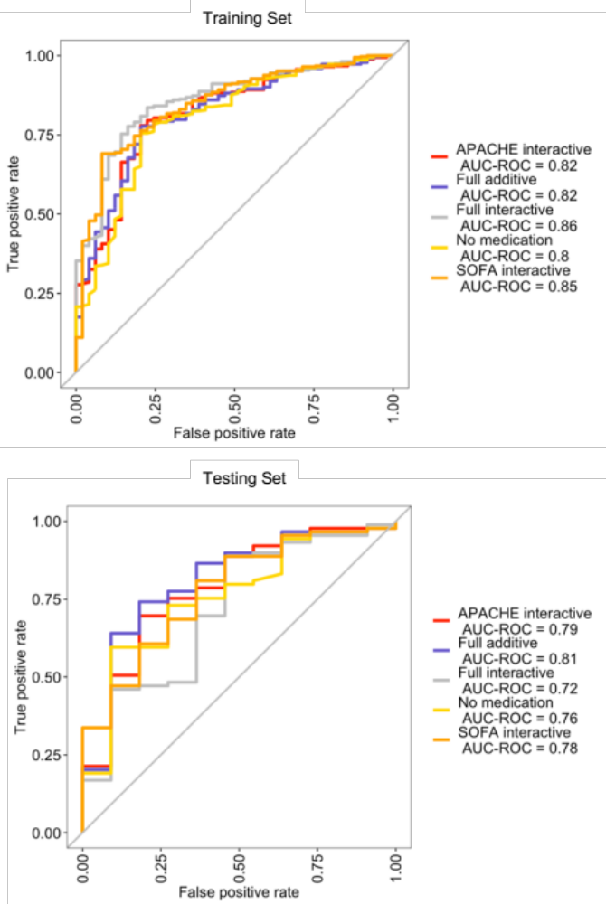

Supplemental Figure 4. Metrics versus threshold plot

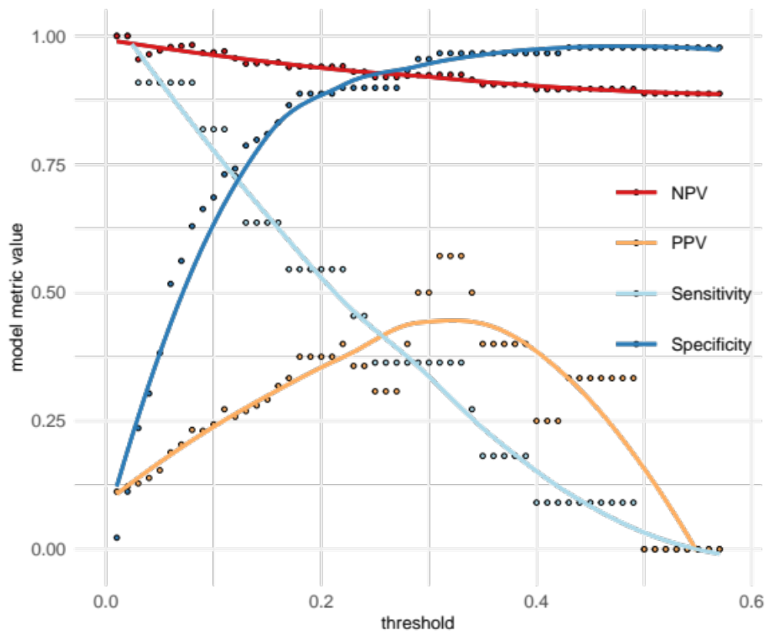
Supplemental Figure 5. Calibration plot
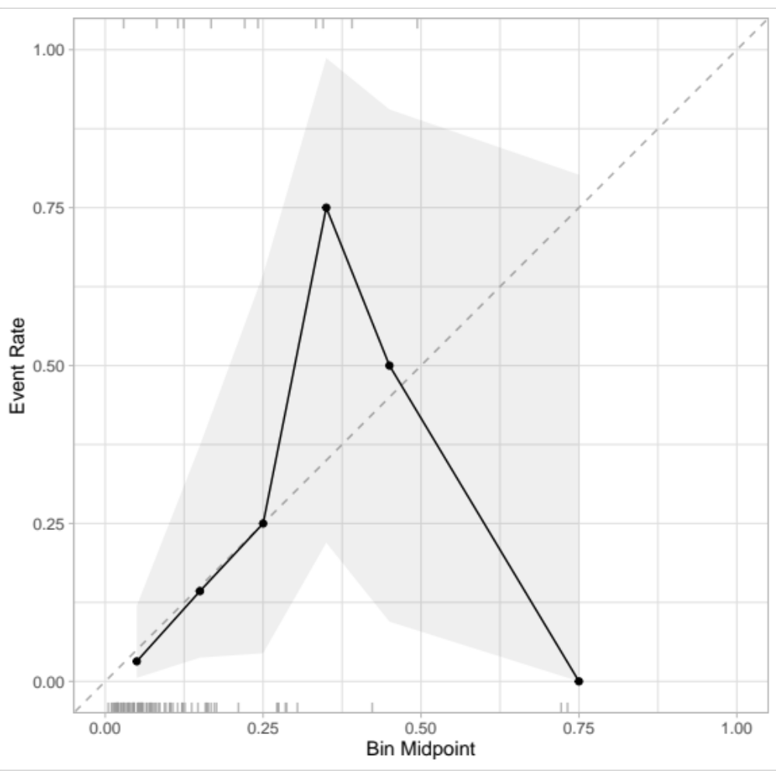

Supplemental Table 1. Line-item representation of the MRC-ICU Score at 24 hours
Component | N = 991  n (%)
Medications
Aminoglycosides (amikacin, gentamicin, tobramycin) | 4 (0.4)
Amphotericin B and liposomal amphotericin B | 1 (0.1)
Antiarrhythmics (amiodarone, dofetilide, sotalol) | 100 (10.0)
Anticonvulsants (carbamazepine, phenobarbital, phenytoin, valproic acid) | 32 (3.2)
Antimicrobials | 372 (37.5)
Azole antifungals (posaconazole, voriconazole) | 10 (1.0)
Blood products (factor products, antithrombin III) | 11 (1.1)
Bowel regimen | 420 (42.3)
Broad Spectrum antimicrobials | 237 (23.9)
Chemotherapy (active inpatient) | 11 (1.1)
Chlorhexidine | 241 (24.3)
Clozapine | 0 (0)
Continuous infusions (exclude those listed elsewhere) | 631 (63.6)
Continuous infusion opioids and sedatives | 481 (48.5)
Digoxin | 17 (1.7)
Ganciclovir/valganciclovir | 4 (0.4)
Glycemic control (subcutaneous insulin; exclude IV insulin) | 430 (43.3)
Hyperosmolar fluids (hypertonic saline (1.5%, 3%, 23.4%), mannitol) | 21 (2.1)
Immunosuppressants (cyclosporine, sirolimus, tacrolimus) | 20 (2.0)
Lidocaine (continuous infusion) | 24 (2.4)
Lithium | 2 (0.2)
Neuromuscular blockers | 64 (6.4)
Opioids and sedatives (scheduled and PRN) | 679 (68.5)
Prostacyclins (epoprostenol, iloprost, treprostinil) | 2 (0.2)
Stress ulcer prophylaxis | 467 (47.1)
Theophylline | 1 (0.1)
Therapeutic heparins (enoxaparin, heparin infusion) | 381 (38.4)
Thromboembolic prophylaxis | 196 (19.7)
Total parenteral nutrition | 6 (0.6)
Vancomycin (IV) | 235 (23.7)
Warfarin | 14 (1.4)
Devices influencing medication dosing
Dialysis | 11 (1.1)
Extracorporeal membrane oxygenation (ECMO) | 2 (0.2)
Intra-aortic balloon pump (IABP) / Left ventricular assist device (LVAD) | 15 (1.5)
Mechanical ventilation | 291 (29.3)
Data are presented as n (%) unless otherwise noted

Supplemental Table 2. Univariate component analysis of MRC-ICU score at 24 hours and risk for hospital mortality.

MRC-ICU Item | Component at 24 hours, n (%)  N = 991 | Hazard Ratio for hospital mortality (95% CI)) | P-value
Aminoglycosides | 4 (0.4) | -- | --
Amphotericin B & Liposomal Amphotericin B | 1 (0.1) | -- | --
Antiarrhythmics | 100 (10.1) | 0.81 (0.37, 1.74) | 0.6
Anticoagulants (oral, fondaparinux) | 34 (3.4) | 1.36 (0.50, 3.65) | 0.5
Anticonvulsants | 32 (3.2) | 1.58 (0.96, 2.59) | 0.07
Argatroban | 1 (0.1) | -- | --
Azole antifungal | 10 (1.0) | 1.35 (0.33, 5.52) | 0.70
Blood products | 11 (1.1) | 2.15 (0.79, 5.87) | 0.13
Chemotherapy | 11 (1.1) | 0.62 (0.12, 3.22) | 0.6
Clozapine | 0 (0) | -- | --
Digoxin | 17 (1.7) | 0.52 (0.07, 3.74) | 0.5
Ganciclovir/valganciclovir | 4 (0.4) | -- | --
Hyperosmolar fluids | 21 (2.1) | 1.85 (1.12, 3.06) | 0.02
Immunosuppressants | 20 (2.0) | 1.31 (0.63, 2.73) | 0.5
Lidocaine | 24 (2.4) | 0.51 (0.07, 3.68) | 0.5
Lithium | 2 (0.2) | -- | --
Prostacyclins | 2 (0.2) | -- | --
Theophylline | 1 (0.1) | -- | --
Therapeutic heparin | 381 (38.5) | 1.14 (0.81, 1.60) | 0.4
Vancomycin | 235 (23.7) | 2.05 (1.37, 3.07) | <0.001
Warfarin | 14 (1.4) | -- | --
Neuromuscular blockers | 64 (6.4) | 1.51 (0.84, 2.72) | 0.2
Continuous infusions | 631 (63.7) | 1.06 (0.98, 1.15) | 0.20
Total parenteral nutrition | 6 (0.6) | -- | --
Thromboembolic prophylaxis | 196 (19.8) | 0.92 (0.56, 1.50) | 0.7
Stress ulcer prophylaxis | 467 (47.1) | 1.48 (0.98, 2.23) | 0.06
Glycemic control | 430 (43.4) | 1.57 (1.05, 2.35) | 0.03
Bowel regimen | 420 (42.4) | 1.11 (0.74, 1.66) | 0.6
Chlorhexidine | 241 (24.3) | 1.52 (1.02, 2.30) | 0.04
Opioids and sedatives | 679 (68.5) | 0.87 (0.76,1.01) | 0.07
Continuous infusion opioids and sedatives | 481 (48.5) | 1.25 (1.03,1.52) | 0.03
Antimicrobials | 372 (37.5) | 1.15 (0.96, 1.38) | 0.13
Broad spectrum antimicrobials | 237 (23.9) | 1.94 (1.47, 2.57) | <0.001
Dialysis | 11 (1.1) | 1.51 (0.48, 4.81) | 0.5
Extracorporeal membrane oxygenation | 2 (0.2) | -- | --
Mechanical circulatory assist devices | 15 (1.5) | 1.78 (0.56, 5.63) | 0.3
Mechanical ventilation | 291 (29.4) | 2.01 (1.34, 3.02) | <0.001
Univariate cox regression evaluation line item relationship to mortality; certain line items were not evaluated due to low representation in the dataset

Supplemental Table 3. Evaluation of multiple logistic regression for hospital mortality with interaction terms between MRC-ICU, APACHE-II and SOFA scores
 | Odds Ratio | 95% Confidence Interval | p-value
Univariate Logistic Regression
Severity of Illness + MRC-ICU
MRC-ICU | 1.05 | 1.02, 1.08 | <0.01
SOFA | 1.32 | 1.21, 1.44 | <0.01
APACHE II | 1.17 | 1.12, 1.23 | <0.01
Multiple Variable Logistic Regression
Severity of Illness
SOFA | 1.15 | 1.04,1.27 | <0.01
APACHE II | 1.12 | 1.07,1.18 | <0.01
Severity of Illness + MRC-ICU
MRC-ICU | 0.93 | 0.89,0.98 | <0.01
SOFA | 1.15 | 1.04,1.28 | <0.01
APACHE II | 1.19 | 1.11,1.27 | <0.01
SOFA + MRC-ICU
SOFA | 1.30 | 1.19,1.44 | <0.01
MRC-ICU | 1.01 | 0.97,1.04 | 0.67
APACHE II + MRCICU
APACHE II | 1.24 | 1.17,1.32 | <0.01
MRC-ICU | 0.94 | 0.90,0.98 | <0.01
Severity of Illness + MRC-ICU + MRC-ICU*SOFA Interaction
MRC-ICU | 0.84 | 0.74,0.95 | <0.01
SOFA | 1.20 | 1.12,1.29 | <0.01
APACHE II | 1.00 | 0.83,1.20 | 0.99
MRC-ICU*SOFA | 1.01 | 1.00,1.02 | 0.05
Severity of Illness + MRC-ICU + MRC-ICU*APACHEII Interaction
MRC-ICU | 1.05 | 0.91,1.22 | 0.48
SOFA | 1.28 | 1.14,1.45 | <0.01
APACHE II | 1.14 | 1.03,1.27 | 0.01
MRC-ICU*APACHEII | 0.99 | 0.98,1.00 | 0.10
Severity of Illness + MRC-ICU + MRC-ICU*APACHEII, MRC-ICU*SOFA Interactions
MRC-ICU | 0.98 | 0.84,1.14 | 0.87
SOFA | 1.47 | 1.27,1.71 | <0.01
APACHE II | 0.81 | 0.65,1.01 | 0.06
MRC-ICU*SOFA | 0.98 | 0.97,0.99 | <0.01
MRC-ICU*APACHEII | 1.02 | 1.01,1.03 | <0.01
Severity of Illness + MRC-ICU + MRC-ICU*APACHEII, MRC-ICU*SOFA, APACHEII*SOFA Interactions
MRC-ICU | 0.96 | 0.79, 1.17 | 0.73
SOFA | 0.86 | 0.59, 1.25 | 0.41
APACHE II | 1.51 | 0.23, 1.88 | <0.01
MRC-ICU*SOFA | 1.03 | 1.01, 1.04 | <0.01
MRC-ICU*APACHEII | 0.98 | 0.97, 0.99 | <0.03
SOFA*APACHEII | 0.99 | 0.98, 1.02 | 0.74
SOFA: sequential organ failure assessment, APACHE II: Acute Physiology and Chronic Health Evaluation; ICU: intensive care unit

Supplemental Table 4. Sensitivity, Specificity, Negative Predictive Value, and Positive Predictive Value for hospital mortality prediction models

 | AUROC (95% CI) | Sensitivity (95% CI) | Specificity (95% CI) | PPV (95% CI) | NPV (95% CI)
APACHE II + SOFA + MRC-ICU | 0.81, 0.65-0.97 | 0.81, 0.52-0.95 | 0.74, 0.64-0.82 | 0.28, 0.16-0.45 | 0.97, 0.9-0.99
APACHE II + MRC-ICU | 0.77, 0.60-0.94 | 0.72, 0.43-0.9 | 0.74, 0.64-0.82 | 0.25, 0.14-0.43 | 0.95, 0.88-0.99
SOFA + MRC-ICU | 0.70, 0.52-0.88 | 0.81, 0.52-0.95 | 0.75, 0.65-0.83 | 0.29, 0.16-0.47 | 0.97, 0.9-0.99
SOFA + APACHE II | 0.76, 0.59-0.93 | 0.90, 0.62-0.98 | 0.59, 0.49-0.69 | 0.21, 0.12-0.36 | 0.98, 0.9-1
APACHE II | 0.73, 0.55-0.91 | 0.81, 0.52-0.95 | 0.53, 0.44-0.64 | 0.18, 0.1-0.31 | 0.96, 0.87-0.99
SOFA | 0.74, 0.57-0.91 | 0.81, 0.52-0.95 | 0.75, 0.65-0.83 | 0.29, 0.16-0.47 | 0.97, 0.9-0.99
MRC-ICU: Medication regimen complexity-intensive care unit; AUROC: area under the receiver operating characteristic; CI: confidence interval; PPV: positive predictive value; NPV: negative predictive value

Supplemental Table 5. Results of DeLong’s Test for comparisons among AUROC curves for training and test sets

Training Set

Models compared | AUROC of model 1 | AUROC of model 2 | z statistic | p value | adjusted  p value
APACHE II vs. SOFA | 0.806 | 0.739 | 2.081 | 0.037 | 0.561
APACHE II vs. APACHE II + MRCICU | 0.806 | 0.817 | -1.391 | 0.164 | 1
APACHE II vs. SOFA + MRCICU | 0.806 | 0.742 | 2.061 | 0.039 | 0.589
APACHE II vs. SOFA + APACHE II | 0.806 | 0.801 | 0.342 | 0.732 | 1
APACHE II vs. SOFA + APACHE II + MRCICU | 0.806 | 0.817 | -0.904 | 0.366 | 1
SOFA vs. APACHE II + MRCICU | 0.739 | 0.817 | -2.255 | 0.024 | 0.362
SOFA vs. SOFA + MRCICU | 0.739 | 0.742 | -0.386 | 0.7 | 1
SOFA vs. SOFA + APACHE II | 0.739 | 0.801 | -3.085 | 0.002 | 0.031
SOFA vs. SOFA + APACHE II + MRCICU | 0.739 | 0.817 | -3.214 | 0.001 | 0.02
APACHE II + MRCICU vs. SOFA + MRCICU | 0.817 | 0.742 | 2.163 | 0.031 | 0.459
APACHE II + MRCICU vs. SOFA + APACHE II | 0.817 | 0.801 | 0.896 | 0.37 | 1
APACHE II + MRCICU vs. SOFA + APACHE II + MRCICU | 0.817 | 0.817 | 0 | 1 | 1
SOFA + MRCICU vs. SOFA + APACHE II | 0.742 | 0.801 | -3.114 | 0.002 | 0.028
SOFA + MRCICU vs. SOFA + APACHE II + MRCICU | 0.742 | 0.817 | -3.022 | 0.003 | 0.038
SOFA + APACHE II vs. SOFA + APACHE II + MRCICU | 0.801 | 0.817 | -1.959 | 0.05 | 0.753

Test Set

Models compared | AUROC of model 1 | AUROC of model 2 | z statistic | p value | adjusted  p value
APACHE II vs. SOFA | 0.726 | 0.740 | -0.146 | 0.884 | 1
APACHE II vs. APACHE II + MRCICU | 0.726 | 0.772 | -2.467 | 0.014 | 0.204
APACHE II vs. SOFA + MRCICU | 0.726 | 0.704 | 0.243 | 0.808 | 1
APACHE II vs. SOFA + APACHE II | 0.726 | 0.758 | -0.830 | 0.407 | 1
APACHE II vs. SOFA + APACHE II + MRCICU | 0.726 | 0.809 | -1.934 | 0.053 | 0.796
SOFA vs. APACHE II + MRCICU | 0.740 | 0.772 | -0.331 | 0.741 | 1
SOFA vs. SOFA + MRCICU | 0.740 | 0.704 | 1.802 | 0.072 | 1
SOFA vs. SOFA + APACHE II | 0.740 | 0.758 | -0.281 | 0.778 | 1
SOFA vs. SOFA + APACHE II + MRCICU | 0.740 | 0.809 | -1.023 | 0.306 | 1
APACHE II + MRCICU vs. SOFA + MRCICU | 0.772 | 0.704 | 0.758 | 0.449 | 1
APACHE II + MRCICU vs. SOFA + APACHE II | 0.772 | 0.758 | 0.366 | 0.714 | 1
APACHE II + MRCICU vs. SOFA + APACHE II + MRCICU | 0.772 | 0.809 | -1.037 | 0.300 | 1
SOFA + MRCICU vs. SOFA + APACHE II | 0.704 | 0.758 | -0.982 | 0.326 | 1
SOFA + MRCICU vs. SOFA + APACHE II + MRCICU | 0.704 | 0.809 | -1.679 | 0.093 | 1
SOFA + APACHE II vs. SOFA + APACHE II + MRCICU | 0.758 | 0.809 | -2.711 | 0.007 | 0.101

Supplemental Table 6. Results of Negative Predictive Value (NPV) and Positive Predictive Value (PPV) threshold analyses

Model metric scores and 95% CIs with threshold choosing by Informedness

 | Threshold | Sensitivity | Specificity | PPV | NPV
APACHE II | 0.1378 | 0.55, 0.28-0.79 | 0.74, 0.64-0.82 | 0.21, 0.1-0.38 | 0.93, 0.85-0.97
APACHE II + MRCICU | 0.1265 | 0.64, 0.35-0.85 | 0.78, 0.68-0.85 | 0.26, 0.13-0.45 | 0.95, 0.87-0.98
SOFA | 0.1448 | 0.82, 0.52-0.95 | 0.75, 0.65-0.83 | 0.29, 0.16-0.47 | 0.97, 0.9-0.99
SOFA + APACHE II | 0.1304 | 0.64, 0.35-0.85 | 0.74, 0.64-0.82 | 0.23, 0.12-0.41 | 0.94, 0.86-0.98
SOFA + APACHE II + MRCICU | 0.1240 | 0.73, 0.43-0.9 | 0.78, 0.68-0.85 | 0.29, 0.15-0.47 | 0.96, 0.88-0.99
SOFA + MRCICU | 0.1371 | 0.82, 0.52-0.95 | 0.73, 0.63-0.81 | 0.27, 0.15-0.44 | 0.97, 0.9-0.99

Model metric scores and 95% CIs with threshold choosing by Mathews Correlation Coefficient (MCC) and F1 score

 | Threshold | Sensitivity | Specificity | PPV | NPV
APACHE II | 0.1378 | 0.55, 0.28-0.79 | 0.74, 0.64-0.82 | 0.21, 0.1-0.38 | 0.93, 0.85-0.97
APACHE II + MRCICU | 0.1321 | 0.64, 0.35-0.85 | 0.79, 0.69-0.86 | 0.27, 0.14-0.46 | 0.95, 0.87-0.98
SOFA | 0.1823 | 0.73, 0.43-0.9 | 0.81, 0.72-0.88 | 0.32, 0.17-0.52 | 0.96, 0.89-0.99
SOFA + APACHE II | 0.1463 | 0.55, 0.28-0.79 | 0.75, 0.65-0.83 | 0.21, 0.1-0.4 | 0.93, 0.85-0.97
SOFA + APACHE II + MRCICU | 0.1240 | 0.73, 0.43-0.9 | 0.78, 0.68-0.85 | 0.29, 0.15-0.47 | 0.96, 0.88-0.99
SOFA + MRCICU | 0.2182 | 0.27, 0.1-0.57 | 0.85, 0.77-0.91 | 0.19, 0.07-0.43 | 0.9, 0.82-0.95

