Socioeconomic Inequalities in Type 2 Diabetes Comorbidities in Different Population Subgroups: Trend Analyses Using German Health Insurance Data

Supplementary Files

Table S1. ICD-10 codes and type of diagnoses of the single comorbidities.
Comorbidity | ICD-10-GM Codes | Type of Diagnosis
Myocardial Infarct | I21 | Primary inpatient
Stroke | I60-I64 | Primary inpatient
Angina Pectoris
Stable Angina | I20.1, I20.8, I20.9 | Primary and secondary inpatient & confirmed outpatient
Unstable Angina | I20.0 | Primary and secondary inpatient & confirmed outpatient
Hypertension | I10-I15 | Primary and secondary inpatient & confirmed outpatient
Hyperlipidemia | E78 | Primary and secondary inpatient & confirmed outpatient
Cardiac Insufficiency | I50 | Primary and secondary inpatient & confirmed outpatient
Retinopathy* | H36 | Confirmed outpatient
Nephropathy | N18, N19, N08.3 | Primary and secondary inpatient & confirmed outpatient
Polyneuropathy** | G63 | Confirmed outpatient & secondary inpatient
Polyneuropathy** | Epilepsy medications: N03AX16, N03AX12 or N03AF01 but with no epilepsy diagnosis: G40-G41  Depression medications: N06AA09, N06AX21 but with no depression diagnosis: F30-F39 | Confirmed outpatient & secondary inpatient
*No inpatient diagnoses were present in the data
**No primary inpatient diagnoses were present in the data
Reference: (1)

Table S2. Reference income figures in Euros and their equivalents for the three income levels for the three time periods of the study.
 |  | AGI* | Adjusted† AGI | <60% AGI | 60%-80% AGI | >80% AGI
Period 1 | 2005 | 29.202 € | 25.406 € | < 15.243 € | 15.243 € - 20.325 € | > 20.325 €
Period 1 | 2006 | 29.494 € | 25.660 € | < 15.396 € | 15.396 € - 20.528 € | > 20.528 €
Period 1 | 2007 | 29.951 € | 26.342 € | < 15.805 € | 15.805 € - 21.074 € | > 21.074 €
Period 2 | 2010 | 31.144 € | 27.609 € | < 16.565 € | 16.565 € - 22.087 € | > 22.087 €
Period 2 | 2011 | 32.100 € | 28.425 € | < 17.055 € | 17.055 € - 22.740 € | > 22.740 €
Period 2 | 2012 | 33.002 € | 29.273 € | < 17.564 € | 17.564 € - 23.418€ | > 23.418 €
Period 3 | 2015 | 35.363 € | 31.526 € | < 18.916 € | 18.916 € - 25.221 € | > 25.221 €
Period 3 | 2016 | 36.187 € | 32.261 € | < 19.356 € | 19.356 € - 25.809 € | > 25.809 €
Period 3 | 2017 | 37.077 € | 33.054 € | < 19.832 € | 19.832 € - 26.443 € | > 26.443 €
*AGI is the average German annual income of the former Western federal states of Germany in terms of salary of working individuals as reported by the Federal Statistical Office of Germany. Reference: (2, 3)
†AGI adjusted for unemployment insurance and pension insurance contributions

Table S3. Socioeconomic trends in the comorbidities group: Less severe CVD (hypertension, hyperlipidemia, cardiac insufficiency) illustrated by 2-sided interactions between time and SES with the corresponding reference groups: period 1 (for the variable time period) * low income (for the variable income), ≤ 9 years of schooling (for the variable school education) and manuals (for the variable occupation). Stratified by gender and population subgroup. Estimated by means of logistic regression, adjusting for age and duration of observation and correcting for within cluster variation. Income Low: <60% AGI, Middle: 60%-80% AGI, Higher: >80% AGI.
 | Men |  |  |  |  |  | Women
 | Working individuals |  | Nonworking Spouses |  | Pensioners |  | Working individuals |  | Nonworking Spouses |  | Pensioners
 | OR | CI | OR | CI | OR | CI | OR | CI | OR | CI | OR | CI
Income
Middle income * Period 2 | 1 | 0,81 - 1,12 | 0,9 | 0,53 - 1,42 | 1,02 | 0,96 - 1,09 | 1 | 0,87 - 1,19 | 0,94 | 0,78 - 1,13 | 1,02 | 0,93 - 1,12
Higher income * Period 2 | 0,9 | 0,83 - 1,06 | 0,7 | 0,53 - 0,9 | 0,92 | 0,85 - 1,01 | 1,1 | 0,99 - 1,28 | 0,78* | 0,69 - 0,89 | 0,91 | 0,82 - 1,02
Middle income * Period 3 | 1,1 | 0,9 - 1,24 | 1 | 0,58 - 1,7 | 1,05 | 0,96 - 1,15 | 1,1 | 0,92 - 1,27 | 0,89 | 0,72 - 1,11 | 1,1 | 0,98 - 1,24
Higher income * Period 3 | 1 | 0,85 - 1,09 | 0,9 | 0,68 - 1,29 | 0,91 | 0,82 - 1,02 | 1 | 0,9 - 1,17 | 0,84 | 0,72 - 0,99 | 0,9 | 0,79 - 1,02
Education
10 years schooling * period 2 | 1 | 0,91 - 1,17 | 1,1 | 0,63 - 1,76 | - | - | 1 | 0,87 - 1,24 | 1,03 | 0,82 - 1,29 | - | -
12-13 years schooling * period 2 | 1 | 0,77 - 1,21 | 1 | 0,45 - 2,26 | - | - | 1,2 | 0,89 - 1,68 | 0,6 | 0,38 - 0,95 | - | -
10 years schooling * period 3 | 1 | 0,9 - 1,17 | 0,5 | 0,29 - 0,93 | - | - | 1,1 | 0,9 - 1,31 | 0,96 | 0,74 - 1,23 | - | -
12-13 years schooling * period 3 | 1 | 0,78 - 1,27 | 0,6 | 0,24 - 1,41 | - | - | 1 | 0,75 - 1,43 | 0,64 | 0,39 - 1,06 | - | -
Occupation
Specialists * Period 2 | 1 | 0,92 - 1,2 | 1,1 | 0,7 - 1,8 | - | - | 1 | 0,84 - 1,11 | 1,1 | 0,79 - 1,43 | - | -
Highly qualified * Period 2 | 1 | 0,74 - 1,23 | 0,4 | 0,15 - 1,37 | - | - | 1,4 | 1 - 2,07 | 0,7 | 0,39 - 1,2 | - | -
Specialists * Period 3 | 1,1 | 0,96 - 1,28 | 1 | 0,57 - 1,74 | - | - | 1 | 0,86 - 1,14 | 1 | 0,76 - 1,42 | - | -
Highly qualified * Period 3 | 1,1 | 0,87 - 1,49 | 0,7 | 0,03 - 0,13 | - | - | 1,3 | 0,9 - 1,92 | 0,6 | 0,36 - 1,17 | - | -
*p<0,001
Table S4. Socioeconomic trends in the comorbidities group: More severe CVD (myocardial infarction, stroke, angina pectoris) illustrated by 2-sided interactions between time and SES with the corresponding reference groups: period 1 (for the variable time period) * low income (for the variable income), ≤ 9 years of schooling (for the variable school education) and manuals (for the variable occupation). Stratified by gender and population subgroup. Estimated by means of logistic regression, adjusting for age and duration of observation and correcting for within cluster variation. Income Low: <60% AGI, Middle: 60%-80% AGI, Higher: >80% AGI.
 | Men |  |  |  |  |  | Women
 | Working individuals |  | Nonworking Spouses |  | Pensioners |  | Working individuals |  | Nonworking Spouses |  | Pensioners
 | OR | CI | OR | CI | OR | CI | OR | CI | OR | CI | OR | CI
Income
Middle income * Period 2 | 1 | 0,75 - 1,31 | 1,5 | 0,78 - 2,67 | 1 | 0,94 - 1,06 | 1,2 | 0,77 - 1,75 | 0,87 | 0,67 - 1,15 | 0,94 | 0,87 - 1,01
Higher income * Period 2 | 1,2 | 0,99 - 1,46 | 1,1 | 0,81 - 1,52 | 0,96 | 0,89 - 1,05 | 1,2 | 0,82 - 1,61 | 1 | 0,82 - 1,23 | 0,79* | 0,72 - 0,88
Middle income * Period 3 | 1,1 | 0,84 - 1,42 | 1,5 | 0,84 - 2,82 | 0,95 | 0,89 - 1,01 | 1,2 | 0,82 - 1,83 | 1,15 | 0,85 - 1,55 | 0,95 | 0,88 - 1,03
Higher income * Period 3 | 1,2 | 0,99 - 1,46 | 1,2 | 0,86 - 1,65 | 0,96 | 0,88 - 1,06 | 1,4 | 0,97 - 1,88 | 1,02 | 0,81 - 1,3 | 0,9 | 0,81 - 1,01
Education
10 years schooling * period 2 | 1,3 | 0,93 - 1,69 | 0,8 | 0,36 - 1,57 | - | - | 1,2 | 0,69 - 2,25 | 1,21 | 0,57 - 2,57 | - | -
12-13 years schooling * period 2 | 1 | 0,56 - 1,70 | 1,3 | 0,42 - 4,2 | - | - | 0,8 | 0,3 - 1,96 | 0,45 | 0,15 - 1,31 | - | -
10 years schooling * period 3 | 1,1 | 0,82 - 1,5 | 0,8 | 0,37 - 1,56 | - | - | 0,8 | 0,43 - 1,43 | 1,57 | 0,75 - 3,3 | - | -
12-13 years schooling * period 3 | 0,8 | 0,48 - 1,43 | 1,3 | 0,4 - 4,39 | - | - | 0,5 | 0,19 - 1,18 | 0,18 | 0,05 - 0,64 | - | -
Occupation
Specialists * Period 2 | 1,1 | 0,85 - 1,46 | 0,9 | 0,47 - 1,61 | - | - | 0,9 | 0,6 - 1,24 | 1,2 | 0,48 - 2,75 | - | -
Highly qualified * Period 2 | 1,1 | 0,64 - 1,9 | 1,3 | 0,14 - 12.5 | - | - | 1,6 | 0,35 - 7,44 | 1,1 | 0,23 - 5,33 | - | -
Specialists * Period 3 | 1 | 0,8 - 1,37 | 0,7 | 0,37 - 1,42 | - | - | 0,7 | 0,47 - 1 | 1 | 0,41 - 2,4 | - | -
Highly qualified * Period 3 | 0,9 | 0,5 - 1,47 | 0,7 | 0,06 - 7,58 | - | - | 2,5 | 0,58 - 10,9 | 0,7 | 0,14 - 3,56 | - | -
*p<0,001
Table S5. Socioeconomic trends in the comorbidities group: Other vascular diseases (nephropathy, polyneuropathy, retinopathy) illustrated by 2-sided interactions between time and SES with the corresponding reference groups: period 1 (for the variable time period) * low income (for the variable income), ≤ 9 years of schooling (for the variable school education) and manuals (for the variable occupation). Stratified by gender and population subgroup. Estimated by means of logistic regression, adjusting for age and duration of observation and correcting for within cluster variation. Income Low: <60% AGI, Middle: 60%-80% AGI, Higher: >80% AGI.
 | Men |  |  |  |  |  | Women
 | Working individuals |  | Nonworking Spouses |  | Pensioners |  | Working individuals |  | Nonworking Spouses |  | Pensioners
 | OR | CI | OR | CI | OR | CI | OR | CI | OR | CI | OR | CI
Income
Middle income * Period 2 | 1 | 0,81 - 1,23 | 1,4 | 0,88 - 2,3 | 1,02 | 0,98 - 1,07 | 1 | 0,83 - 1,26 | 1,03 | 0,88 - 1,2 | 0,98 | 0,93 - 1,02
Higher income * Period 2 | 1,1 | 0,95 - 1,26 | 1 | 0,78 - 1,27 | 0,91 | 0,86 - 0,97 | 1,1 | 0,96 - 1,35 | 0,97 | 0,86 - 1,09 | 0,83* | 0,78 - 0,89
Middle income * Period 3 | 1 | 0,85 - 1,26 | 1,3 | 0,78 - 2,05 | 1 | 0,96 - 1,05 | 1,1 | 0,86 - 1,28 | 1,01 | 0,86 - 1,2 | 1,01 | 0,96 - 1,07
Higher income * Period 3 | 1,1 | 0,93 - 1,22 | 1 | 0,74 - 1,23 | 0,86* | 0,81 - 0,92 | 1,2 | 0,98 - 1,36 | 0,96 | 0,85 - 1,09 | 0,85* | 0,79 - 0,92
Education
10 years schooling * period 2 | 0,8 | 0,68 - 0,99 | 0,8 | 0,49 - 1,44 | - | - | 1 | 0,73 - 1,3 | 0,83 | 0,59 - 1,16 | - | -
12-13 years schooling * period 2 | 1 | 0,72 - 1,5 | 0,9 | 0,44 - 1,93 | - | - | 0,9 | 0,52 - 1,47 | 0,71 | 0,34 - 1,5 | - | -
10 years schooling * period 3 | 0,8 | 0,66 - 0,95 | 0,8 | 0,45 - 1,39 | - | - | 1 | 0,73 - 1,29 | 0,92 | 0,66 - 1,28 | - | -
12-13 years schooling * period 3 | 1,1 | 0,74 - 1,57 | 0,6 | 0,27 - 1,27 | - | - | 0,7 | 0,43 - 1,2 | 0,68 | 0,34 - 1,39 | - | -
Occupation
Specialists * Period 2 | 0,9 | 0,72 - 1 | 1,2 | 0,74 - 2,05 | - | - | 0,9 | 0,78 - 1,13 | 0,7 | 0,47 - 0,95 | - | -
Highly qualified * Period 2 | 1 | 0,68 - 1,4 | 0,7 | 0,23 - 2 | - | - | 1,6 | 0,83 - 3,07 | 1,9 | 0,73 - 5,06 | - | -
Specialists * Period 3 | 0,9 | 0,7 - 1 | 1,1 | 0,65 - 1,91 | - | - | 0,9 | 0,78 - 1,11 | 0,8 | 0,59 - 1,18 | - | -
Highly qualified * Period 3 | 1 | 0,68 - 1,35 | 0,8 | 0,25 - 2,53 | - | - | 1,6 | 0,86 - 3,15 | 2,2 | 0,84 - 5,8 | - | -
*p<0,001
Table S6. Socioeconomic trends in the outcome: Number of comorbidities (with the 4 categories: 0, 1, 2 & >2 comorbidities) illustrated by 2-sided interactions between time and SES with the corresponding reference groups: period 1 (for the variable time period) * low income (for the variable income), ≤ 9 years of schooling (for the variable school education) and manuals (for the variable occupation). Stratified by gender and population subgroup. Estimated by means of ordinal regression, adjusting for age and duration of observation and correcting for within cluster variation. Income Low: <60% AGI, Middle: 60%-80% AGI, Higher: >80% AGI.
 | Men |  |  |  |  |  | Women
 | Working individuals |  | Nonworking Spouses |  | Pensioners |  | Working individuals |  | Nonworking Spouses |  | Pensioners
 | OR | CI | OR | CI | OR | CI | OR | CI | OR | CI | OR | CI
Income
Middle income * Period 2 | 1 | 0,88 - 1,15 | 1,2 | 0,85 - 1,63 | 0,99 | 0,95 - 1,03 | 1 | 0,89 - 1,15 | 0,97 | 0,86 - 1,08 | 0,96 | 0,92 - 1
Higher income * Period 2 | 1 | 0,93 - 1,13 | 0,9 | 0,72 - 1,05 | 0,89* | 0,85 - 0,94 | 1,1 | 0,97 - 1,19 | 0,89 | 0,81 - 0,97 | 0,88* | 0,83 - 0,94
Middle income * Period 3 | 1 | 0,89 - 1,16 | 1,1 | 0,77 - 1,53 | 1,02 | 0,98 - 1,07 | 1,1 | 0,92 - 1,19 | 0,96 | 0,84 - 1,1 | 0,97 | 0,93 - 1,02
Higher income * Period 3 | 1 | 0,89 - 1,09 | 1 | 0,82 - 1,23 | 0,86* | 0,8 - 0,91 | 1 | 0,93 - 1,14 | 0,95 | 0,86 - 1,05 | 0,86* | 0,81 - 0,92
Education
10 years schooling * period 2 | 1 | 0,93 - 1,14 | 1 | 0,65 - 1,38 | - | - | 1 | 0,84 - 1,13 | 0,99 | 0,82 - 1,19 | - | -
12-13 years schooling * period 2 | 1 | 0,8 - 1,17 | 1,2 | 0,7 - 2,15 | - | - | 1,1 | 0,81 - 1,46 | 0,74 | 0,49 - 1,13 | - | -
10 years schooling * period 3 | 1 | 0,89 - 1,1 | 0,9 | 0,57 - 1,28 | - | - | 1 | 0,83 - 1,13 | 0,94 | 0,77 - 1,15 | - | -
12-13 years schooling * period 3 | 1 | 0,83 - 1,24 | 0,9 | 0,49 - 1,6 | - | - | 0,9 | 0,65 - 1,18 | 0,65 | 0,43 - 1 | - | -
Occupation
Specialists * Period 2 | 1 | 0,89 - 1,1 | 1 | 0,7 - 1,38 | - | - | 0,9 | 0,83 - 1,04 | 0,9 | 0,67 - 1,11 | - | -
Highly qualified * Period 2 | 1 | 0,78 - 1,17 | 0,7 | 0,36 - 1,42 | - | - | 1,2 | 0,86 - 1,66 | 0,8 | 0,55 - 1,28 | - | -
Specialists * Period 3 | 1 | 0,91 - 1,14 | 0,8 | 0,58 - 1,23 | - | - | 0,9 | 0,81 - 1 | 1 | 0,73 - 1,25 | - | -
Highly qualified * Period 3 | 1 | 0,81 - 1,21 | 1 | 0,48 - 2,03 | - | - | 1,2 | 0,82 - 1,62 | 0,8 | 0,5 - 1,22 | - | -
*p<0,001

Table S7. Prevalence/odds ratios and confidence intervals on the effect of time period on the 3 comorbidity-index variables and the number of comorbidities, stratified by gender, population subgroup and years of school education. Estimated by means of logistic regression and ordinal regression, adjusting for within cluster variation. Adjusted for age and insurance duration. Time periods p1 (reference): 2005-2007, p2: 2010-2012, p3:2015-2017. Comorbidities Less severe CVD: Hypertension, Hyperlipidemia, Cardiac insufficiency; More severe CVD: Myocardial infarction, Stroke, Angina Pectoris; Other vascular diseases: Nephropathy, Neuropathy, Retinopathy.
 |  | Less Severe CVD CMs |  |  |  | More Severe CVD CMs |  |  |  | Other Vascular Diseases |  |  |  | Number of Comorbidities
 | n | p2 |  | p3 |  | p2 |  | p3 |  | p2 |  | p3 |  | p2 |  | p3
Men |  | PR | 95% CI | PR | 95% CI | PR | 95% CI | PR | 95% CI | PR | 95% CI | PR | 95% CI | OR | 95% CI | OR | 95% CI
Employed
≤ 9 years | 29168 | 1,08 | 1,06 - 1,10 | 1,17 | 1,14 - 1,19 | 1,19 | 1,01 - 1,37 | 1,25 | 1,06 - 1,45 | 1,58 | 1,43 - 1,73 | 2,14 | 1,94 - 2,35 | 1,43 | 1,36 - 1,51 | 2,25 | 2,12 - 2,4
10 years | 14137 | 1,1 | 1,06 - 1,13 | 1,18 | 1,14 - 1,21 | 1,41 | 1,06 - 1,76 | 1,31 | 0,98 - 1,65 | 1,31 | 1,13 - 1,48 | 1,71 | 1,48 - 1,95 | 1,48 | 1,36 - 1,61 | 2,23 | 2,03 - 2,44
12-13 years | 3184 | 1,07 | 1,01 - 1,14 | 1,17 | 1,09 - 1,24 | 1,13 | 0,56 - 1,70 | 1,02 | 0,52 - 1,52 | 1,6 | 1,09 - 2,1 | 2,18 | 1,47 - 2,89 | 1,35 | 1,12 - 1,62 | 2,18 | 1,79 - 2,66
Non-working Spouses
≤ 9 years | 1275 | 1,06 | 1 - 1,13 | 1,16 | 1,08 - 1,24 | 0,97 | 0,64 - 1,30 | 1,04 | 0,65 - 1,44 | 1,46 | 1,06 - 1,87 | 1,96 | 1,37 - 2,54 | 1,39 | 1,09 - 1,77 | 2,22 | 1,69 - 2,91
10 years | 825 | 1,05 | 0,98 - 1,12 | 1,04 | 0,96 - 1,12 | 0,78 | 0,32 - 1,24 | 0,87 | 0,37 - 1,36 | 1,28 | 0,85 - 1,71 | 1,62 | 1,04 - 2,2 | 1,34 | 1 - 1,81 | 1,92 | 1,35 - 2,73
12-13 years | 269 | 1,06 | 0,92 - 1,2 | 1,08 | 0,93 - 1,23 | 1,26 | 0 - 2,53 | 1,38 | 0 - 2,9 | 1,31 | 0,65 - 1,96 | 1,21 | 0,53 - 1,89 | 1,72 | 1,04 - 2,86 | 1,94 | 1,10 - 3,41
Women
Employed
≤ 9 years | 11126 | 1,08 | 1,04 - 1,12 | 1,16 | 1,12 - 1,21 | 1,11 | 0,74 - 1,49 | 1,2 | 0,78 - 1,62 | 1,58 | 1,34 - 1,83 | 2,12 | 1,79 - 2,44 | 1,39 | 1,27 - 1,53 | 2,21 | 2 - 2,45
10 years | 9398 | 1,1 | 1,05 - 1,14 | 1,2 | 1,14 - 1,25 | 1,3 | 0,69 - 1,91 | 0,88 | 0,46 - 1,30 | 1,54 | 1,21 - 1,86 | 2,04 | 1,61 - 2,48 | 1,36 | 1,20 - 1,54 | 2,14 | 1,89 - 2,43
12-13 years | 2295 | 1,16 | 1,04 - 1,28 | 1,21 | 1,08 - 1,34 | 0,78 | 0,13 - 1,43 | 0,51 | 0,1 - 0,92 | 1,39 | 0,77 - 2 | 1,6 | 0,9 - 2,3 | 1,47 | 1,12 - 1,94 | 1,86 | 1,41 - 2,45
Non-working Spouses
≤ 9 years | 7793 | 1,04 | 1,02 - 1,06 | 1,08 | 1,06 - 1,11 | 1,24 | 0,81 - 1,66 | 1,21 | 0,78 - 1,64 | 1,48 | 1,26 - 1,7 | 1,81 | 1,54 - 2,09 | 1,33 | 1,21 - 1,48 | 2,04 | 1,83 - 2,29
10 years | 3231 | 1,04 | 1,01 - 1,07 | 1,07 | 1,03 - 1,1 | 1,57 | 0,54 - 2,6 | 2,03 | 0,65 - 3,41 | 1,27 | 0,97 - 1,57 | 1,68 | 1,29 - 2,08 | 1,31 | 1,10 - 1,55 | 1,89 | 1,57 - 2,27
12-13 years | 592 | 0,96 | 0,9 - 1,02 | 1,01 | 0,94 - 1,07 | 0,61 | 0 - 1,27 | 0,21 | 0 - 0,52 | 1,11 | 0,50 - 1,72 | 1,31 | 0,63 - 1,98 | 0,94 | 0,63 - 1,39 | 1,21 | 0,8 - 1,81

Table S8. Prevalence/odds ratios and confidence intervals on the effect of time period on the 3 comorbidity-index variables less severe CVD, more severe CVD and other vascular diseases and the number of comorbidities, stratified by gender, population subgroup and occupation group. Estimated by means of logistic regression and ordinal regression, adjusting for within cluster variation. Adjusted for age and insurance duration. Time periods p1 (reference): 2005-2007, p2: 2010-2012, p3:2015-2017. Comorbidities Less severe CVD: Hypertension, Hyperlipidemia, Cardiac insufficiency; More severe CVD: Myocardial infarction, Stroke, Angina Pectoris; Other vascular diseases: Nephropathy, Neuropathy, Retinopathy.
 |  | Less Severe CVD CMs |  |  |  | More Severe CVD CMs |  |  |  | Other Vascular Diseases |  |  |  | Number of Comorbidities
 | n | p2 |  | p3 |  | p2 |  | p3 |  | p2 |  | p3 |  | p2 |  | p3
Men |  | PR | 95% CI | PR | 95% CI | PR | 95% CI | PR | 95% CI | PR | 95% CI | PR | 95% CI | OR | 95% CI | OR | 95% CI
Employed
Manuals | 64208 | 1,1 | 1,08 - 1,1 | 1,2 | 1,16 - 1,19 | 1 | 0,93 - 1,1 | 1 | 0,92 - 1,1 | 1,4 | 1,31 - 1,45 | 1,8 | 1,71 - 1,9 | 1,3 | 1,35 - 1,44 | 2,1 | 2,05 - 2,2
Specialists | 8889 | 1,1 | 1,07 - 1,14 | 1,2 | 1,16 - 1,24 | 1,1 | 0,84 - 1,38 | 1,1 | 0,79 - 1,31 | 1,2 | 1,04 - 1,34 | 1,5 | 1,35 - 1,75 | 1,4 | 1,24 - 1,52 | 2,1 | 1,93 - 2,39
Highly Qualified | 3371 | 1,1 | 1 - 1,16 | 1,2 | 1,12 - 1,3 | 1,1 | 0,52 - 1,62 | 0,9 | 0,42 - 1,29 | 1,3 | 0,92 - 1,73 | 1,7 | 1,21 - 2,25 | 1,4 | 1,1 - 1,66 | 2,2 | 1,76 - 2,67
Non-working Spouses
Manuals | 3084 | 1,1 | 1,02 - 1,12 | 1,2 | 1,1 - 1,2 | 1,1 | 0,82 - 1,31 | 1,1 | 0,8 - 1,34 | 1,6 | 1,29 - 1,8 | 2,1 | 1,72 - 2,44 | 1,5 | 1,25 - 1,67 | 2,8 | 1,92 - 2,71
Specialists | 716 | 1,1 | 0,99 - 1,17 | 1,1 | 1,02 - 1,22 | 1 | 0,47 - 1,43 | 0,8 | 0,34 - 1,23 | 1,9 | 1,16 - 2,61 | 2,3 | 1,39 - 3,27 | 1,4 | 1,05 - 1,97 | 1,9 | 1,36 - 2,74
Highly Qualified | 159 | 0,9 | 0,7 - 1,14 | 1,1 | 0,84 - 1,31 | 1,6 | 0 - 5,1 | 0,8 | 0 - 2,57 | 1,1 | 0,1 - 2,09 | 1,8 | 0,11 - 3,43 | 1,1 | 0,5 - 2,26 | 2,6 | 1,14 - 5,71
Women
Employed
Manuals | 27641 | 1,1 | 1,06 - 1,1 | 1,2 | 1,14 - 1,19 | 0,9 | 0,77 - 1,08 | 0,8 | 0,68 - 0,95 | 1,3 | 1,21 - 1,41 | 1,7 | 1,55 - 1,8 | 1,3 | 1,24 - 1,38 | 2 | 1,87 - 2,09
Specialists | 10378 | 1,1 | 1,03 - 1,11 | 1,2 | 1,12 - 1,2 | 0,8 | 0,55 - 1,04 | 0,6 | 0,37 - 0,72 | 1,2 | 1,07 - 1,42 | 1,6 | 1,36 - 1,79 | 1,2 | 1,1 - 1,33 | 1,8 | 1,61 - 1,95
Highly Qualified | 1576 | 1,2 | 1,06 - 1,38 | 1,3 | 1,11 - 1,46 | 1,5 | 0 - 3,76 | 2,1 | 0 - 5,03 | 2 | 0,81 - 3,19 | 2,6 | 1,07 - 4,18 | 1,6 | 1,14 - 2,19 | 2,3 | 1,65 - 3,26
Non-working Spouses
Manuals | 17293 | 1,1 | 1,05 - 1,1 | 1,1 | 1,11 - 1,16 | 1 | 0,85 - 1,23 | 1 | 0,8 - 1,18 | 1,3 | 1,19 - 1,4 | 1,6 | 1,45 - 1,71 | 1,3 | 1,23 - 1,4 | 1,9 | 1,76 - 2,02
Specialists | 1614 | 1,1 | 1,01 - 1,2 | 1,2 | 1,06 - 1,27 | 1,2 | 0,22 - 2,18 | 1 | 0,16 - 1,89 | 0,9 | 0,66 - 1,18 | 1,4 | 0,99 - 1,71 | 1,1 | 0,9 - 1,44 | 1,8 | 1,38 - 2,28
Highly Qualified | 586 | 1 | 0,83 - 1,08 | 1 | 0,87 - 1,13 | 1,1 | 0 - 2,86 | 0,7 | 0 - 1,81 | 2,4 | 0,27 - 4,44 | 3,2 | 0,36 - 6,09 | 1,1 | 0,71 - 1,65 | 1,4 | 0,92 - 2,26

Figure S1. Predicted probabilities of comorbidity groups over the three time periods for men, stratified by school education (displayed as years of schooling) and population subgroup. Time periods p1: 2005-2007, p2: 2010-2012, p3:2015-2017. Comorbidities Less severe CVD: Hypertension, Hyperlipidemia, Cardiac insufficiency; More severe CVD: Myocardial infarction, Stroke, Angina Pectoris; Other vascular diseases: Nephropathy, Neuropathy, Retinopathy.
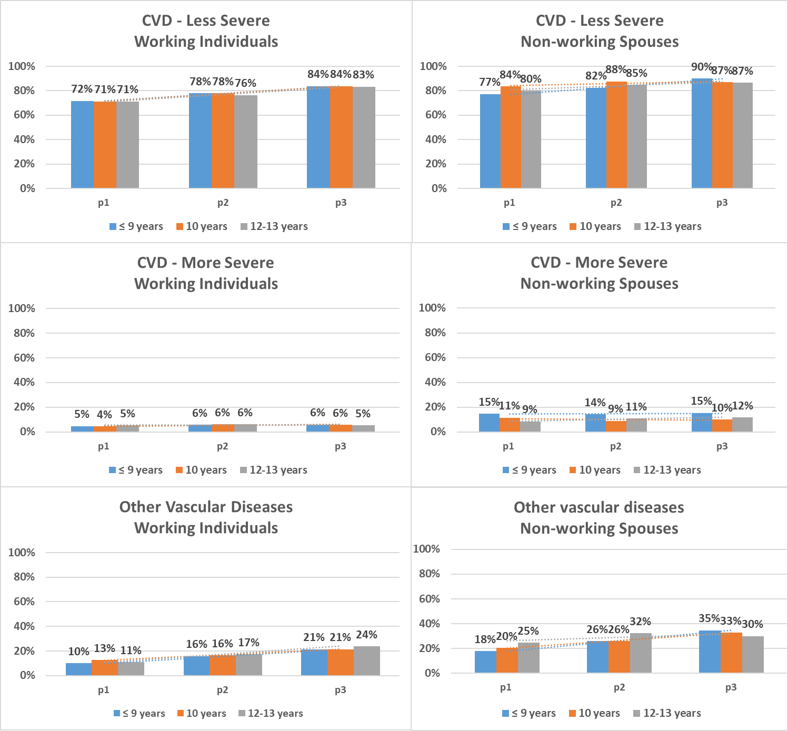

Figure S2. Predicted probabilities of comorbidity groups over the three time periods for women, stratified by school education (displayed as years of schooling) and population subgroup. Time periods p1: 2005-2007, p2: 2010-2012, p3:2015-2017. Comorbidities Less severe CVD: Hypertension, Hyperlipidemia, Cardiac insufficiency; More severe CVD: Myocardial infarction, Stroke, Angina Pectoris; Other vascular diseases: Nephropathy, Neuropathy, Retinopathy. 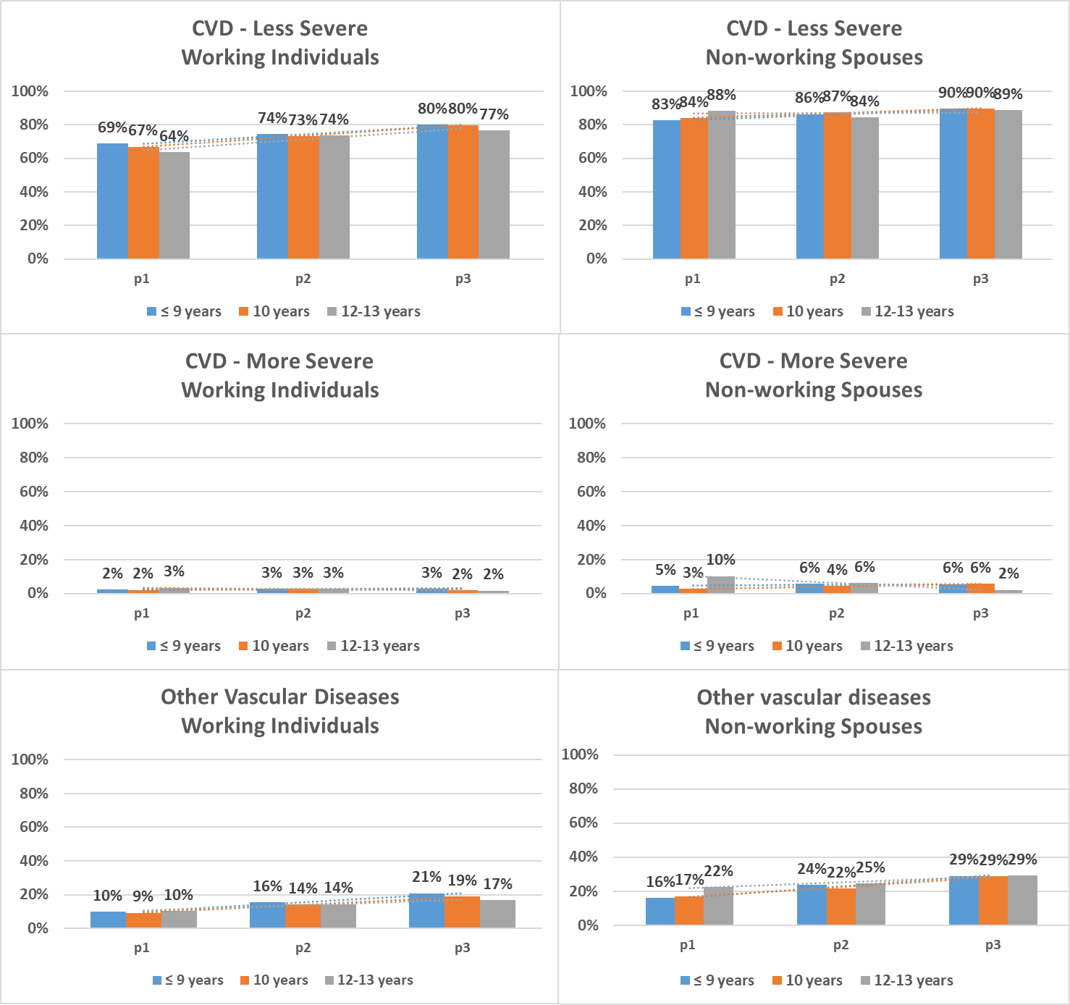

Figure S3. Predicted probabilities of the number of comorbidities over the three time periods for men, stratified by school education (displayed as years of schooling) and population subgroup. Time periods p1: 2005-2007, p2: 2010-2012, p3:2015-2017.
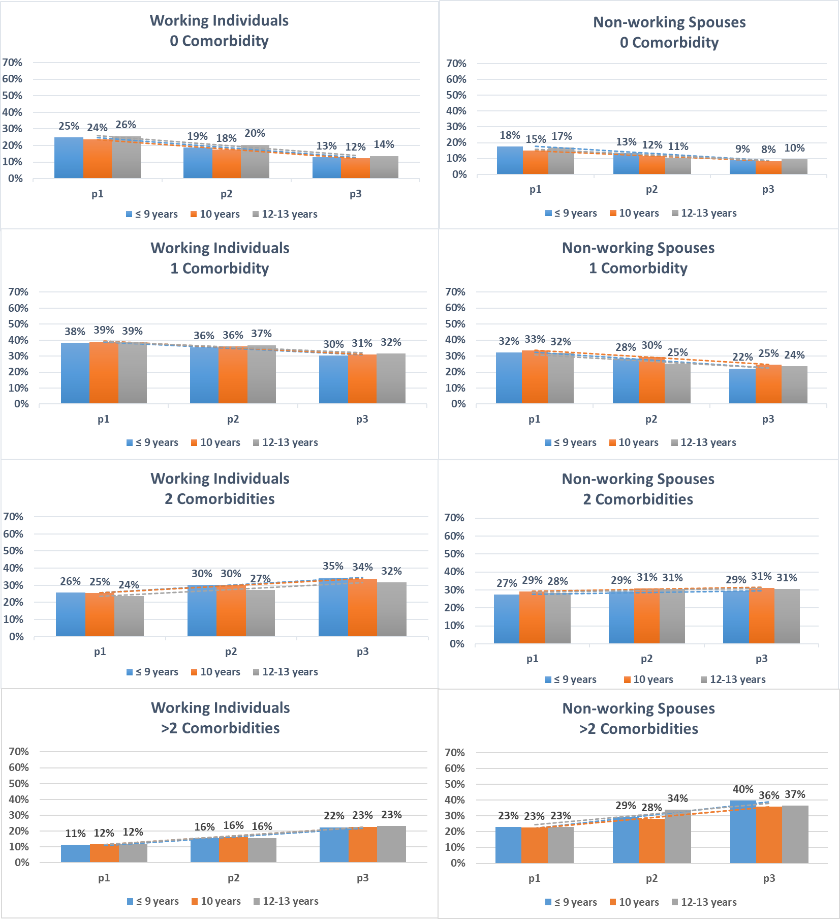

Figure S4. Predicted probabilities of the number of comorbidities over the three time periods for women, stratified by school education (displayed as years of schooling) and population subgroup. Time periods p1: 2005-2007, p2: 2010-2012, p3:2015-2017.

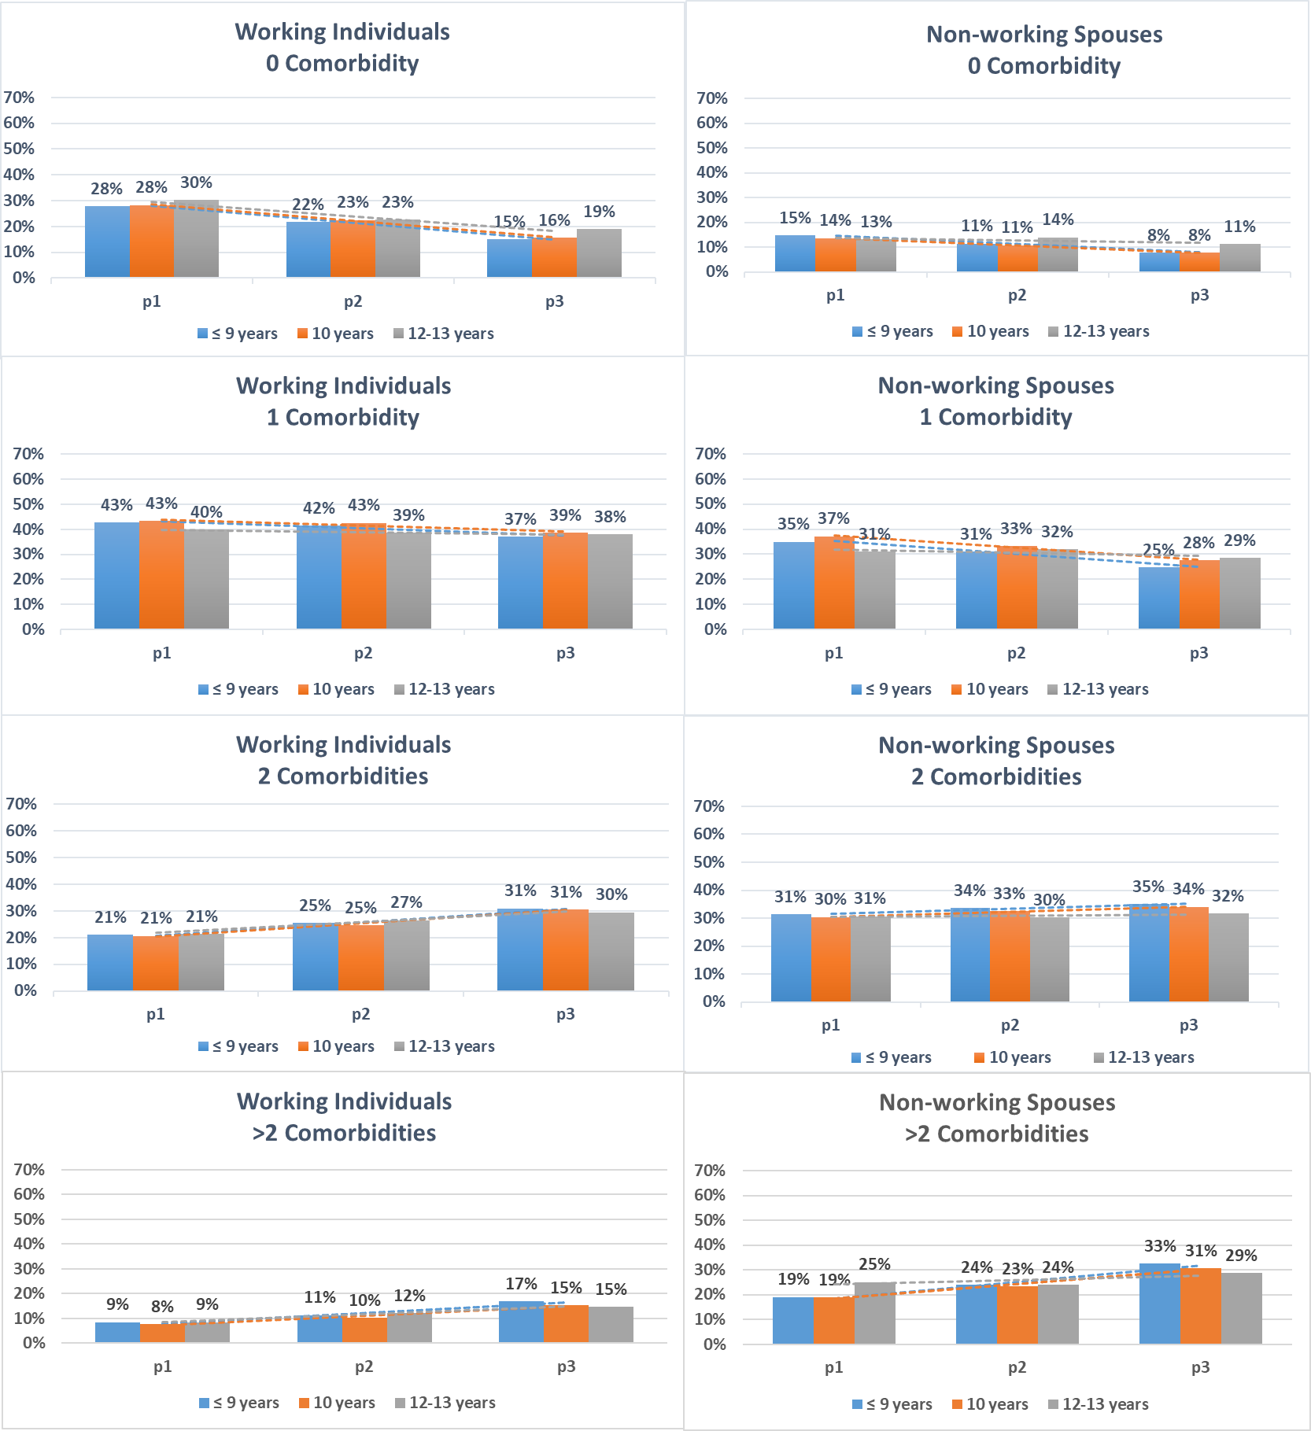

Figure S5. Predicted probabilities of comorbidity groups over the three time periods for men, stratified by occupation and population subgroup. Time periods p1: 2005-2007, p2: 2010-2012, p3:2015-2017. Comorbidities Less severe CVD: Hypertension, Hyperlipidemia, Cardiac insufficiency; More severe CVD: Myocardial infarction, Stroke, Angina Pectoris; Other vascular diseases: Nephropathy, Neuropathy, Retinopathy.
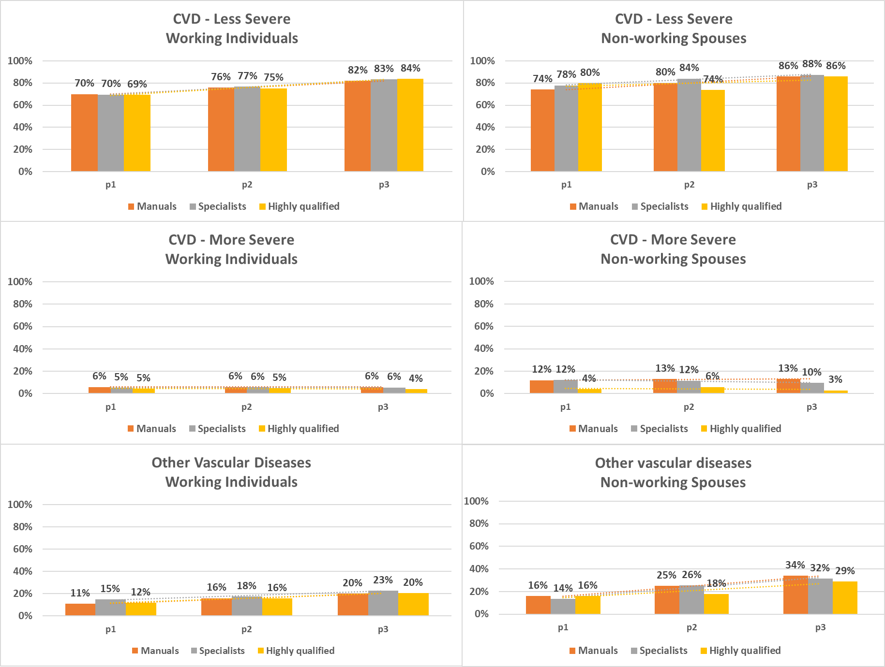

Figure S6. Predicted probabilities of comorbidity groups over the three time periods for women, stratified by occupation and population subgroup. Time periods p1: 2005-2007, p2: 2010-2012, p3:2015-2017. Comorbidities Less severe CVD: Hypertension, Hyperlipidemia, Cardiac insufficiency; More severe CVD: Myocardial infarction, Stroke, Angina Pectoris; Other vascular diseases: Nephropathy, Neuropathy, Retinopathy.
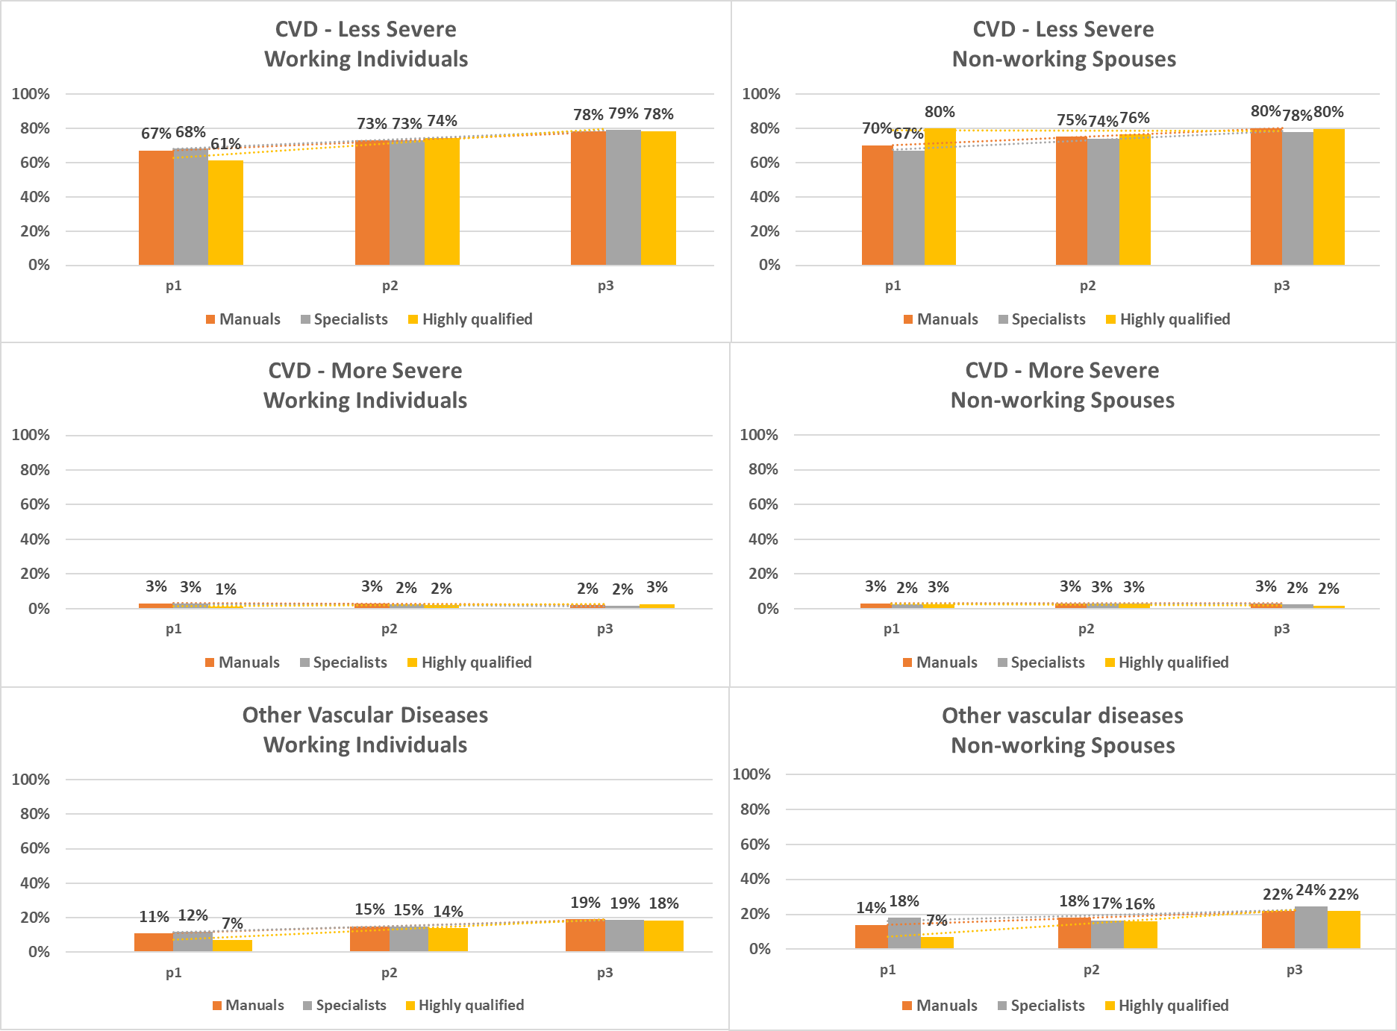

Figure S7. Predicted probabilities of the number of comorbidities over the three time periods for men, stratified by occupation and population subgroup. Time periods p1: 2005-2007, p2: 2010-2012, p3:2015-2017.
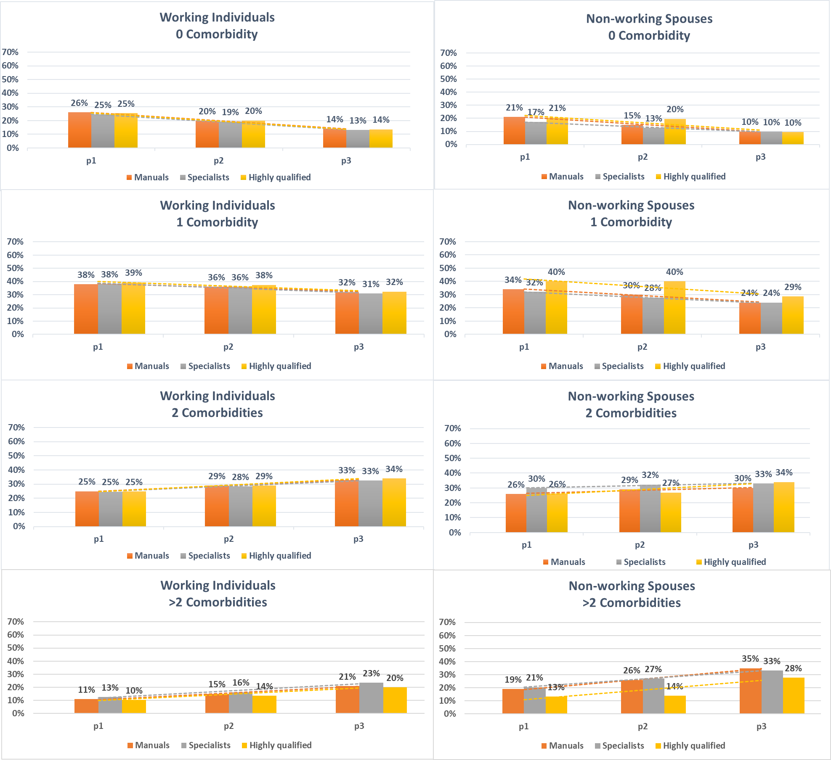

Figure S8. Predicted probabilities of the number of comorbidities over the three time periods for women, stratified by occupation and population subgroup. Time periods p1: 2005-2007, p2: 2010-2012, p3:2015-2017.
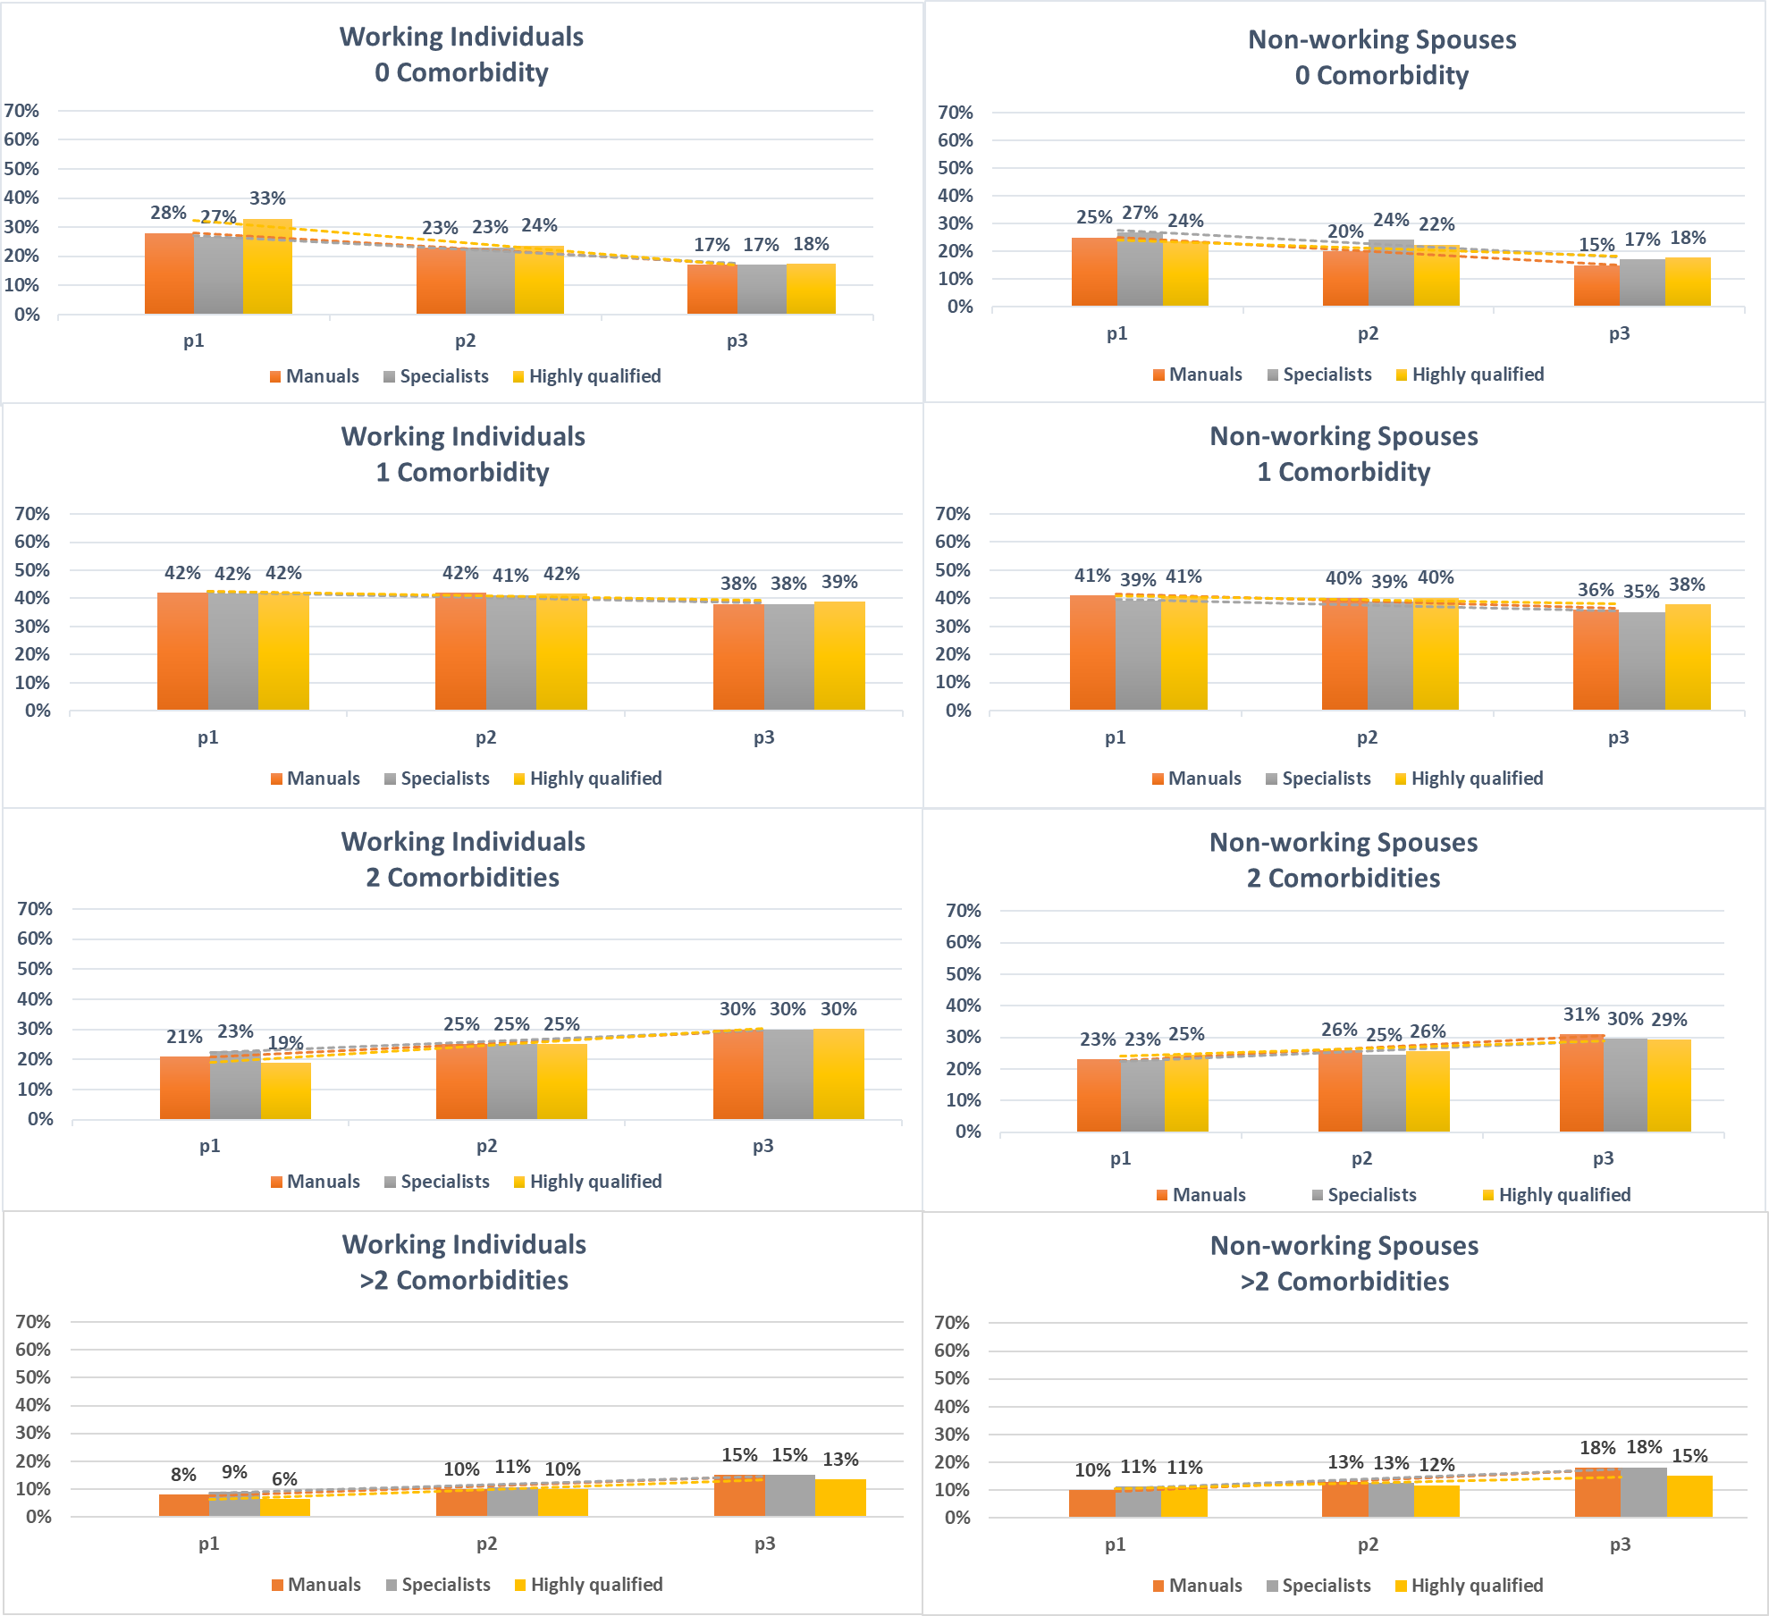

References
1. Safieddine B, Sperlich S, Epping J, Lange K, Geyer S. Development of comorbidities in type 2 diabetes between 2005 and 2017 using German claims data. Scientific reports. 2021;11(1):1-10.
2. Bundesministerium der Justiz. Sozialgesetzbuch (SGB) Sechstes Buch (VI) - Gesetzliche Rentenversicherung - (Artikel 1 des Gesetzes v. 18. Dezember 1989, BGBl. I S. 2261, 1990 I S. 1337) 2023 [Available from: https://www.gesetze-im-internet.de/sgb_6/.
3. Bundesministerium für Arbeit und Soziales. Verordnung über maßgebende Rechengrößen der Sozialversicherung für 2017 [Available from: https://www.bmas.de/SharedDocs/Downloads/DE/Meldungen/2016/referentenentwurf-zur-sozialversicherungs-rechengroessenverordnung.pdf?__blob=publicationFile&v=2.

