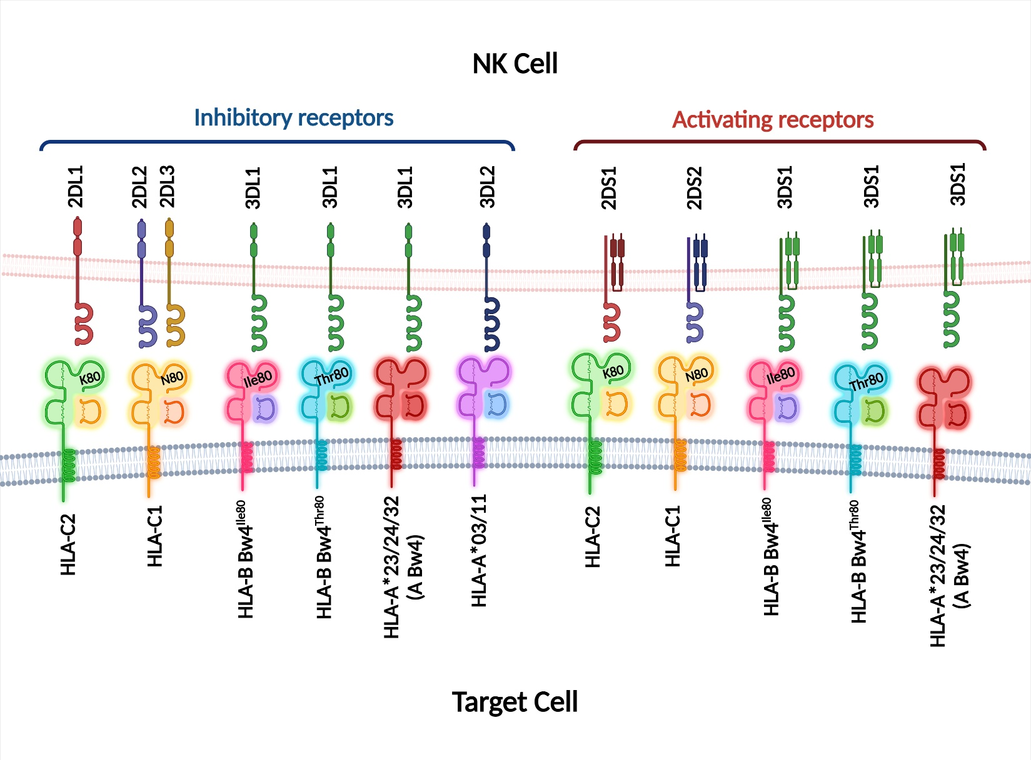
Supplementary Figure S1: KIRs and their cognate HLA-I ligands (Created with BioRender.com).

