Supplementary Materials
for
How level of understanding and type of sources used relate to adherence to COVID-19 public health measures in Canada

Table of content

Supplementary 1: Study Materials 2
Supplementary 1a. COVID-19: the end of the world as we know it? 2
Table 1. Descriptive statistics of the survey 2
Supplementary 1b. Variables 4
Adherence to public health measures 4
Table 2. Detailed description of the questions used as dependant variables 4
Figure 1. Correlations between social distancing items at each time point 5
Figure 2. Correlations between contacts’ limitation items at each time point 6
Figure 3. Correlations between mask wearing items at each time point 7
Table 3. Correlations and Cronbach’s alpha for all three public health measures items at each time point 8
Type of used sources 9
Figure 4. Results from the iCare Study on the importance of sources of information 9
Table 4. Percentages of top 3 chosen sources of COVID information among 10 10
Figure 5. Correlations between top 3 chosen sources of COVID information among 10 11
Control variables 12
Table 5. Descriptive statistics for control variables 12
Figure 6. Correlations between independent variables 13

Supplementary 2: Results 14
Supplementary 2a. Social distancing trajectories 14
Table 6. Bayesian information criterion for selection of a trajectory model 14
Table 7. Bivariate statistics for groups of adherence to social distancing 15
Table 8. Detailed results for trajectories of adherence to social distancing (model parameters) 16
Table 9. Average group assignment probability to social distancing group, conditional on assignment by maximum probability 16
Table 10. Associations with predictors and control variables 17
Supplementary 2b. Contacts’ limitation trajectories 19
Table 11. Bayesian information criterion for selection of a trajectory model 19
Table 12. Bivariate statistics for adherence trajectories to contacts limitation 20
Table 13. Detailed results for trajectories of adherence to contacts’ limitation (model parameters) 21
Table 14. Average group assignment probability to contacts’ limitation group, conditional on assignment by maximum probability 21
Table 15. Associations with predictors and control variables 22
Supplementary 2c. Mask wearing trajectories 24
Table 16. Bayesian information criterion for selection of a trajectory model 24
Table 17. Bivariate statistics for adherence trajectories to mask wearing 25
Table 18. Detailed results for trajectories of adherence to social distancing (model parameters) 26
Table 19. Average group assignment probability to mask wearing group, conditional on assignment by maximum probability 26
Table 20. Associations with predictors and control variables 27

References 30

Supplementary 1. Study Materials

This project is part of a longitudinal study on the psychological impacts of COVID-19 on the Canadian population. This project, entitled "COVID-19 Canada: the end of the world as we know it?", was carried out with the collaboration of several researchers from different disciplines. The objective of this project is to understand the impacts on the Canadian population of a dramatic social change such as the COVID-19 pandemic through three themes: adherence to health measures, social cohesion, and well-being. The participants were questioned on more than a hundred variables covering concepts as diverse as emotions, behaviors, attitudes, and cognitions related to the COVID-19 pandemic.

Supplementary 1a. COVID-19: the end of the world as we know it?

Table 1. Descriptive statistics of the survey
Time point |  | Survey dates | Sample Size  (N) | Intervals between time points |  | Number of weeks elapsed since launch of survey
1 | April 6th – May 6th 2020 |  | 3617 | 2 weeks | 0
2 | April 21st – May 13th 2020 |  | 2282 | 2 weeks | 2
3 | May 4th – May 25th 2020 |  | 2369 | 2 weeks | 4
4 | May 18th – June 10th 2020 |  | 2296 | 2 weeks | 6
5 | June 1st – June 23rd 2020 |  | 2154 | 2 weeks | 8
6 | June 15th – July 13th 2020 |  | 2116 | 2 weeks | 10
7 | July 13th – August 8th 2020 |  | 2072 | 4 weeks | 14
8 | August 17th – September 13th2020 |  | 1871 | 5 weeks | 19
9 | September 21st – October 19th 2020 |  | 1821 | 5 weeks | 24
10 | November 26th –December 29th 2020 |  | 1883 | 9 weeks | 33
11 | April 13th – May 31st 2021 |  | 2002 | 20 weeks | 53
12 | Mars 2nd – April 19th 2022 |  | 1672 | 46 weeks | 99

Table 1 illustrates various elements of the survey: the number of time points, the timeline of the survey, and the sample size. Most importantly, this table indicates the coding scheme for this study, in which we only refer to the number of weeks elapsed since the launch of the survey as time point (from 0 to 53).

Supplementary 1b. Variables

Adherence to public health measure

Table 2. Detailed description of the questions used as dependant variables
Questions from the survey | Scale | Dates of entry in the survey
Currently, how often do you do the following?
Maintain a distance of at least two meters (about two arm's lengths) from others when I am not at home | 1-10 (Never to Always) | April 6th – May 6th 2020
Stay home as much as I can | 1-10 (Never to Always) | April 6th – May 6th 2020
Wear a mask in public | 1-10 (Never to Always) | June 1st – June 23rd 2020

Participants were questioned on their level of adherence to public health measures by reporting how often they would follow the public health recommendations. Table 2 shows that mask wearing was introduced later in the survey, which explains the time gap with other measures.

Figure 1. Correlations between social distancing items at each time point
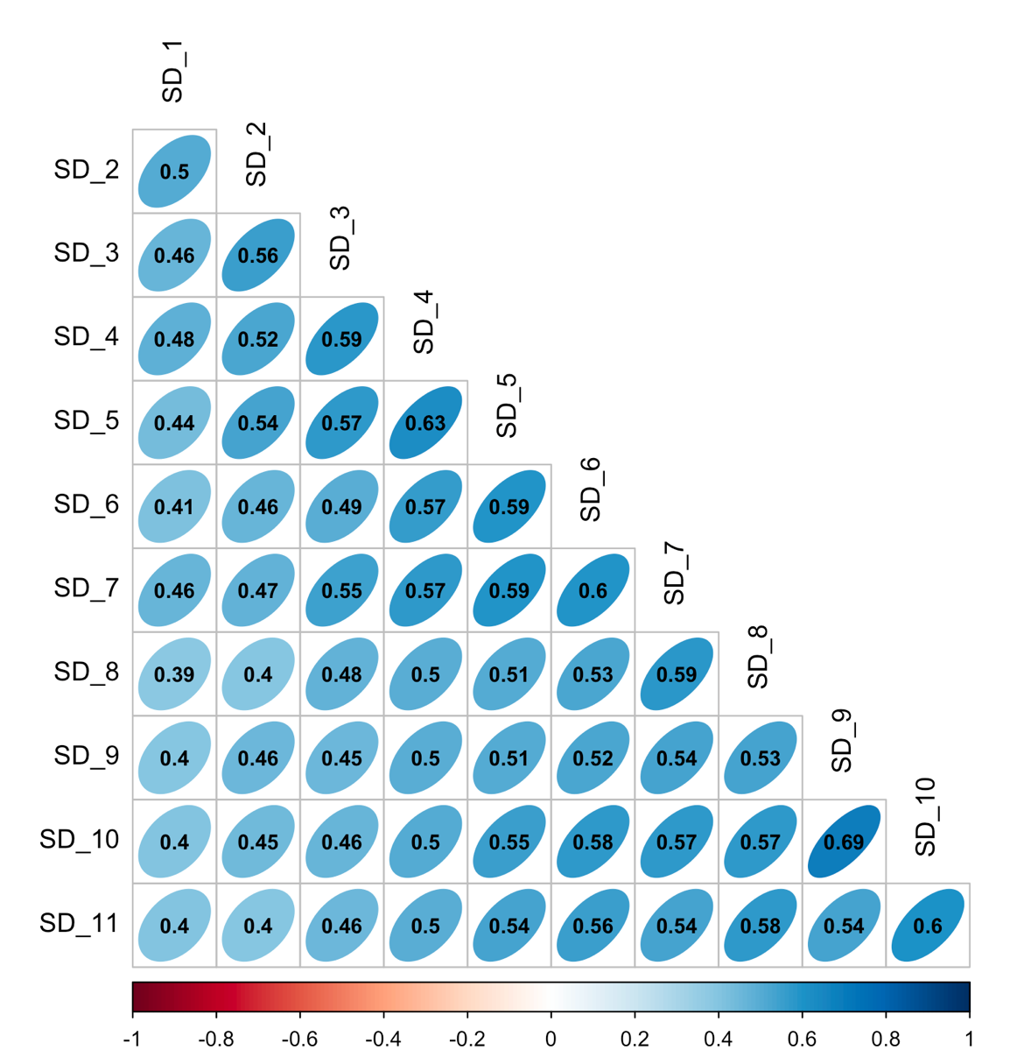
Figure 1 illustrates the Pearson correlations between social distancing variables at all 11 time points. Associations between the same variable at different time measures were evaluated to verify the validity of the question from the survey. Indeed, this allowed us to verify whether the answers from one time point to another were similar in pattern. In the case of social distancing, we can confirm that all variables are strongly associated with one another as correlations range between 0.39 and 0.69.
N.B. All numbers displayed with only one-digit have a zero as the following digit and were automatically rounded by the software.

Figure 2. Correlations between contacts limitation items at each time point
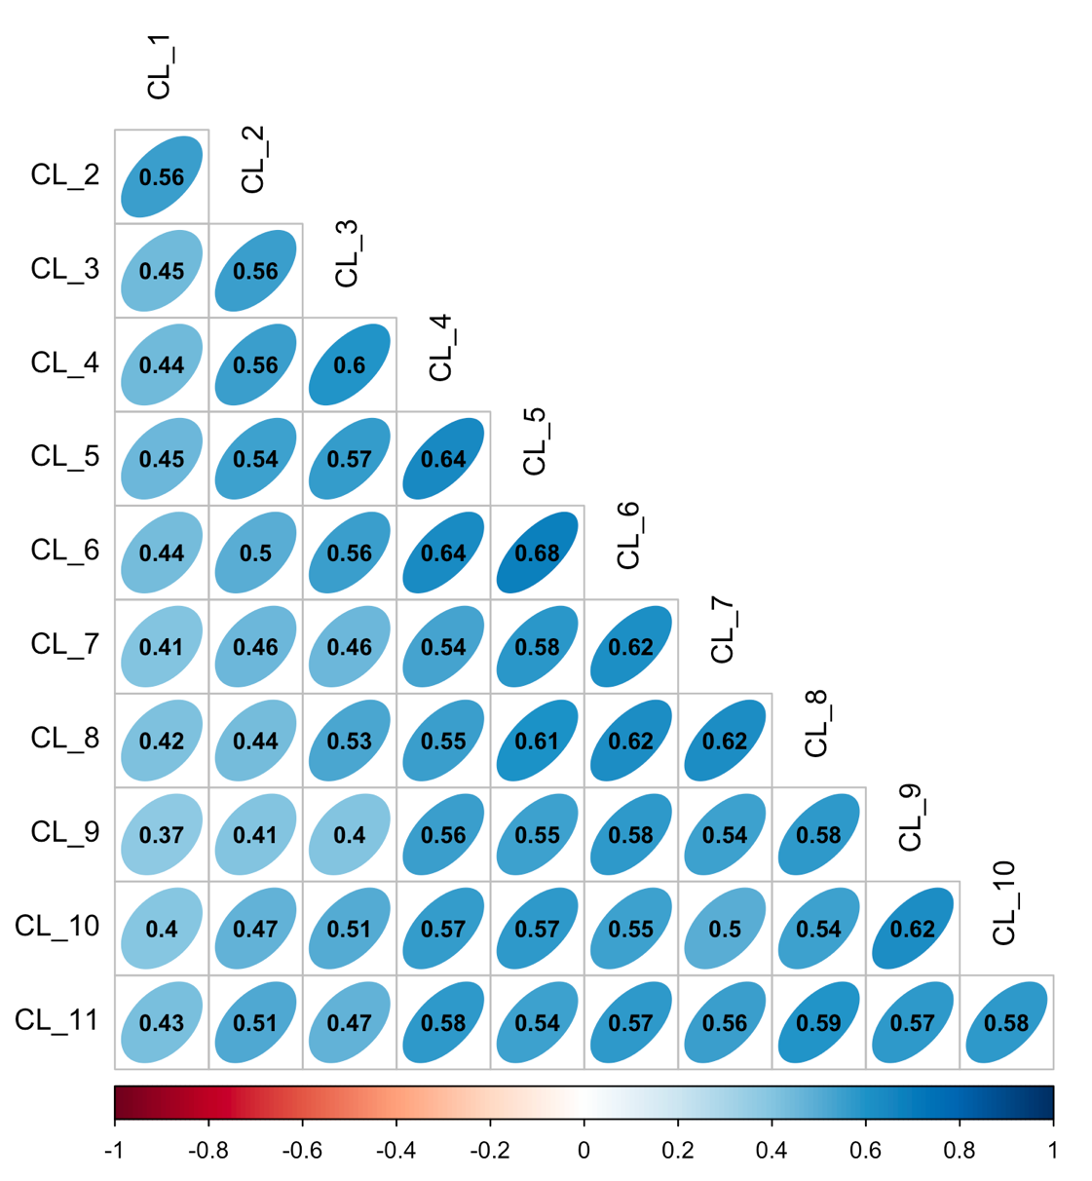
Figure 2 illustrates the Pearson correlations between contacts limitation variables at all 11 time points. The correlations vary between 0.37 and 0.68, which indicates the presence of strong associations between variables of contacts limitations.

N.B. All numbers displayed with only one-digit have a zero as the following digit and were automatically rounded by the software.

Figure 3. Correlations between mask wearing items at each time point
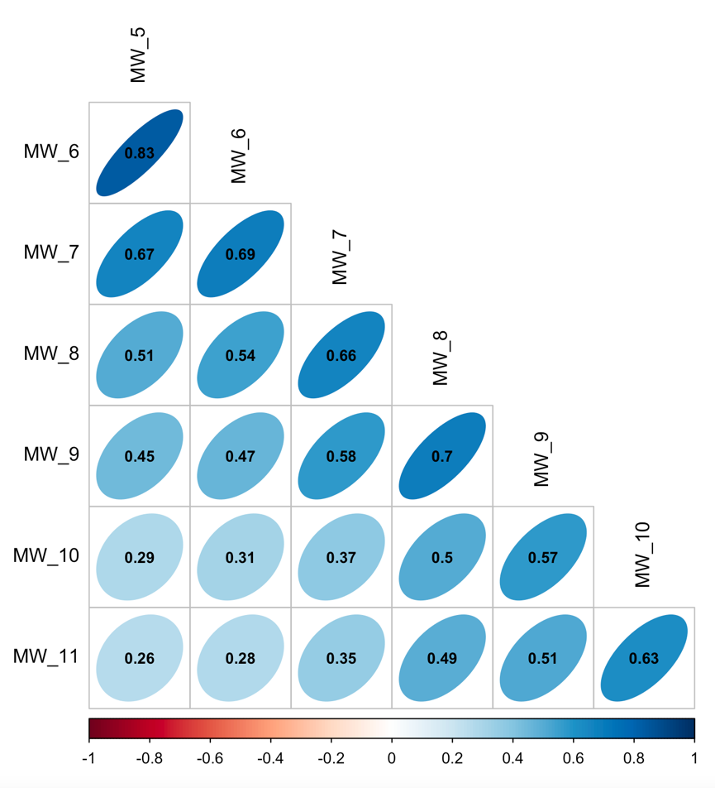
Figure 3 illustrates the Pearson correlations between mask wearing variables at all 6 time points. The correlations vary between 0.26 and 0.83, which indicates the presence of strong associations between variables of mask wearing.
N.B. All numbers displayed with only one-digit have a zero as the following digit and were automatically rounded by the software.

Table 3. Correlations and Cronbach’s alpha for public health measures at each time point

Time point | Correlation  SD & CL | Correlation  SD & MW | Correlation  CL & MW | Cronbach’s Alpha (CI)
1 | .44 | N/A | N/A | .62  (.56–.66)
2 | .44 | N/A | N/A | .62  (.55–.67)
3 | .46 | N/A | N/A | .63  (.58–.68)
4 | .49 | N/A | N/A | .65  (.60–.70)
5 | .49 | .36 | .37 | .61  (.58–.64)
6 | .50 | .38 | .39 | .65  (.62–.68)
7 | .53 | .43 | .33 | .57  (.45–.66)
8 | .49 | .50 | .38 | .66  (.52–.77)
9 | .52 | .50 | .47 | .73  (.58–.83)
10 | .63 | .58 | .47 | .84  (.72–.93)
11 | .63 | .60 | .44 | .80  (.65–.90)
SD: social distancing
CL: contacts limitation
MW: mask wearing
CI: Confidence Interval

This table illustrates the Pearson correlations between the items for each public health measure at each time point (mask wearing was included only starting at the fifth time point) and the Cronbach’s Alpha between those items. The correlations between different health measures items vary between 0.33 and 0.63, which indicates the presence of medium strong associations between public health measures. Cronbach’s Alpha varies from 0.57 to 0.84, indicating at most time point that the public health measures items could be used to construct one variable, but are still separate, distinctive items.

Type of used sources

This question was derived from a larger study on COVID-19, the iCare Study (Bacon et al., 2021). In this study, participants were asked: “Among the following sources of information about COVID-19, please rank all the sources that you use, from most to least important.” In the longitudinal survey for the project “COVID-19 Canada: the end of the world as we know it”, we used the same source options, but participants were only asked to rank up to three sources that they “trusted the most to get information regarding COVID-19”. The underlying reasoning put forward by the iCare study (conducted in 14 countries by a team composed of over 100 scientists) is that people will use primarily sources they believe to be trustworthy. Although convenience or easy access to the source of information may also play a role, the results seem to support that people choose sources first and foremost according to their perceived trustworthiness, as more “accessible” or “convenient” sources were ranked low (family and friends, workplace, community, internet), whereas less convenient but potentially more trustworthy sources were ranked higher (health authorities, news, WHO, scientific literature). However, trustworthiness of source as perceived by participant is highly subjective. Thus, we divided sources into official and informal sources by using both our own observation in our survey’s answer and the results of the iCare study.

Figure 4. Results from the iCare Study on the importance of sources of information
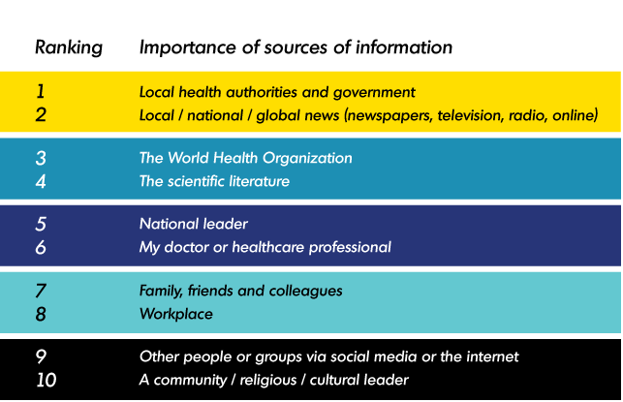
Source : iCARE Study – Results. (2021). MBMC. https://mbmc-cmcm.ca/covid19/research/stats/other/

Table 4. Percentages of top 3 chosen sources of COVID information among 10
Sources | 1  (%) | 2  (%) | 3  (%) | In the top 3
 |  |  |  | Yes  (%) | No  (%)
Family/friends | 2 | 3 | 5 | 10 | 90
Workplace | 2 | 2 | 3 | 7 | 93
News | 21 | 19 | 20 | 60 | 40
Doctor | 8 | 11 | 12 | 31 | 69
Health authorities | 35 | 30 | 15 | 80 | 20
Community | 0,8 | 0,8 | 1,3 | 3 | 97
WHO | 18 | 18 | 17 | 52 | 48
Scientific literature | 11 | 11 | 12 | 34 | 66
Others/internet | 1,5 | 1,5 | 3 | 6 | 94
In our preliminary analysis, we found that participants relied mostly on health authorities, news outlets and the WHO to obtain information on the COVID-19 pandemic. Table 4 presents the percentages of sources selected in the top 3, with 80% of participants reporting that health authorities are one the most used sources of information. These results reflect those obtained in the iCare Study, for which the question was originally designed.

Figure 5. Correlations between top 3 chosen sources of COVID information among 10
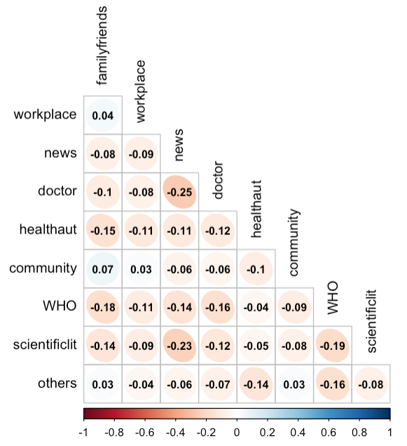
Following the identification of most used sources by participants with the question “Which of the following sources do you trust the most when you want to be informed about COVID-19? Select up to three answers starting with the most trusted source.”, we proceeded to evaluate the correlations between the selected sources. Figure 5 illustrates the degree of correlations between the various sources of information. Unsurprisingly, most sources are negatively correlated with the others, as participants were restrained to choose and rank a maximum of three sources, meaning that each selected source was conjointly selected with only two other sources for each participant. The positive correlations suggest that the two sources were more often selected conjointly by participants as part of their most trusted sources of information, though the positive correlation we observe are very weak. Following this reasoning, we can see that the following pairs of sources were slightly more often selected together: family and friends and workplace; family and friends and community; family and friends and others; workplace and community; community and others. As a reminder, we categorized healthcare authorities, news organisations, the WHO and doctors as official sources. The remaining options, like family/friends, the workplace, the community, and others/Internet, were identified as informal sources. From these preliminary results, we can see that people using informal sources often used them conjointly, whereas people using official sources seldom used them conjointly with an informal source, as shown by negative correlations.

Control Variables

Table 5. Descriptive statistics for control variables
 | Sub-sample used in this study (N=2659) |  | Full original sample (N=3617)
Variables | Mean (SD) | Weighted mean (SD) | Mean  (SD)
Age | 49.8 (16.6) | 45.4 (15.6) | 48.0 (16.9)
Political identity  (1: left, 10: right) | 5.2 (1.9) | 5.3 (1.9) | 5.2 (1.9)
 | % (n) | Weighted % | % (n)
Gender
Male | 50.1 (1316) | 50.2 | 50.3 (1778)
Female | 49.9 (1313) | 49.2 | 49.7 (1759)
Education level
No diploma | 2.1 (55) | 2.7 | 2.3 (87)
Secondary school diploma | 17.3 (454) | 16.0 | 17.1 (606)
College, CEGEP or other non-university diploma | 28.8 (756) | 29.5 | 30.2 (1068)
Bachelor's degree | 32.5 (854) | 32.5 | 31.3 (1106)
Master's degree | 12.4 (325) | 11.7 | 12.1 (429)
Earned doctorate | 7.0 (185) | 6.7 | 6.8 (241)
Canadian Regions
Ontario | 40.5 (1058) | 37.9 | 39.2 (1378)
Atlantic | 6.8 (177) | 6.2 | 6.8 (239)
Quebec | 20.3 (532) | 23.6 | 21.0 (739)
Prairies | 18.0 (474) | 18.2 | 18.1 (636)
BC | 14.3 (374) | 13.1 | 14.8 (521)
Born in Canada
Yes | 79.5 (2077) | 76.9 | 80.0 (2813)
No | 20.5 (526) | 21.8 | 20.0 (703)
SD: Standard Deviation

Figure 6. Correlations between independent variables
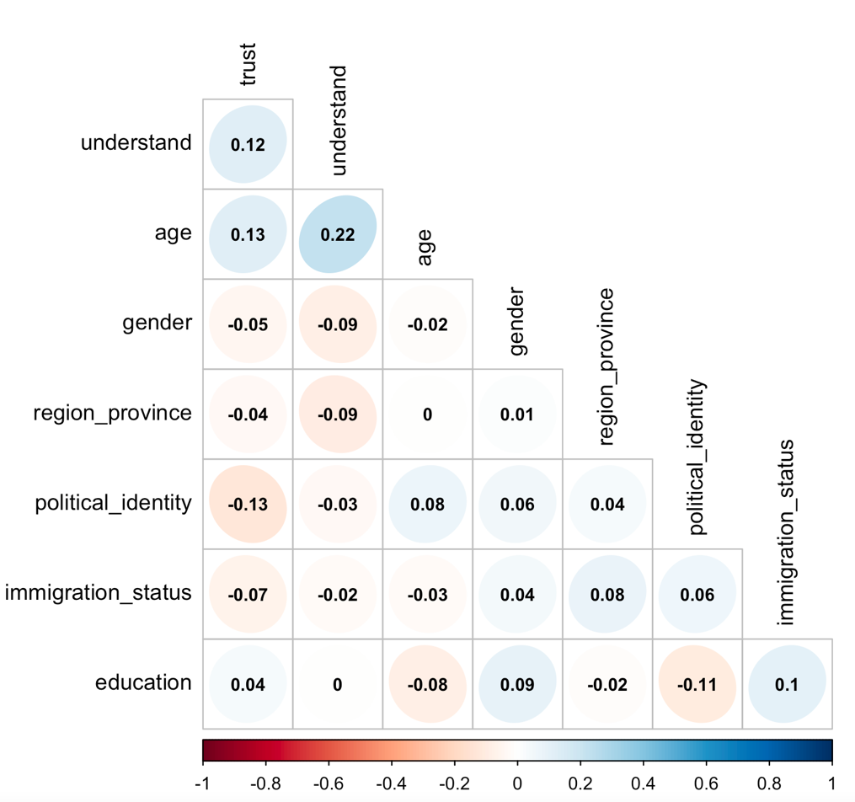
Figure 6 displays the various degrees of associations between independent variables, including both the two main predictors and all control variables. The correlations range from 0 to |0.13|, which reveals that independent variables are not strongly correlated. The only correlation that is slightly higher is between age and perceived understanding (0.22) which may explain why age was often a significant predictor of adherence.

Supplementary 2. Results

Supplementary 2A. Social distancing trajectories

Table 6. Bayesian information criterion for selection of a trajectory model
Model | K | Order | BIC
1 | 1 | 2 | -30 582.30*
2 | 2 | 2,2 | -27 467.71*
3 | 3 | 2,2,2 | -26 595.36*
4 | 4 | 2,2,2,2 | -26 443.93
5 | 5 | 2,2,2,2,2 | -26 356.12
6 | 6 | 2,2,2,2,2,2 | -26 375.61
7 | 4 | 1,2,2,2 | -26 448.29
8 | 4 | 1,2,2,1 | -26 449.99*
9 | 4 | 1,2,2,0 | -26 449.64*
10 | 4 | 1,3,2,0 | -26 379.29*
11 | 4 | 1,3,3,0 | -26 344.55*
Table 6 shows the various attempts at obtaining the best model of social distancing trajectories. Only models with an * were retained for comparison, as the parameters’ estimates were significant (p < 0.05). Models in which the smallest group included less than 2% of the sample (above four groups) were not considered. The models were compared according to the Bayesian information criterion (BIC): indeed, the solution with the lowest absolute value of BIC was selected. In this case, we selected the model with 4 trajectories (1,3,3,0).

Table 7. Bivariate statistics for groups of adherence to social distancing

Group | 1 – Low & decreasing  (n = 139, 5.3%) |  | 2: Medium & fluctuating  (n=855, 32.7%) | 3: High & fluctuating  (n=1018, 39.0%) | 4: High & constant  (n=601, 23.0%) | p-value for ANOVA’s F statistic
Variables |  | Mean (SD) |  |  |  | p-value for ANOVA’s F statistic
Understanding  (1: low, 10: high) | 6.9 (2.1) |  | 7.8 (1.5) | 8.6 (1.3) | 9.1 (1.3) | 0.000 ***
Age | 36.7 (12.0) |  | 41.7 (13.8) | 51.1 (15.1) | 51.2 (15.6) | 0.000 ***
Political identity  (1: left, 10: right) | 6.0 (1.9) |  | 5.1 (1.8) | 5.2 (1.9) | 5.2 (1.9) | 0.307
 |  | % (n) |  |  |  | p-value for χ² joint test of significance
Use of official sources (Yes) | 44.6 (62) |  | 75.1 (642) | 82.0 (835) | 82.4 (495) | 0.000 ***
Gender (Male) | 61.2 (85) |  | 57.1 (488) | 48.1 (490) | 40.4 (243) | 0.000 ***
Education level |  |  |  |  |  | 0.000 ***
No diploma | 2.9 (4) |  | 1.1 (9) | 2.7 (27) | 2.5 (15)
Secondary school diploma | 21.6 (30) |  | 14.2 (121) | 17.4 (177) | 20.6 (124)
College, CEGEP or other non-university diploma | 29.5 (41) |  | 30.4 (260) | 25.4 (259) | 32.3 (194)
Bachelor's degree | 28.8 (40) |  | 37.3 (319) | 31.4 (320) | 28.1 (169)
Master's degree | 10.8 (15) |  | 12.3 (105) | 14.0 (143) | 9.8 (59)
Earned doctorate | 6.5 (9) |  | 4.8 (41) | 9.0 (92) | 6.7 (40)
Canadian Regions |  |  |  |  |  | 0.000 ***
Ontario | 33.1 (46) |  | 35.8 (304) | 41.5 (421) | 46.8 (279)
Atlantic | 4.3 (6) |  | 4.1 (35) | 8.2 (83) | 8.6 (51)
Quebec | 18.7 (26) |  | 20.5 (174) | 19.9 (202) | 21.6 (129)
Prairies | 28.1 (39) |  | 22.0 (187) | 17.5 (177) | 11.4 (68)
BC | 15.8 (22) |  | 17.6 (150) | 12.9 (131) | 11.6 (69)
Born in Canada (Yes) | 77.0 (107) |  | 82.9 (709) | 78.0 (794) | 77.7 (467) | 0.030 *

*p< 0.05 **p< 0.01 *** p< 0.001

Table 8. Detailed results for trajectories of adherence to social distancing (model parameters)
Group | Parameter | β | SE | t | p-value
1 | Intercept | 5.871 | .379 | 15.489 | .000
1 | Linear | -.029 | .011 | -2.603 | .009
2 | Intercept | 8.759 | .290 | 30.204 | .000
2 | Linear | -.177 | .025 | -7.088 | .000
2 | Quadratic | .008 | .001 | 6.380 | .000
2 | Cubic | -.000 | .000 | -5.618 | .000
3 | Intercept | 10.826 | .551 | 19.661 | .000
3 | Linear | -.226 | .039 | -5.746 | .000
3 | Quadratic | .009 | .001 | 5.790 | .000
3 | Cubic | -.000 | .000 | -5.354 | .000
4 | Intercept | 12.463 | .275 | 45.278 | .000
Note. β: Standardized coefficients
SE: Standard Errors

Table 9. Average group assignment probability to social distancing group, conditional on assignment by maximum probability

Group assignment | Probability (%)
Group assignment | 1 | 2 | 3 | 4
1 | 91.0 | 0.2 | .0 | .0
2 | 9.0 | 87.2 | 10.2 | .0
3 | .0 | 10.6 | 84.8 | 8.0
4 | .0 | .0 | 4.9 | 92.0

Overall average group assignment probability to assigned group: 88.8%

Table 10. Associations with predictors and control variables

Variable | Group | β | SE | t | p-value
Constant | 2 | -1.041 | 1.059 | -.983 | .325
Constant | 3 | -3.978 | 1.538 | -2.587 | .010
Constant | 4 | -7.995 | 1.777 | -4.498 | .000
Level of understanding | 2 | .239 | 0.078 | 3.073 | .002
Level of understanding | 3 | .557 | .082 | 6.807 | .000
Level of understanding | 4 | .957 | .135 | 7.076 | .000
Use of official sources | 2 | .991 | 0.408 | 2.431 | .015
Use of official sources | 3 | 1.077 | .456 | 2.362 | .018
Use of official sources | 4 | 1.221 | .406 | 3.008 | .002
Age | 2 | .029 | .010 | 2.800 | .005
Age | 3 | .067 | .009 | 7.614 | .000
Age | 4 | .064 | .010 | 6.373 | .000
Gender – Male | 2 | .103 | 0.357 | .288 | .871
Gender – Male | 3 | -.294 | .300 | -0.980 | .327
Gender – Male | 4 | -.540 | .317 | -1.704 | .088
Region of residence  – Atlantic | 2 | .432 | .761 | .568 | .570
Region of residence  – Atlantic | 3 | .929 | .629 | 1.477 | .140
Region of residence  – Atlantic | 4 | .663 | .653 | 1.016 | .310
Region of residence  – Quebec | 2 | -.278 | .416 | -.667 | .504
Region of residence  – Quebec | 3 | -.586 | .381 | -1.539 | .124
Region of residence  – Quebec | 4 | -.695 | .419 | -1.600 | .097
Region of residence  – Prairies | 2 | -.344 | .338 | -1.020 | .308
Region of residence  – Prairies | 3 | -.821 | .349 | -2.352 | .019
Region of residence  – Prairies | 4 | -1.408 | .374 | -3.762 | .000
Region of residence  – British Columbia | 2 | -.115 | .387 | -.297 | .767
Region of residence  – British Columbia | 3 | -.761 | .465 | -1.636 | .102
Region of residence  – British Columbia | 4 | -1.036 | .405 | -2.557 | .097
Immigrant | 2 | .099 | .363 | .271 | .786
Immigrant | 3 | .453 | .346 | 1.310 | .190
Immigrant | 4 | .648 | .336 | 1.932 | .053
Education level  – High school | 2 | .126 | .870 | .145 | .885
Education level  – High school | 3 | -.698 | .909 | -.767 | .443
Education level  – High school | 4 | -.289 | .949 | -.304 | .761
Education level  – College | 2 | .452 | .862 | .524 | .600
Education level  – College | 3 | -.938 | .865 | -1.084 | .278
Education level  – College | 4 | -.688 | .897 | -.767 | .443
Education level  – Bachelor | 2 | .898 | .874 | 1.028 | .304
Education level  – Bachelor | 3 | -.296 | .846 | -.350 | .726
Education level  – Bachelor | 4 | -.224 | .888 | -.252 | .801
Education level  – Master | 2 | .296 | .904 | .327 | .743
Education level  – Master | 3 | -.675 | .958 | -.705 | .481
Education level  – Master | 4 | -.744 | 1.026 | -.725 | .469
Education level  – Doctorate | 2 | -.171 | 1.103 | -.155 | .877
Education level  – Doctorate | 3 | -.651 | 1.079 | -.603 | .546
Education level  – Doctorate | 4 | -.743 | 1.103 | -.674 | .500
Political identity | 2 | -.230 | .077 | -2.988 | .002
Political identity | 3 | -.223 | .096 | -2.310 | .021
Political identity | 4 | -.214 | .095 | -2.256 | .024
Note. β: Standardized coefficients of multinomial logistic regression
SE: Standard Errors

Supplementary 2b. Contacts’ limitation trajectories

Table 11. Bayesian information criterion for selection of a trajectory model
Model | K | Order | BIC
1 | 1 | 2 | -32 696.63*
2 | 2 | 2,2 | -29 472.33*
3 | 3 | 2,2,2 | -28 631.99*
4 | 4 | 2,2,2,2 | -28 383.46*
5 | 5 | 2,2,2,2,2 | -28 284.00
6 | 6 | 2,2,2,2,2,2 | -28 317.39
7 | 4 | 2,2,2,1 | -28 390.28
8 | 4 | 2,2,2,0 | -28 386.83*
9 | 4 | 3,2,2,0 | -28 306.14*
10 | 4 | 3,3,2,0 | -28 198.56*
11 | 4 | 3,3,3,0 | -28 104.50*
Table 11 shows the various attempts at obtaining the best model of contacts’ limitation trajectories. Only models with an * were retained for comparison, as the parameters’ estimates were significant (p < 0.05). Models in which the smallest group included less than 2% of the sample (above four groups) were not considered. The models were compared according to the Bayesian information criterion (BIC): indeed, the solution with the lowest absolute value of BIC was selected. In this case, we selected the model with 4 trajectories (3,3,3,0).

Table 12. Bivariate statistics for adherence trajectories to contacts limitation

Group | 1 – Low & fluctuating (n=156, 6.0%) |  | 2: Medium & fluctuating (n=917, 35.1%) | 3: High & fluctuating (n=1027, 39.3%) | 4: High & constant (n=513, 19.6%) | p-value for ANOVA’s F statistic
Variables |  | Mean (SD) |  |  |  | p-value for ANOVA’s F statistic
Understanding  (1: low, 10: high) | 7.4 (2.1) |  | 8.0 (1.4) | 8.6 (1.4) | 9.0 (1.3) | 0.000 ***
Age | 41.6 (13.2) |  | 46.0 (14.7) | 48.5 (16.0) | 47.8 (16.1) | 0.000 ***
Political identity  (1: left, 10: right) | 6.0 (2.0) |  | 5.3 (1.8) | 5.1 (1.9) | 5.1 (2.0) | 0.000 ***
 |  | % (n) |  |  |  | p-value for χ² joint test of significance
Use of official sources (Yes) | 54.5 (85) |  | 73.6 (675) | 83.3 (856) | 81.5 (418) | 0.000 ***
Gender (Male) | 59.6 (93) |  | 60.3 (553) | 46.8 (481) | 34.9 (179) | 0.000 ***
Education level |  |  |  |  |  | 0.020 *
No diploma | 1.9 (3) |  | 2.4 (22) | 2.5 (26) | 0.8 (4)
Secondary school diploma | 21.8 (34) |  | 18.8 (172) | 14.7 (151) | 18.5 (95)
College, CEGEP or other non-university diploma | 32.1 (50) |  | 25.8 (237) | 31.5 (323) | 28.1 (144)
Bachelor's degree | 25.6 (40) |  | 33.3 (305) | 33.7 (346) | 30.6 (157)
Master's degree | 11.5 (18) |  | 12.1 (111) | 12.1 (124) | 13.5 (69)
Earned doctorate | 7.1 (11) |  | 7.6 (70) | 5.6 (57) | 8.6 (44)
Canadian Regions |  |  |  |  |  | 0.000 ***
Ontario | 33.8 (52) |  | 34.7 (316) | 43.5 (445) | 46.3 (237)
Atlantic | 4.5 (7) |  | 5.4 (49) | 8.0 (82) | 7.2 (37)
Quebec | 20.8 (32) |  | 23.2 (211) | 18.5 (189) | 19.4 (99)
Prairies | 27.9 (43) |  | 19.5 (178) | 16.8 (172) | 15.3 (78)
BC | 13.0 (20) |  | 17.2 (157) | 13.2 (135) | 11.7 (60)
Born in Canada (Yes) | 76.9 (120) |  | 82.4 (756) | 79.7 (819) | 74.5 (382) | 0.004 **

*p< 0.05 **p< 0.01 *** p< 0.001

Table 13. Detailed results for trajectories of adherence to contacts’ limitation (model parameters)
Group | Parameter | β | SE | t | p-value
1 | Intercept | 7.014 | .491 | 14.278 | .000
1 | Linear | -.528 | .066 | -7.967 | .000
1 | Quadratic | .023 | .004 | 6.454 | .000
1 | Cubic | -.000 | .000 | -5.716 | .000
2 | Intercept | 8.995 | .228 | 36.266 | .000
2 | Linear | -.305 | .028 | -11.053 | .000
2 | Quadratic | .012 | .001 | 8.457 | .000
2 | Cubic | -.000 | .000 | -6.982 | .000
3 | Intercept | 11.386 | .268 | 42.533 | .000
3 | Linear | -.341 | .023 | -14.984 | .000
3 | Quadratic | .014 | .001 | 12.587 | .000
3 | Cubic | -.000 | .000 | -10.571 | .000
4 | Intercept | 13.051 | .199 | 65.486 | .000
Note. β: Standardized coefficients
SE: Standard Errors

Table 14. Average group assignment probability to contacts’ limitation group, conditional on assignment by maximum probability
Group assignment | Probability (%)
Group assignment | 1 | 2 | 3 | 4
1 | 88.8 | 3.0 | .0 | .0
2 | 11.2 | 87.8 | 8.5 | .0
3 | .0 | 9.2 | 86.9 | 9.3
4 | .0 | .0 | 4.6 | 90.6
Overall average group assignment probability to assigned group: 88.5%

Table 15. Associations with predictors and control variables
Variable | Group | β | SE | t | p-value
Constant | 2 | 0.751 | 1.272 | .590 | .555
Constant | 3 | 0.749 | 1.355 | .553 | .580
Constant | 4 | -4.827 | 1.838 | -2.627 | .009
Level of understanding | 2 | .157 | .095 | 1.646 | .010
Level of understanding | 3 | .368 | .090 | 4.071 | .000
Level of understanding | 4 | .683 | .130 | 5.245 | .00
Use of official sources | 2 | .589 | .282 | 2.089 | .037
Use of official sources | 3 | 1.179 | .255 | 4.631 | .000
Use of official sources | 4 | 1.074 | .287 | 3.738 | .000
Age | 2 | .019 | .007 | 2.814 | .005
Age | 3 | .025 | .007 | 3.477 | .000
Age | 4 | .018 | .008 | 2.230 | .026
Gender – Male | 2 | .010 | .271 | .035 | .972
Gender – Male | 3 | -.405 | .256 | -1.584 | .113
Gender – Male | 4 | -.815 | .275 | -2.965 | .003
Region of residence  – Atlantic | 2 | .137 | .641 | .214 | .831
Region of residence  – Atlantic | 3 | .284 | .612 | .464 | .643
Region of residence  – Atlantic | 4 | .283 | .630 | .448 | .640
Region of residence  – Quebec | 2 | -.288 | .344 | -.838 | .402
Region of residence  – Quebec | 3 | -.780 | .349 | -2.232 | .026
Region of residence  – Quebec | 4 | -.739 | .377 | -1.961 | .050
Region of residence  – Prairies | 2 | -.384 | .486 | -.791 | .429
Region of residence  – Prairies | 3 | -.712 | .399 | -1.785 | .074
Region of residence  – Prairies | 4 | -.859 | .421 | -2.042 | .041
Region of residence  – British Columbia | 2 | .062 | .417 | .148 | .823
Region of residence  – British Columbia | 3 | -.481 | .410 | -1.173 | .241
Region of residence  – British Columbia | 4 | -.638 | .427 | -1.493 | .136
Immigrant | 2 | -.190 | .323 | -.587 | .558
Immigrant | 3 | .042 | .309 | .136 | .892
Immigrant | 4 | .612 | .322 | 1.903 | .057
Education level  – High school | 2 | -.421 | 1.061 | -.396 | .692
Education level  – High school | 3 | -.753 | .998 | -.754 | .451
Education level  – High school | 4 | .601 | 1.318 | .456 | .648
Education level  – College | 2 | -.612 | 1.192 | -.513 | .608
Education level  – College | 3 | -.593 | 1.084 | -.547 | .584
Education level  – College | 4 | .252 | 1.397 | .181 | .857
Education level  – Bachelor | 2 | .154 | 1.023 | .151 | .880
Education level  – Bachelor | 3 | -.148 | .941 | -.158 | .875
Education level  – Bachelor | 4 | .867 | 1.25 | .696 | .486
Education level  – Master | 2 | -.391 | 1.176 | -.333 | .739
Education level  – Master | 3 | -.662 | 1.035 | -.640 | .522
Education level  – Master | 4 | .616 | 1.392 | .443 | .658
Education level  – Doctorate | 2 | -.327 | 1.247 | -.262 | .793
Education level  – Doctorate | 3 | -.899 | 1.034 | -.640 | .522
Education level  – Doctorate | 4 | .624 | 1.487 | .420 | .675
Political identity | 2 | -.197 | .081 | -2.432 | .015
Political identity | 3 | -.899 | 1.117 | -0.804 | .421
Political identity | 4 | -.239 | .092 | -2.599 | .009
Note. Β: Standardized coefficients of multinomial logistic regression
SE : Standard Errors

Supplementary 2c. Mask wearing trajectories

Table 16. Bayesian information criterion for selection of a trajectory model
Model | K | Order | BIC
1 | 1 | 2 | -18 157.69*
2 | 2 | 2,2 | -16 470.32*
3 | 3 | 2,2,2 | -15 988.87*
4 | 4 | 2,2,2,2 | -15 814.35*
5 | 5 | 2,2,2,2,2 | -15 644.83
6 | 6 | 2,2,2,2,2,2 | -15 580.94
7 | 7 | 2,2,2,2,2,2,2 | -15 557.67
8 | 5 | 1,2,2,2,2 | -15 647.44
9 | 5 | 1,2,1,2,2 | -15 741.80
10 | 5 | 1,2,0,2,2 | -15 761.18*

Table 16 shows the various attempts at obtaining the best model of mask wearing trajectories. Only models with an * were retained for comparison, as the parameters’ estimates were significant (p < 0.05). The models were compared according to the Bayesian information criterion (BIC): indeed, the solution with the lowest absolute value of BIC was selected. In this case, we selected the model with 5 trajectories (1,2,0,2,2).

Table 17. Bivariate statistics for adherence trajectories to mask wearing

Group | 1 – Low & increasing slowly (n = 50, 2.5%) |  | 2: Low & increasing fast (n=362, 18.3%) | 3: Medium & constant (n=137, 6.9%) | 4: Medium & increasing fast (n=779, 39.4%) | 5: High & constant (n=647, 32.8%) | p-value for ANOVA’s F statistic
Variables |  | Mean (SD) |  |  |  |  | p-value for ANOVA’s F statistic
Understanding  (1: low, 10: high) | 7.5 (2.4) |  | 8.2 (1.5) | 7.1 (2.0) | 8.5 (1.3) | 8.9 (1.3) | 0.000 ***
Age | 45.2 (12.5) |  | 44.4 (14.6) | 41.6 (12.6) | 47.4 (15.9) | 50.9 (16.2) | 0.000 ***
Political identity  (1: left, 10: right) | 6.7 (2.2) |  | 5.4 (1.8) | 5.9 (1.8) | 4.9 (1.8) | 5.2 (2.0) | 0.000 ***
 |  | % (n) |  |  |  |  | p-value for χ² joint test of significance
Use of official sources (Yes) | 50.0 (25) |  | 76.0 (275) | 54.7 (75) | 83.8 (653) | 80.7 (522) | 0.000 ***
Gender (Male) | 52.0 (26) |  | 57.2 (207) | 84.7 (116) | 49.9 (389) | 41.3 (267) | 0.000 ***
Education level |  |  |  |  |  |  | 0.000 ***
No diploma | 4.0 (2) |  | 3.0 (11) | 1.5 (2) | 2.1 (16) | 1.2 (8)
Secondary school diploma | 24.0 (12) |  | 22.4 (81) | 5.1 (7) | 15.1 (118) | 17.5 (113)
College, CEGEP or other non-university diploma | 38.0 (19) |  | 29.8 (108) | 24.8 (34) | 29.4 (229) | 27.2 (176)
Bachelor's degree | 20.0 (10) |  | 30.1 (109) | 44.5 (61) | 31.8 (248) | 33.4 (216)
Master's degree | 4.0 (2) |  | 8.8 (32) | 14.6 (20) | 14.9 (116) | 12.5 (81)
Earned doctorate | 10.0 (5) |  | 5.8 (21) | 9.5 (13) | 6.7 (52) | 8.2 (53)
Canadian Regions |  |  |  |  |  |  | 0.000 ***
Ontario | 20.4 (10) |  | 18.3 (65) | 55.5 (76) | 40.5 (314) | 54.1 (349)
Atlantic | 0.0 (0) |  | 9.0 (32) | 2.2 (3) | 8.5 (66) | 6.0 (39)
Quebec | 20.4 (10) |  | 16.6 (59) | 16.8 (23) | 15.1 (117) | 22.2 (143)
Prairies | 42.9 (21) |  | 32.9 (117) | 5.1 (7) | 22.4 (174) | 8.4 (54)
BC | 16.3 (8) |  | 23.3 (83) | 20.4 (28) | 13.5 (105) | 9.3 (60)
Born in Canada (Yes) | 70.0 (35) |  | 89.2 (323) | 69.3 (95) | 81.6 (636) | 75.0 (485) | 0.000 ***
*p< 0.05 **p< 0.01 *** p< 0.001

Table 18. Detailed results for trajectories of adherence to social distancing (model parameters)
Group | Parameter | β | SE | t | p-value
1 | Intercept | -2.112 | .813 | -2.596 | .009
1 | Linear | 0.162 | .024 | 6.646 | .000
2 | Intercept | -5.541 | .782 | -7.084 | .000
2 | Linear | .835 | .058 | 14.494 | .000
2 | Quadratic | -.010 | .000 | -12.844 | .000
3 | Intercept | 7.379 | .347 | 21.268 | .000
4 | Intercept | 2.410 | .755 | 3.189 | .001
4 | Linear | .503 | .054 | 9.383 | .000
4 | Quadratic | -.006 | .000 | -8.834 | .000
5 | Intercept | 7.231 | .594 | 12.166 | .000
5 | Linear | .505 | .064 | 7.854 | .000
5 | Quadratic | -.007 | .001 | -6.952 | .000
Note. Β: Standardized coefficients
SE : Standard Errors

Table 19. Average group assignment probability to mask wearing group, conditional on assignment by maximum probability
Group assignment | Probability (%)
Group assignment | 1 | 2 | 3 | 4 | 5
1 | 91.9 | 2.2 | .1 | .0 | .0
2 | 7.3 | 86.7 | 4.0 | 3.8 | .0
3 | .8 | 2.1 | 81.4 | 4.9 | .5
4 | .0 | 9.0 | 14.1 | 85.1 | 8.2
5 | .0 | .0 | .3 | 6.3 | 91.2
Overall average group assignment probability to assigned group: 87%

Table 20. Associations with predictors and control variables

Variable | Group | β | SE | t | p-value
Constant | 2 | 1.702 | 1.593 | 1.075 | .282
Constant | 3 | 2.276 | 2.456 | 1.122 | .262
Constant | 4 | 1.825 | 1.548 | 1.179 | .262
Constant | 5 | 1.656 | 1.653 | 1.002 | .317
Level of understanding | 2 | .193 | 1.153 | 1.266 | .208
Level of understanding | 3 | -.094 | 1.164 | .-.575 | .566
Level of understanding | 4 | .280 | .151 | 1.853 | .064
Level of understanding | 5 | .515 | .157 | 3.284 | .001
Use of official sources | 2 | .869 | .503 | 1.729 | .084
Use of official sources | 3 | .142 | .545 | .261 | .794
Use of official sources | 4 | .056 | .456 | 2.318 | .021
Use of official sources | 5 | .729 | .466 | 1.563 | .118
Age | 2 | .000 | .013 | .021 | .983
Age | 3 | -.001 | .018 | -.086 | .931
Age | 4 | .015 | .013 | 1.184 | .236
Age | 5 | .030 | .012 | 2.405 | .016
Gender – Male | 2 | .651 | .673 | .967 | .334
Gender – Male | 3 | 1.762 | .663 | 2.656 | .008
Gender – Male | 4 | .270 | .575 | .470 | .638
Gender – Male | 5 | -.047 | .603 | -.078 | .937
Region of residence  – Atlantic | 2 | 13.671 | 2.441 | 5.601 | .000
Region of residence  – Atlantic | 3 | 11.989 | 2.571 | 4.664 | .000
Region of residence  – Atlantic | 4 | 12.823 | 2.377 | 5.394 | .000
Region of residence  – Atlantic | 5 | 12.129 | 2.372 | 5.113 | .000
Region of residence  – Quebec | 2 | -.406 | .622 | -.653 | .514
Region of residence  – Quebec | 3 | -1.234 | .644 | -1.917 | .055
Region of residence  – Quebec | 4 | -1.183 | .573 | -2.065 | .039
Region of residence  – Quebec | 5 | -1.110 | .572 | -1.940 | .052
Region of residence  – Prairies | 2 | -.219 | .591 | -.372 | .710
Region of residence  – Prairies | 3 | -3.638 | 1.253 | -2.902 | .004
Region of residence  – Prairies | 4 | -1.478 | .561 | -2.634 | .008
Region of residence  – Prairies | 5 | -2.622 | .567 | -4.625 | .000
Region of residence  – British Columbia | 2 | .411 | .814 | .505 | .614
Region of residence  – British Columbia | 3 | -.735 | .840 | -.875 | .382
Region of residence  – British Columbia | 4 | -.943 | .797 | -1.183 | .237
Region of residence  – British Columbia | 5 | -1.699 | .771 | -2.203 | .028
Immigrant | 2 | -1.220 | .579 | -2.107 | .035
Immigrant | 3 | -.339 | .606 | -.560 | .576
Immigrant | 4 | -.459 | .548 | -.837 | .402
Immigrant | 5 | -.005 | .524 | -.009 | .923
Education level  – High school | 2 | -.191 | 1.227 | -.156 | 0.876
Education level  – High school | 3 | -.740 | 2.204 | -.335 | .737
Education level  – High school | 4 | -.152 | 1.161 | -.131 | .896
Education level  – High school | 5 | .679 | 1.211 | .561 | .575
Education level  – College | 2 | -.229 | 1.195 | -.192 | .848
Education level  – College | 3 | .044 | 2.072 | .021 | .983
Education level  – College | 4 | .015 | 1.115 | .013 | .990
Education level  – College | 5 | .632 | 1.165 | .542 | .588
Education level  – Bachelor | 2 | .463 | 1.234 | .375 | .708
Education level  – Bachelor | 3 | 1.272 | 2.201 | .578 | .563
Education level  – Bachelor | 4 | .831 | 1.159 | .717 | .473
Education level  – Bachelor | 5 | 1.646 | 1.202 | 1.369 | .171
Education level  – Master | 2 | -.182 | 1.330 | -.137 | .891
Education level  – Master | 3 | .364 | 2.778 | .160 | .873
Education level  – Master | 4 | .488 | 1.251 | .390 | .697
Education level  – Master | 5 | 1.150 | 1.303 | .882 | .378
Education level  – Doctorate | 2 | -.756 | 1.349 | -.560 | .575
Education level  – Doctorate | 3 | .344 | 2.276 | .151 | .880
Education level  – Doctorate | 4 | -.527 | 1.284 | -.411 | .681
Education level  – Doctorate | 5 | .507 | 1.294 | .392 | .695
Political identity | 2 | -.344 | .175 | -1.961 | 0.050
Political identity | 3 | -.234 | .177 | -1.323 | .186
Political identity | 4 | -.429 | .167 | -2.564 | .010
Political identity | 5 | -.368 | .167 | -2.203 | .028
Note. β: Standardized coefficients of multinomial logistic regression
SE: Standard Errors

References

Bacon, S. L., Lavoie, K. L., Boyle, J., Stojanovic, J., & Joyal-Desmarais, K. (2021). International assessment of the link between COVID-19 related attitudes, concerns and behaviours in relation to public health policies: optimising policy strategies to improve health, economic and quality of life outcomes (the iCARE Study). BMJ Open, 11(3), e046127. https://doi.org/10.1136/bmjopen-2020-046127

de la Sablonnière, R., Dorfman, A., Pelletier-Dumas, M., Lacourse, É., Lina, J. M., Stolle, D., Taylor, D. M., Benoit, Z., Boulanger, A., Caron-Diotte, M., Mérineau, S., & Nadeau, A. (2020). COVID-19 Canada: The end of the world as we know it? (Technical report No. 1). Presenting the COVID-19 Survey. Université de Montréal.

