Supplementary Information for

Construction of a New LED Chamber to Measure Net Ecosystem Exchange in Low Vegetation and Validation Study in Grain Crops

Taewhan Shin, Wei Xue, Jonghan Ko*

*Corresponding author. Email: jonghan.ko@jnu.ac.kr

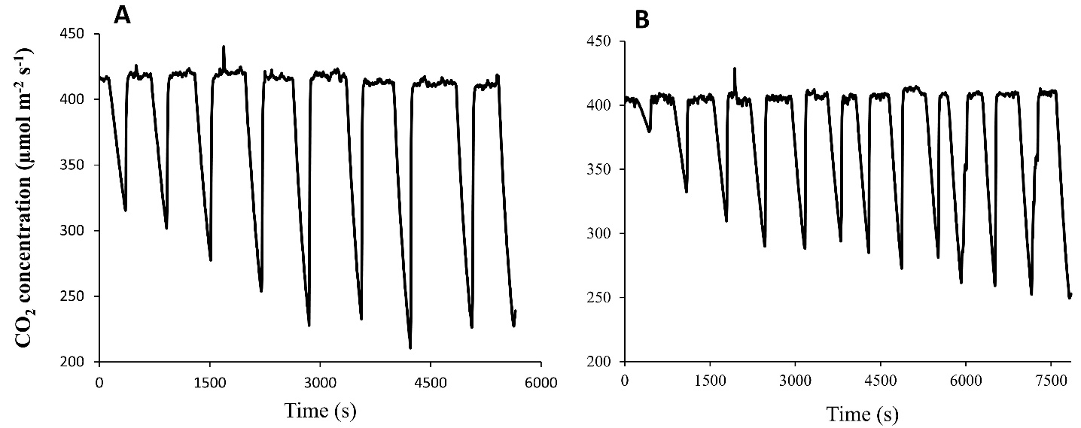

Fig. S1. Changes in CO₂ concentration in (A) barley and (B) wheat canopies inside the chamber at 5-second intervals in the field. The rate of CO₂ uptake by the canopy was calculated based on determining the gradient of changes in CO₂ concentration over time after the cover was closed.

Fig. S2. Changes in gross primary production (GPP) with respect to distinct ranges of photosynthetically active radiation (PAR). (A) GPP changes of barley at the max tillering and heading stages. (B) GPP changes of wheat at the max tillering and grain filling stages.

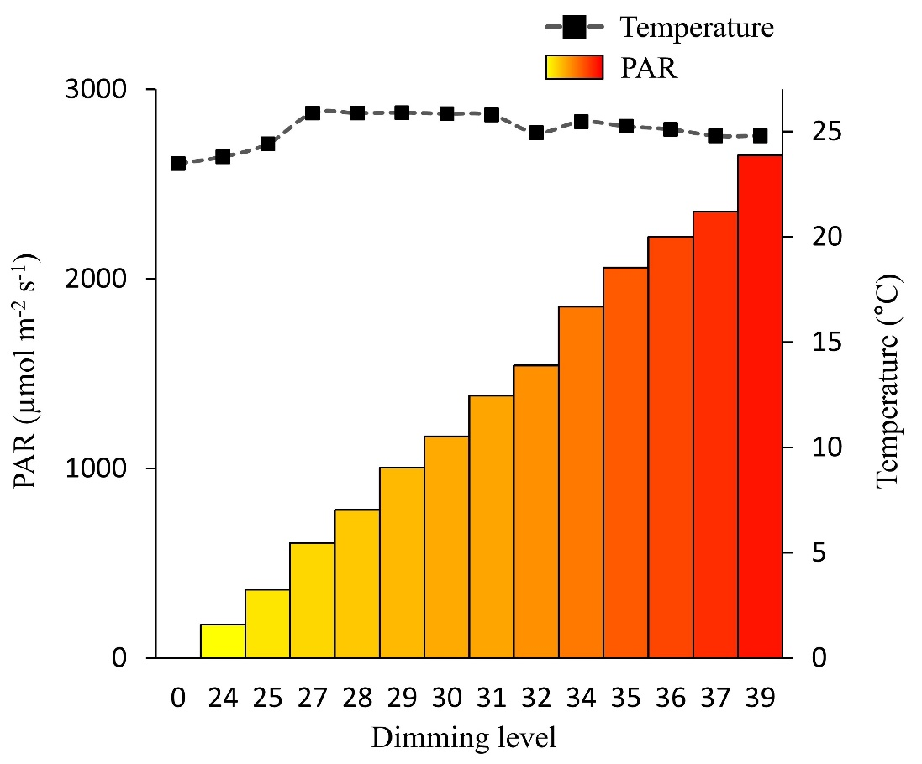

Fig. S3. PAR and temperature changes in the LED chamber in response to the control console operation.

Table S1. Sensor information used to measure environmental variables in the light-emitting diode chamber system.
Variable | Sensor | Input power  (V) | Output power  (V) | Measuring range
CO₂ | Infrared gas analyzer† | 100 to 240 AC | 12 DC | 0-20000 ppm
Air temperature | Thermometer A‡ | 9 DC | N/A | −100 to 1300 ℃
Soil temperature | Thermometer B§ | 9 DC | N/A | −50 to 1300 ℃
PAR* | Quantum sensor¶ | N/A | N/A | 0-3000 µmol
* PAR stands for photosynthetically active radiation. †LI-850 (LI-Cor, Inc., Lincoln, NE, USA). ‡TM-926 (Lutron Electronics, Inc., Coopersburg, PA, USA). §TM-902C (Lutron Electronics, Inc., Coopersburg, PA, USA). ¶LI-190R (LI-Cor, Inc.).

Table S2. CO₂ flux parameters used to calculate net ecosystem exchanges of barley and wheat growth stages.
Parameter | Barley |  |  | Wheat
Parameter | Max tillering | Heading |  | Max tillering | Grain filling
α* | 0.07 | 0.11 |  | 0.06 | 0.03
β† | 45.38 | 64.0 |  | 41.44 | 8.26
γ‡ | 7.08 | 17.11 |  | 6.65 | 5.70
* (µmol CO₂ m⁻² s⁻¹ per µmol photon m⁻² s⁻¹) is the canopy radiation utilization efficiency; †β (µmol CO₂ m⁻² s⁻¹) is the maximum CO₂ uptake rate of the plant canopy; ‡γ (µmol CO₂ m⁻² s⁻¹) is the average ecosystem respiration.

