Supplementary Data
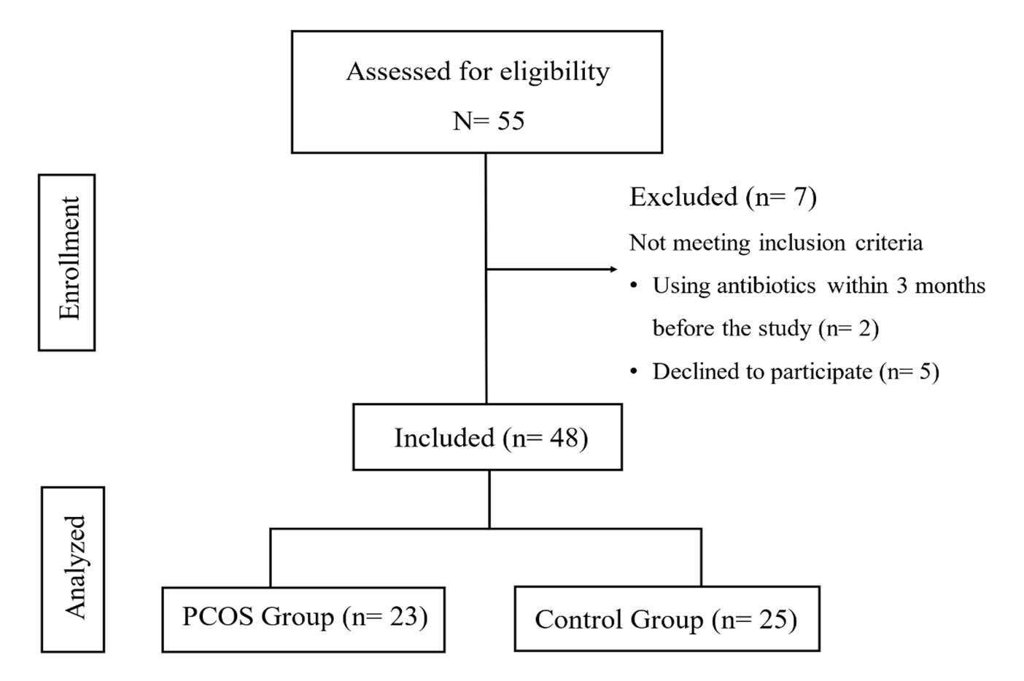
Figure S1 Diagrammatic representation of participant recruitment in the study
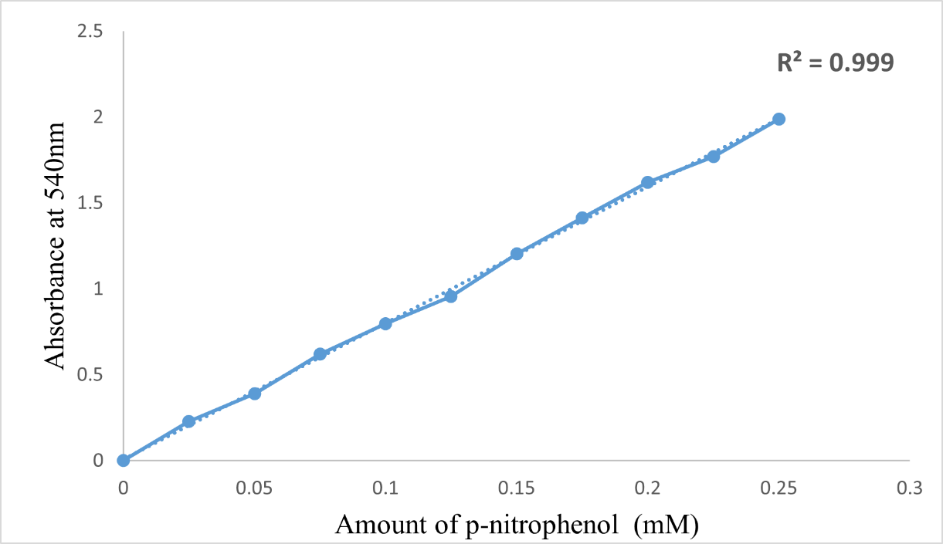
Figure S2 Calibration curve of p-nitrophenol

