Stabilizing High-Humidity Perovskite Solar Cells with MoS₂ Hybrid HTL
Puteri Nor Aznie Fahsyar ^{1,2*}, Norasikin Ahmad Ludin^{2*}, Noor Fadhilah Ramli², Puteri Intan Zulaikha², Suhaila Sepeai², Ahmad Shah Hizam Md Yasir³

¹Clean Technology Impact Laboratory, Taylor’s University, Selangor, Malaysia
²Solar Energy Research Institute, University Kebangsaan Malaysia, Selangor, Malaysia
³Faculty of Resilience, Rabdan Academy, Abu Dhabi, United Arab Emirates

*Corresponding authors: puteri.syedmahadzir@taylors.edu.my; sheekeen@ukm.edu.my

Supplementary documents
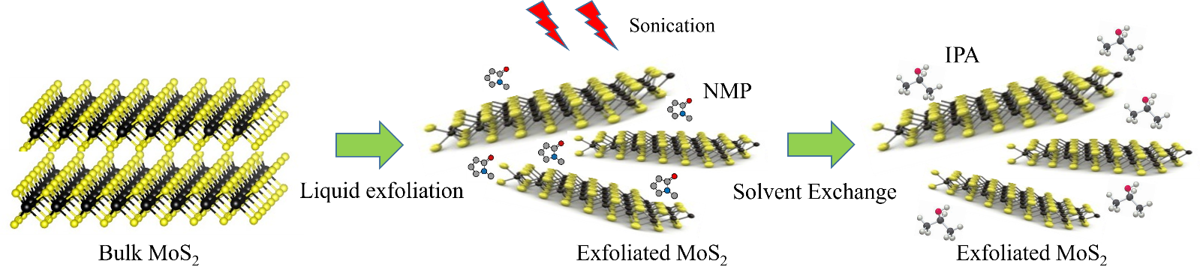
Fig. S1. MoS₂ preparation using liquid exfoliation and solvent exchange process.
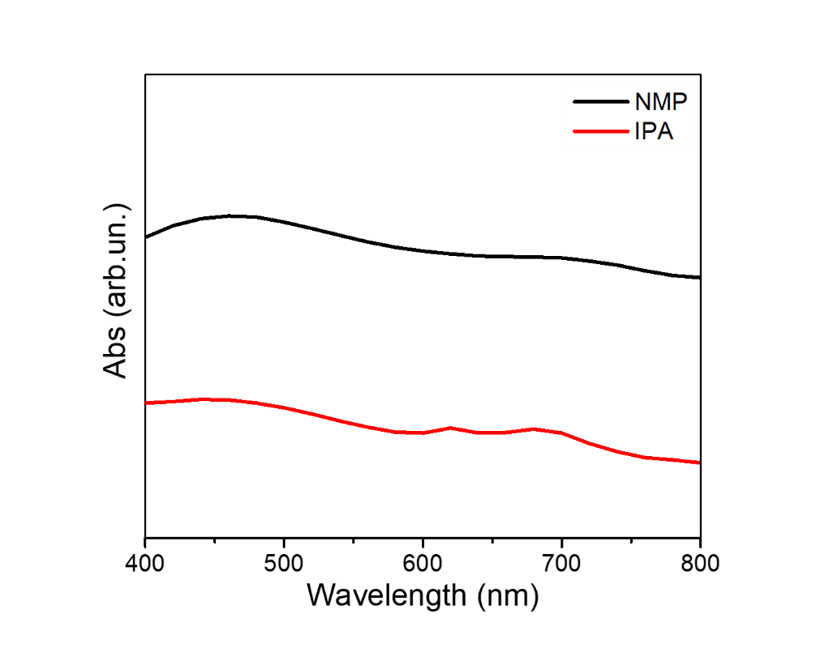
Fig. S2. Absorbance spectra of exfoliated MoS₂ in NMP and IPA

Table S1. The values of all parameters of Raman peak shift.
Sample | E12g (cm-1) | A1g (cm-1) | A1g -E12g (cm-1) | Thickness(nm)
M1 | 381.6 | 404.6 | 23.0 | 9
M2 | 381.1 | 405.1 | 24.0 | 29
M3 | 380.6 | 405.6 | 25.0 | 45
M4 | 380.1 | 406.5 | 26.4 | 65

Table S2. Summary of the bandgap for different concentrations of MoS_{2.}
Sample | Eg, eV
M0 | 1.59
M1 | 1.59
M2 | 1.58
M3 | 1.60
M4 | 1.61

Table S3. The values of all parameters of the fitted curves in the Nyquist plot.
Sample | R_{S} (Ω) | CPE₁ (F) | R_{CT} (Ω) | CPE₂ (F) | R_{Rec} (Ω)
M0 | 72.67 | 7.948x10⁻⁷ | 223.27 | 5.440x10⁻⁵ | 368.7
M1 | 62.46 | 9.159x10⁻⁷ | 280.7 | 9.101x10⁻⁴ | 1026
M2 | 45.81 | 2.310x10⁻⁷ | 183.4 | 1.720x10⁻⁴ | 3983.5
M3 | 111.22 | 6.847x10⁻⁸ | 390.4 | 5.430x10⁻⁵ | 874.6
M4 | 145.58 | 1.184x10⁻⁶ | 588.56 | 1.523x10⁻⁴ | 5944

Table S4. Photovoltaic-performance parameters for M0 samples under 1 sun illumination (AM 1.5G, 100 mW cm⁻²) for PSC device at reverse scan direction.
Time (hours) | J_{sc} (mA/cm²) | V_{oc} (V) | FF | PCE (%)
0 | 16.6 | 0.92 | 0.54 | 8.3
24 | 15.8 | 0.83 | 0.54 | 7.1
48 | 15.0 | 0.80 | 0.52 | 6.3
72 | 14.3 | 0.77 | 0.38 | 4.2
96 | 10.6 | 0.70 | 0.27 | 2.0
120 | 8.1 | 0.61 | 0.24 | 1.2

Table S5. Photovoltaic-performance parameters for M1 samples under 1 sun illumination (AM 1.5G, 100 mW cm⁻²) for PSC device at reverse scan direction.
Time (hours) | J_{sc} (mA/cm²) | V_{oc} (V) | FF | PCE (%)
0 | 16.8 | 0.94 | 0.54 | 8.7
24 | 16.0 | 0.89 | 0.53 | 7.5
48 | 15.6 | 0.82 | 0.53 | 6.8
72 | 13.8 | 0.76 | 0.50 | 5.1
96 | 13.1 | 0.72 | 0.49 | 4.7
120 | 10.6 | 0.66 | 0.46 | 3.2

Table S6. Photovoltaic-performance parameters for M2 samples under 1 sun illumination (AM 1.5G, 100 mW cm⁻²) for PSC device at reverse scan direction.
Time (hours) | J_{sc} (mA/cm²) | V_{oc} (V) | FF | PCE (%)
0 | 17.2 | 0.97 | 0.57 | 9.5
24 | 16.8 | 0.91 | 0.57 | 8.7
48 | 15.7 | 0.87 | 0.57 | 7.9
72 | 15.2 | 0.82 | 0.57 | 7.1
96 | 14.8 | 0.78 | 0.56 | 6.5
120 | 14.0 | 0.68 | 0.55 | 5.2

Table S7. Photovoltaic-performance parameters for M3 samples under 1 sun illumination (AM 1.5G, 100 mW cm⁻²) for PSC device at reverse scan direction.
Time (hours) | J_{sc} (mA/cm²) | V_{oc} (V) | FF | PCE (%)
0 | 14.5 | 0.97 | 0.53 | 7.6
24 | 13.7 | 0.95 | 0.53 | 7.0
48 | 12.6 | 0.92 | 0.51 | 5.9
72 | 11.5 | 0.88 | 0.49 | 5.0
96 | 11.2 | 0.86 | 0.49 | 4.9
120 | 10.8 | 0.81 | 0.49 | 4.6

Table S8. Photovoltaic-performance parameters for M4 samples under 1 sun illumination (AM 1.5G, 100 mW cm⁻²) for PSC device at reverse scan direction.
Time (hours) | J_{sc} (mA/cm²) | V_{oc} (V) | FF | PCE (%)
0 | 14.2 | 0.97 | 0.50 | 6.9
24 | 13.1 | 0.94 | 0.49 | 6.0
48 | 12.4 | 0.90 | 0.47 | 5.1
72 | 11.9 | 0.87 | 0.47 | 4.9
96 | 10.9 | 0.85 | 0.47 | 4.5
120 | 10.5 | 0.84 | 0.47 | 4.3

