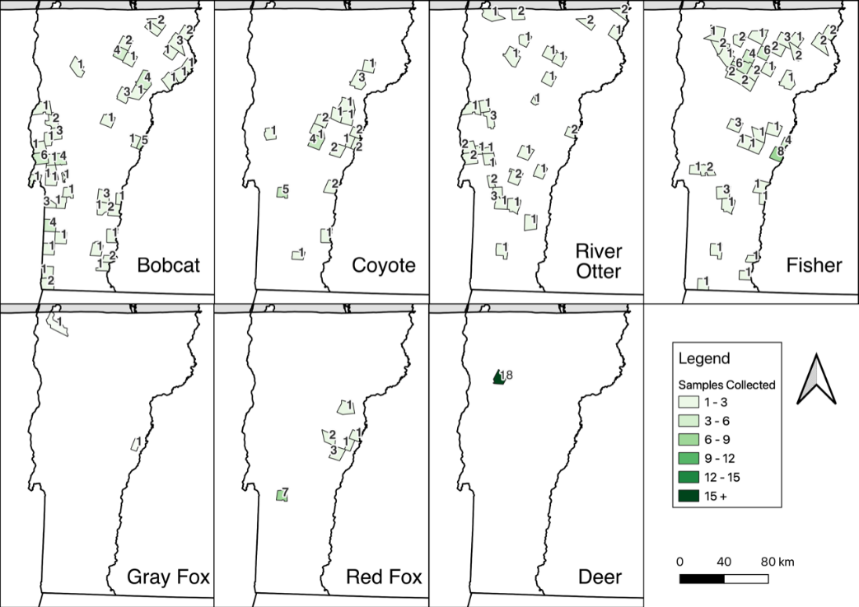
Supplemental Figures
Supplemental Figure 1. Geographic distribution of 2021 sample collection by species. Graphs were generated using QGIS version 3.28.2 (Firenze) https://qgis.org/.
.

Supplemental Figure 2: Power to Detect a Given Prevalence. Using the binomial distribution for 472 trials (the number of deer samples collected in the 2022 hunting season), we calculated the probability of at least one success (SARS-CoV-2 detection) as a function of the unknown underlying SARS-CoV-2 prevalence (percent positivity).

