RAW Western Blots
Images exported from Licor Odyssey Fc were quantified using Licor Image Studio Lite v5.2 analysis software.

Figure 3B 3GPa
Membrane A

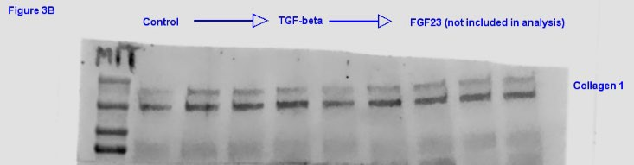
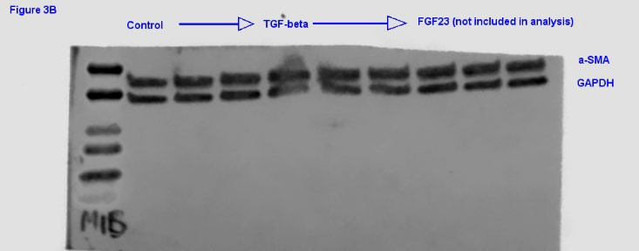

250 kDa
150 kDa
100 kDa
75 kDa

50 kDa
37 kDa

25 kDa
20 kDa
15 kDa
10 kDa

250 kDa

150 kDa
100 kDa
75 kDa
Membrane B
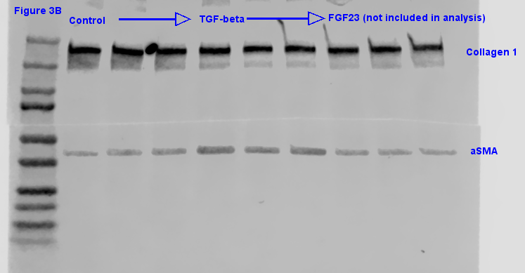

50 kDa
37 kDa

25 kDa
20 kDa
15 kDa

50 kDa
37 kDa

25 kDa
20 kDa
15 kDa
10 kDa
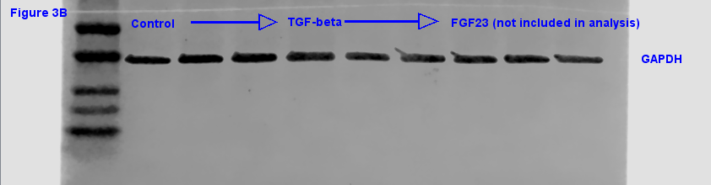

Membrane C

50 kDa
37 kDa

25 kDa
20 kDa

15 kDa
10 kDa
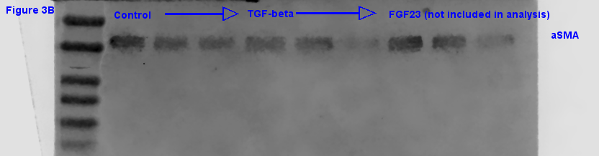

50 kDa
37 kDa

25 kDa
20 kDa
15 kDa

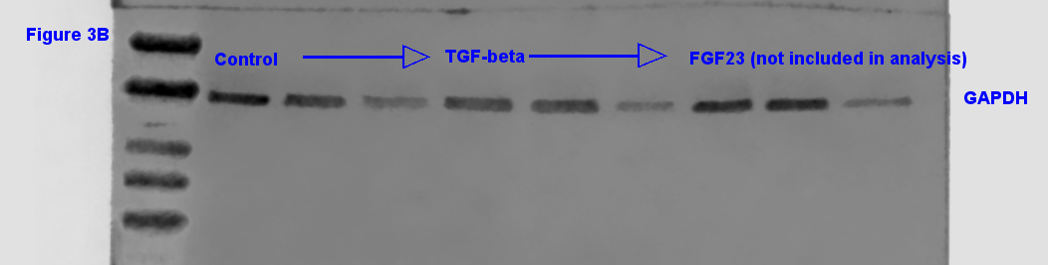

Figure 4B 25kPa
Membrane A
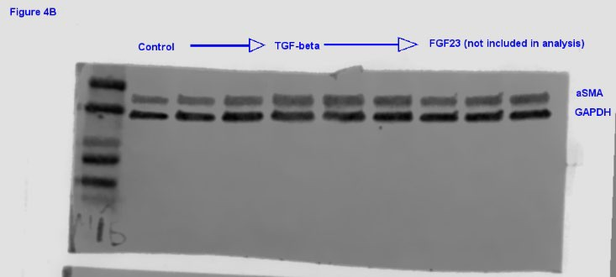
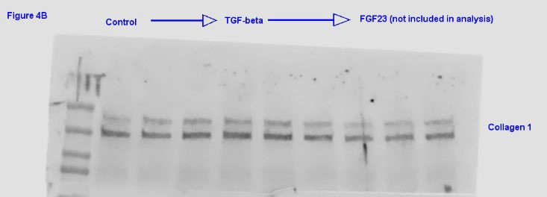

50 kDa
37 kDa
25 kDa
20 kDa
15 kDa
10 kDa

250 kDa
150 kDa
100 kDa
75 kDa

Membrane B
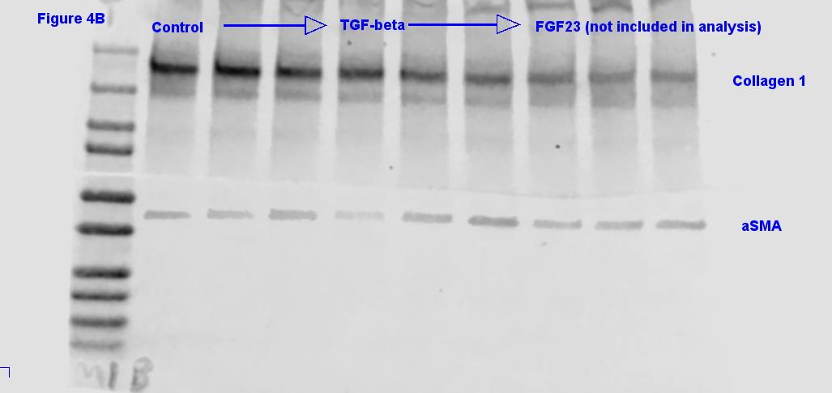

50 kDa
37 kDa

25 kDa
20 kDa
15 kDa
10 kDa

250 kDa
150 kDa

100 kDa
75 kDa

50 kDa
37 kDa

25 kDa
20 kDa
15 kDa
10 kDa

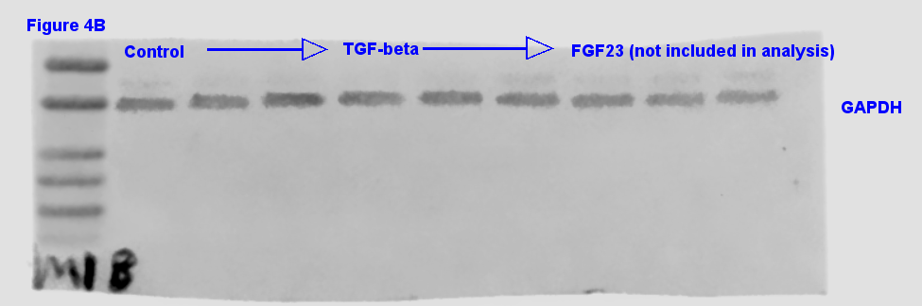

Membrane C
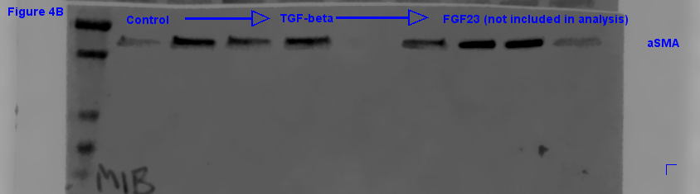

50 kDa

37 kDa

25 kDa

20 kDa
15 kDa

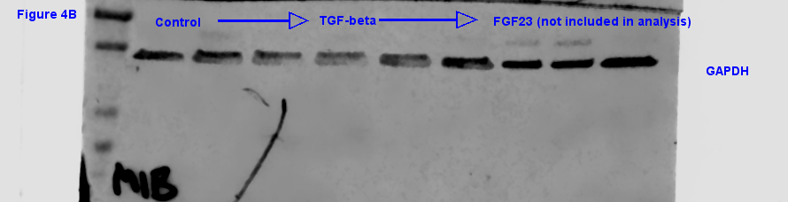

50 kDa
37 kDa

25 kDa

20 kDa

15 kDa

Figure 4B 25kPa continued
Membrane D
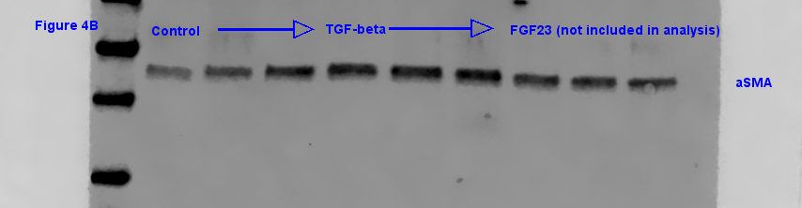

50 kDa

37 kDa

20 kDa

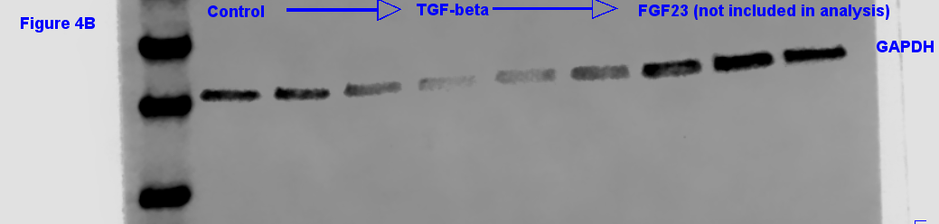

50 kDa

37 kDa

20 kDa

Figure 5B 2kPa
Membrane A
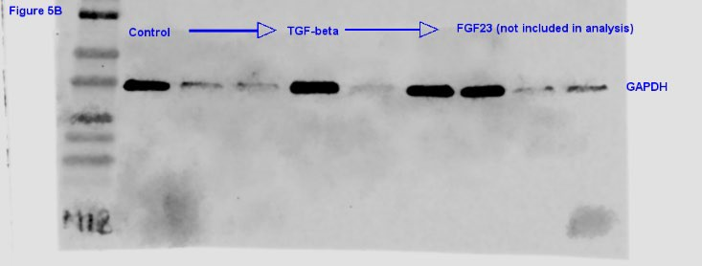
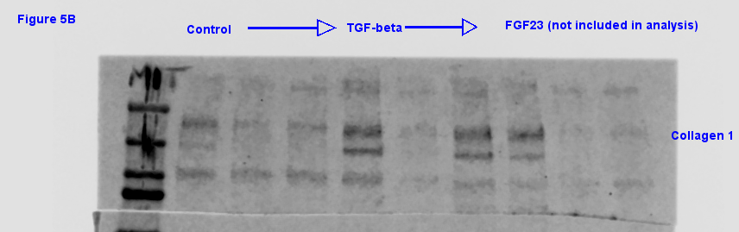
50 kDa
37 kDa
25 kDa
20 kDa
15 kDa
10 kDa
250 kDa
150 kDa

100 kDa
75 kDa

Membrane B
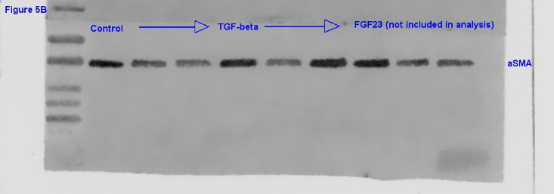

50 kDa
37 kDa
25 kDa
20 kDa
15 kDa
10 kDa
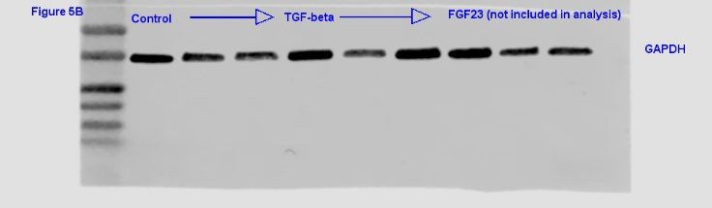
50 kDa
37 kDa
25 kDa
20 kDa
15 kDa
10 kDa

Membrane C
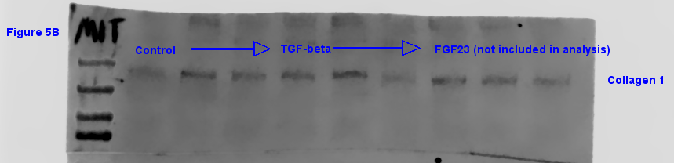
250 kDa
150 kDa

100 kDa
75 kDa
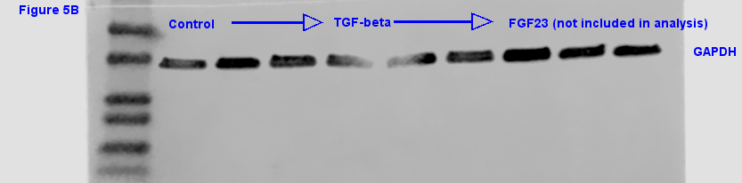
50 kDa
37 kDa

25 kDa
20 kDa
15 kDa
10 kDa

Membrane D
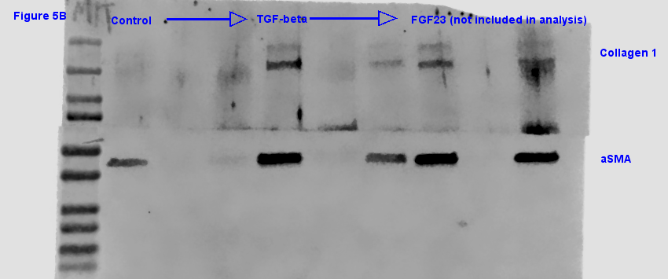
50 kDa
37 kDa

25 kDa
20 kDa
15 kDa
10 kDa
250 kDa
150 kDa

100 kDa
75 kDa
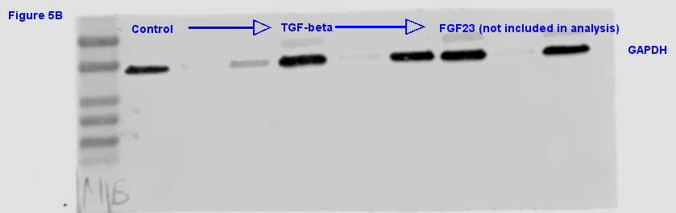
50 kDa
37 kDa

25 kDa
20 kDa
15 kDa
10 kDa

