Supplemental data
Table S1. Case number and proportion of lung cancer in males and females during 2001-2019.
Year | Total | Males  n(%) | Female  n(5)
2001 | 195,939 | 109,982(56.1) | 85,957(43.9)
2002 | 198,954 | 110,710(55.6) | 88,244(44.4)
2003 | 205,126 | 113,965(55.6) | 91,161(44.4)
2004 | 206,287 | 113,844(55.2) | 92,443(44.8)
2005 | 210,777 | 115,095(54.6) | 95,682(45.4)
2006 | 211,828 | 114,898(54.2) | 96,930(45.8)
2007 | 213,532 | 115,449(54.1) | 98,083(45.9)
2008 | 216,462 | 116,390(53.8) | 100,072(46.2)
2009 | 217,401 | 116,387(53.5) | 101,014(46.5)
2010 | 214,637 | 114,564(53.4) | 100,073(46.6)
2011 | 215,055 | 114,516(53.2) | 100,539(46.8)
2012 | 217,981 | 115,249(52.9) | 102,732(47.1)
2013 | 219,583 | 115,677(52.7) | 103,906(47.3)
2014 | 221,587 | 116,371(52.5) | 105,216(47.5)
2015 | 224,815 | 116,957(52) | 107,858(48)
2016 | 224,995 | 116,594(51.8) | 108,401(48.2)
2017 | 226,950 | 116,628(51.4) | 110,322(48.6)
2018 | 223,429 | 113,711(50.9) | 109,718(49.1)
2019 | 221,097 | 112,003(50.7) | 109,094(49.3)
Total | 4,086,435 | 2,178,990(53.3) | 1,907,445(46.7)

Figure S1. Female to male of rate ratio among age groups during 2001-2019.
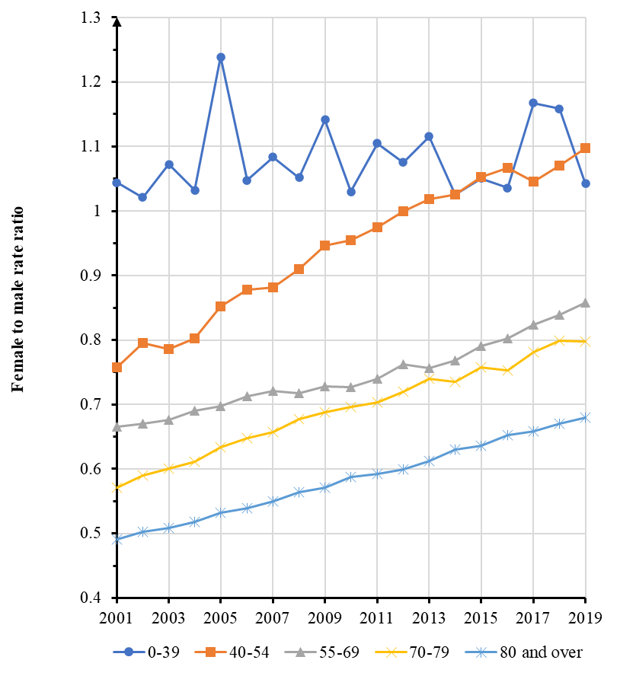

Figure S2. Female to male of rate ratio among races during 2001-2019. AIAN: non-Hispanic American Indian and Alaska Native; API: non-Hispanic Asian or Pacific Islander; NHB: non-Hispanic black; NHW: non-Hispanic white.
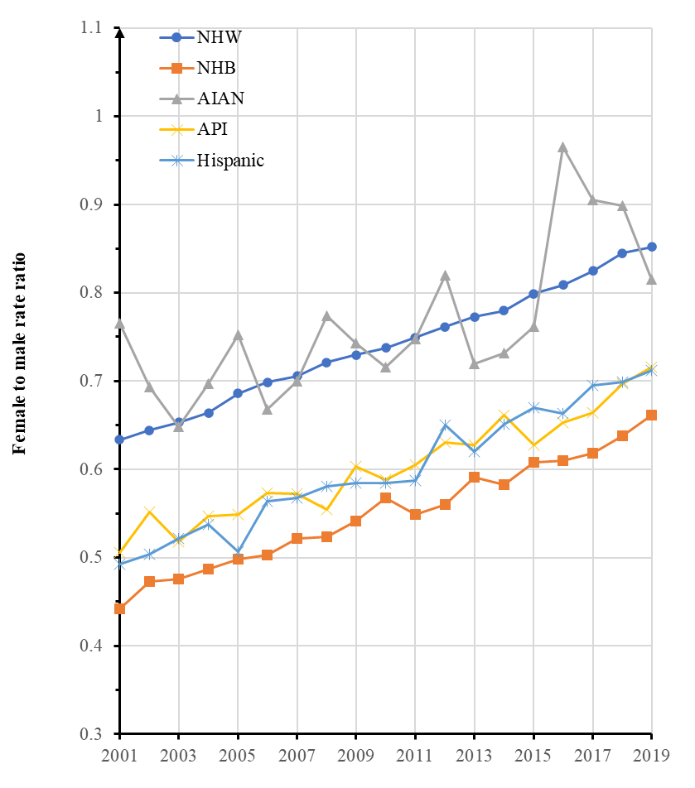

Figure S3. Female to male of rate ratio among regions during 2001-2019.
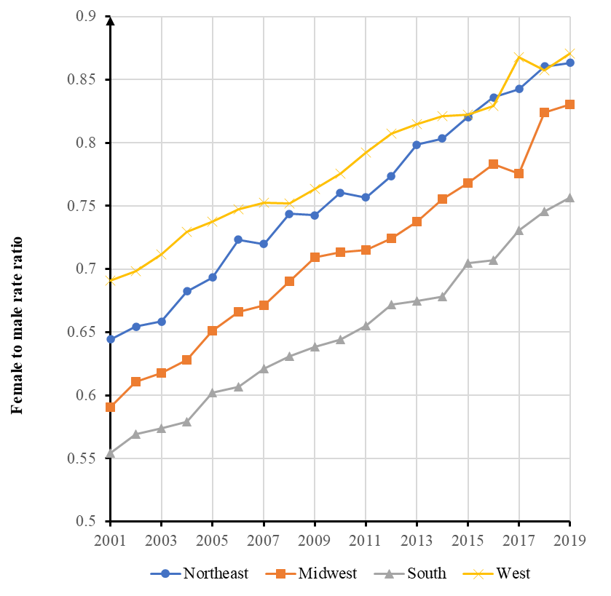

Figure S4. Female to male rate ratio among major histological types during 2001-2019.
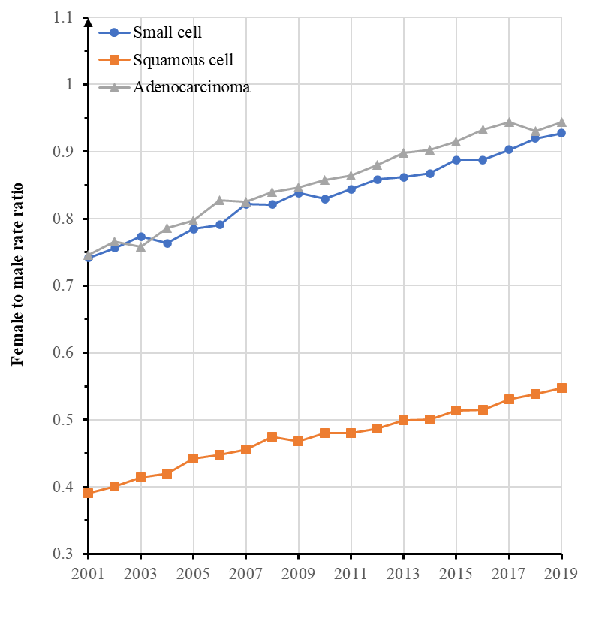

Figure S5. Female to male of rate ratio among races aged 0-54 years during 2001-2019. AIAN: non-Hispanic American Indian and Alaska Native; API: non-Hispanic Asian or Pacific Islander; NHB: non-Hispanic black; NHW: non-Hispanic white.
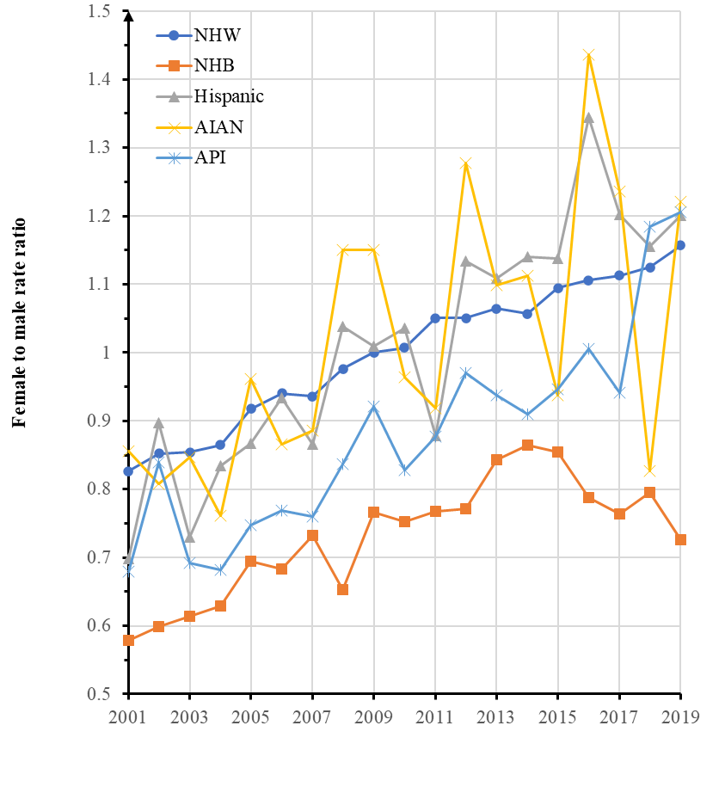

Figure S6. Female to male of rate ratio among regions aged 0-54 years during 2001-2019.
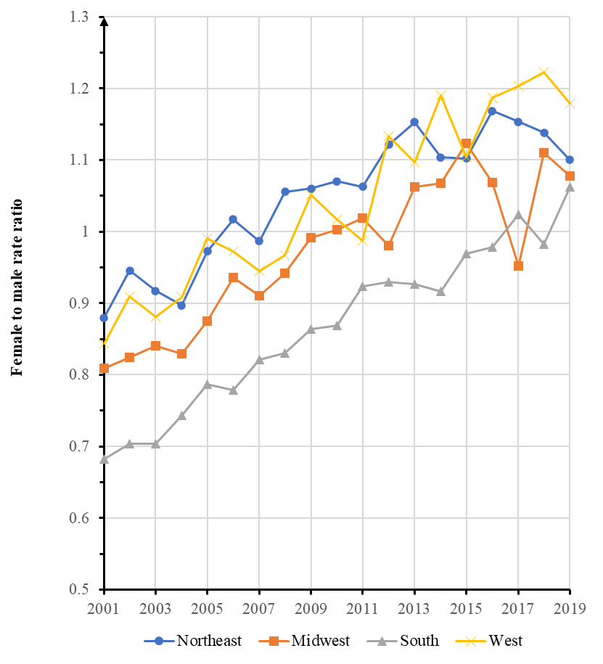

Figure S7. Female to male rate ratio among histological types aged 0-54 years during 2001-2019.
