Table S1. Trimming results of FASTQ file obtained by Trimmomatic software.
Samples | Total reads | Total paired reads | Forward unpaired reads (removed) | Reverse unpaired reads  (removed)
Sample 1 | 25,590,414 | 25,590,361 | 17 | 36
Sample 2 | 24,336,138 | 24,336,067 | 52 | 19
Sample 3 | 23,569,775 | 23,569,741 | 28 | 6
Sample 4 | 24,238,704 | 24,238,647 | 42 | 15

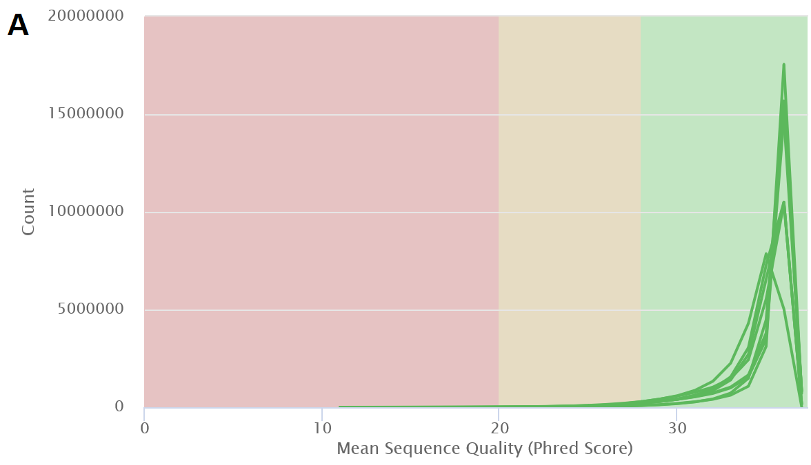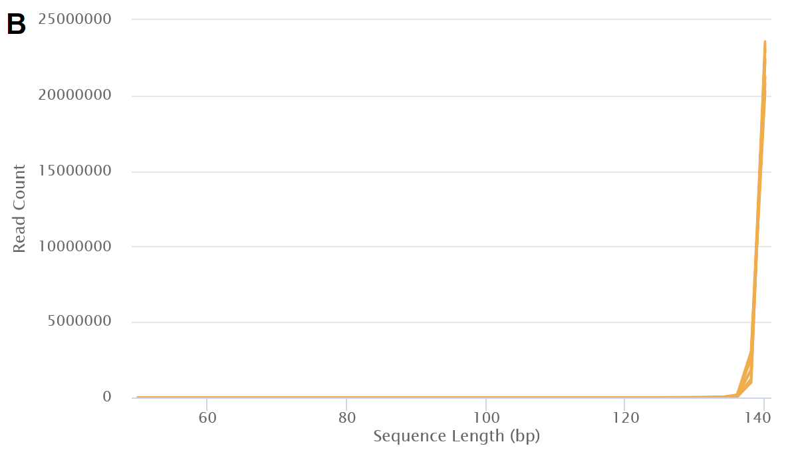
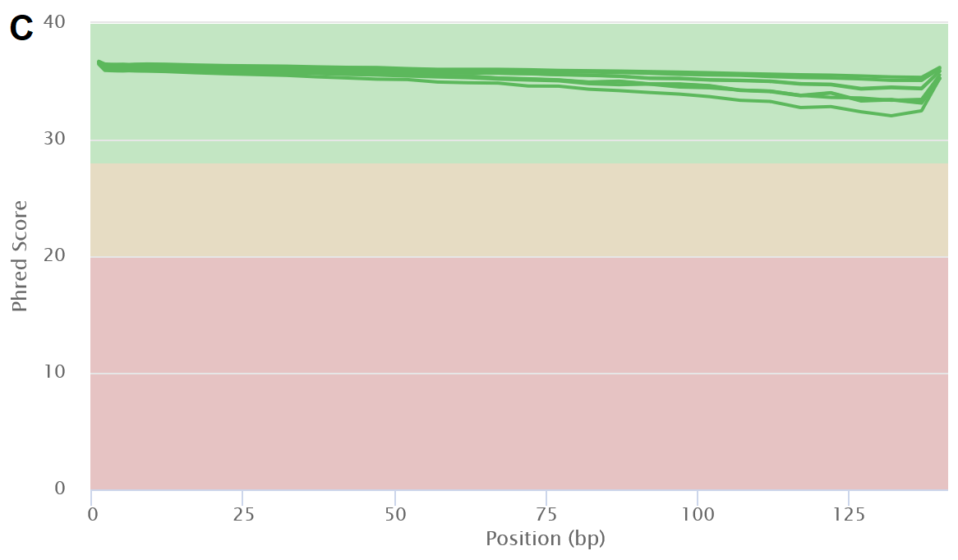
Fig S1. Multi-FASTQ quality check results for the trimmed RNA-Seq data related to reverse and forward files of experimental samples. (A) Per sequence quality scores. (B). Sequence length Distribution (C). Mean quality scores.

Fig S2. Gene ontology classification of EvidentialGene results as the best performance transcriptome assembler.

Fig S3. Gene ontology classification of EvidentialGene results as the best performance transcriptome assembler.

