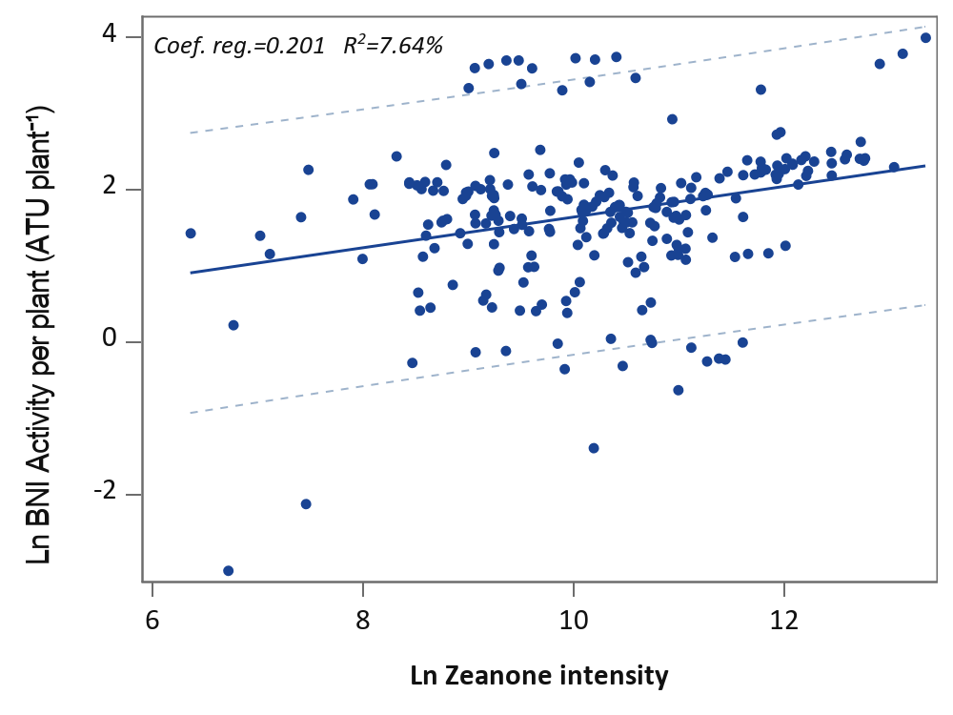
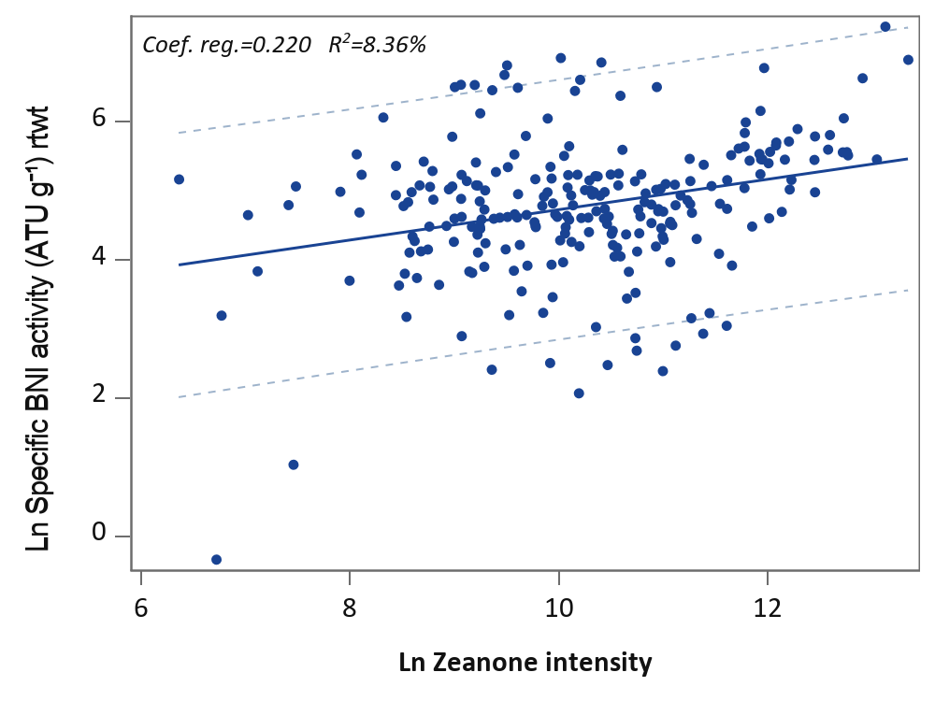

Fig. S1 Linear simple regression of the CML mean natural logarithms of Zeanone with BNI per plant (BNIPP) and Specific BNI (SBNI). Dotted line is the 95% confidence interval for one individual (one CML). Coef. Re.: linear coefficient of regression, R²: square of the correlation coefficient

