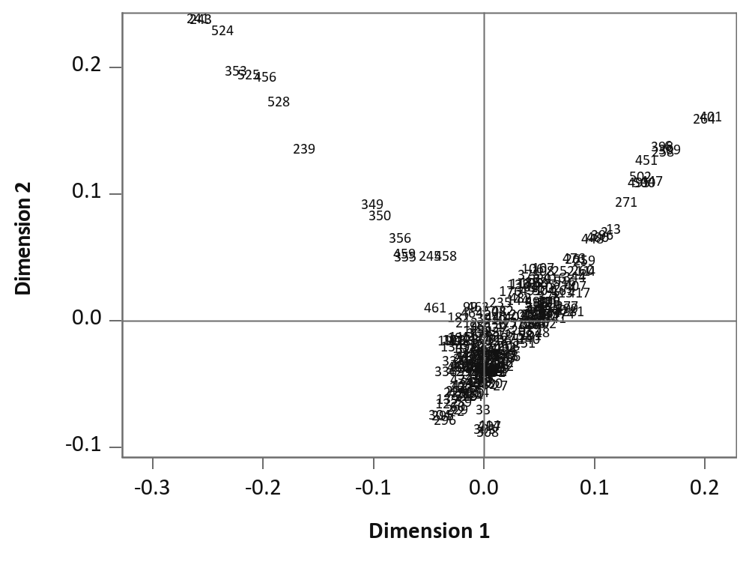
Fig. S4 Two first dimensions of multidimensional scaling using representation of the modified Roger distance between 250 CMLs. Numbers represent the original number of each CML. There is not a clear clustering effect on the analyzed set of samples

