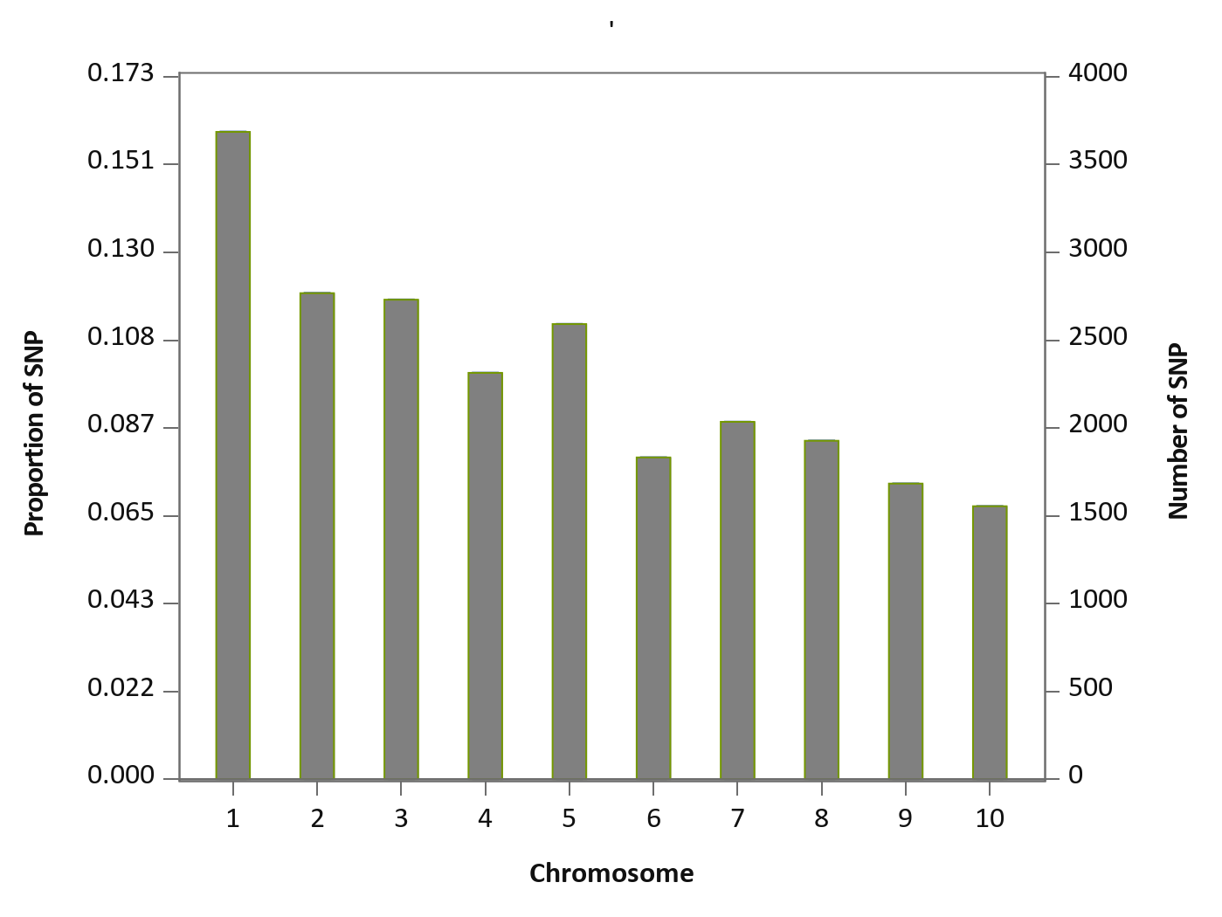
Fig. S5 SNPs density on each chromosome of the reference genome (B73 RefGen v4)

