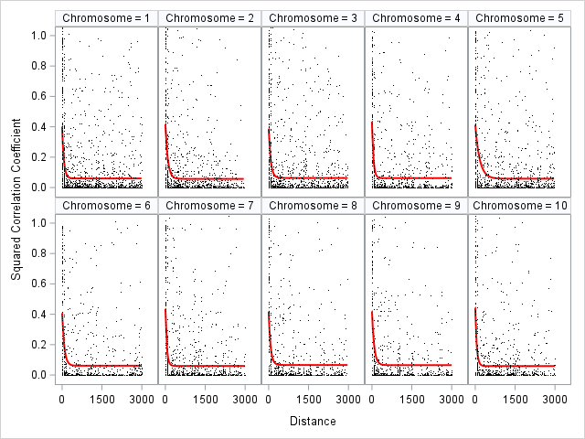
Fig. S6 LD decay analysis by chromosome. The red line represents the fitted curve SRC=a+b*log(distance)+e. Distances are represented in Mbp.

