Supplementary file 1

S1a. Feeding test
The feeding system was tested on Aedes albopictus in cages and BG traps placed in insectary (14:10 light-dark; 70±10% RH; 26±2°C), to assess the mosquitoes’ ability to take a sugar meal and estimate the sugar feeding rate on the FTA cards. Methylene blue, a dye with low toxicity for mosquitoes, was added to the sugar solution to identify fed specimens after feeding on the FTA card. To allow a gradual release of solution over the time, hydroxy-ethyl cellulose (HEC), a colloidal mixture of polymers with the feature of absorbing large quantities of water (over 90-95%), was also added. Under insectary conditions all the FTA cards inserted in feeders remained moist for over a week, reducing the volume of solution up to 50% without drying.
Different sugar delivery systems were tested in BG traps (Tab. S1):
- 0.5cm height x 6cm ∅ petri dish (VWR International S.r.l., Italy), containing 4.7ml of solution;
- 1cm height x 2cm ∅ PE-HD stopper, containing 1.6ml of solution;
- 1.7cm x 12cm 15ml Falcon tube (15ml, Thermo Fisher Scientific Inc., USA) with sponge, containing 5ml of solution;
- 1.7cm x 12cm Falcon tube (15ml, Thermo Fisher Scientific Inc., USA), containing 5ml of solution;
Sugar solutions (honey/30% sucrose with HEC -see main manuscript for manufacturer details- at 2%, 5%, 8%, 10% at the following proportions: 1:1, 1:3, 3:2).
The highest feeding rate in BG trap (58%) was achieved with FTA-card partially soaked in a solution based on honey and 2% HEC in 3:2 proportion, inserted in a 15ml tube.

Delivery system/solution | N mosquitoes | mean % fed | N tests
∅ 6cm petri dish with filter paper | 778 | 40% | 27
Cage | 778 | 40% | 27
8% HEC + Honey (1:1) | 62 | 0% | 3
10% HEC + 30% Honey (1:1) | 41 | 5% | 2
10% HEC + Honey (1:3) | 427 | 12% | 11
5 % HEC + Honey (3:2) | 248 | 86% | 11
∅ 6cm petri dish with FTA-card | 71 | 21% | 4
Cage | 34 | 43% | 2
8% HEC + Honey (3:2) | 34 | 43% | 2
BGS | 37 | 0% | 2
5% HEC + Honey (3:2) | 19 | 0% | 1
8% HEC + Honey (3:2) | 18 | 0% | 1
∅ 2cm stopper with FTA-card | 120 | 12% | 8
Cage | 20 | 9% | 2
2% HEC + 30% sucrose | 9 | 0% | 1
2% HEC + Honey (3:2) | 11 | 18% | 1
BGS | 100 | 13% | 6
5% HEC + Honey (3:2) | 89 | 1% | 4
HEC 2% + Honey (3:2) | 6 | 33% | 1
HEC 2% + 30% sucrose | 5 | 40% | 1
15ml tube with FTA-card and sponge | 341 | 12% | 8
Cage | 236 | 2% | 4
2% HEC + Honey (3:2) | 118 | 2% | 2
2% HEC + 30% sucrose | 118 | 2% | 2
BG | 105 | 23% | 4
2% HEC + 30% sucrose | 51 | 20% | 2
2% HEC + Honey (3:2) | 54 | 26% | 2
15ml tube with FTA-card | 940 | 42% | 36
Cage | 469 | 23% | 14
2% HEC + Honey (3:2) | 240 | 22% | 7
2% HEC + 30% sucrose | 229 | 24% | 7
BG | 471 | 54% | 22
2% HEC + 30% sucrose | 140 | 46% | 7
2% HEC + Honey (3:2) | 331 | 58% | 15
Total | 2250 | 35% | 83

Table S1. Sugar feeding tests performed with Aedes albopictus using different solutions and delivery systems.

S1b. WNV-1 detection from FTA-card collected at different time points.
WNV-1 CT 678 strain was released on FTA cards at 3.25x10⁵ PFU/ml diluted 1:50 (20µl of seed + 980 µl of dilution buffer) directly spotted on the substrate to obtain a final viral load of 32.5 PFU (5µl + 15µl dilution buffer). Feeders with infected FTA cards were placed in BG traps and collected at different time points (7-, 10- and 15-days post deployment), testing 2 traps outdoors and 1 trap indoors for each time point. RNA extraction and detection of WNV-1 from collected FTA-cards was performed as described in Materials and Methods. All viral RNA from FTA-card was successfully amplified at all time points (Tab. S2, Fig. 1 and 2).

7 days |  | 10 days |  | 15 days
Tm mean | Ct mean | Tm mean | Ct mean | Tm mean | Ct mean
85,12 | 31,28 | 85,10 | 31,21 | 85,15 | 31,57
85,19 | 31,89 | 85,12 | 31,36 | 85,22 | 31,34
85,07 | 31,48 | 85,14 | 31,19 | 85,12 | 30,78
Table S2. Signal parameters of real-time PCR for WNV-1 extracted from FTA cards at different time points . Mean ct values (ct mean) and melting temperature (Tm) of tested samples.

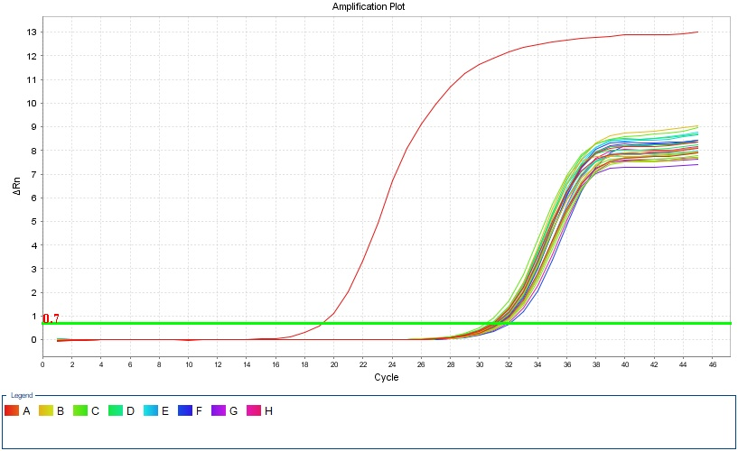

Figure S1- Amplification curve of real-time PCR for WNV-1 extracted from FTA cards at different time points. In red is reported the positive control (field strain of USUV RNA extracted from a cell culture, 2.5* 10^5 TCID50/ml), the other curves represent tested samples and negative control (NTC: No Template Control). All samples were tested in triplicate wells.
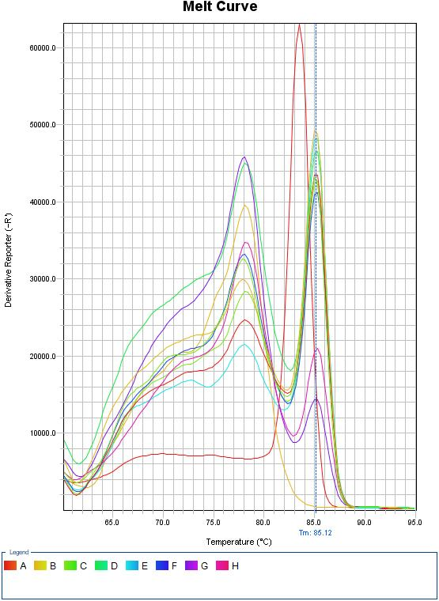
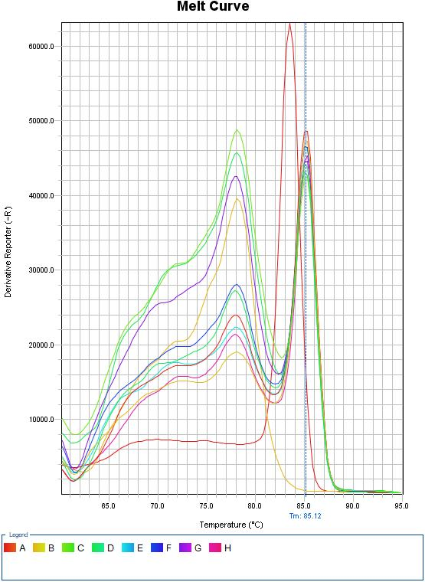
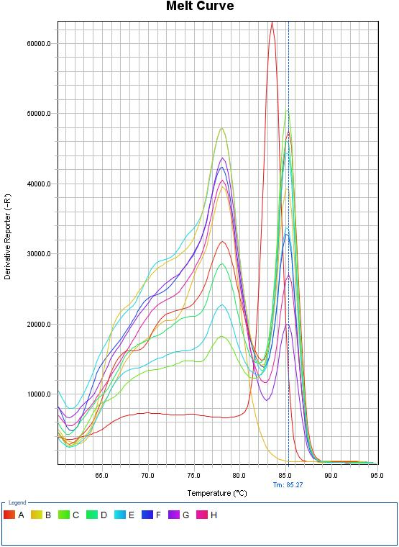
7 days
15 days
10 days

*
*
*

Figure S2 - Melt curve plot. In red is reported the positive control (field strain of USUV RNA extracted from a cell culture, 2.5* 10^5 TCID50/ml), the other curves represent tested samples and negative control (NTC: No Template Control, marked as *). All samples were tested in triplicate wells.

