Supplementary Information for

Fully Fluorinated Non-Carbon Compounds NF₃ and SF₆ as Ideal Technosignature Gases

Sara Seager^{1,2,3}, Janusz J. Petkowski^{1,4}, Jingcheng Huang¹, Zhuchang Zhan¹, Sai Ravela¹, William Bains^{1,5}

Affiliations

¹ Department of Earth, Atmospheric and Planetary Sciences, Massachusetts Institute of Technology, 77 Massachusetts Avenue, Cambridge, MA 02139, USA
² Department of Physics, Massachusetts Institute of Technology, 77 Massachusetts Avenue, Cambridge, MA 02139, USA
³ Department of Aeronautics and Astronautics, Massachusetts Institute of Technology, 77 Massachusetts Avenue, Cambridge, MA 02139, USA
⁴ JJ Scientific, 02-792 Warsaw, Poland
⁵ School of Physics and Astronomy, Cardiff University, 4 The Parade, Cardiff CF24 3AA, UK

*Correspondence: seager@mit.edu

SI 1 A Summary of Proposed Technosignature Gases

Multiple studies have examined the detectability of CFCs in exoplanet atmospheres (e.g.,^{1,2}). For instance, ² investigated the detectability of CFC-11 (CCl₃F) and CFC-12 (CCl₂F₂) on TRAPPIST-1e. Assuming a James Webb Space Telescope (JWST) Mid-Infrared Instrument low-resolution spectrometer (MIRI-LRS) noise floor of 10 ppm, they found that present-day Earth abundances of these two CFCs could be detected on TRAPPIST-1e, with about 100 hours of JWST observation time². However, assuming a conservative JWST noise level of 50 ppm, they concluded that even CFCs five times the present-day Earth level would not be detectable by JWST, regardless of the observation time ². In another study, researchers investigated the detectability of CFC-11 (CCl₃F) on an Earth-sized planet transiting a white dwarf star similar to Beta Persei (commonly known as Algol)¹. They found that CFC-11 at an abundance ten times the present Earth level could be detected by JWST with about 1.2 days of observation time¹. While no Earth-sized planets transiting bright white dwarf stars have yet been detected, they remain promising candidates for atmosphere study if they exist and can be discovered.

Other proposed technosignature gases include the simultaneous detection of NH₃ and N₂O in an atmosphere that also contains H₂O, O₂, and CO₂ as a signature of extraterrestrial agriculture³. The gas NO₂ as an atmospheric technosignature has been proposed as a sign of an industrial revolution, specifically combustion engines⁴. These technosignature gases, however, are far from unique as both the planet and life also produces them. Terrestrial agriculture is an exploitation of the biochemistry of Earth, and so its reliance of exogenous sources of NH₃ (as fertilizer) and its production of N₂O might be specific to terrestrial biology, and not a general sign of agriculture. NO₂ from internal combustion engines assumes a very specific technological trajectory for the planet: the widespread use of a specific type of fossil-fuel-powered transport infrastructure rather than, for example, steam- or electric-powered transport.

SI 2 An Overview of NF₃ and SF₆

Both NF₃ and SF₆ are present in Earth’s atmosphere not from intentional release but from leakage from industrial use. Here we summarize the origin and properties of NF₃ and SF₆.

2.1 NF₃ and SF₆ Physical and Chemical Properties

At room temperature, NF₃ is a colorless and non-flammable gas. At room temperature, NF₃ is only slightly soluble in water⁵ and does not react with water or dilute acids^{6–8}. NF₃ is thermodynamically and chemically stable; for example it does not react with most metals below 250 °C^{6,9}, but it can act as a potent yet slow oxidizer⁸.

In recent years, NF₃ has been widely used in the microelectronics and semiconductor industries where it is used as an etchant in producing thin-film-transistor liquid-crystal displays (TFT-LCD), semiconductors, and solar photovoltaic panels (e.g.,^{6,9–12}).

Sulfur hexafluoride (SF₆) is a colorless, non-toxic, and non-flammable gas⁷. At room temperature, SF₆ is almost insoluble in water; the solubility of SF₆ is even lower than that of helium (He), one of the least water-soluble gases⁵ (Figure 6 in the main text). SF₆ is completely chemically inert and non-toxic. At room temperature, it is unreactive towards most metals. It does not react with magnesium (Mg) and copper (Cu) even if they are heated to “red hot” temperatures. It does not react with phosphorus (P) or arsenic (As), nor with hydrochloric acid (HCl), sodium hydroxide (NaOH), or potassium hydroxide (KOH). SF₆ does not decompose even when heated to 500 °C. In addition, SF₆ does not react with liquid water or high-pressure steam. SF₆ will only react with boiling sodium (Na)^{7,13–18}. SF₆’s only toxic effect on mammals, including humans, is when it is breathed in at greater than 80% concentration and so replaces oxygen in inspired air¹⁹.

The main reason behind the chemical stability and unreactivity of SF₆ is a kinetic barrier to its hydrolysis⁷. SF₆ has a unique molecular structure among sulfur-containing compounds. SF₆ is an octahedrally-shaped molecule with six fluorine atoms symmetrically attached to the central sulfur atom (Figure 1 in the main text). As a result, the S atom is sterically shielded by the surrounding F atoms, making it inaccessible to other reacting molecules, e.g., water.

SF₆ is used in a wide variety of industries, including the electrical power industry, semiconductor manufacturing, and the production of aluminum and magnesium, to name a few^{7,20–22}. In the electrical utility industry, SF₆ is often used as an insulating gas in electrical transmission and distribution equipment, such as current/voltage transformers, circuit breakers, switchgear, and capacitors (e.g.,^{7,20,23}). SF₆’s chemical stability, non-flammability, and non-toxicity add to its usefulness as an excellent insulating gas^{7,24}.

As a result of the low reactivity of NF₃ and the chemical inertness of SF₆, once released to the atmosphere these gases have very long residence times.

2.2 A Steady and Rapid Increase of Atmospheric Concentration of SF₆ and NF₃ in an Industrialized World

The widespread use of NF₃ and SF₆ due to their unique advantages and pivotal roles across multiple industries has nonetheless raised concerns about their environmental impact. Both NF₃ and SF₆ are very potent greenhouse gases (e.g.,^{25–27}). NF₃ has a 100-year Global Warming Potential (GWP) of about 16100, while SF₆ has a GWP of about 23500²⁸. NF₃ and SF₆ are more than five orders of magnitude more efficient greenhouse gases than CO₂. Since NF₃ and SF₆ are very stable, they are difficult to break down and remove from the atmosphere, and hence NF₃ and SF₆ have very long atmospheric lifetimes. The atmospheric lifetime of NF₃ is about 500 years, and that of SF₆ is 850 - 3200 years^{28,29}.

Since the use of NF₃ in specialized industry began in the 1970s, and was later used in more wide-spread applications in the electronic industry in the late 1990’s, the amount of atmospheric NF₃ has been rapidly increasing and has doubled every five years since the late 20th century (https://gml.noaa.gov/hats/gases/NF3.html). In contrast to SF₆, NF₃ does not have any known non-human-made source and measurements of air entrapped in ancient ice Antarctica as well as measurements of NF₃ in archived air tanks filled before 1975, i.e., before the introduction of NF₃ to human industry, have resulted in undetectable levels of NF₃. The undetectable levels of NF₃ in pre-industrial samples suggest that background NF₃ levels were essentially zero or no greater than the limit of detection of 0.008 ppt³⁰. The rapid rise in the global atmospheric abundance and projected future demands of human industry place NF₃ as the fastest growing contributor to radiative forcing of all the synthetic greenhouse gases by the mid-XXI century³¹. Lack of detectable pre-industrial NF₃ supports its potential as a technosignature gas and strongly suggests that NF₃ does not have any significant abiotic source.

The increase in atmospheric SF₆ follows the same trend as NF₃. Over the last 70 years, since its first application in industry in 1953, SF₆’s concentration in the troposphere increased dramatically from approx. 0.05 ppt to > 4 ppt (Figure 2 in the main text)³².

There is limited atmospheric chemistry reactivity data for NF₃ and SF₆ with potential destruction pathways possibly unknown. The known rates show very low reaction rates with the dominant atmospheric radical OH, and the only significant rates are for gases of low atmosphere abundance (Tables S1 and S2).

SI 3 Other Fully Fluorinated Non-Carbon Molecules?

Given how compelling NF₃ and SF₆ are as technosignature gases, one should ask if other volatile fully fluorinated molecules are equally promising as technosignature gases.

Other fully fluorinated human-made gases do exist and are worth further exploration as technosignature gases because they do not exist in nature. However, there are a limited number of possibilities, and the ones that have been synthesized have limited data (e.g., reactivity, water solubility, or gas phase spectral feature information). The list includes PF₃, P₂F₄, SeF₆, or S₂F₁₀ (Table 1)³³. Out of the list of possibilities (Table S3), SiF₄ is made by Earth’s volcanoes and therefore not a suitable technosignature gas (see 5.3) and PF₃ slowly hydrolyzes in water. Despite its reactivity to water, PF₃ is worth further exploration, but so far, perhaps because it is not useful for industry, there is almost no spectral or any other relevant information on its potential as a technosignature gas. The other gas candidates listed in Table S3 are all highly reactive in water and not worth further comment, except to note that for some gases life does produce the hydrogenated versions, such as NH₃, H₂S, PH₃, GeH₄, but never partially fluorinated versions.

Reactants | Products | Rate Law [cm³/molecule s] | Valid Temperature  Range [K] | Rate at 298K | Source | Note
NF₃ + N | NF₂ + NF | 2.13x10-12 (T/298)^{1.97} exp(-15154.3/T) | 200 - 4000 | 1.98x10⁻³⁴ | NIST
NF₃ | NF₂ + F | 6.81x10⁻⁸ exp(-24174.7/T) | 1100 - 1800 | N/A | NIST | High temp rxn
OH + NF₃ | F + H₂O + NO₂ | <4.0x10⁻¹⁶ | 298 | 4.0×10⁻¹⁶ | NIST | Products unknown
CF₃ + NF₃ | CF₃NF₂ + F | 1.99x10⁻¹⁴ exp(-3740.5/T) | 303 - 423 | N/A | NIST
CH₃ + NF₃ | CH₃F₂N + F | 7.09x10⁻¹⁴ exp(-4899.9/T) | 374 - 467 | N/A | NIST
C₂H₅ + NF₃ | C₂H₅F₂N + F | 2.41x10⁻¹¹ exp(-8300/T) | 410 - 486 | N/A | NIST
O(1D) + NF₃ | NF₂ + OF | 1.1x10⁻¹¹ | 298 | 1.1×10⁻¹¹ | NIST
O(1D) + NF₃ | O(3P) + NF₃ | 1.40x10⁻¹² exp(44/T) | 199 - 356 | 2.3×10⁻¹¹ | JPL 19-5
O(1D) + NF₃ | Products | 1.86x10⁻¹¹ exp(44/T) | 199 - 356 | 2.3×10⁻¹¹ | JPL 19-5 | Products unknown
Table S1. Potential NF₃ atmospheric destruction pathways.

Reactants | Products | Rate Law [cm3/molecule s] | Valid Temperature  Range [K] | Rate at 298K | Source | Note
SF₆ + H | HF + SF₅ | 3.32x10⁻⁹ exp(-15154.3/T) | 1460 - 1700 | N/A | NIST | High temp rxn
SF₆ + CCl | Products | 2.41x10⁻¹⁴ | 298 | 2.41×10⁻¹⁴ | NIST | Products unknown
SF₆ + CH | Products | <5.0x10⁻¹⁷ | 297 | N/A | NIST | Products unknown
SF₆ | SF5 + F | 3.38x10¹⁷ (T/298)^-1.90 exp(-50754.9/T) | 1700 - 2000 | N/A | NIST | First-order reaction; Unit: [s-1]
CF₃ + SF₆ | CF₄ + SF₅ | 1.66x10⁻¹³ exp(-10100.5/T) | 303 - 638 | N/A | NIST
CH₃ + SF₆ | CH₃F + SF₅ | 3.32x10⁻¹¹ exp(-7099.7/T) | 413 - 443 | N/A | NIST
O(1D) + SF₆ | O(1D) + SF₆ | 1.79x10⁻¹⁴ | 298 | 1.79×10⁻¹⁴ | NIST
O(1D) + SF₆ | O(1D) + SF₆ | N/A |  | 1.80×10⁻¹⁴ | JPL 19-5
Table S2. Potential SF₆ atmospheric destruction pathways.

Atom | Formula | Name | Boiling Point | Phase (at STP)
B | BF₃ | Boron Trifluoride | −100.3 | gas
B | B₂F₄ | Diboron Tetrafluoride | −34 | gas
Si | SiF₄ | Silicon Tetrafluoride | −90.3 | gas
Ge | GeF₄ | Germanium Tetrafluoride | −36.5 | gas
N | NF₃ | Nitrogen Trifluoride | −128.75 | gas
P | PF₃ | Phosphorus Trifluoride | −101.8 | gas
P | P₂F₄ | Diphosphorus Tetrafluoride | −6.2 | gas
As | AsF₃ | Arsenic Trifluoride | 57.8 | liquid
S | SF₆ | Sulfur Hexafluoride | −50.8 | gas
Se | SeF₆ | Selenium Hexafluoride | −34.5 | gas

Table S3. Fully fluorinated molecules and their physical and chemical properties. STP is standard temperature and pressure.

SI 4 Thermodynamics of Volcanic SF₆ and NF₃ Formation

We have estimated the amount of SiF₄, SF₆ and NF₃ that could be volcanically produced under a variety of atmospheric conditions. The conditions are those at which the gas erupts, and so is rapidly thermodynamically quenched into low temperature atmosphere, not necessarily conditions in the atmosphere. Below we show the analysis of all combinations of the following conditions:
- Temperature from 500K to 1500K in 100K steps
- 8 mineral redox buffers (QIF, IW, WM, IM, CoCoO, FMQ, NiNiO, MH)
- Abundance of water from 5% to 90% in 5% steps
- Pressure of 1, 10, 100, 1000, 10,000, 100,000 bar
- total gas sulfur content of 0.001, 0.01 or 0.1
- total gas HF content of 0.0001, 0.001, 0.01

The above conditions give a total of 85536 combinations. We assume that the 'activity' of SiO₂ is 1, and that SiO₂ is present as quartz: all other species are assumed to be gases. Abundances of H₂, O₂, H₂S and SO₂ are calculated from the oxygen fugacity (set by the mineral redox buffer) and the abundance of water and total sulfur.

Plotting the amount of SiF₄ vs the amount of SF₆ or NF₃ shows that under almost all conditions the amount of SF₆ and NF₃ is less than SiF₄ by many orders of magnitude (Figure S1).

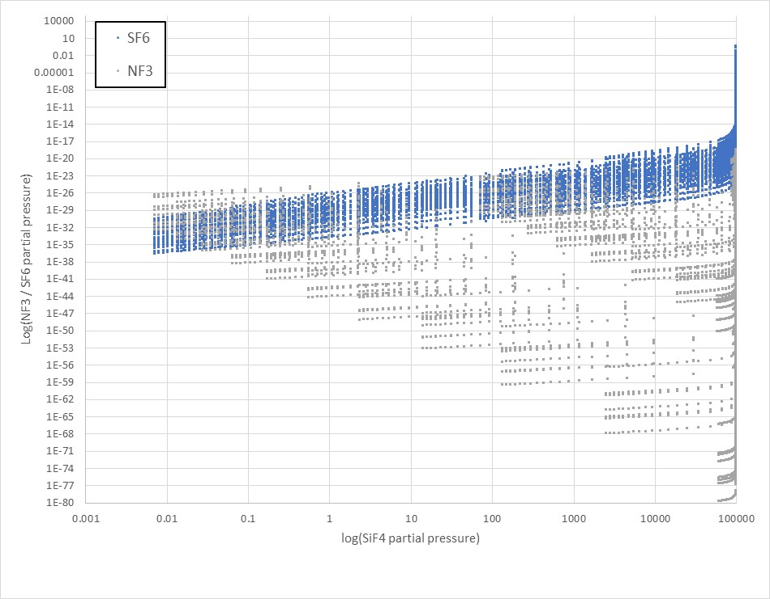
Figure S1. The amount of SiF₄ compared to the amounts of NF₃ and SF₆ produced by volcanoes under 85,536 combinations of tested conditions. x axis: partial pressure of SiF₄, y axis: partial pressure of SF₆ (blue dots) and NF₃ (grey dots). Under almost all conditions the amount of SF₆ and NF₃ is less than SiF₄ by many orders of magnitude.

In a few sets of conditions shown on the Figure S1 the SF₆ is a few % of SiF₄ (top right area on the Figure S1). Those conditions are high pressure, low water, low temperature conditions where thermodynamics predicts that the atmosphere is composed almost entirely of SiF₄, i.e. under those conditions the crustal rocks are being liquified and turned into SiF₄. Such a scenario is physically and stoichiometrically implausible. (We assume an infinite reservoir of F in the rocks, which is implausible, although not impossible given the mass of the crust compared to the mass of the atmosphere.). We have therefore plot the abundance ratios of SF₆/SiF₄ and NF₃/SiF₄ (Figure S2). Plotting the ratios of SF₆/SiF₄ and NF₃/SiF₄ allows for the partial pressure of SiF₄ to be arbitrary, therefore reflecting the ratios more accurately.

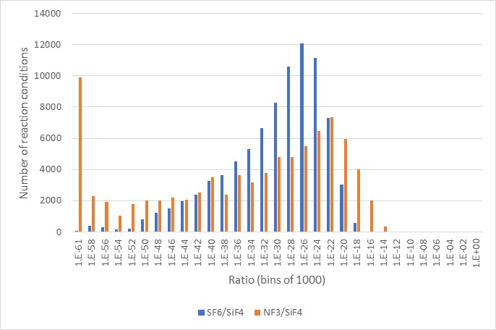
Figure S2. Abundance ratios of SF₆/SiF₄ and NF₃/SiF₄. y axis: number of reactions conditions. x axis: abundance ratios. No significant amounts of NF₃ and SF₆ are produced by volcanoes under 85,536 combinations of tested conditions.

SI 5 Supplementary References

1. Lin, H. W., Abad, G. G. & Loeb, A. Detecting industrial pollution in the atmospheres of earth-like exoplanets. Astrophys. J. Lett. 792, L7 (2014).
2. Haqq-Misra, J. et al. Detectability of Chlorofluorocarbons in the Atmospheres of Habitable M-dwarf Planets. Planet. Sci. J. 3, 60 (2022).
3. Haqq-Misra, J., Fauchez, T. J., Schwieterman, E. W. & Kopparapu, R. Disruption of a Planetary Nitrogen Cycle as Evidence of Extraterrestrial Agriculture. Astrophys. J. Lett. 929, L28 (2022).
4. Kopparapu, R., Arney, G., Haqq-Misra, J., Lustig-Yaeger, J. & Villanueva, G. Nitrogen dioxide pollution as a signature of extraterrestrial technology. Astrophys. J. 908, 164 (2021).
5. Sander, R. Compilation of Henry’s law constants (version 4.0) for water as solvent. Atmos. Chem. Phys. 15, 4399–4981 (2015).
6. Golja, B., Barkanic, J. A. & Hoff, A. A review of nitrogen trifluoride for dry etching in microelectronics processing. Microelectronics J. 16, 5–21 (1985).
7. Greenwood, N. N. & Earnshaw, A. Chemistry of the Elements 2nd Edition. (Butterworth-Heinemann, 1997).
8. Klapötke, T. M. Nitrogen–fluorine compounds. J. Fluor. Chem. 127, 679–687 (2006).
9. Ishii, F. & Kita, Y. Chapter 19 - Applications of Fluorides to Semiconductor Industries. in (eds. Nakajima, T., Žemva, B. & Tressaud, A. B. T.-A. I. F.) 625–660 (Elsevier, 2000). doi:https://doi.org/10.1016/B978-044472002-3/50020-X.
10. Woytek, A. J., Lileck, J. T. & Barkanic, J. A. Nitrogen trifluoride―A new dry etchant gas. Solid state Technol. 27, 172–175 (1984).
11. Greenberg, K. E. & Verdeyen, J. T. Kinetic processes of NF3 etchant gas discharges. J. Appl. Phys. 57, 1596–1601 (1985).
12. Perrin, J., Méot, J., Siéfert, J.-M. & Schmitt, J. Mass spectrometric study of NF3 plasma etching of silicon. Plasma Chem. plasma Process. 10, 571–587 (1990).
13. Elvers, B. Ullmann’s encyclopedia of industrial chemistry. vol. 17 (Verlag Chemie Hoboken, NJ, 1991).
14. Macintyre, J. E. Dictionary of inorganic compounds. (CRC Press, 1992).
15. Suslick, K. S. Kirk-Othmer encyclopedia of chemical technology. J. Wiley Sons New York 26, 517–541 (1998).
16. Holleman, A. F., Wiberg, E. & Wiberg, N. Inorganic chemistry. (Academic press, 2001).
17. Atkins, P. & Overton, T. Shriver and Atkins’ inorganic chemistry. (Oxford University Press, USA, 2010).
18. Raj, G. Advanced Inorganic Chemistry: Vollume II. (Krishna Prakashan Media, 2010).
19. Lester, D. & Greenberg, L. A. The toxicity of sulfur hexafluoride. Arch. Indust. Hyg. Occup. Med. 2, 348–349 (1950).
20. Dervos, C. T. & Vassiliou, P. Sulfur hexafluoride (SF6): global environmental effects and toxic byproduct formation. J. Air Waste Manage. Assoc. 50, 137–141 (2000).
21. Ricketts, N. J. & Cashion, S. P. Hydrofluorocarbons as a replacement for sulphur hexafluoride in magnesium processing. Magnes. Technol. 2001, 31–36 (2001).
22. Liptak, R. W., Devetter, B., Thomas, J. H., Kortshagen, U. & Campbell, S. A. SF6 plasma etching of silicon nanocrystals. Nanotechnology 20, 35603 (2008).
23. Ottinger, D., Averyt, M. & Harris, D. US consumption and supplies of sulphur hexafluoride reported under the greenhouse gas reporting program. J. Integr. Environ. Sci. 12, 5–16 (2015).
24. Dervos, C. T., Vassiliou, P. & Mergos, J. A. Thermal stability of SF6 associated with metallic conductors incorporated in gas insulated switchgear power substations. J. Phys. D. Appl. Phys. 40, 6942 (2007).
25. Forster, P. et al. Changes in atmospheric constituents and in radiative forcing. Chapter 2. in Climate change 2007. The physical science basis (2007).
26. Prather, M. J. & Hsu, J. NF3, the greenhouse gas missing from Kyoto. Geophys. Res. Lett. 35, (2008).
27. Zhang, X., Xiao, H., Tang, J., Cui, Z. & Zhang, Y. Recent advances in decomposition of the most potent greenhouse gas SF6. Crit. Rev. Environ. Sci. Technol. 47, 1763–1782 (2017).
28. Myhre, G., Shindell, D. & Pongratz, J. Anthropogenic and natural radiative forcing. (2014).
29. Ray, E. A. et al. Quantification of the SF6 lifetime based on mesospheric loss measured in the stratospheric polar vortex. J. Geophys. Res. Atmos. 122, 4626–4638 (2017).
30. Arnold, T. et al. Nitrogen trifluoride global emissions estimated from updated atmospheric measurements. Proc. Natl. Acad. Sci. 110, 2029–2034 (2013).
31. Rigby, M. et al. Recent and future trends in synthetic greenhouse gas radiative forcing. Geophys. Res. Lett. 41, 2623–2630 (2014).
32. Simmonds, P. G. et al. The increasing atmospheric burden of the greenhouse gas sulfur hexafluoride (SF 6). Atmos. Chem. Phys. 20, 7271–7290 (2020).
33. Lide, D. R. CRC handbook of chemistry and physics, internet version 2005. (2005).

