Delay-differential SEIR modeling for improved modelling of infection dynamics

Kiselev I.N.^{1,2,3,*}, Akberdin I.R.^{1,3,4}, Kolpakov F.A.^{1,2,3}

¹ BIOSOFT.RU, Ltd, Novosibirsk, Russia
² FRC for Information and Computational Technologies, Novosibirsk, Russia
³ Sirius University, Sochi, Russia
⁴ Novosibirsk State University, Novosibirsk, Russia

*E-mail: axec@systemsbiology.ru

Supplementary material 2: Automatic generation models for other countries
Here we present results of automatic model generation for several European and non-European countries. As a basis we took a model fitted for Germany data and used it for automatic fitting based on statistical data for other countries. Of course, the resulting models are not final products, but they may be used as a starting point for full-fledged models describing Covid-19 pandemic in correspondent countries. Additional information may be found at
https://gitlab.sirius-web.org/covid-19/dde-epidemiology-model.

Supplementary 2 Table S1. Parameters which values are estimated for different countries.
Name | Description | Initial guess | Lower boundary | Upper boundary
$$SI_{Effect}$$ | Stringency index efficacy | 0.74 | 0.3 | 1
$$CF$$ | Average number of contacts per day for one individual | 8 | 1.6 | 100
$$Q_{E^{T}}$$ | Mobility limit for registered without symptoms | 0.3 | 0 | 1
$$Q_{M^{}}$$ | Mobility limit for mildly symptomatic (not registered) | 0.2 | 0 | 1
$$Q_{M^{T}}$$ | Mobility limit for mildly symptomatic (registered) | 0.1 | 0 | 1
$$T_{E}$$ | Percent of registered while in incubation period or asymptomatic. In brackets - starting date of new testing value. | 25% | 0% | 100%
$$T_{M}$$ | Percent of registered while having mild symptoms. In brackets - starting date of new testing value. | 48% | 0% | 100%
$$I_{Ended}$$ | Infections imported per day at $T_{Ended}$ | 500 cases | 0 cases | 3000 cases

Supplementary 2 Table S2. Parameter values estimated for individual countries. MSD - mean squared deviation.
Country | $$CF$$ | $$SI_{Effect}$$ | $$I_{Ended}$$ | $$Q_{M^{}}$$ | $$T_{E}$$ | $$T_{M}$$ | $$Q_{E^{T}}$$ | $$Q_{M^{T}}$$ | MSD
Brazil | 4 | 0.55 | 2485 | 0.3 | 0.6 | 0.54 | 0.99 | 0.41 | 7308271
Argentina | 4.18 | 0.32 | 1471 | 0.15 | 0.57 | 0.12 | 0.82 | 0.19 | 1561563
Russia | 3.32 | 0.32 | 1936 | 0.05 | 0.49 | 0.25 | 0.83 | 0.58 | 142823
Italy | 9.5 | 0.99 | 5112 | 0.26 | 0.17 | 0.53 | 0.86 | 0.94 | 134092
Spain | 5.15 | 0.61 | 198 | 0.07 | 0.53 | 0.58 | 0.96 | 0.08 | 115627
Poland | 7.81 | 0.77 | 1286 | 0.19 | 0.06 | 0.48 | 0.19 | 0.06 | 81643
Mexico | 6.49 | 0.40 | 1776 | 0.04 | 0.44 | 0.04 | 0.41 | 0.06 | 737347
Czechia | 6.09 | 0.72 | 183 | 0.1 | 0.56 | 0.36 | 0.20 | 0.76 | 725553
Portugal | 6.02 | 0.60 | 1102 | 0.28 | 0.11 | 0.11 | 0.31 | 0.24 | 22143
Austria | 8.47 | 0.86 | 251 | 0.04 | 0.11 | 0.22 | 0.43 | 0.21 | 204447
Sweden | 6.57 | 0.81 | 287 | 0.22 | 0.04 | 0.21 | 0.89 | 0.35 | 18745
Japan | 4.19 | 0.54 | 226 | 0.85 | 0.19 | 0.36 | 0.43 | 0.59 | 134672
Greece | 8.62 | 0.97 | 242 | 0.23 | 0.06 | 0.54 | 0.52 | 0.51 | 6534
South Korea | 4.31 | 0.43 | 507 | 0.03 | 0.06 | 0.08 | 0.46 | 0.95 | 5362

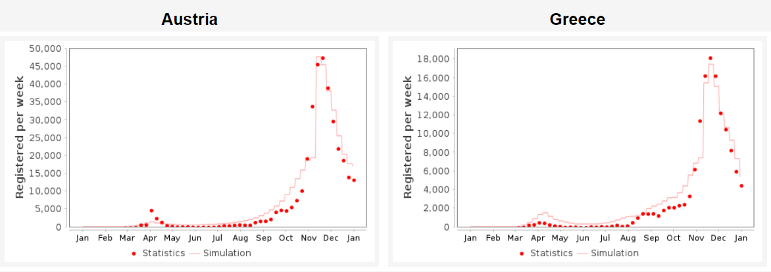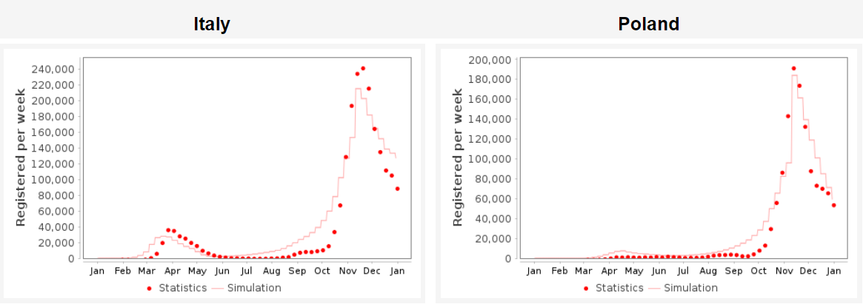
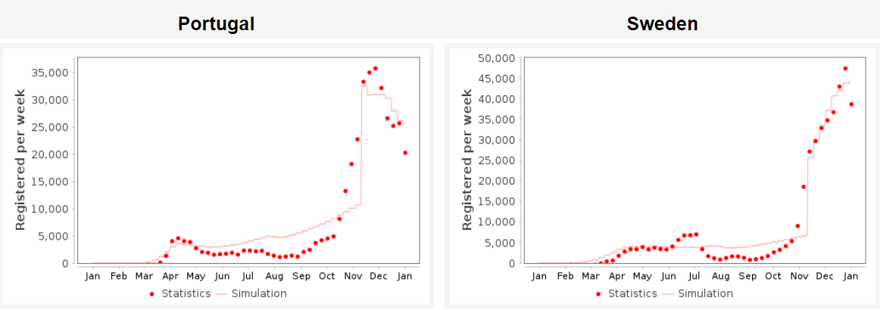
Supplementary 2 Fig. S1. Simulation results for autogenerated models for 6 European countries. Axis Y - cases per week. The curve - simulation results, while dots -statistics data.

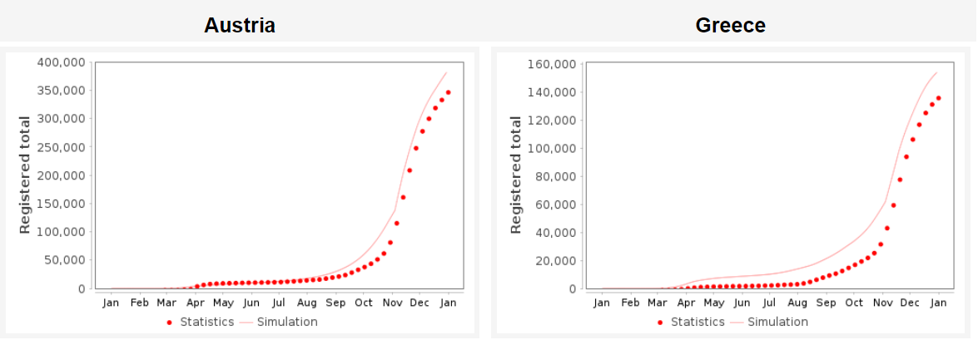
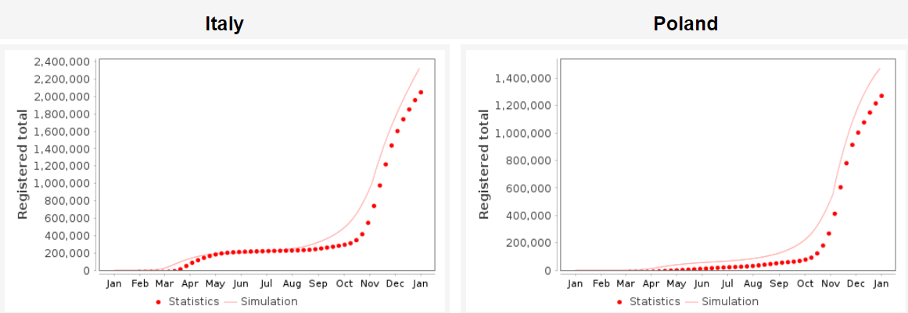
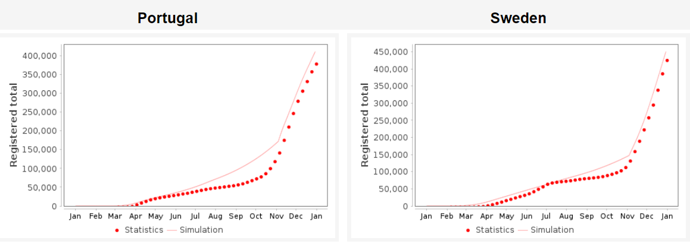
Supplementary 2 Fig. S2. Simulation results for autogenerated models for 6 European countries. Axis Y - total number of cases. The curve - simulation results, while dots -statistics data.

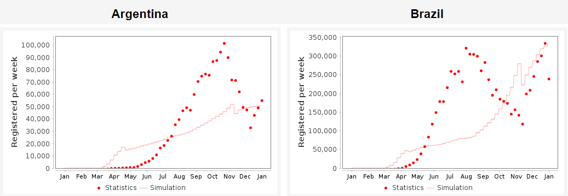
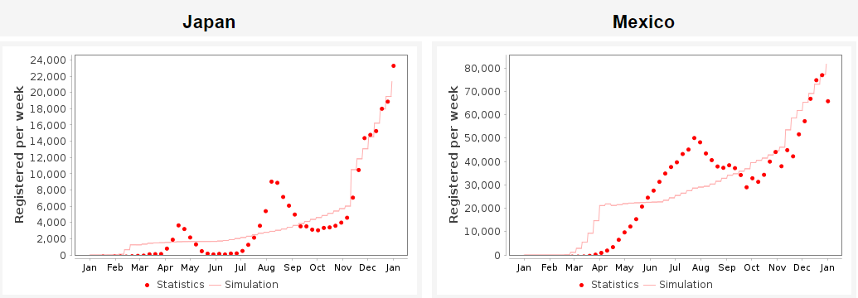
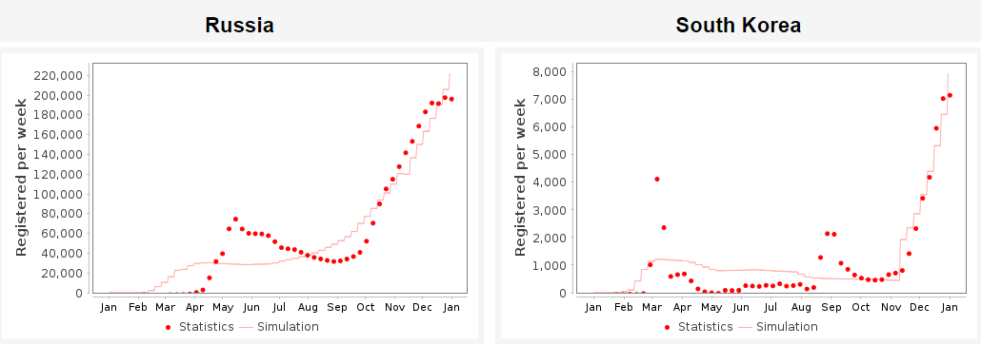
Supplementary 2 Fig. S3. Simulation results for autogenerated models for 6 non-European countries. Axis Y - cases per week. The curve - simulation results, while dots -statistics data.

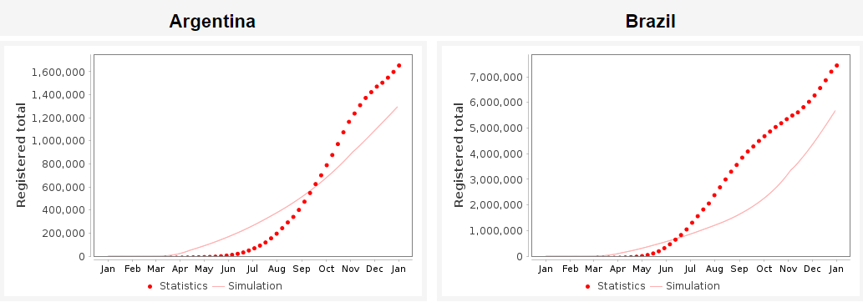
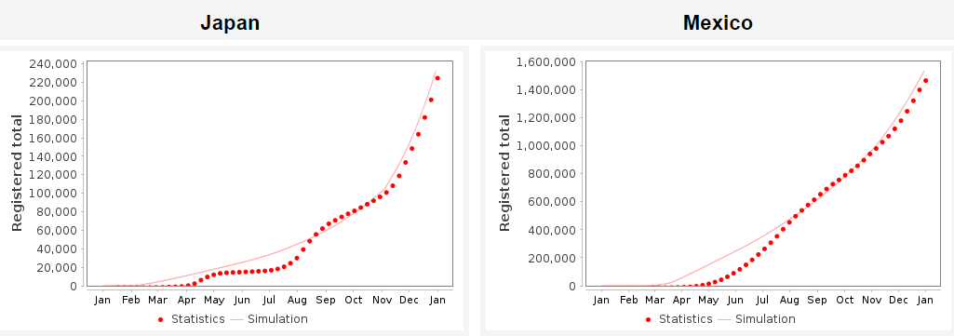
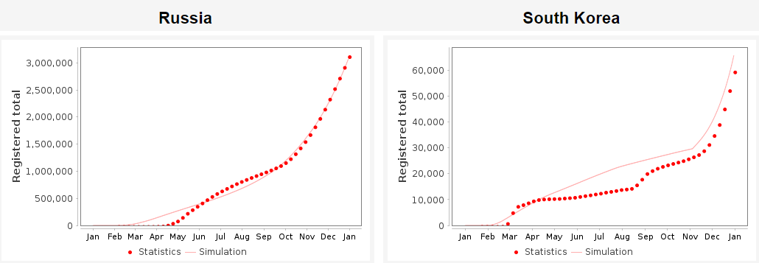
Supplementary 2 Fig. S4. Simulation results for autogenerated models for 6 non-European countries. Axis Y - total number of cases. The curve - simulation results, while dots -statistics data.

