Line-field confocal optical coherence tomography coupled with artificial intelligence algorithms to identify quantitative biomarkers of facial skin ageing

Bonnier, Franck^{1,*}; Pedrazzani, Mélanie²; Fischman, Sébastien²; Viel, Théo²; Lavoix, Agnes³; Pegoud, Didier³; Nili, Meryem³; Jimenez, Yolande³; Ralambondrainy, Samuel¹; Cauchard Jean-Hubert¹; Korichi, Rodolphe¹

¹ LVMH Recherche, 185 avenue de Verdun, 45804 Saint Jean de Braye, France
² DAMAE Medical, 14 Rue Sthrau, 75013 Paris, France
³ DERMATECH, 8 Rue Jacqueline Auriol, 69008 Lyon

* Bonnier Franck, 185 avenue de Verdun, 45804 Saint Jean de Braye, France, +33 2 38 60 31 32, fbonnier@research.lvmh-pc.com

SUPPLEMENTARY DATA

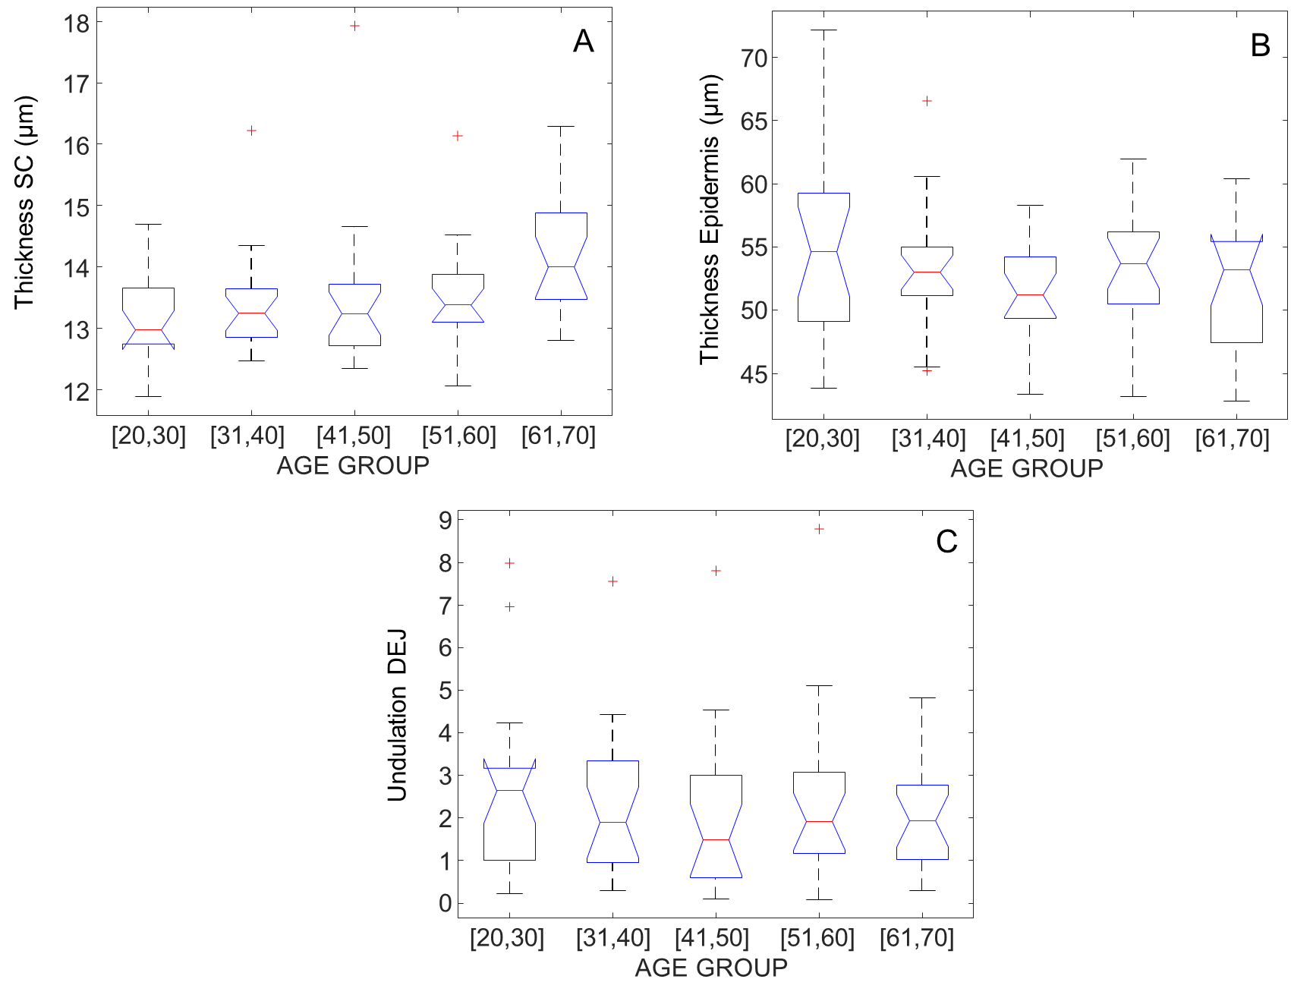

Figure S1: Characterisation of age-related variations in skin layers for the temple. Boxplots for the thickness of the stratum corneum (A), the thickness of viable epidermis (B) and Undulation of the DEJ (C).
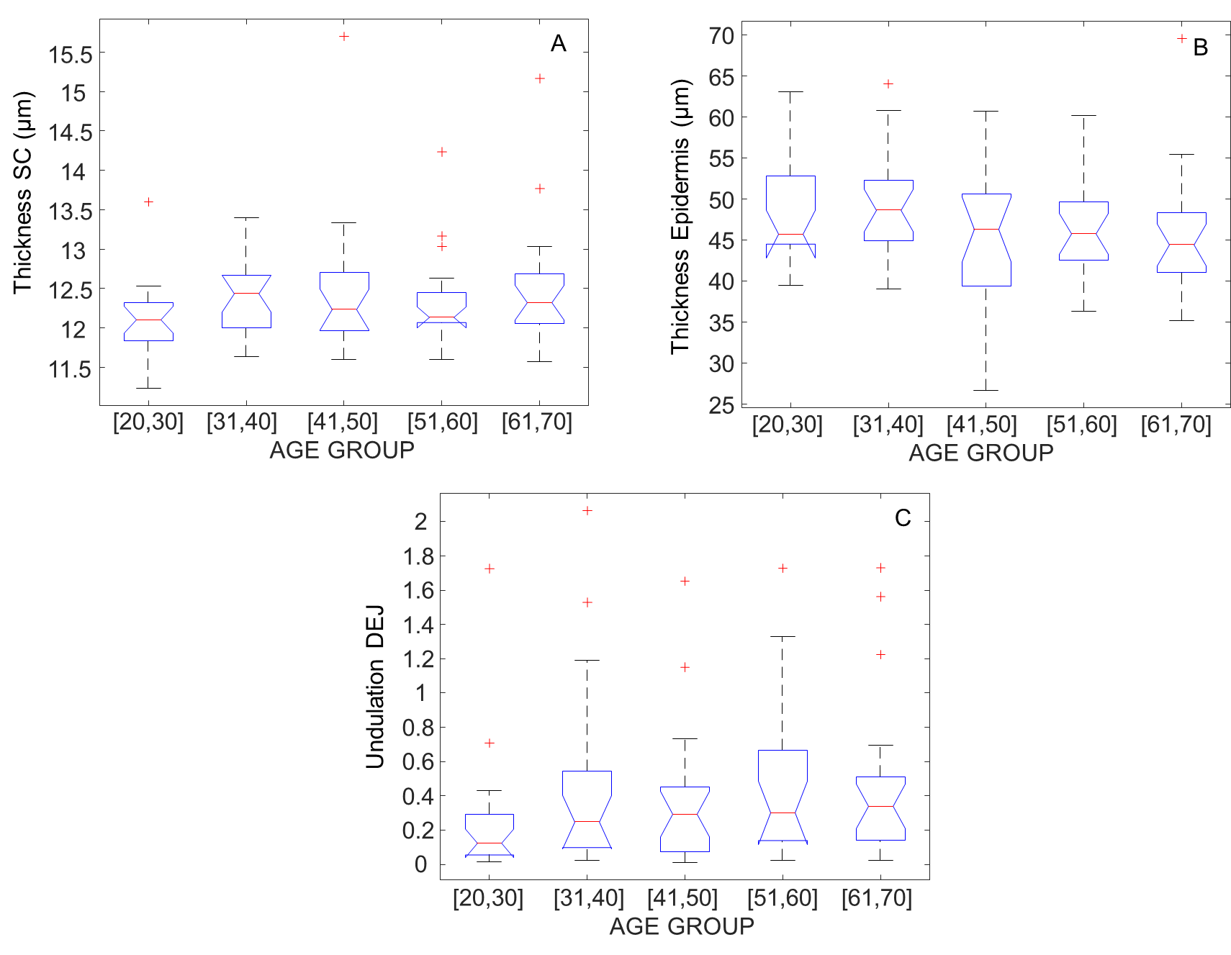

Figure S2: Characterisation of age-related variations in skin layers for the cheekbone. Boxplots for the thickness of the stratum corneum (A), the thickness of viable epidermis (B) and Undulation of the DEJ (C).

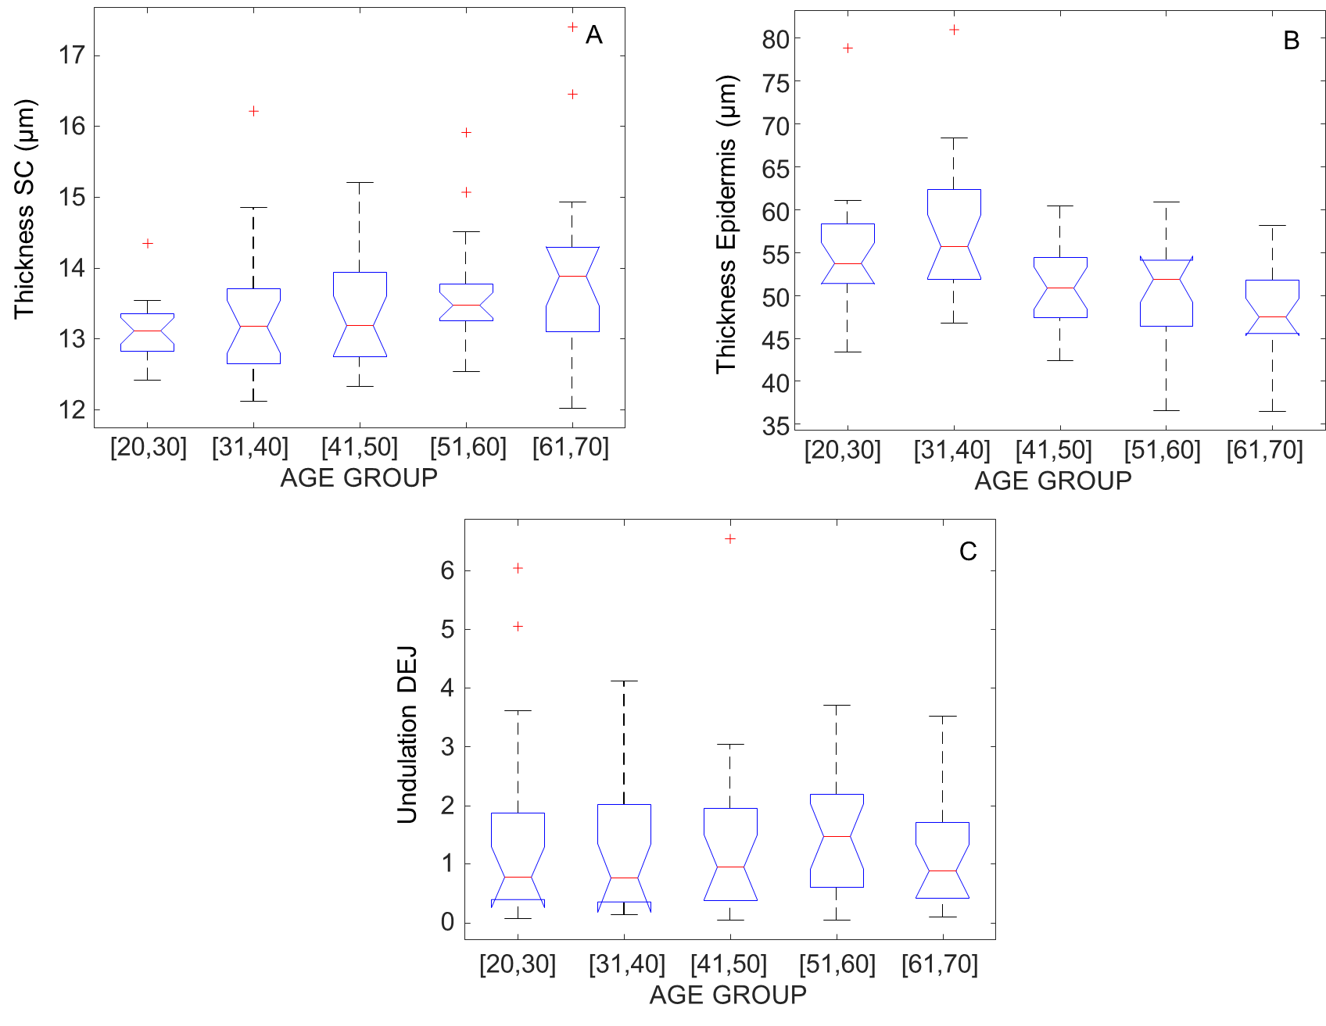

Figure S3: Characterisation of age-related variations in skin layers for the mandible. Boxplots for the thickness of the stratum corneum (A), the thickness of viable epidermis (B) and Undulation of the DEJ (C).

