Fig.S1: Unprocessed blot images for western blotting results.
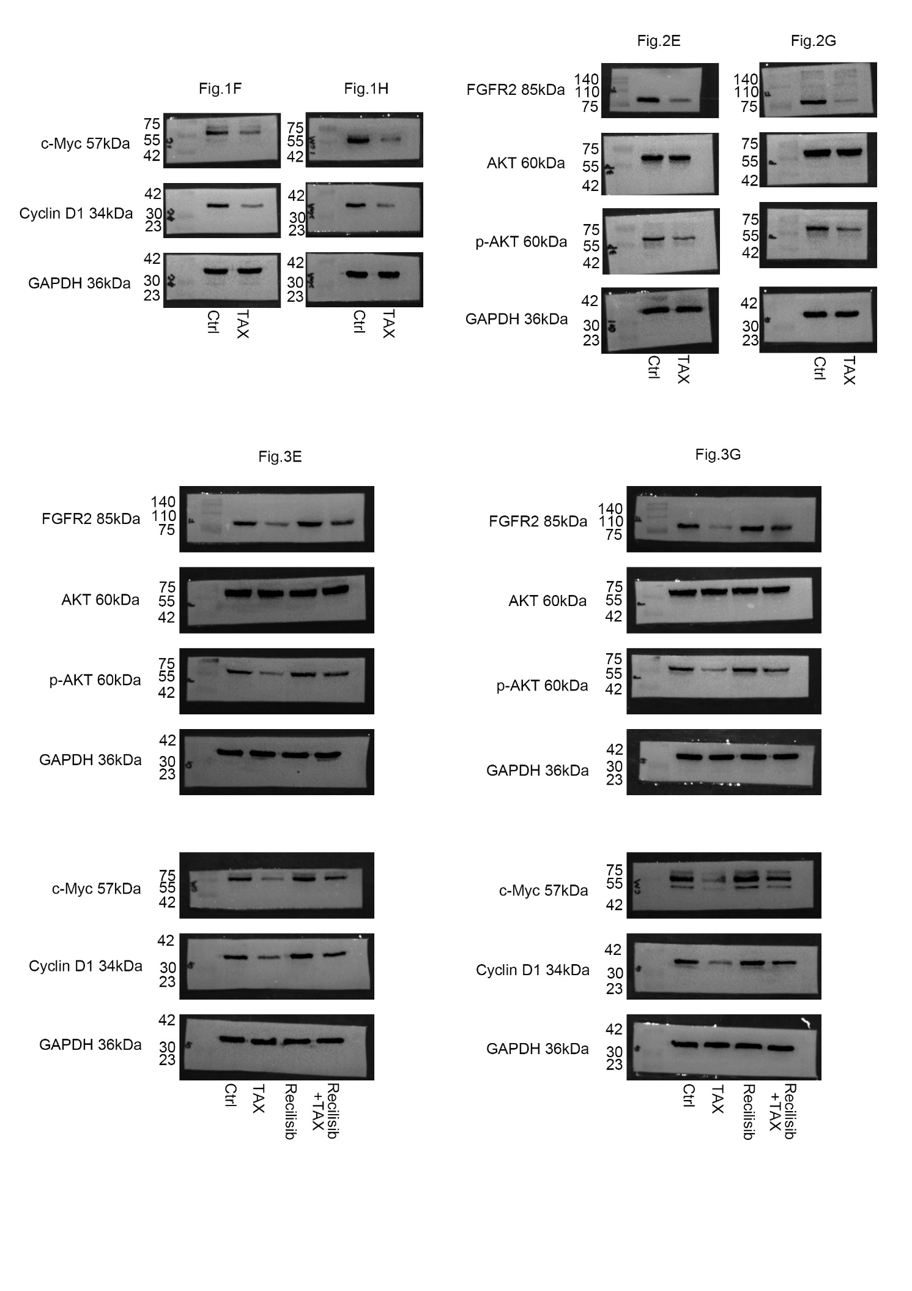

Table S1: Primer sequences used in various PCRs in the study.
Gene | Primer (5’ to 3’)
GAPDH | Forward: GGAAGCTTGTCATCAATGGAAATC
GAPDH | Reverse: TGATGACCCTTTTGGCTCCC
FGFR2 | Forward: AGAGTGATGTCTGGTCCTTCGG
FGFR2 | Reverse: TGGCTGGCTTATCCATTCTGTG
AKT1 | Forward: TACTCTTTCCAGACCCACGACC
AKT1 | Reverse: CCCGGTACACCACGTTCTTCT
Cyclin D1 | Forward: AGCTGTGCATCTACACCGAC
Cyclin D1 | Reverse: GAAATCGTGCGGGGTCATTG
c-Myc | Forward: GGTAGTGGAAAACCAGCAGCC
c-Myc | Reverse: CTCCTCGTCGCAGTAGAAATACG
PDGFA | Forward: AGTGTCAAGTGCCAGCCCTC
PDGFA | Reverse: CGGATTCAGGCTTGTGGTCG
S6K1 | Forward: TCCGATCACCTCGAAGATTTATTG
S6K1 | Reverse: CATCTGCTCTATGCCACTTGTTTC
4E-BP1 | Forward: CTATGACCGGAAATTCCTGATGG
4E-BP1 | Reverse: CCCGCTTATCTTCTGGGCTA

