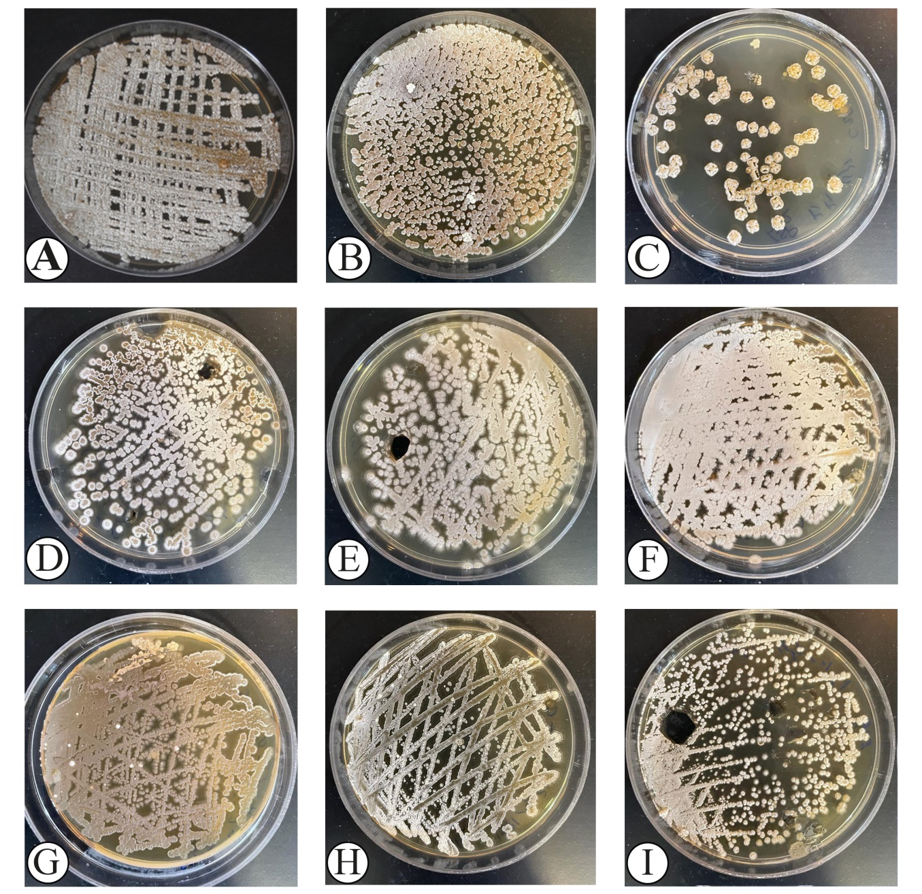
Supplementary Figure 1; Morphological characterization of actinobacteria isolates.
Colony morphology of actinobacteria isolates after two weeks of incubation onto ISP2 at 28ºC. IKBG03 (A), IKBG05 (B), IKBG07 (C), IKBG13 (D), IKBG14 (E), IKBG17 (F), IKBG18 (G), IKBG19 (H), IKBG20 (I).

