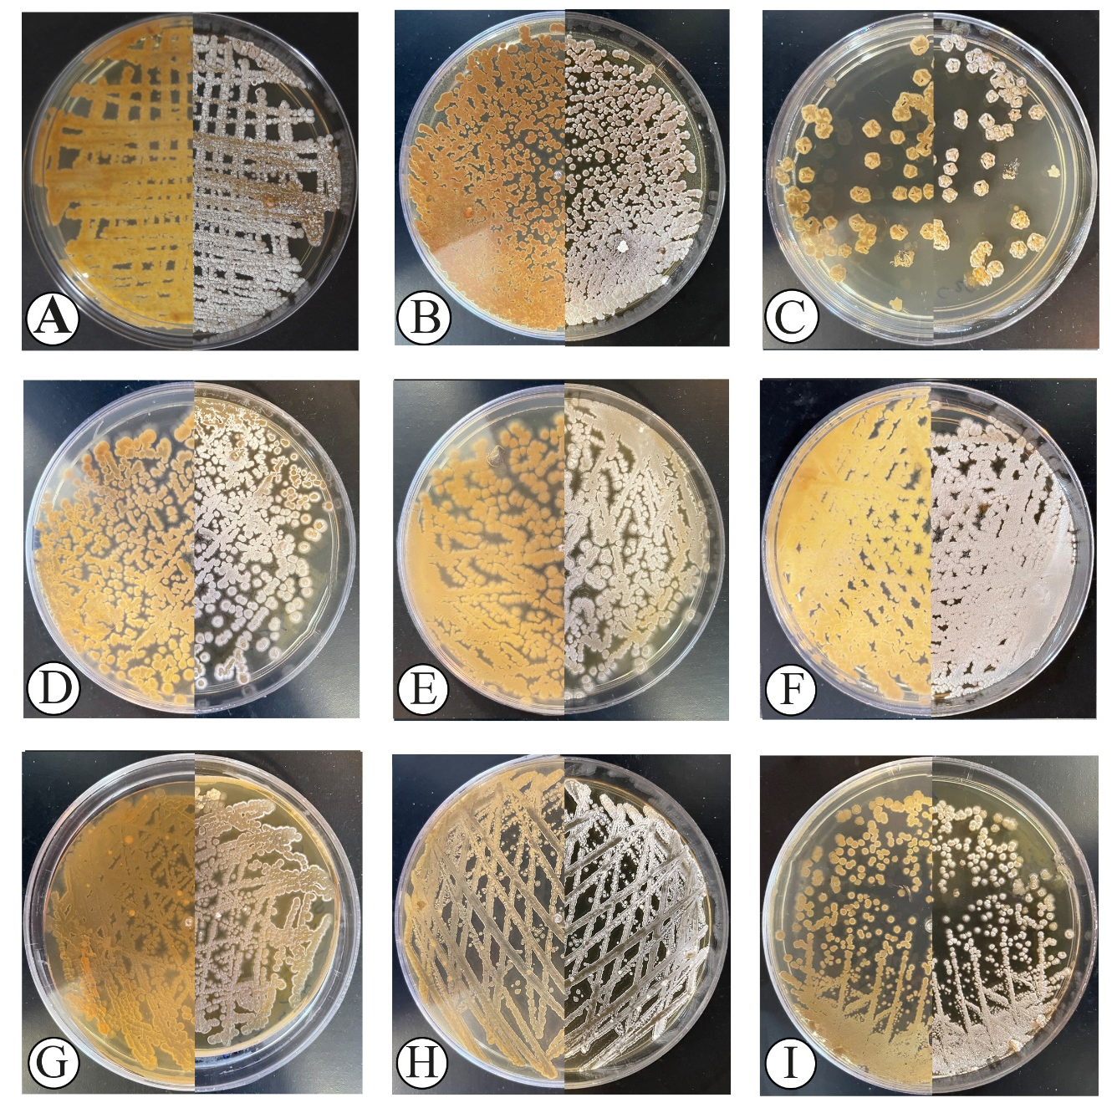
Supplementary Figure 2; Morphological characterization of actinobacteria isolates.
Colony morphology of actinobacteria isolates after two weeks of incubation onto ISP2 at 28ºC. IKBG03 (A), IKBG05 (B), IKBG07 (C), IKBG13 (D), IKBG14 (E), IKBG17 (F), IKBG18 (G), IKBG19 (H), IKBG20 (I). The right half of each plate shows the front of culture, while the left half shows the back of each culture.

