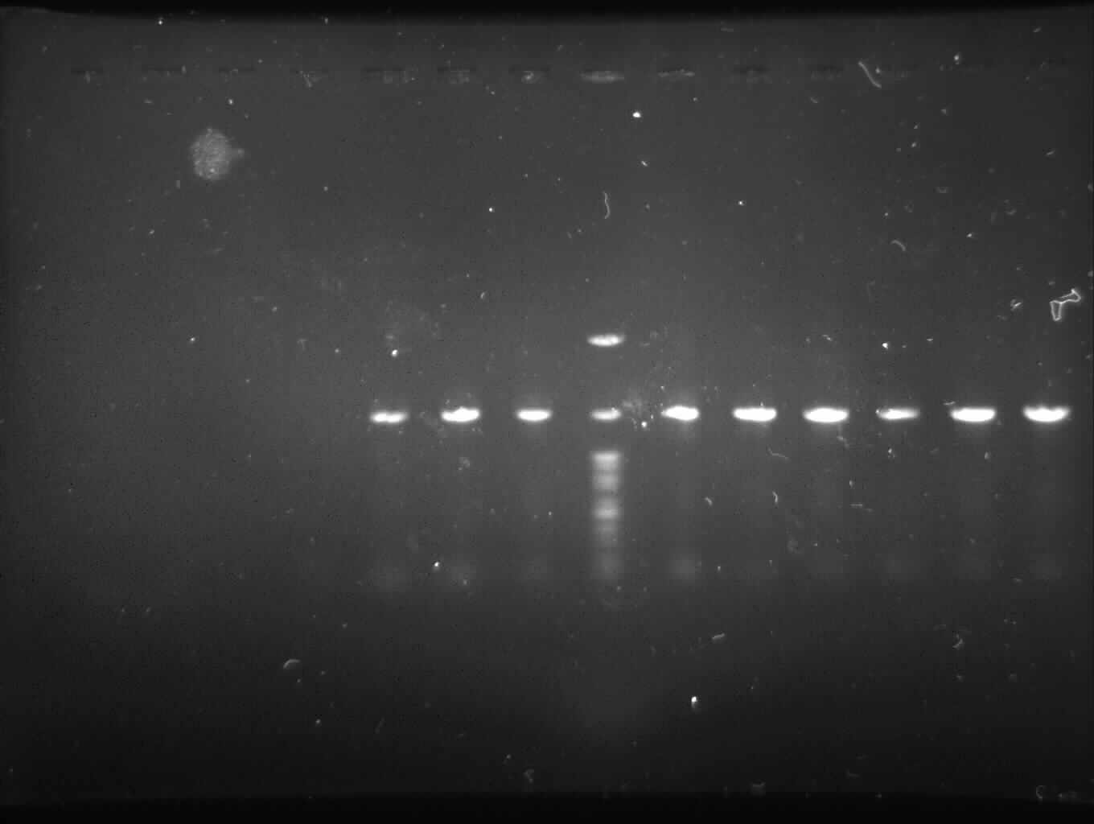
Supplementary Figure 3; The original image of PCR products gel.
Gel electrophoresis of PCR products. PCR products of 16S rDNA of isolated strains using 27F and 1492R primers that amplify a 1.5 Kb product from strains. The 1.5 Kb amplified 16S rDNA fragments observed on 1% agarose gel electrophoresis. From left to right; IKBG03 (lane 1), IKBG05 (lane 2), IKBG07 (lane 3), DNA ladder (lane 4, SinaClon, Iran), IKBG13 (lane 5), IKBG14 (lane 6), IKBG17 (lane 7), IKBG18 (lane 8), IKBG19 (lane 9), IKBG20 (lane 10).

