Fantastic report on
Document1



Distribution:

Name | Function | 0.1 | 0.5 | 1.0
N.N.-999 | Masterking Group Manager (MGM)
N.N.-998 | Product Ontwikkelt Manager (POM)
N.N.-1 | (AS)
N.N.-2 | (DS)
N.N.-3 | (BS)
T.P. | Supervisor All Coding

Table of Contents:
Table of Contents: 2
Anchor Scan Parameters: (Bookmark1) 3
Graphics: (Bookmark2) 3
Peak List: (Bookmark 3) 3
Identified Patterns List: (Bookmark4) 3
Plot of Identified Phases: (Bookmark 5) 3
Document History: (Bookmark 6) 3

Anchor Scan Parameters: (Bookmark1)

Dataset Name 1
File name E:\X'Pert Data\2023\3\Dr Khaled xrd\1.xrdml
Comment Configuration=Stage Flat Samples, Owner=r, Creation date=2/28/2009 2:36:26 PM
Goniometer=PW3050/60 (Theta/Theta); Minimum step size 2Theta:0.001; Minimum step size Omega:0.001
Sample stage=PW3071/xx Bracket
Diffractometer system=XPERT-PRO
Measurement program=Program1, Owner=r, Creation date=7/7/2004 10:36:35 AM
Measurement Date / Time 3/18/2023 12:12:37 PM
Operator cwi
Raw Data Origin XRD measurement (*.XRDML)
Scan Axis Gonio
Start Position [°2Th.] 5.0100
End Position [°2Th.] 89.9900
Step Size [°2Th.] 0.0200
Scan Step Time [s] 1.0000
Scan Type Continuous
Offset [°2Th.] 0.0000
Divergence Slit Type Fixed
Divergence Slit Size [°] 0.4785
Specimen Length [mm] 10.00
Receiving Slit Size [mm] 0.1000
Measurement Temperature [°C] 25.00
Anode Material Cu
K-Alpha1 [Å] 1.54060
K-Alpha2 [Å] 1.54443
K-Beta [Å] 1.39225
K-A2 / K-A1 Ratio 0.50000
Generator Settings 30 mA, 40 kV
Diffractometer Type 0000000000005545
Diffractometer Number 0
Goniometer Radius [mm] 240.00
Dist. Focus-Diverg. Slit [mm] 91.00
Incident Beam Monochromator No
Spinning No

Graphics: (Bookmark2)

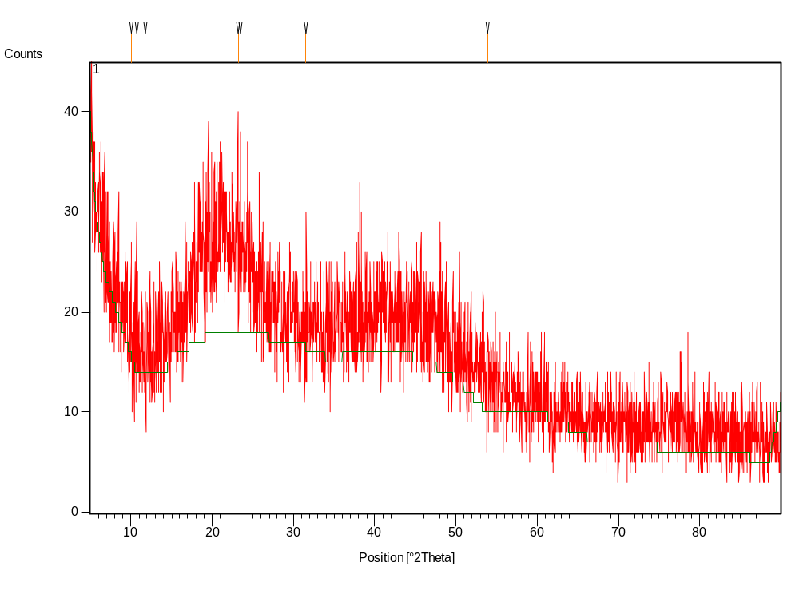

Peak List: (Bookmark 3)

Pos. [°2Th.] | Height [cts] | FWHM [°2Th.] | d-spacing [Å] | Rel. Int. [%] | Tip width [°2Th.] | Matched by
10.0341 | 11.50 | 0.0787 | 8.81557 | 52.27 | 0.0945
10.6947 | 14.69 | 0.0590 | 8.27246 | 66.76 | 0.0708
11.7830 | 7.72 | 0.0984 | 7.51074 | 35.09 | 0.1181
23.1501 | 22.00 | 0.0787 | 3.84216 | 100.00 | 0.0945
23.4513 | 11.89 | 0.1968 | 3.79350 | 54.02 | 0.2362
31.5697 | 13.60 | 0.0394 | 2.83406 | 61.82 | 0.0472
53.8896 | 7.41 | 0.0960 | 1.69994 | 33.66 | 0.1152

Identified Patterns List: (Bookmark4)

Plot of Identified Phases: (Bookmark 5)

Document History: (Bookmark 6)

Insert Measurement:
- File name = "1.xrdml"
- Modification time = "3/18/2023 1:32:24 PM"
- Modification editor = "cwi"

Default properties:
- Measurement step axis = "None"
- Internal wavelengths used from anode material: Copper (Cu)
- Original K-Alpha1 wavelength = "1.54060"
- Used K-Alpha1 wavelength = "1.54060"
- Original K-Alpha2 wavelength = "1.54443"
- Used K-Alpha2 wavelength = "1.54443"
- Original K-Beta wavelength = "1.39225"
- Used K-Beta wavelength = "1.39225"
- Incident beam monochromator = "No"
- Dist. focus to div. slit = "91.00000"
- Irradiated length = "10.00000"
- Spinner used = "No"
- Receiving slit size = "0.10000"
- Linear detector mode = "None"
- Length linear detector = "2"
- Step axis value = "0.00000"
- Offset = "0.00000"
- Sample length = "10.00000"
- Modification time = "3/18/2023 1:32:24 PM"
- Modification editor = "cwi"

Determine Background:
- Correction method = "Automatic"
- Bending factor = "21"
- Use smoothed input data = "Yes"
- Granularity = "18"
- Add to net scan = "Nothing"
- Modification time = "9/26/2022 9:58:01 AM"
- Modification editor = "cwi"

Determine Background:
- Correction method = "Automatic"
- Bending factor = "5"
- Use smoothed input data = "Yes"
- Granularity = "20"
- Add to net scan = "Nothing"
- Modification time = "2/22/2001 10:17:43 AM"
- Modification editor = "PANalytical"

Search Peaks:
- Minimum significance = "2.00"
- Minimum tip width = "0.01"
- Maximum tip width = "1.00"
- Peak base width = "2.00"
- Method = "Minimum 2nd derivative"
- Modification time = "2/20/2001 11:55:18 AM"
- Modification editor = "PANalytical"

Search & Match:
- Data source = Profile
- Restriction = "None"
- Scoring schema = "Multi phase"
- Auto residue = "Yes"
- Match intensity = "Yes"
- Demote unmatched strong = "Yes"
- Allow pattern shift = "No"
- Two theta shift = "0"
- Identify = "Yes"
- Max. no. of accepted patterns = "5"
- Minimum score = "27"
- Search depth = "6"
- Min. new lines / total lines = "40"
- Minimum new lines = "3"
- Minimum scale factor = "0.06"
- Modification time = "2/16/2001 11:03:07 AM"
- Modification editor = "PANalytical"

Determine Background:
- Correction method = "Automatic"
- Bending factor = "5"
- Use smoothed input data = "Yes"
- Granularity = "20"
- Add to net scan = "Nothing"
- Modification time = "2/22/2001 10:17:43 AM"
- Modification editor = "PANalytical"

Search Peaks:
- Minimum significance = "2.00"
- Minimum tip width = "0.01"
- Maximum tip width = "1.00"
- Peak base width = "2.00"
- Method = "Minimum 2nd derivative"
- Modification time = "2/20/2001 11:55:18 AM"
- Modification editor = "PANalytical"

Search & Match:
- Data source = Profile
- Restriction = "Restriction set"
- Description = "Common phases subfile only"
- All of: elements = ""
- At least one of: elements = ""
- None of: elements = ""
- Maximum no. of elements = "105"
- Skip marked as deleted by ICDD = "No"
- Skip marked as deleted by a user = "No"
- Skip non ambient pressure = "No"
- Skip non ambient temperature = "No"
- Quality marks set = ""
- Subfiles = "Common Phase"
- Scoring schema = "Multi phase"
- Auto residue = "Yes"
- Match intensity = "Yes"
- Demote unmatched strong = "Yes"
- Allow pattern shift = "No"
- Two theta shift = "0"
- Identify = "Yes"
- Max. no. of accepted patterns = "5"
- Minimum score = "27"
- Search depth = "6"
- Min. new lines / total lines = "40"
- Minimum new lines = "3"
- Minimum scale factor = "0.06"
- Modification time = "2/16/2001 3:30:09 PM"
- Modification editor = "PANalytical"

Smooth:
- Type of smoothing = "Polynomial"
- Polynomial type = "Low pass"
- Convolution range = "5"
- Modification time = "3/18/2023 1:33:14 PM"
- Modification editor = "cwi"

Search Peaks:
- Minimum significance = "0.50"
- Minimum tip width = "0.01"
- Maximum tip width = "1.00"
- Peak base width = "2.00"
- Method = "Minimum 2nd derivative"
- Modification time = "3/18/2023 1:33:41 PM"
- Modification editor = "cwi"

Determine Background:
- Correction method = "Automatic"
- Bending factor = "5"
- Use smoothed input data = "Yes"
- Granularity = "20"
- Add to net scan = "Nothing"
- Modification time = "2/22/2001 10:17:43 AM"
- Modification editor = "PANalytical"

Search Peaks:
- Minimum significance = "2.00"
- Minimum tip width = "0.01"
- Maximum tip width = "1.00"
- Peak base width = "2.00"
- Method = "Minimum 2nd derivative"
- Modification time = "2/20/2001 11:55:18 AM"
- Modification editor = "PANalytical"

Search & Match:
- Data source = Profile
- Restriction = "None"
- Scoring schema = "Multi phase"
- Auto residue = "Yes"
- Match intensity = "Yes"
- Demote unmatched strong = "Yes"
- Allow pattern shift = "No"
- Two theta shift = "0"
- Identify = "Yes"
- Max. no. of accepted patterns = "5"
- Minimum score = "27"
- Search depth = "6"
- Min. new lines / total lines = "40"
- Minimum new lines = "3"
- Minimum scale factor = "0.06"
- Modification time = "2/16/2001 11:03:07 AM"
- Modification editor = "PANalytical"

Search & Match:
- Data source = Profile
- Restriction = "Restriction set"
- Description = "Minerals subfile only"
- All of: elements = ""
- At least one of: elements = ""
- None of: elements = ""
- Maximum no. of elements = "105"
- Skip marked as deleted by ICDD = "No"
- Skip marked as deleted by a user = "No"
- Skip non ambient pressure = "No"
- Skip non ambient temperature = "No"
- Quality marks set = ""
- Subfiles = "Mineral"
- Scoring schema = "Multi phase"
- Auto residue = "Yes"
- Match intensity = "Yes"
- Demote unmatched strong = "No"
- Allow pattern shift = "No"
- Two theta shift = "0"
- Identify = "No"
- Modification time = "1/11/2001 10:27:07 AM"
- Modification editor = "PANalytical"

Determine Background:
- Correction method = "Automatic"
- Bending factor = "5"
- Use smoothed input data = "Yes"
- Granularity = "20"
- Add to net scan = "Nothing"
- Modification time = "2/22/2001 10:17:43 AM"
- Modification editor = "PANalytical"

Search Peaks:
- Minimum significance = "2.00"
- Minimum tip width = "0.01"
- Maximum tip width = "1.00"
- Peak base width = "2.00"
- Method = "Minimum 2nd derivative"
- Modification time = "2/20/2001 11:55:18 AM"
- Modification editor = "PANalytical"

Search & Match:
- Data source = Profile
- Restriction = "None"
- Scoring schema = "Multi phase"
- Auto residue = "Yes"
- Match intensity = "Yes"
- Demote unmatched strong = "Yes"
- Allow pattern shift = "No"
- Two theta shift = "0"
- Identify = "Yes"
- Max. no. of accepted patterns = "5"
- Minimum score = "27"
- Search depth = "6"
- Min. new lines / total lines = "40"
- Minimum new lines = "3"
- Minimum scale factor = "0.06"
- Modification time = "2/16/2001 11:03:07 AM"
- Modification editor = "PANalytical"

Search Peaks:
- Minimum significance = "0.50"
- Minimum tip width = "0.01"
- Maximum tip width = "1.00"
- Peak base width = "2.00"
- Method = "Minimum 2nd derivative"
- Modification time = "3/18/2023 1:37:40 PM"
- Modification editor = "cwi"

