2017-2018 NRD admission for cancer
N=1,022,879
Analytic cohort
N=358,629
Exclusions:
- Age <18 years old: N=9,476
- CVD at the index hospitalization: N=291,414
- Missing values: N=15,964
- July to December discharge: N=491,011
- Died during index hospitalization: N=43,294
Supplementary Fig 1. Patient selection flow

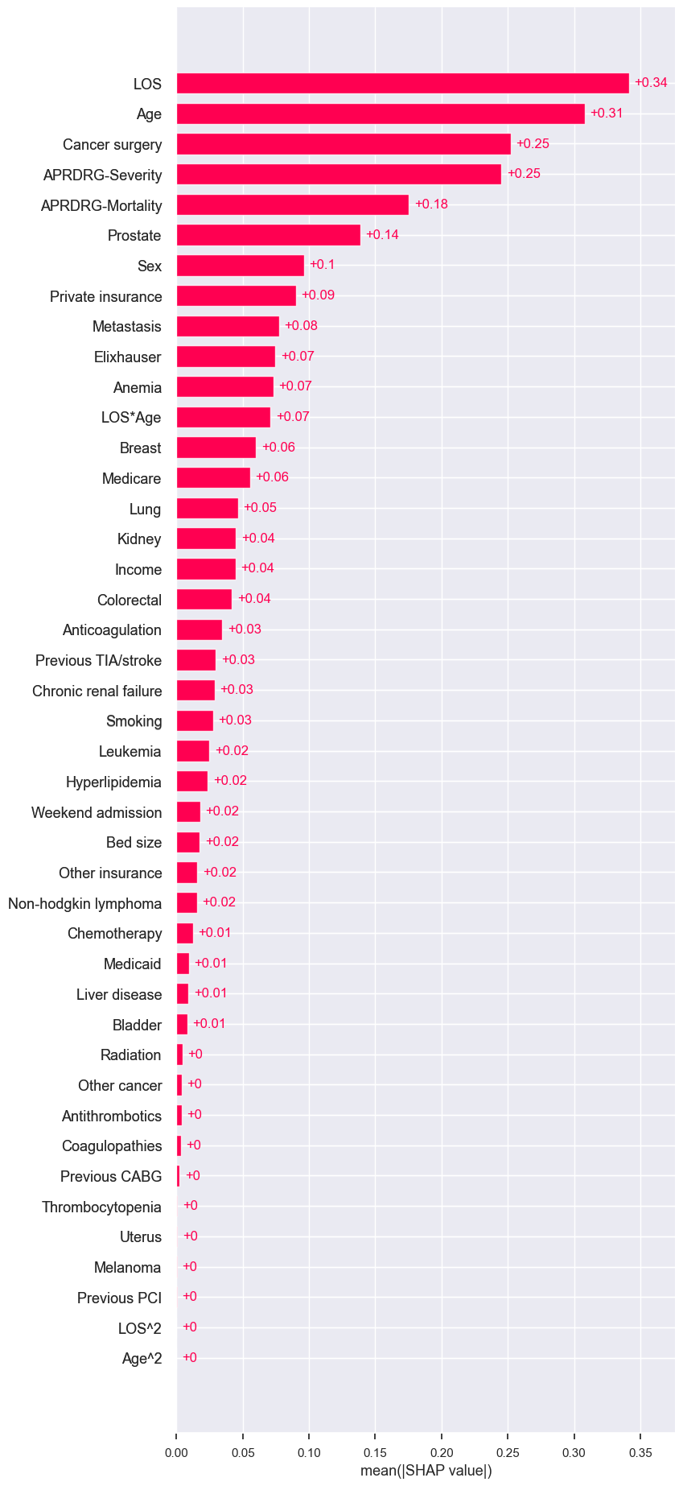
Supplementary Fig 2. Feature importance of XGBoost ranked by SHAP value.
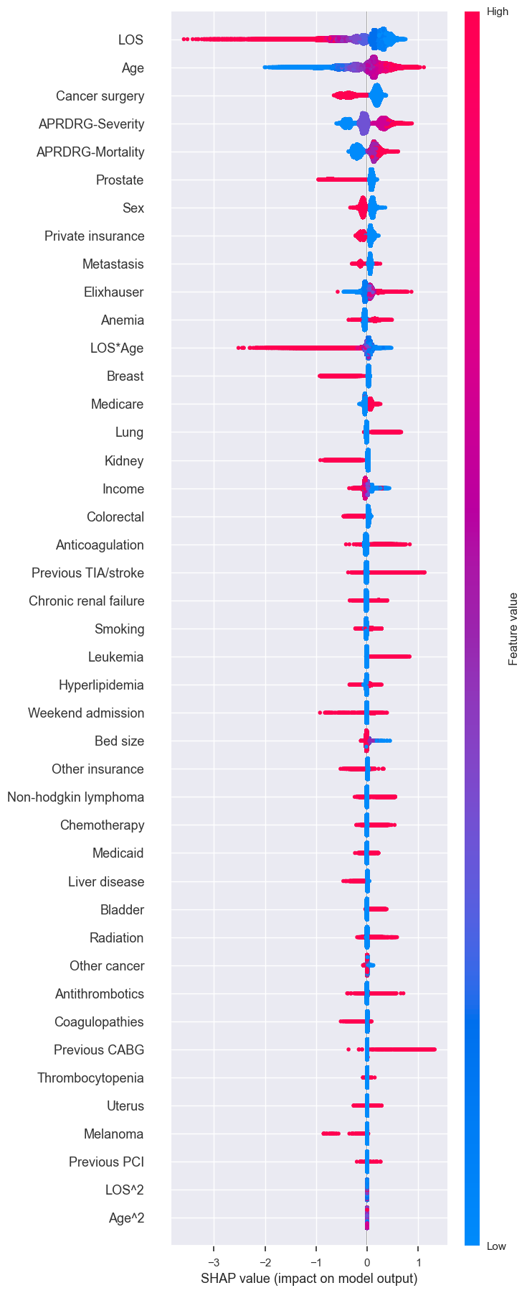
Supplementary Fig S3. The summary plot utilizes SHAP values from XGBoost.

