Supplementary Information
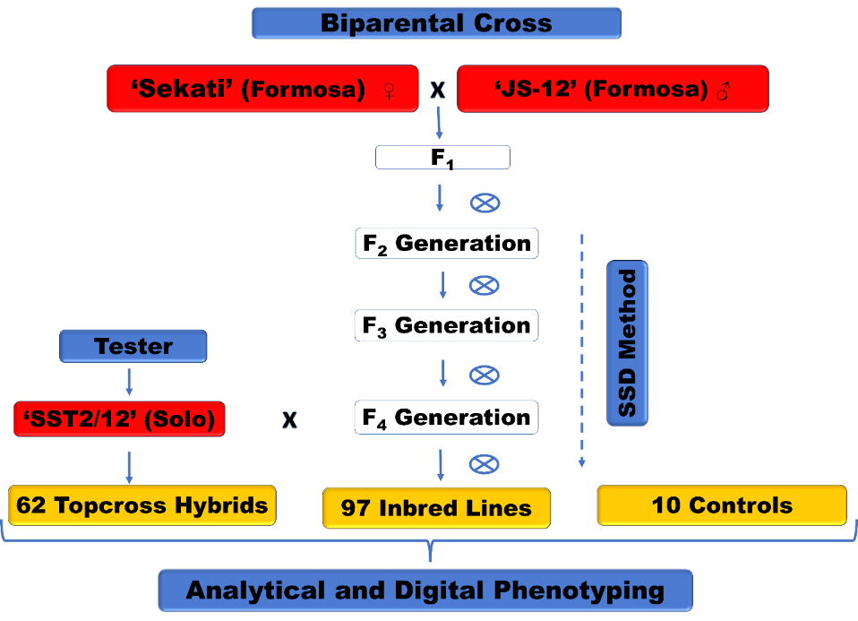
Figure S1. Flowchart of the steps for obtaining and conducting segregating populations of inbred lines and topcross hybrids from the UENF/CALIMAN papaya genetic breeding program. The biparental cross between the genotypes JS-12 and Sekati created the F₁ generation. This generation was conducted by the Single Seed Descend (SSD) method until the F₄ generation, in which the inbred lines were crossed with the SS-72/12 tester to obtain topcross hybrids, and the same inbred lines were self-fertilized to obtain the inbred lines in the F₅ generation.

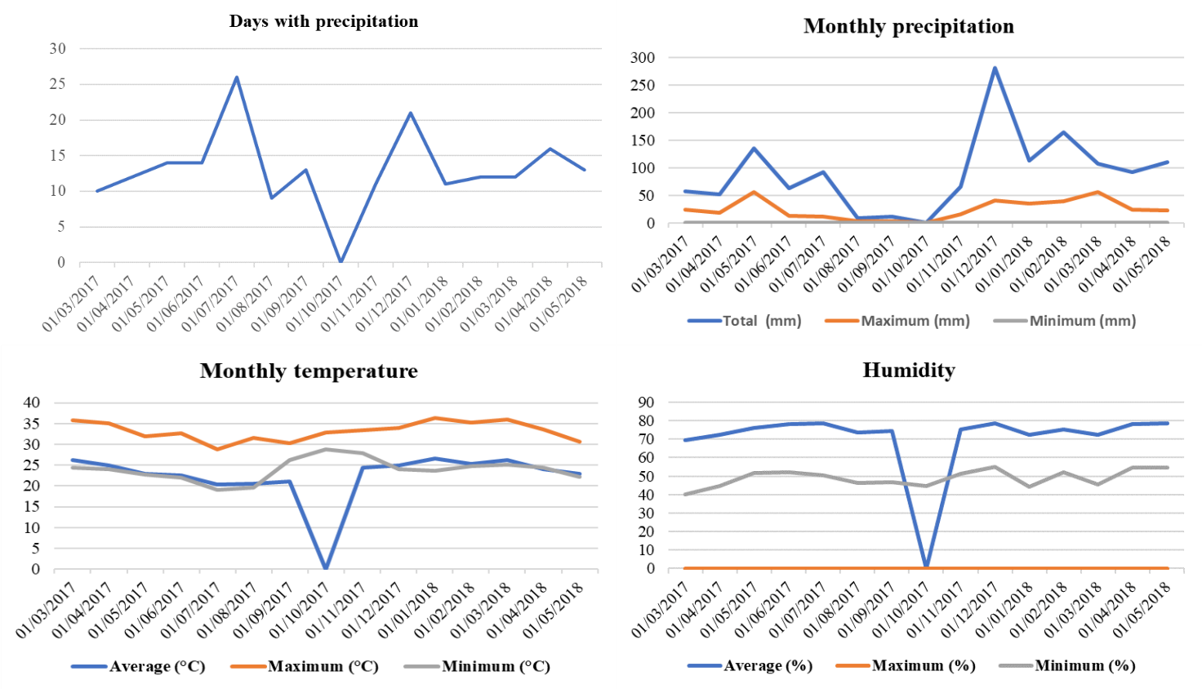
Figure S2. Monthly climatic variables during the experiment in the county of Linhares-ES. Source: adapted of INMET (2018). Zero average: no information about this climate variable.
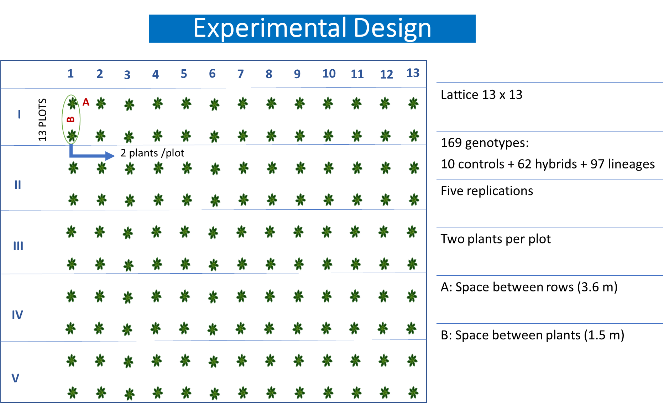
Figure S3. Sketch of the experimental design used in the genotype competition trial.

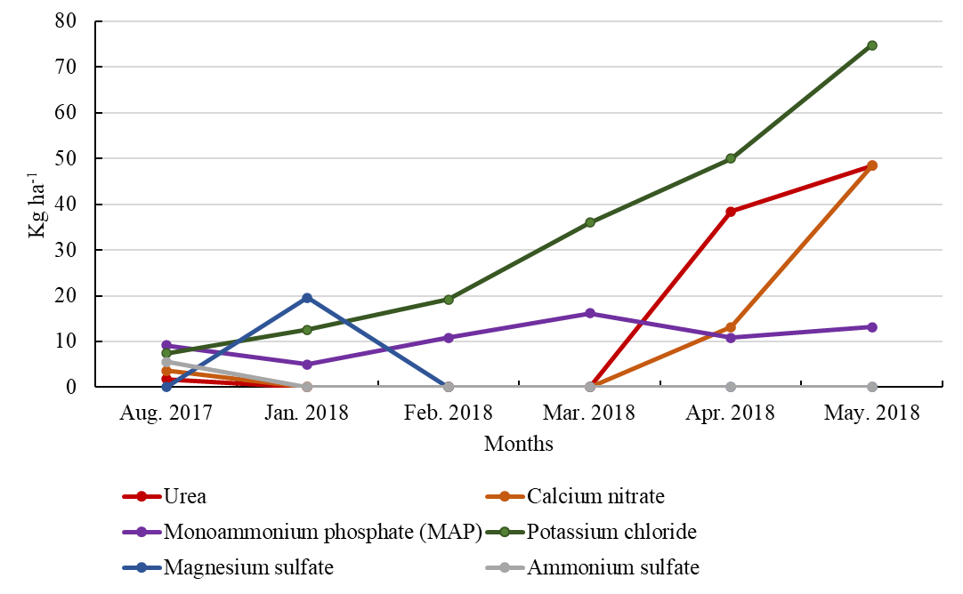
Figure S4. Fertilizers applied (kg ha⁻¹) during the three stages of fruiting.

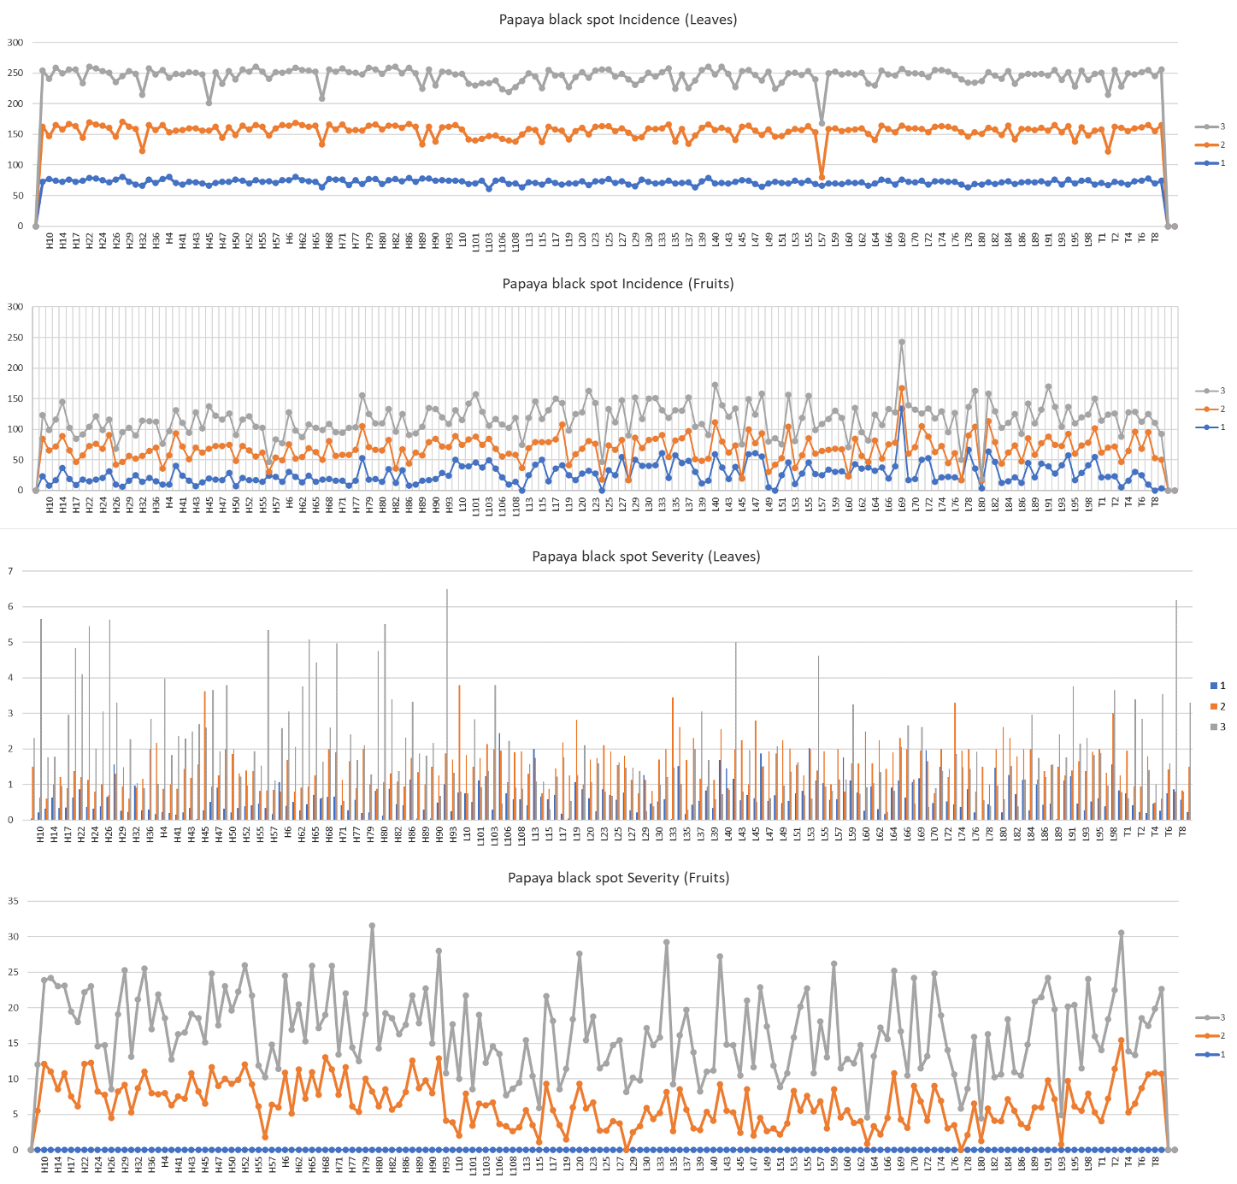
Figure S5. Incidence and severity of black spot evaluated in papaya. Seasons: 1- January/2018; 2-May/2018; 3-July/2018.

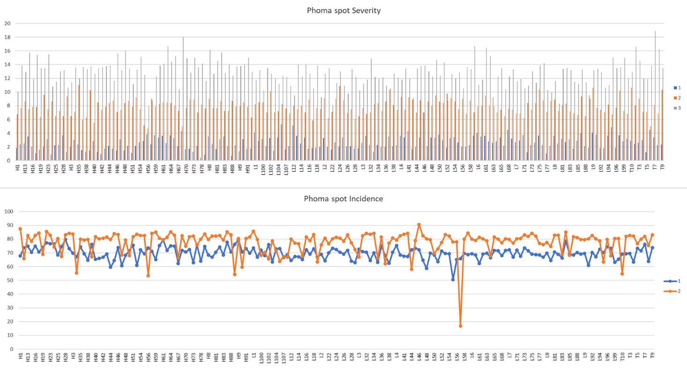Figure S6. Incidence and severity of phoma spot evaluated in papaya. Seasons: 1- January/2018; 2-May/2018; 3-July/2018.

Table S1. Phytosanitary products used during the experiment (March 2017–May 2018).
Active ingredients | Type | Application
Bifenthrin | Insecticide/Acaricide | Monthly
Abamectin | Insecticide/Acaricide | Monthly
Pyraclostrobin | Fungicide | Monthly
Chlorothalonil | Fungicide | Monthly
Difenoconazole | Fungicide | Monthly
Glyphosate | Herbicide | Every two months

Table S2. Diagnosis of the multicollinearity of the nine traits in 97 inbred papaya lines.
Traits | r ≥ 0.80 | VIF ≥ 10.0 | CN (λmax/λmin) | Matrix determinant | Multicollinearity
9 | 1 | 2 | 77.28 | 0.013247 | Weak
r: correlation coefficient; VIF: variance inflation factor; CN: condition number of the correlation matrix.

Table S3. Means by pattern of lines and controls for nine morphoagronomic traits related to fruit quality.
 |  | Traits
Pattern |  | AFW | FF | FLF | SSC | FLT | OCL | OCD | FLV | FLY
Formosa |  | 1335.64 b | 126.51 a | 87.33 a | 9.65 a | 2.84 b | 19.24 b | 4.91 b | 1003.68 b | 79.55 a
Intermediate |  | 910.16 a | 127.40 a | 84.74 a | 9.90 a | 2.60 a | 16.96 a | 4.34 a | 729.50 a | 80.12 a
Solo |  | 611.44 a | 123.79 a | 88.79 a | 10.61 a | 2.30 a | 14.93 a | 3.78 a | 507.20 a | 81.62 a
Controls
JS-12 |  | 1143.9 | 131.0 | 96.8 | 10.3 | 2.5 | 19.8 | 4.6 | 792.2 | 77.7
Sekati |  | 1200.4 | 120.4 | 87.2 | 9.2 | 2.6 | 18.9 | 5.6 | 838.9 | 71.9
SS-72/12 |  | 401.7 | 116.9 | 81.4 | 10.8 | 2.0 | 9.7 | 4.4 | 272.7 | 72.8
Maradol |  | 2231.8 | 123.9 | 86.1 | 9.4 | 3.2 | 21.7 | 6.9 | 1534.2 | 73.8
Waimanalo |  | 1752.8 | 123.4 | 75.8 | 8.5 | 2.9 | 20.2 | 6.4 | 1038.9 | 67.9
Calimosa |  | 1177.1 | 120.2 | 90.5 | 9.7 | 2.6 | 16.2 | 6.3 | 628.0 | 64.1
Tainung |  | 1750.7 | 132.9 | 89.5 | 8.4 | 2.9 | 22.2 | 6.1 | 1426.9 | 76.2
Golden |  | 371.3 | 123.7 | 78.5 | 10.4 | 1.9 | 11.5 | 3.8 | 268.4 | 75.9
Aliança |  | 547.9 | 129.6 | 78.7 | 10.2 | 2.2 | 10.4 | 4.7 | 376.6 | 75.1
UC10 |  | 1663.9 | 128.4 | 88.1 | 9.9 | 3.0 | 21.2 | 5.6 | 1085.9 | 75.6
Tukey-Kramer post hoc test for Formosa, Intermediate and Solo patterns (P < 0.05). AFW: Average Fruit Weight (g); FF: External fruit firmness (Newtons); FLF: Pulp firmness (Newtons); SSC: Soluble solids content (°Brix); FLT: Pulp thickness (cm); OCL: Length of ovarian cavity; OCD: Diameter of ovarian cavity; FLV: Flesh volume (cm³), FLY: Pulp yield (%).
Table S4. Scores of inbred papaya lines in F₅ generation on three principal components.
Componente | Linhagens
Componente | L1 | L10 | L100 | L101 | L102 | L103 | L104 | L106 | L107 | L108 | L12 | L13 | L14 | L15
1 | 1.24 | 1.25 | -0.6 | 0.18 | 1.81 | -1.77 | -2.62 | 2.75 | 3.7 | 1.87 | 1.75 | -0.88 | -0.61 | -0.81
2 | 2.24 | 0.35 | -1.74 | -1.41 | -0.55 | -1.26 | 0.74 | -1.4 | -1.13 | -2.42 | 0.17 | 0.29 | 0.65 | 0.34
3 | -0.11 | 1.54 | -2.08 | 2.18 | -0.59 | -0.05 | -2.16 | 0.31 | -0.08 | 0.57 | 1.27 | 0.61 | 0.35 | -0.99
 | L16 | L17 | L18 | L19 | L2 | L20 | L22 | L23 | L24 | L25 | L26 | L27 | L28 | L29
1 | -0.59 | -0.79 | 0.54 | 3.05 | -2.15 | -1.62 | -0.11 | 0.39 | 1.12 | 1.28 | 0.37 | -0.13 | -0.87 | -0.23
2 | 1.39 | 0.12 | -0.45 | -0.15 | -0.13 | 0.9 | 2.79 | 0.78 | -0.82 | 2.15 | -0.22 | 0.08 | -0.49 | 0.8
3 | 0.26 | -0.89 | -0.28 | 0.37 | 0.17 | -0.14 | 0.56 | -0.26 | -2.52 | -1.03 | 0.89 | 1.15 | 2.22 | -0.05
 | L3 | L30 | L32 | L33 | L34 | L35 | L36 | L37 | L38 | L39 | L4 | L40 | L41 | L43
1 | -1.12 | 2.09 | -1.2 | -0.1 | -0.12 | 0.65 | 0.54 | -1.27 | 0.7 | 3.12 | -1.2 | 0.48 | 0.14 | -1.62
2 | -0.58 | -0.64 | -1.02 | -0.93 | 1.95 | -0.44 | -0.3 | -0.41 | -0.24 | 2.35 | 0.07 | 1.2 | -0.73 | 0.31
3 | 1.21 | -1.4 | -0.08 | -0.12 | 0.06 | -0.84 | -0.91 | -0.79 | -0.17 | 0.44 | -0.61 | -0.67 | -1.31 | -0.56
 | L44 | L45 | L46 | L47 | L48 | L49 | L50 | L51 | L52 | L53 | L54 | L55 | L56 | L57
1 | -1.41 | 1.39 | 0.08 | -0.77 | -0.8 | -0.71 | -2.24 | 3.52 | -2.89 | -1.7 | -1.95 | -0.97 | 1.15 | -0.79
2 | -0.69 | -0.28 | -0.38 | 0.79 | 1.47 | 2.22 | -2.81 | 1.6 | 2.18 | -0.48 | -1.02 | -1.92 | -1.19 | -0.37
3 | -0.75 | 0.6 | -1.25 | -0.37 | 1.1 | 0.75 | -1.38 | -1.69 | -0.38 | -0.39 | -0.09 | -0.2 | -1.63 | -0.03
 | L58 | L59 | L6 | L60 | L61 | L62 | L63 | L64 | L65 | L66 | L68 | L69 | L7 | L70
1 | 0.63 | -0.72 | -0.64 | -0.65 | 4.9 | -1.93 | 4.21 | 0.75 | -0.78 | 2.13 | -1.87 | -0.99 | 0.95 | -2.29
2 | -1.27 | -1.22 | 1.26 | 0.27 | 0.44 | -1.04 | 1.47 | 0.31 | 0.09 | 1.19 | 0.89 | 0.43 | 2.54 | 0.84
3 | 0.95 | -0.61 | -0.34 | -0.94 | 0.5 | -0.46 | -0.98 | 0.78 | -1.14 | -0.11 | -0.71 | 0.71 | -2.4 | 1.86
 | L71 | L72 | L73 | L74 | L75 | L76 | L77 | L78 | L8 | L80 | L81 | L82 | L83 | L84
1 | -1.05 | 0.17 | -1.35 | -0.44 | -1.24 | 1.4 | 0.43 | 0.49 | -1.31 | 1.13 | -2.11 | 0.55 | 1.3 | -1.97
2 | -2.19 | 1.73 | 1.74 | -0.27 | -1.01 | 0.31 | -0.2 | -1.11 | -1.71 | 1.36 | -1.5 | 0.3 | -0.98 | 0.3
3 | 2.29 | 0.72 | 0.05 | 0.08 | 0.17 | -0.86 | 0.06 | -0.27 | 0.34 | 1.24 | 0.13 | 1.55 | -1.06 | 0.27
 | L85 | L86 | L88 | L89 | L9 | L91 | L92 | L93 | L94 | L95 | L96 | L98 | L99
1 | -0.69 | 3.99 | -3.77 | 1.72 | -1.35 | -1.06 | 1.33 | 0.55 | 0.1 | -2.42 | 3.89 | -1.08 | -1.41
2 | -0.5 | -1.87 | 1.15 | 0.37 | 0.25 | 0.71 | 0.19 | 0.57 | -1.06 | -0.95 | -2.91 | -0.7 | 0.49
3 | 0.73 | 1.75 | 1.7 | 1.63 | -0.31 | 0.54 | 0.12 | 2.95 | -0.33 | 0.8 | 0.07 | -0.64 | -0.58

