Water Resources Allocation Considering Water Supply and Demand Uncertainties Using Newsvendor Model-based Framework
Yanhu He^{1,2}, Yanhui Zheng^{3,4*}, Xiaohong Chen⁵, Binfen Liu¹, Qian Tan¹

D1: The derivation procedure of the optimal allocated water (${x_{i,j}^{t}}^{∗}$) without considering the constraint of reservoir inflow
The expected cost function of water allocation of $j_{th}$ water use sector in the $i_{th}$ calculation unit is as follow:
$E\left[C\left(x\right)\right]=E[C\left(x_{i,j}^{t}\right)]={E[C}_{o}\left(x_{i,j}^{t}\right)+C_{u}\left(x_{i,j}^{t}\right)+C_{p}(x_{i,j}^{t})]$
The expected cost functions of $C_{o}\left(x_{i,j}^{t}\right),$ $C_{u}\left(x_{i,j}^{t}\right)$ and $C_{p}\left(x_{i,j}^{t}\right)$ are as follows:
$E[C_{o}\left(x_{i,j}^{t}\right)]=h∙\int_{0}^{∞}{g\left(R^{t}\right)\int_{0}^{x_{i,j}^{t}}{\left(x_{i,j}^{t}−D_{i,j}^{t}\right)∙f_{i,j}\left(D_{i,j}^{t}\right)}}∙dD_{i,j}^{t}∙dR^{t}$
$E[C_{u}\left(x_{i,j}^{t}\right)]=v∙\int_{0}^{∞}{g\left(R^{t}\right)\int_{x_{i,j}^{t}}^{∞}{\left(D_{i,j}^{t}−x_{i,j}^{t}\right)∙f_{i,j}\left(D_{i,j}\right)}}∙dD_{i,j}^{t}∙dR^{t}$
$E[C_{p}\left(x_{i,j}^{t}\right)]=c∙x_{i,j}^{t}$
Thus, the first derivative of $E\left[C\left(x\right)\right]$ is as follow:
$\frac{∂E[C\left(x_{i,j}^{t}\right)]}{∂x_{i,j}^{t}}=\left(h+v\right)F_{i,j}\left(x_{i,j}^{t}\right)−1+c$
The second derivative of $E\left[C\left(x\right)\right]$ is as follow:
$\frac{∂^{2}E[C\left(x_{i,j}^{t}\right)]}{∂x_{i,j}^{t}}=\left(h+v\right)f_{i,j}\left(x_{i,j}^{t}\right)>0$
Therefore, $C\left(x_{i,j}^{t}\right)$ is a concave function, and it needs to be minimized to obtain the optimal allocated water. The upper and lower bounds of runoff and water demand should be compared to define $C\left(x_{i,j}^{t}\right)$.
$D_{i,jmin}^{t}<D_{i,j}^{t}<D_{i,jmax}^{t}$
${ R}_{min}^{t}<R^{t}<R_{max}^{t}$
If $R_{max}^{t}<D_{i,jmax}^{t}$,
$E[C_{o}\left(x_{i,j}^{t}\right)]=h∙\int_{R_{min}^{t}}^{R_{max}^{t}}{g\left(R\right)\int_{0}^{x_{i,j}^{t}}{\left(x_{i,j}^{t}−D_{i,j}^{t}\right)∙f_{i,j}\left(D_{i,j}^{t}\right)}}∙dD_{i,j}^{t}∙dR^{t}$
$E[C_{u}\left(x_{i,j}^{t}\right)]=v∙\int_{R_{min}^{t}}^{R_{max}^{t}}{g\left(R\right)\int_{x_{i,j}^{t}}^{D_{i,jmax}^{t}}{\left(D_{i,j}^{t}−x_{i,j}^{t}\right)∙f_{i,j}\left(D_{i,j}^{t}\right)}}∙dD_{i,j}^{t}∙dR^{t}$
$\frac{∂E[C_{o}\left(x_{i,j}^{t}\right)]}{∂x_{i,j}^{t}}=hF_{i,j}\left(x_{i,j}^{t}\right)$
$\frac{∂E[C_{u}\left(x_{i,j}^{t}\right)]}{∂x_{i,j}^{t}}=v\left(F_{i,j}\left(x_{i,j}^{t}\right)−1\right)$
$\frac{∂E[C\left(x_{i,j}^{t}\right)]}{∂x_{i,j}^{t}}=\left(h+v\right)F_{i,j}\left(x_{i,j}^{t}\right)−v+c$
when $\frac{∂E[C\left(x_{i,j}^{t}\right)]}{∂x_{i,j}^{t}}=0$,
$$F_{i,j}\left({x_{i,j}^{t}}^{∗}\right)=\frac{v−c}{h+v}$$
If $R_{max}^{t}>D_{i,jmax}^{t}$,
$E[C_{o}\left(x_{i,j}^{t}\right)]=h∙\int_{R_{min}^{t}}^{D_{i,jmax}^{t}}{g\left(R^{t}\right)\int_{0}^{x_{i,j}^{t}}{\left(x_{i,j}^{t}−D_{i,j}^{t}\right)∙f_{i,j}\left(D_{i,j}^{t}\right)}}∙dD_{i,j}^{t}∙dR^{t}+h∙\int_{D_{i,jmax}^{t}}^{R_{max}^{t}}{g\left(R^{t}\right)\int_{0}^{D_{i,jmax}^{t}}{\left(x_{i,j}^{t}−D_{i,j}^{t}\right)∙f_{i,j}\left(D_{i,j}^{t}\right)}}∙dD_{i,j}^{t}∙dR^{t}$
$E[C_{u}\left(x_{i,j}^{t}\right)]=v∙\int_{R_{min}^{t}}^{D_{i,jmax}^{t}}{g\left(R^{t}\right)\int_{x_{i,j}^{t}}^{D_{i,jmax}^{t}}{\left(D_{i,j}^{t}−x_{i,j}^{t}\right)∙f_{i,j}\left(D_{i,j}^{t}\right)}}∙dD_{i,j}^{t}∙dR^{t}$
when $\frac{∂E[C\left(x_{i,j}^{t}\right)]}{∂x_{i,j}^{t}}=0$,
$F_{i,j}\left({x_{i,j}^{t}}^{∗}\right)=1−\frac{h+c}{(h+v)G(D_{i,jmax}^{t})}$
${x_{i,j}^{t}}^{∗}$ is the optimal allocated water, $F_{i,j}()$ represents the cumulative distribution function (CDF) of the water demand.
D2: The derivation procedure of the optimal allocated water (${x_{i,j}^{t}}^{∗}$) without considering the constraint of reservoir inflow
The new Lagrange function is as follows:
$L(x_{i,j}^{t},λ)=\sum_{i=1}^{I}{\sum_{j=1}^{J}{[C_{o}\left(x_{i,j}^{t}\right)+C_{u}\left(x_{i,j}^{t}\right)+C_{p}\left(x_{i,j}^{t}\right)]}}+λ(\sum_{i=1}^{I}{\sum_{j=1}^{J}{x_{i,j}^{t}−Q_{max}^{t}}})$
$λ$ represents the Lagrange parameter.
If $l\left(x_{i,j}^{t},λ\right)=C_{o}\left(x_{i,j}^{t}\right)+C_{u}\left(x_{i,j}^{t}\right)+C_{p}\left(x_{i,j}^{t}\right)+λ(x_{i,j}^{t}−Q_{max}^{t})$
The following equation can be obtained according to the rule of taking the derivative of the sum of functions:
$$L^{’}\left(x_{1,1},x_{1,2},…,x_{i,j}^{t},λ\right)=l^{’}\left(x_{i,j}^{1},λ\right)+l^{’}\left(x_{i,j}^{2},λ\right)…+l^{’}\left(x_{i,j}^{T},λ\right)=\sum_{t=1}^{T}{l^{'}\left(x_{i,j}^{t},λ\right)}$$
The optimal allocated water ${x_{i,j}^{t}}^{∗}$ can be obtained as follow:
If $R_{max}<D_{i,jmax}$, when $\frac{∂l\left(x_{i,j}^{t},λ\right)}{∂x_{i,j}^{t}}=0$, $F_{i,j}\left({x_{i,j}^{t}}^{∗}\right)=\frac{v−c−λ}{h+v}$
If $R_{max}>D_{i,jmax}$,
$$C_{o}\left(x_{i,j}^{t}\right)=h∙\int_{R_{min}^{t}}^{D_{i,jmax}^{t}}{g\left(R^{t}\right)\int_{0}^{x_{i,j}^{t}}{\left(x_{i,j}^{t}−D_{i,j}^{t}\right)∙f_{i,j}\left(D_{i,j}^{t}\right)}}∙dD_{i,j}^{t}∙dR^{t}+h∙\int_{D_{i,jmax}^{t}}^{R_{max}^{t}}{g\left(R^{t}\right)\int_{0}^{D_{i,jmax}^{t}}{\left(x_{i,j}^{t}−D_{i,j}^{t}\right)∙f_{i,j}\left(D_{i,j}^{t}\right)}}∙dD_{i,j}^{t}∙dR^{t}$$
$C_{u}\left(x_{i,j}^{t}\right)=v∙\int_{R_{min}^{t}}^{D_{i,jmax}^{t}}{g\left(R^{t}\right)\int_{x_{i,j}^{t}}^{D_{i,jmax}^{t}}{\left(D_{i,j}^{t}−x_{i,j}^{t}\right)∙f_{i,j}\left(D_{i,j}^{t}\right)}}∙dD_{i,j}^{t}∙dR^{t}$
when $\frac{∂l\left(x_{i,j}^{t},λ\right)}{∂x_{i,j}^{t}}=0$, $F_{i,j}\left({x_{i,j}^{t}}^{∗}\right)=1−\frac{h+c−λ}{(h+v)G(D_{i,jmax}^{t})}$
where ${x_{i,j}^{t}}^{∗}$ is the optimal allocated water and it can be represented by $λ$. An optimal value of $λ$ is calculated to obtain the optimal allocated water${x_{i,j}^{t}}^{∗}$.

Figure caption

Fig. S1 The frequency curves of the monthly inflow of the Baipenzhu reservoir

Fig. S2 Change rates of optimal allocated water caused by doubled or decreased by 50% changes in c, h and v for each water use sector

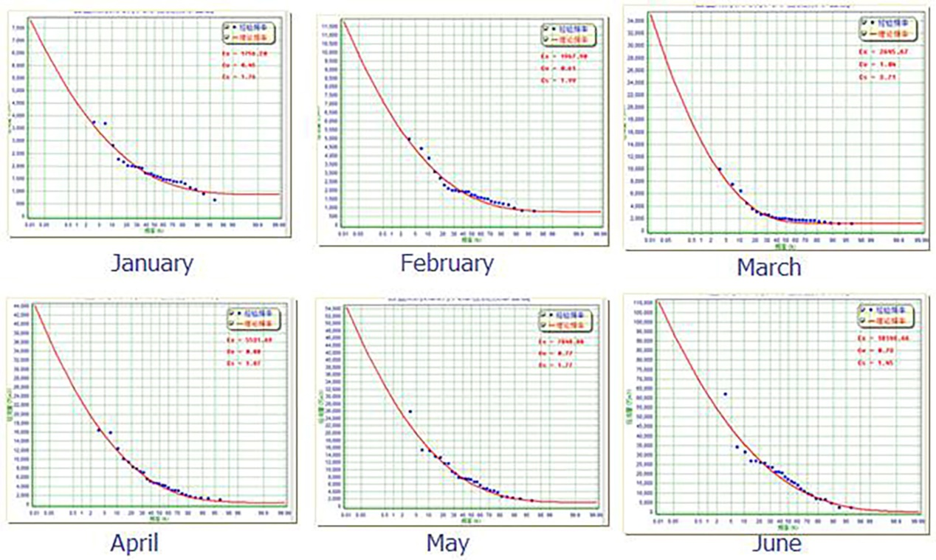
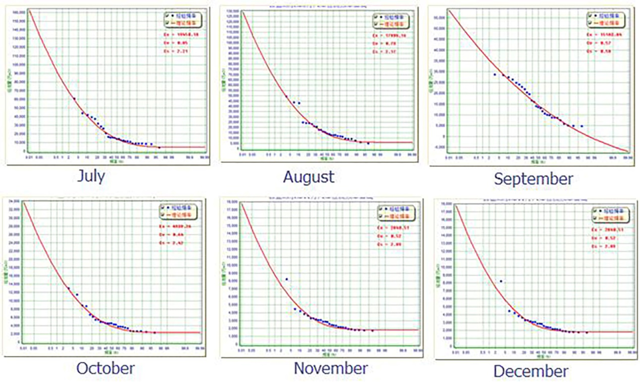
Fig. S1 The frequency curves of the monthly inflow of the Baipenzhu reservoir(this figure was generated using Delphi 7.0. (https://www.embarcadero.com/products/delphi/starter)

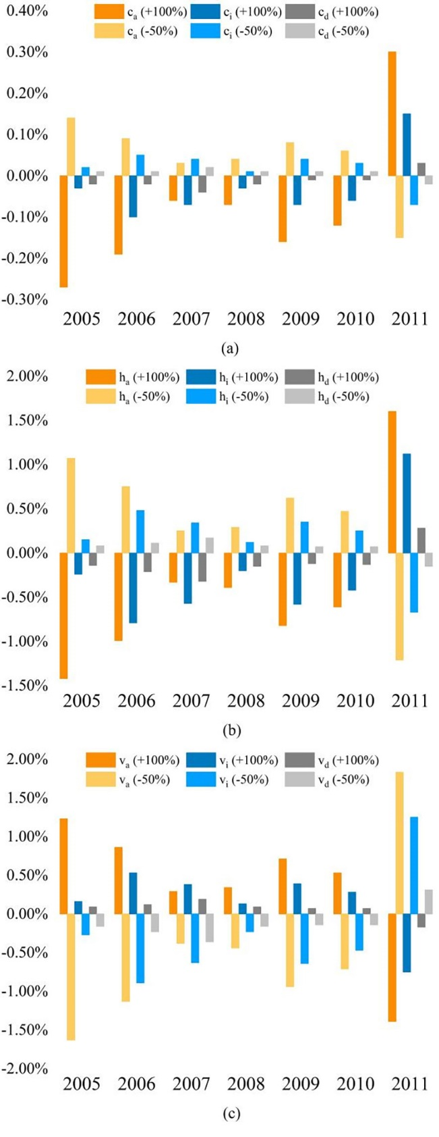
Fig. S2 Change rates of optimal allocated water caused by doubled or decreased by 50% changes in c, h and v for each water use sector

Table captions

Table. S1 Water price, the unit loss of the penalty and opportunity loss

Table. S2 The correlation coefficient of monthly reservoir inflow fitting the frequency curves

Table. S3 The intra-annual distribution coefficients of each water use sector

Table. S4 Actual allocated water from 2005 to 2011 (million m³)

Table. S5 Comparison of the water surplus for each industry under actual and optimal water allocation (million m³)

Table. S6 Comparison of the total cost of actual and optimal allocated water for each industry (million CHY)

Table. S7 Comparison of the water allocation results from the Water allocation based on the Improved Newsvendor Model and Multi-Objective Analysis model

Table. S1 Water price, the unit loss of the penalty and opportunity loss (m³/s)

Item | Huidong | Huiyang
c_{a} | 0.5 | 0.5
c_{i} | 2.38 | 3.18
c_{d} | 2.765 | 2.95
h_{a} | 5 | 5
h_{i} | 23.8 | 31.8
h_{d} | 27.65 | 29.5
v_{a} | 12 | 12
v_{i} | 222 | 148
v_{d} | 351 | 234

Note: c_{a,} c_{i} and c_{d} respectively represent water price of agriculture, industrial and domestic; h_{a,} h_{i} and h_{d} represent the unit loss of the penalty; v_{a,} v_{i} and v_{d} represents the unit loss of the opportunity loss.

Table. S2 The correlation coefficient of monthly reservoir inflow fitting the frequency curves

Month | Correlation coefficient | Month | Correlation coefficient
Jan | 0.93 | Jul | 0.97
Feb | 0.95 | Aug | 0.95
Mar | 0.97 | Sep | 0.96
Apr | 0.98 | Oct | 0.97
May | 0.96 | Nov | 0.9
Jun | 0.92 | Dec | 0.98

Table. S3 The intra-annual distribution coefficients of each water use sector
Industry | Month
Industry | Jan | Feb | Mar | Apr | May | Jun | Jul | Aug | Sep | Oct | Nov | Dec
Agriculture | 0.026 | 0.026 | 0.026 | 0.053 | 0.105 | 0.211 | 0.184 | 0.158 | 0.105 | 0.053 | 0.026 | 0.026
Industrial | 0.083 | 0.083 | 0.083 | 0.083 | 0.083 | 0.083 | 0.083 | 0.083 | 0.083 | 0.083 | 0.083 | 0.083
Domestic | 0.083 | 0.083 | 0.083 | 0.083 | 0.083 | 0.083 | 0.083 | 0.083 | 0.083 | 0.083 | 0.083 | 0.083

Table. S4 Actual allocated water from 2005 to 2011 (million m³)
Year | Huidong |  |  | Huiyang |  |  | The whole basin
Year | Agricultural | Industrial | Domestic | Agricultural | Industrial | Domestic | Agricultural | Industrial | Domestic | Total
2005 | 465.3 | 139.6 | 106.4 | 166.3 | 49.9 | 38.0 | 631.7 | 189.5 | 144.4 | 965.5
2006 | 669.6 | 198.2 | 170.6 | 239.4 | 70.9 | 61.0 | 908.9 | 269.1 | 231.5 | 1409.5
2007 | 368.0 | 123.0 | 98.5 | 131.6 | 44.0 | 35.2 | 499.6 | 167.0 | 133.8 | 800.4
2008 | 641.4 | 270.4 | 195.3 | 229.3 | 96.6 | 69.8 | 870.7 | 367.0 | 265.2 | 1502.8
2009 | 313.4 | 133.3 | 85.7 | 112.0 | 47.6 | 30.6 | 425.5 | 180.9 | 116.3 | 722.7
2010 | 291.7 | 136.7 | 87.9 | 104.3 | 48.9 | 31.4 | 395.9 | 185.6 | 119.3 | 700.8
2011 | 248.6 | 112.6 | 74.6 | 88.9 | 40.3 | 26.7 | 337.5 | 152.9 | 101.3 | 591.6

Table. S5 Comparison of the water surplus for each industry under actual and optimal water allocation (million m³)
Year |  |  | 2005 | 2006 | 2007 | 2008 | 2009 | 2010 | 2011
Actual water allocation | Huidong | Agriculture | 89.2 | 299.3 | 4.8 | 299.1 | 0.0 | 0.0 | 0.0
Actual water allocation | Huidong | Industrial | 26.7 | 88.6 | 1.6 | 126.1 | 0.0 | 0.0 | 0.0
Actual water allocation | Huidong | Domestic | 20.4 | 76.2 | 1.3 | 91.1 | 0.0 | 0.0 | 0.0
Actual water allocation | Huiyang | Agriculture | 31.9 | 107.0 | 1.7 | 106.9 | 0.0 | 0.0 | 0.0
Actual water allocation | Huiyang | Industrial | 9.6 | 31.7 | 0.6 | 45.1 | 0.0 | 0.0 | 0.0
Actual water allocation | Huiyang | Domestic | 7.3 | 27.3 | 0.5 | 32.6 | 0.0 | 0.0 | 0.0
Actual water allocation | The whole basin | Agriculture | 121.0 | 406.3 | 6.5 | 406.0 | 0.0 | 0.0 | 0.0
Actual water allocation | The whole basin | Industrial | 36.3 | 120.3 | 2.2 | 171.1 | 0.0 | 0.0 | 0.0
Actual water allocation | The whole basin | Domestic | 27.7 | 103.5 | 1.7 | 123.7 | 0.0 | 0.0 | 0.0
Actual water allocation | The whole basin | Total | 1526.3
Optimal water allocation | Huidong | Agriculture | 16.5 | 15.0 | 8.8 | 28.9 | 14.5 | 24.4 | 0.0
Optimal water allocation | Huidong | Industrial | 0.0 | 0.0 | 0.0 | 0.0 | 0.0 | 0.0 | 0.8
Optimal water allocation | Huidong | Domestic | 0.0 | 0.0 | 0.0 | 0.0 | 9.1 | 3.7 | 2.2
Optimal water allocation | Huiyang | Agriculture | 6.8 | 6.0 | 3.3 | 10.6 | 5.7 | 9.1 | 0.0
Optimal water allocation | Huiyang | Industrial | 0.0 | 0.0 | 0.0 | 0.0 | 0.0 | 0.0 | 0.0
Optimal water allocation | Huiyang | Domestic | 0.0 | 0.0 | 0.0 | 0.0 | 3.1 | 1.2 | 0.5
Optimal water allocation | The whole basin | Agriculture | 23.3 | 21.0 | 12.1 | 39.5 | 20.2 | 33.6 | 0.0
Optimal water allocation | The whole basin | Industrial | 0.0 | 0.0 | 0.0 | 0.0 | 0.0 | 0.0 | 0.6
Optimal water allocation | The whole basin | Domestic | 0.0 | 0.0 | 0.0 | 0.0 | 12.2 | 4.9 | 2.7
Optimal water allocation | The whole basin | Total | 169.9

Table. S6 Comparison of the total cost of actual and optimal allocated water for each industry (million CHY)
Year |  |  | 2005 | 2006 | 2007 | 2008 | 2009 | 2010 | 2011
Actual  allocated water | Huidong | Agriculture | 678.4 | 1831.3 | 207.9 | 1816.1 | 535.7 | 614.9 | 1149.0
Actual  allocated water | Huidong | Industrial | 968.8 | 2580.9 | 330.9 | 3643.8 | 3298.3 | 4393.0 | 8853.9
Actual  allocated water | Huidong | Domestic | 857.5 | 2579.5 | 307.8 | 3058.7 | 3266.9 | 4378.2 | 9200.1
Actual  allocated water | Huiyang | Agriculture | 242.5 | 654.7 | 74.3 | 649.2 | 191.5 | 219.8 | 410.7
Actual  allocated water | Huiyang | Industrial | 462.7 | 1232.8 | 158.0 | 1740.4 | 862.0 | 1124.8 | 2174.2
Actual  allocated water | Huiyang | Domestic | 327.1 | 983.8 | 117.4 | 1166.6 | 812.5 | 1078.2 | 2222.1
Actual  allocated water | The whole basin | Agriculture | 920.9 | 2486.0 | 282.2 | 2465.4 | 727.1 | 834.7 | 1559.7
Actual  allocated water | The whole basin | Industrial | 1431.5 | 3813.7 | 488.9 | 5384.3 | 4160.3 | 5517.7 | 11028.1
Actual  allocated water | The whole basin | Domestic | 1184.5 | 3563.4 | 425.3 | 4225.3 | 4079.4 | 5456.3 | 11422.1
Actual  allocated water | The whole basin | Total | 3536.9 | 9863.0 | 1196.4 | 12074.9 | 8966.8 | 11808.8 | 24009.9
Optimal  allocated water | Huidong | Agriculture | 279.0 | 267.6 | 229.8 | 330.0 | 252.2 | 299.8 | 838.1
Optimal  allocated water | Huidong | Industrial | 7717.9 | 804.8 | 3061.1 | 5683.2 | 1830.3 | 2890.5 | 381.1
Optimal  allocated water | Huidong | Domestic | 2355.5 | 3650.2 | 2039.7 | 3063.2 | 536.8 | 388.2 | 344.6
Optimal  allocated water | Huiyang | Agriculture | 104.4 | 99.0 | 83.3 | 119.3 | 93.1 | 109.4 | 263.2
Optimal  allocated water | Huiyang | Industrial | 1934.4 | 423.2 | 911.7 | 1466.8 | 645.2 | 864.8 | 200.4
Optimal  allocated water | Huiyang | Domestic | 627.9 | 953.2 | 598.1 | 803.0 | 200.4 | 143.8 | 122.0
Optimal  allocated water | The whole basin | Agriculture | 383.3 | 366.6 | 313.1 | 449.4 | 345.3 | 409.2 | 1101.2
Optimal  allocated water | The whole basin | Industrial | 9652.3 | 1227.9 | 3972.8 | 7150.0 | 2475.4 | 3755.3 | 581.5
Optimal  allocated water | The whole basin | Domestic | 2983.4 | 4603.4 | 2637.8 | 3866.2 | 737.2 | 532.0 | 466.6
Optimal  allocated water | The whole basin | Total | 13019.1 | 6198.0 | 6923.7 | 11465.6 | 3558.0 | 4696.5 | 2149.4

Table. S7 Comparison of the water allocation results from the Water allocation based on the Improved Newsvendor Model and Multi-Objective Analysis model

Water use sector | Actual water use (million m³) | Allocated water (million m³) |  | Water deficit （million m³） |  | Water surplus （million m³） |  | Total cost （million CHY）
Water use sector | Actual water use (million m³) | WAINM | MOA | WAINM | MOA | WAINM | MOA | WAINM | MOA
Agriculture | 510.6 | 533.9 | 282.9 | 0.0 | 227.7 | 23.3 | 0.0 | 383.3 | 2874.1
Industrial | 153.2 | 106.8 | 141.9 | 46.4 | 11.3 | 0.0 | 0.0 | 9652.3 | 11466.5
Domestic | 116.7 | 108.3 | 29.3 | 8.4 | 87.4 | 0.0 | 0.0 | 2983.4 | 28148.8
Total | 780.5 | 749.0 | 454.1 | 54.8 | 326.4 | 0.0 | 0.0 | 13019.0 | 42489.4

