Genome-wide Study of Globally Distributed Respiratory Syncytial Virus (RSV) Strains Implicates Diversification Utilizing Phylodynamics and Mutational Analysis

Tushar Ahmed Shishir^{1*}, Otun Saha^{2*#}, Sultana Rajia², Spencer Mark Mondol³, Md. Habib Ullah Masum², Md Mizanur Rahaman³, Foysal Hossen², Newaz Mohammed Bahadur⁴, Firoz Ahmed², Iftekhar Bin Naser¹, Mohammad Ruhul Amin^{2#}
¹Department of Mathematics and Natural Sciences, BRAC University, Bangladesh.
²Department of Microbiology, Noakhali Science and Technology University, Noakhali, Bangladesh.
³Department of Microbiology, University of Dhaka, Dhaka, Bangladesh.
⁴Department of Chemistry, Noakhali Science and Technology University, Bangladesh

#Corresponding Author
Mohammad Ruhul Amin
Associate Professor
Department of Microbiology
Noakhali Science and Technology University, Noakhali, Bangladesh
E-mail: ruhulmicro4355@gmail.com
and
Dr. Otun Saha
Assistant Professor
Department of Microbiology
Noakhali Science and Technology University, Noakhali, Bangladesh
Mobile: +8801725830666
E-mail: otun.saha@nstu.edu.bd
*Equal Contribution
#Correspondence

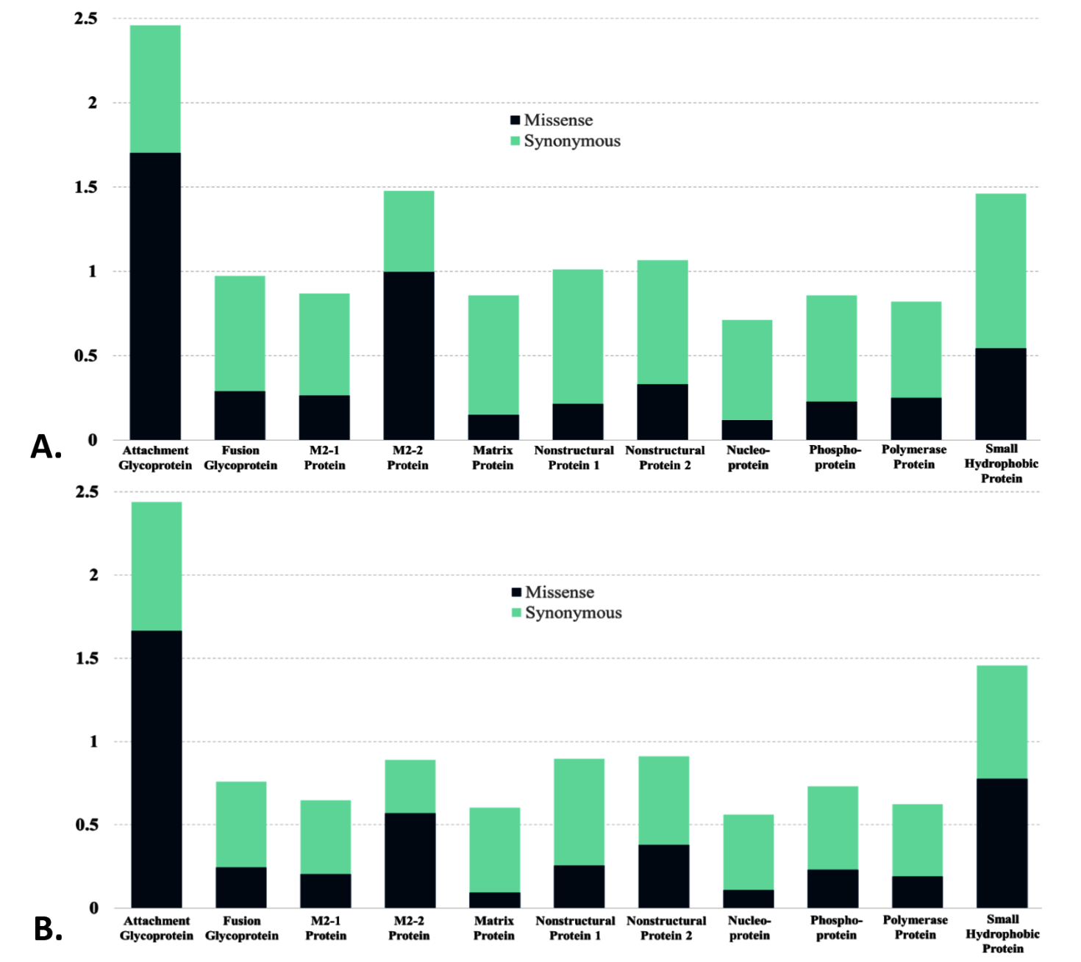
Supplementary Figure 1. The mutation per base including missense and synonymous mutation of the proteins from RSV A (A) and RSV B (B).

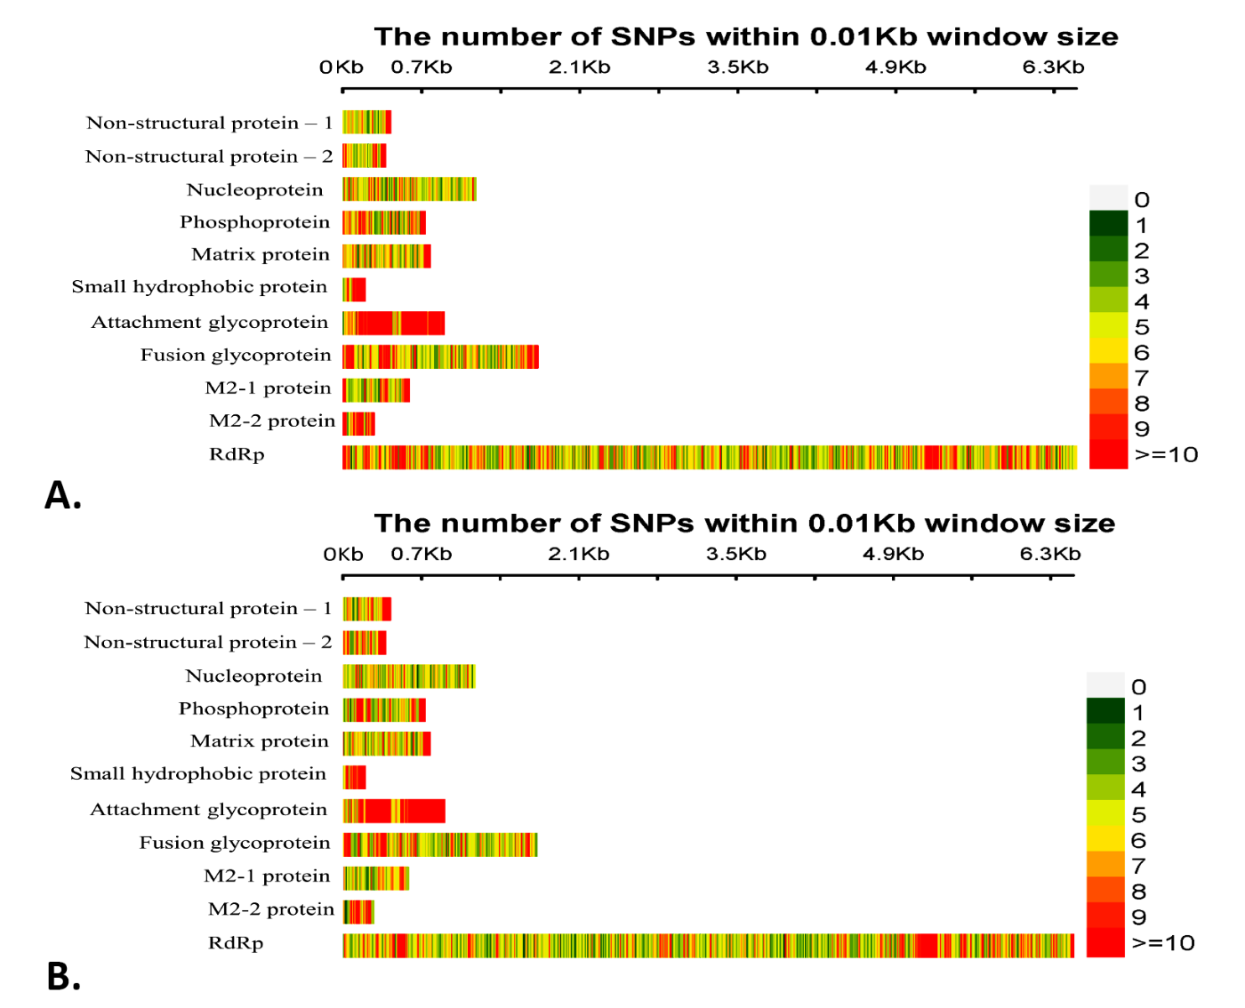
Supplementary figure 2. The number of SNPs calculated in RSV A (A) and RSV B (B) genome. The vertical plot represents the genome size and the color gradient represents the intensity of the SNPs, where red (>10) and white color (0) signifies highest and lowest intensity of SNPs, respectively.

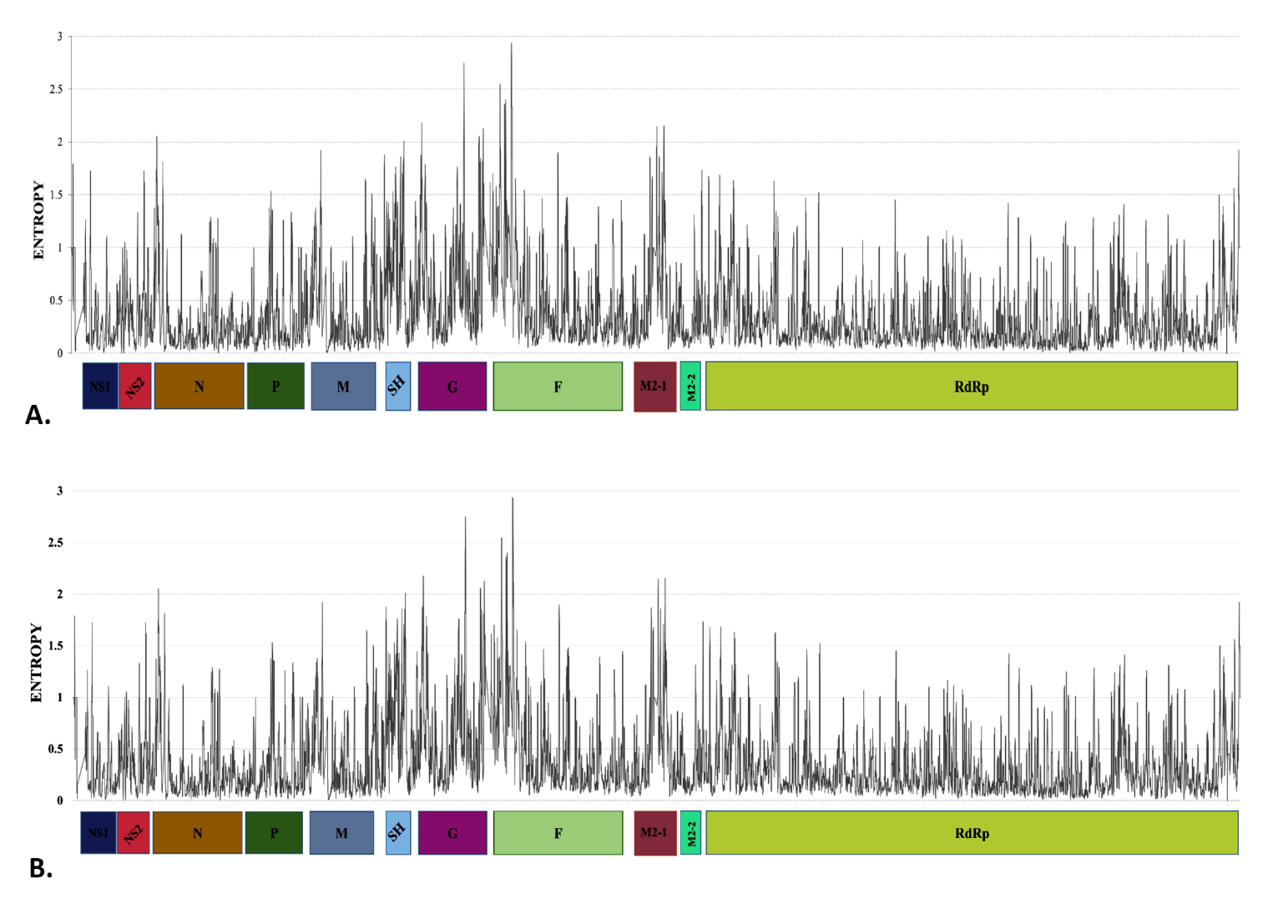
Supplementary figure 3. Graphical depiction of Shanon’s Entropy of each protein from RSV A (A) and RSV B (B) strain.

Supplementary table 1. The mutational effects of RSV A including nucleotide diversity, shanon’s entropy, tajima’s D, dN/dS, and the no. of sites towards positive and negative selection.
Gene | Nucleotide diversity (π) | Shanon’s Entropy | Tajima’s D | dN/dS | No. of sites towards positive selection | No. of sites towards negative selection
Attachment glycoprotein | 0.0682 | 0.673744 | -1.20544 | 0.555 | 30 | 88
Fusion glycoprotein | 0.05493 | 0.597168 | -1.58848 | 0.126 | 3 | 287
M2-1 protein | 0.00571 | 0.607837 | -2.74577 | 0.146 | 0 | 81
M2-2 protein | 0.04326 | 0.393619 | -1.87467 | 0.44 | 1 | 20
Matrix protein | 0.05086 | 0.402197 | -0.158127 | 0.054 | 0 | 136
Nonstructural protein 1 | 0.01642 | 0.348631 | -2.1172 | 0.112 | 0 | 46
Nonstructural protein 2 | 0.03293 | 0.466468 | -2.07846 | 0.147 | 1 | 55
Nucleoprotein | 0.04528 | 0.407658 | -1.7071 | 0.0492 | 0 | 211
Phosphoprotein | 0.03824 | 0.307252 | -1.83539 | 0.106 | 2 | 124
Polymerase Protein | 0.02071 | 0.391668 | -2.39656 | 0.116 | 7 | 1028
Small Hydrophobic Protein | 0.0411 | 0.595248 | -1.86818 | 0.23 | 1 | 17

Supplementary table 2. The mutational effects of RSV B including nucleotide diversity, shanon’s entropy, tajima’s D, dN/dS, and the no. of sites towards positive and negative selection.
Gene | Nucleotide diversity (π) | Shanon’s Entropy | Tajima’s D | dN/dS | No. of sites towards positive selection | No. of sites towards negative selection
Attachment glycoprotein | 0.02861 | 0.585509 | -2.20653 | 0.506 | 4 | 42
Fusion glycoprotein | 0.02307 | 0.475052 | -2.35027 | 0.133 | 4 | 261
M2-1 protein | 0.01681 | 0.479818 | -2.42557 | 0.167 | 1 | 87
M2-2 protein | 0.00533 | 0.294856 | -2.76488 | 0.412 | 3 | 20
Matrix protein | 0.0211 | 0.334778 | -2.3569 | 0.0528 | 0 | 135
Nonstructural protein 1 | 0.01302 | 0.272656 | -2.41123 | 0.15 | 0 | 47
Nonstructural protein 2 | 0.01155 | 0.374362 | -2.61719 | 0.248 | 1 | 55
Nucleoprotein | 0.0147 | 0.294509 | -2.53579 | 0.049 | 0 | 225
Phosphoprotein | 0.01688 | 0.317647 | -2.44577 | 0.129 | 0 | 126
Polymerase Protein | 0.02597 | 0.308025 | -2.30037 | 0.113 | 5 | 928
Small Hydrophobic Protein | 0.01147 | 0.953729 | -2.62595 | 0.351 | 1 | 16

