Supplementary Figures

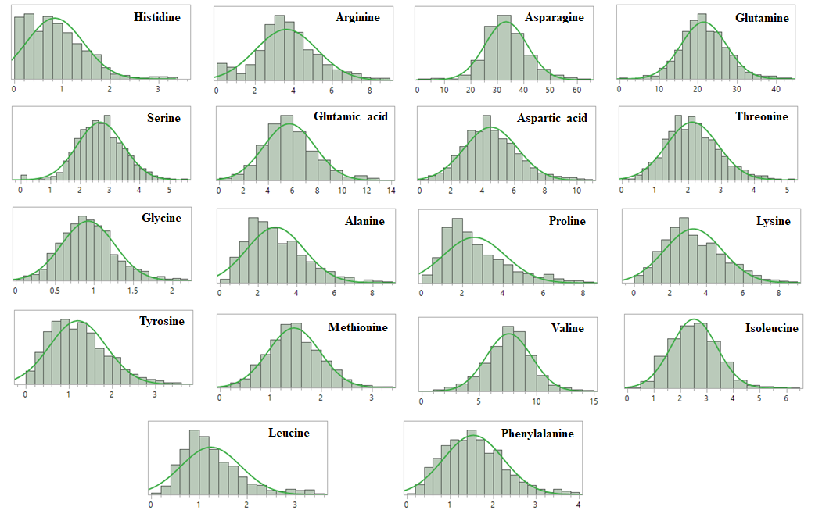
W = 0.983 P = 0.012
W = 0.987 P = 0.043
W = 0.991 P = 0.178
W = 0.973 P = 0.0004
W = 0.990 P = 0.149
W = 0.993 P = 0.456
W = 0.995 P = 0.689
W = 0.973 P = 0.0004
W = 0.945 P = <.0001
W = 0.995 P = 0.724
W = 0.997 P = 0.950
W = 0.979 P = 0.003
W = 0.994 P = 0.558
W = 0.993 P = 0.401
W = 0.995 P = 0.714
W = 0.973 P = 0.0004
W = 0.957 P = <.0001
W = 0.985 P = 0.029

Supplementary Figure 1: Distributions of percent free amino acids across 217 potato clones evaluated in Dalhart, Texas in 2019 and 2020, and Springlake, Texas in 2020. Both the test statistic (W) and associated p value from a Shapiro–Wilk normality test are shown.

