Supplementary Information

Targeted gene expression profiling for accurate endometrial receptivity testing
Alvin Meltsov^{Ϯ1,2} & Merli Saare^{Ϯ1,3}, Hindrek Teder^{1,4}, Priit Paluoja^{1,3}, Riikka K. Arffman⁵, Terhi Piltonen⁵, Piotr Laudanski^{6,7,8}, Mirosław Wielgoś⁹, Luca Gianaroli¹⁰, Mariann Koel¹¹, Maire Peters^{1,3}, Andres Salumets^{1,3,12}, Kaarel Krjutškov*^{1,3} and Priit Palta*^{1,11,13}

1 Competence Centre on Health Technologies; 50411 Tartu, Estonia
2 Department of Genetics and Cell Biology, GROW School for Oncology and Developmental Biology, Maastricht University; 6200 MD Maastricht, The Netherlands

3 Department of Obstetrics and Gynecology, Institute of Clinical Medicine, University of Tartu; 50406 Tartu, Estonia

4 Institute of Biomedicine and Translational Medicine, University of Tartu; 50411 Tartu, Estonia

5 Department of Obstetrics and Gynecology, PEDEGO Research Unit, Medical Research Center, Oulu University Hospital, University of Oulu; FI-90014 Oulu, Finland

6 Oviklinika Infertility Center; 01-377 Warsaw, Poland

7 Women’s Health Research Institute, Calisia University; 62-800 Kalisz, Poland

8 Department of Obstetrics, Gynaecology, Gynecology and Gynaecological Oncology, Medical University of Warsaw; 02-091 Warsaw, Poland

9 Premium Medical Clinic; 04-359 Warsaw, Poland

10 SISMeR, Reproductive Medicine Institute; 40138 Bologna, Italy

11 Institute of Genomics, University of Tartu; 51010 Tartu, Estonia

12 Division of Obstetrics and Gynecology, Department of Clinical Science, Intervention and Technology (CLINTEC), Karolinska Institutet and Karolinska University Hospital; SE-141 52 Stockholm, Sweden

13 Institute for Molecular Medicine Finland (FIMM), University of Helsinki; FI-00014 Helsinki, Finland

Ϯ The authors consider that the first two authors should be regarded as joint First Authors

* The authors consider that the last two authors should be regarded as joint Last Authors

Supplementary Table
Supplementary Table I. Gene-wise differential analysis between PCOS and healthy subjects. FDR – false discovery rate; ANOVA – analysis of variance.
Gene | Pre-receptive P-Value | Pre-receptive FDR | Receptive P-Value | Receptive FDR | Post-receptive P-Value | Post-receptive FDR | ANOVA P-Value
ABCC3 | 0.563 | 0.985 | 0.601 | 0.971 | 0.846 | 0.913 | 0.628
ACADSB | 0.324 | 0.985 | 0.245 | 0.882 | 0.041 | 0.630 | 0.882
ANXA2 | 0.855 | 0.985 | 0.661 | 0.971 | 0.774 | 0.877 | 0.988
ANXA4 | 0.978 | 0.985 | 0.235 | 0.882 | 0.887 | 0.928 | 0.794
AOX1 | 0.524 | 0.985 | 0.641 | 0.971 | 0.487 | 0.715 | 0.361
APOD | 0.629 | 0.985 | 0.149 | 0.882 | 0.451 | 0.696 | 0.364
AQP3 | 0.947 | 0.985 | 0.819 | 0.971 | 0.393 | 0.696 | 0.990
ARG2 | 0.524 | 0.985 | 0.313 | 0.882 | 0.228 | 0.630 | 0.613
ARID5B | 0.514 | 0.985 | 0.324 | 0.882 | 0.433 | 0.696 | 0.610
BCL6 | 0.475 | 0.985 | 0.432 | 0.956 | 0.934 | 0.948 | 0.650
C10orf10 | 0.099 | 0.985 | 0.483 | 0.965 | 0.170 | 0.630 | 0.706
C1R | 0.251 | 0.985 | 0.832 | 0.971 | 0.377 | 0.696 | 0.950
C4BPA | 0.908 | 0.985 | 0.786 | 0.971 | 0.238 | 0.630 | 0.998
CAAP1 | 0.772 | 0.985 | 0.946 | 0.971 | 0.361 | 0.696 | 0.752
CAMK2D | 0.759 | 0.985 | 0.767 | 0.971 | 0.361 | 0.696 | 0.646
CD55 | 0.693 | 0.985 | 0.729 | 0.971 | 0.341 | 0.696 | 0.898
CEBPD | 0.973 | 0.985 | 0.290 | 0.882 | 0.105 | 0.630 | 0.867
CFD | 0.517 | 0.985 | 0.926 | 0.971 | 0.125 | 0.630 | 0.782
CLDN4 | 0.733 | 0.985 | 0.189 | 0.882 | 0.603 | 0.804 | 0.733
COMP | 0.798 | 0.985 | 0.306 | 0.882 | 0.281 | 0.681 | 0.544
CP | 0.270 | 0.985 | 0.904 | 0.971 | 0.200 | 0.630 | 0.692
CRABP2 | 0.961 | 0.985 | 0.536 | 0.971 | 0.635 | 0.814 | 0.849
DDX52 | 0.470 | 0.985 | 0.565 | 0.971 | 0.565 | 0.784 | 0.989
DEFB1 | 0.262 | 0.985 | 0.682 | 0.971 | 0.300 | 0.685 | 0.901
DKK1 | 0.208 | 0.985 | 0.058 | 0.850 | 0.347 | 0.696 | 0.594
DPP4 | 0.512 | 0.985 | 0.926 | 0.971 | 0.183 | 0.630 | 0.458
DYNLT3 | 0.873 | 0.985 | 0.898 | 0.971 | 0.227 | 0.630 | 0.848
EDN3 | 0.487 | 0.985 | 0.321 | 0.882 | 0.831 | 0.912 | 0.921
EDNRB | 0.983 | 0.985 | 0.296 | 0.882 | 0.471 | 0.711 | 0.558
EFNA1 | 0.703 | 0.985 | 0.928 | 0.971 | 0.166 | 0.630 | 0.978
ENPEP | 0.395 | 0.985 | 0.847 | 0.971 | 0.155 | 0.630 | 0.265
FOXN2 | 0.384 | 0.985 | 0.938 | 0.971 | 0.753 | 0.877 | 0.401
G0S2 | 0.482 | 0.985 | 0.423 | 0.956 | 0.727 | 0.877 | 0.642
GADD45A | 0.738 | 0.985 | 0.357 | 0.899 | 0.175 | 0.630 | 0.700
GBP2 | 0.908 | 0.985 | 0.902 | 0.971 | 0.197 | 0.630 | 0.920
GGNBP2 | 0.776 | 0.985 | 0.118 | 0.882 | 0.210 | 0.630 | 0.674
GNLY | 0.266 | 0.985 | 0.652 | 0.971 | 0.877 | 0.928 | 0.783
GPX3 | 0.836 | 0.985 | 0.660 | 0.971 | 0.770 | 0.877 | 0.675
HABP2 | 0.101 | 0.985 | 0.920 | 0.971 | 0.087 | 0.630 | 0.579
ICA1L | 0.400 | 0.985 | 0.095 | 0.850 | 0.214 | 0.630 | 0.072
ID4 | 0.815 | 0.985 | 0.477 | 0.965 | 0.347 | 0.696 | 0.829
IDO1 | 0.226 | 0.985 | 0.818 | 0.971 | 0.442 | 0.696 | 0.864
IGFBP1 | 0.301 | 0.985 | 0.100 | 0.850 | 0.179 | 0.630 | 0.819
IL15 | 0.170 | 0.985 | 0.283 | 0.882 | 0.496 | 0.715 | 0.771
LAMB3 | 0.165 | 0.985 | 0.815 | 0.971 | 0.664 | 0.836 | 0.866
LEFTY1 | 0.316 | 0.985 | 0.046 | 0.850 | 0.996 | 0.996 | 0.278
MAOA | 0.772 | 0.985 | 0.528 | 0.971 | 0.420 | 0.696 | 0.930
MAP3K5 | 0.677 | 0.985 | 0.461 | 0.965 | 0.162 | 0.630 | 0.773
MMP7 | 0.985 | 0.985 | 0.090 | 0.850 | 0.165 | 0.630 | 0.625
MT1G | 0.624 | 0.985 | 0.895 | 0.971 | 0.302 | 0.685 | 0.816
MT1H | 0.307 | 0.985 | 0.299 | 0.882 | 0.385 | 0.696 | 0.886
NDRG1 | 0.972 | 0.985 | 0.011 | 0.761 | 0.827 | 0.912 | 0.103
NNMT | 0.366 | 0.985 | 0.957 | 0.971 | 0.197 | 0.630 | 0.995
OGT | 0.654 | 0.985 | 0.064 | 0.850 | 0.200 | 0.630 | 0.983
OLFM1 | 0.461 | 0.985 | 0.309 | 0.882 | 0.706 | 0.873 | 0.987
PAEP | 0.769 | 0.985 | 0.848 | 0.971 | 0.755 | 0.877 | 0.689
PPIP5K2 | 0.700 | 0.985 | 0.256 | 0.882 | 0.156 | 0.630 | 0.675
PRUNE2 | 0.599 | 0.985 | 0.370 | 0.899 | 0.438 | 0.696 | 0.921
RIC3 | 0.374 | 0.985 | 0.750 | 0.971 | 0.627 | 0.814 | 0.295
S100P | 0.459 | 0.985 | 0.912 | 0.971 | 0.902 | 0.930 | 0.896
SERPING1 | 0.864 | 0.985 | 0.994 | 0.994 | 0.441 | 0.696 | 0.890
SFRP4 | 0.343 | 0.985 | 0.436 | 0.956 | 0.585 | 0.795 | 0.897
SLC1A1 | 0.856 | 0.985 | 0.763 | 0.971 | 0.280 | 0.681 | 0.481
SPP1 | 0.629 | 0.985 | 0.059 | 0.850 | 0.125 | 0.630 | 0.805
TCN1 | 0.221 | 0.985 | 0.370 | 0.899 | 0.504 | 0.715 | 0.344
TPM2 | 0.505 | 0.985 | 0.549 | 0.971 | 0.241 | 0.630 | 0.499
TSPAN8 | 0.907 | 0.985 | 0.292 | 0.882 | 0.051 | 0.630 | 0.529
YARS2 | 0.517 | 0.985 | 0.200 | 0.882 | 0.040 | 0.630 | 0.305

Supplementary Figures
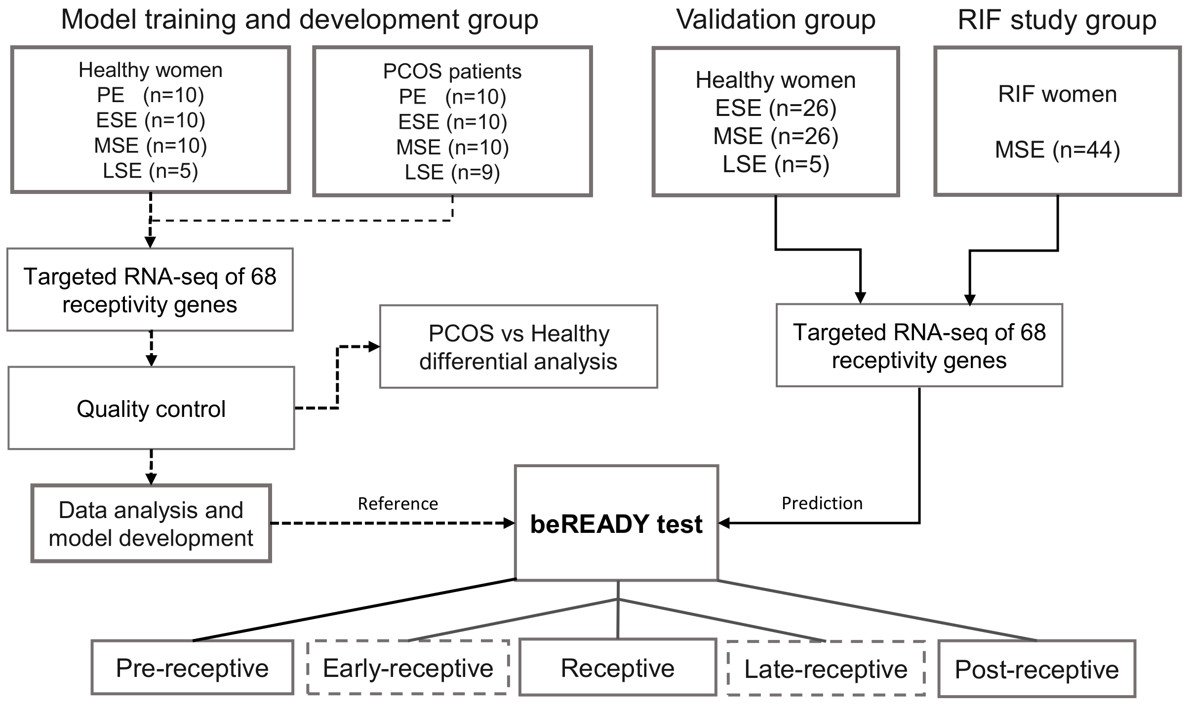
Supplementary Figure 1. Overview of the study design.
RIF – recurrent implantation failure, PCOS – polycystic ovary syndrome, ESE – early-secretory phase, MSE – mid-secretory phase, LSE – late-secretory phase.
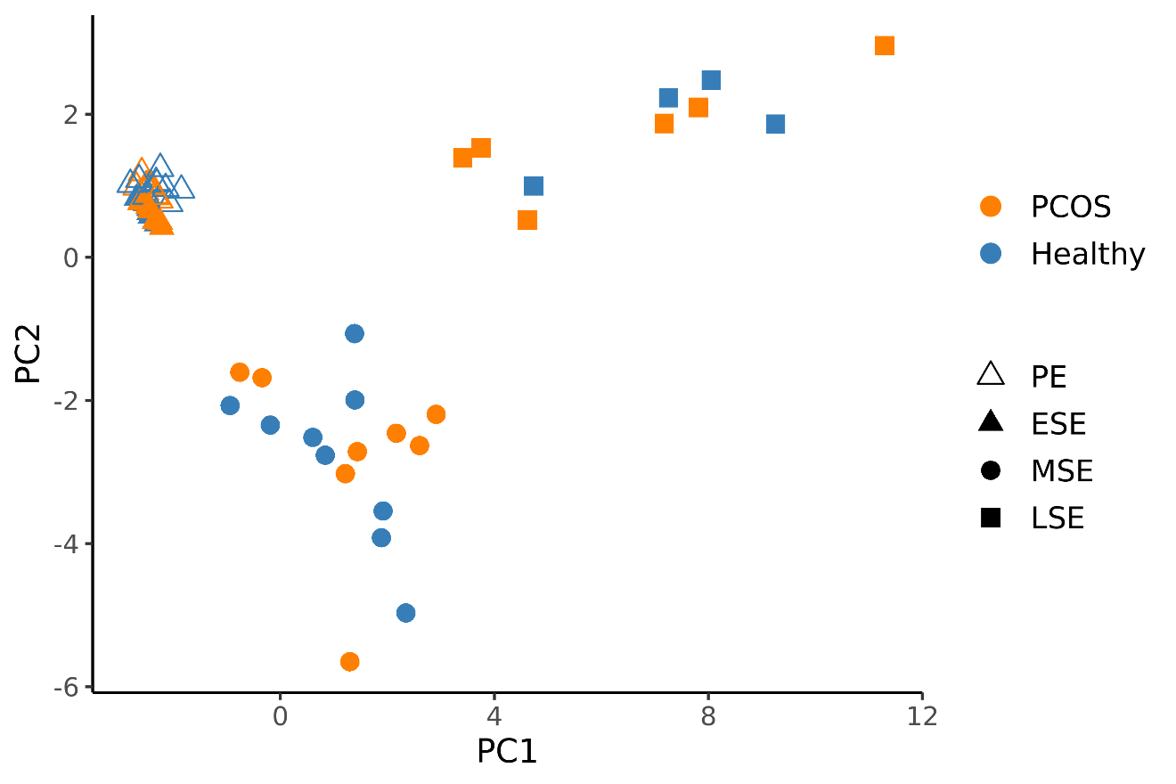
Supplementary Figure 2. PCA plot of the model development (MD) set.
The UMI-corrected counts were normalised with the geometric mean of housekeepers and scaled. PCOS – polycystic ovarian syndrome, PE – proliferative phase, ESE – early-secretory phase, MSE – mid-secretory phase, LSE – late-secretory phase.

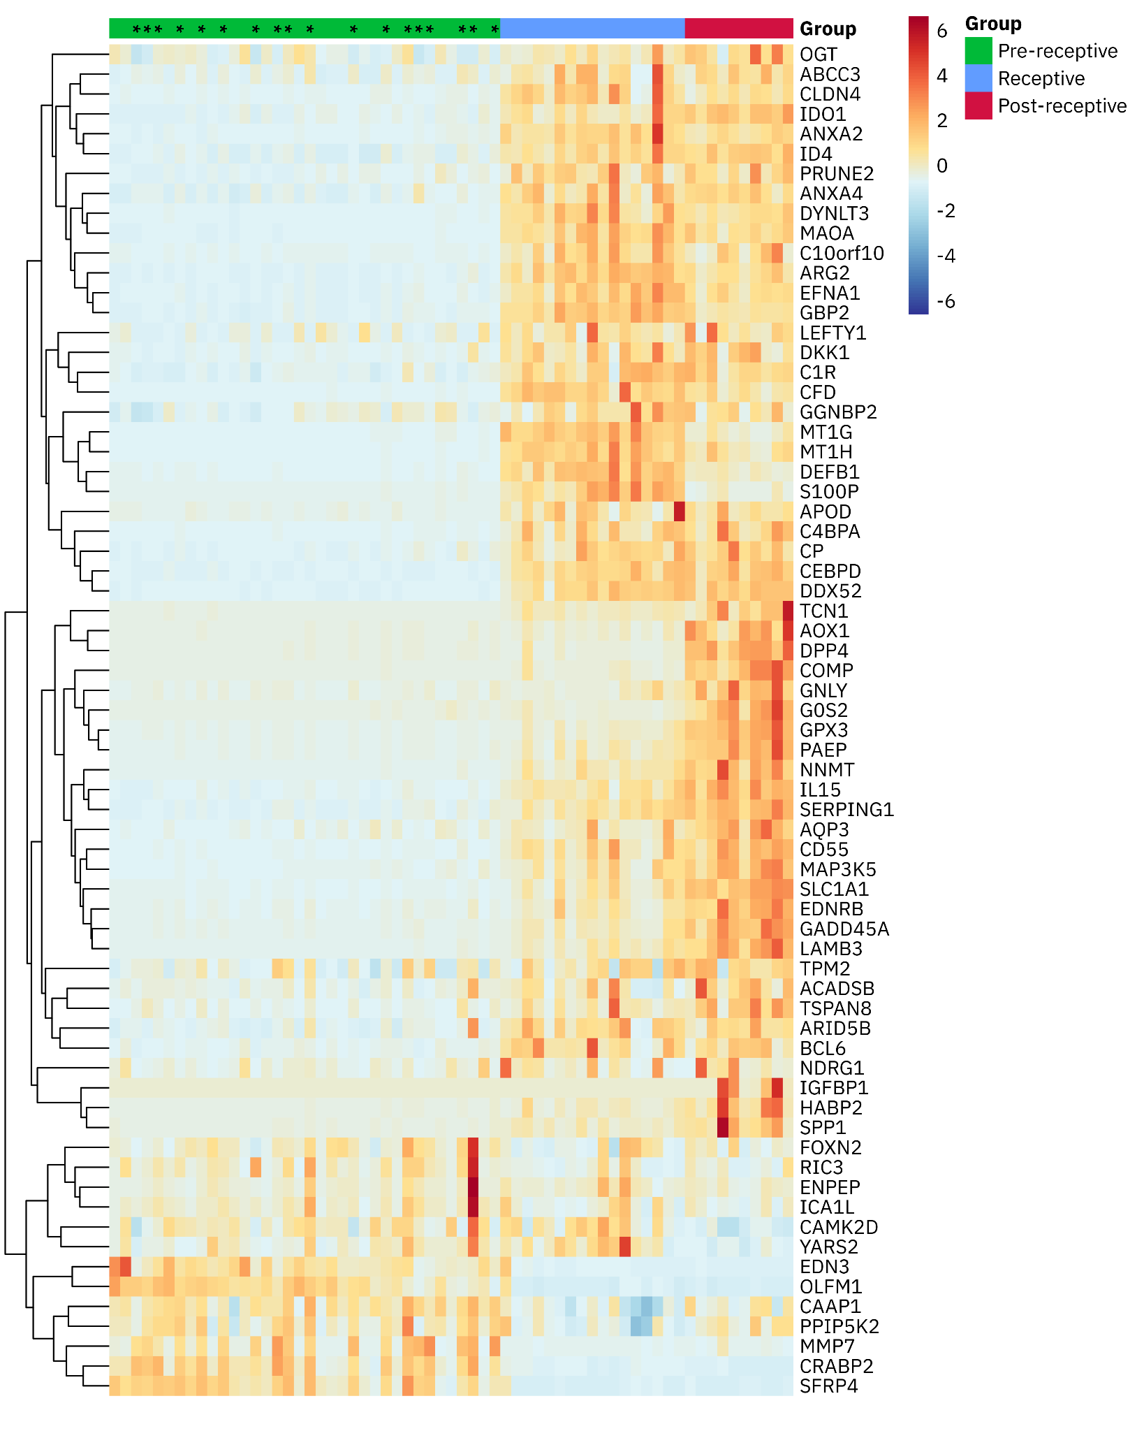
Supplementary Figure 3. Heatmap of the scaled expression levels of normalised model training and development group samples.
Samples are ordered by the output score of the model. The genes are clustered hierarchically. Biomarker read counts are normalised with the harmonic mean of the housekeeper gene counts and gene-wise scaling was applied. Proliferative phase samples are marked with an asterisk (*).

