Figure i. Proportionate incidence of diarrheagenic bacterial pathogens among children.

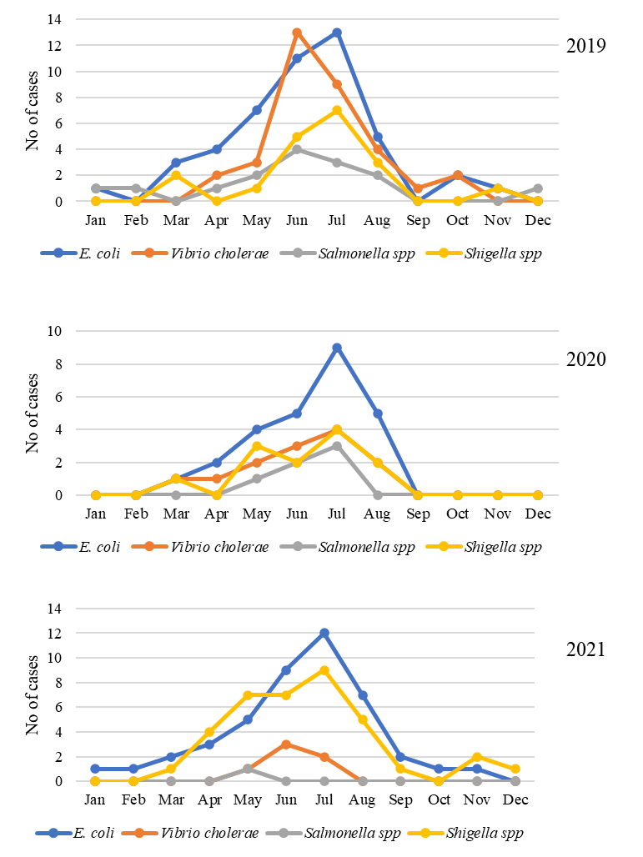
Figure ii. Seasonal distribution of bacterial pathogens isolated from children with diarrhea in Bangladesh.

Figure iii. Prevalence of mixed infection among children with diarrhea.

Figure iv. Frequency of clinical symptoms among patients infected with diarrheagenic pathogens.

Figure v. Duration of diarrhea among patients infected with bacterial pathogens.

Figure vi. Frequency of phenotypic and genotypic resistance properties of bacterial pathogens among patients with diarrhea.

