Homogentisate 1,2-dioxygenase (HGD) gene variants in young Egyptian patients with alkaptonuria

Zeinab S. Abdelkhalek^{1,} *, Iman G. Mahmoud², Heba Omair¹, Mohamed Abdulhay³, Mohamed A. Elmonem¹

¹ Clinical and Chemical Pathology Department, Faculty of Medicine, Cairo University, Cairo, Egypt
² Pediatrics Neurology Department, Metabolic Division, Faculty of Medicine, Cairo University Children’s Hospital, Cairo, Egypt
³ Pediatrics Department, Faculty of Medicine, Helwan University, Cairo, Egypt

Supplementary Table1: PCR primers for genomic amplification of the human HGD exons
(5’ → 3’).
Primer location | Primer Name | Primer sequence | Number of bases | Annealing temperture | Amplicon size (bp)
Exon 1 | HGD_EX1_F | CCCTGTGTATGAGTTAGACA | 20 | 56 | 294
 | HGD_EX1_R | CTCTAAGTCTTTTCCAACTCTG | 22
Exon2 | HGD_EX2_F | GCAATATCCAGCACTCTTCTGA | 22 | 57.7 | 437
 | HGD_EX2_R | CCCCTATGACTTGGGAAACC | 20
Exon3 | HGD_EX3_F | GGGGCAAGTCACATCAAAAG | 20 | 64.6 | 415
 | HGD_EX3_R | GCTGGCAGGAAGTTCATTCT | 20
Exon4 | HGD_EX4_F | TTGGCAGCATGGAAATAACC | 20 | 56.6 | 514
 | HGD_EX4_R | TGAGCAGAAAACAGACACACT | 21
Exon5 | HGD_EX5_F | AAAACTCACTGATGTGCCTGG | 21 | 58.5 | 526
 | HGD_EX5_R | TTGTCTCTGCTGCCTCCT | 18
Exon6 | HGD_EX6_F | ATGAGTCAGTAAATTCAGGCTC | 22 | 64.6 | 471
 | HGD_EX6_R | GATGTTCAGTCAAGATAAATGCC | 23
Exon7 | HGD_EX7_F | GTCGCTATTCTTTCATTCCCTC | 22 | 64 | 532
 | HGD_EX7_R | GTCCAGAAGAGATGGGCAAA | 20
Exon8 | HGD_EX8_F | CCCCTTTTTGACCATGTCAC | 20 | 61 | 473
 | HGD_EX8_R | CTCAGATTCCCTCCTCGTTG | 20
Exon9 | HGD_EX9_F | CATGTTTGCTCTGGTCACCT | 20 | 64 | 400
 | HGD_EX9_R | TTTTCTGGGAAGACACTTGGTC | 22
Exon10 | HGD_EX10_F | CTCTCTTCCCTTCCCCTCAC | 20 | 61 | 551
 | HGD_EX10_R | TTTGTAGTGCCGTAGTGGTATGA | 23
Exon11 | HGD_EX11_F | ATACTTCTCCCAAAGGACGG | 20 | 63.1 | 396
 | HGD_EX11_R | CTCCCTCACCAAAGGACAAA | 20
Exon12 | HGD_EX12_F | CCCTACCCCAAACCTCAGTA | 20 | 58.2 | 595
 | HGD_EX12_R | CACGAGCCAAATGAACCTCT | 20
Exon13 | HGD_EX13_F | TGCCAAGAATGCCAATATGA | 20 | 61 | 477
 | HGD_EX13_R | CCTCTTTTGACTCTTCCTCTG | 21
Exon14 | HGD_EX14_F | TTGTACCAGGTCTCACCAG | 19 | 58.7 | 610
 | HGD_EX14_R | CTGCCAGGTTTGTCTCATCA | 20

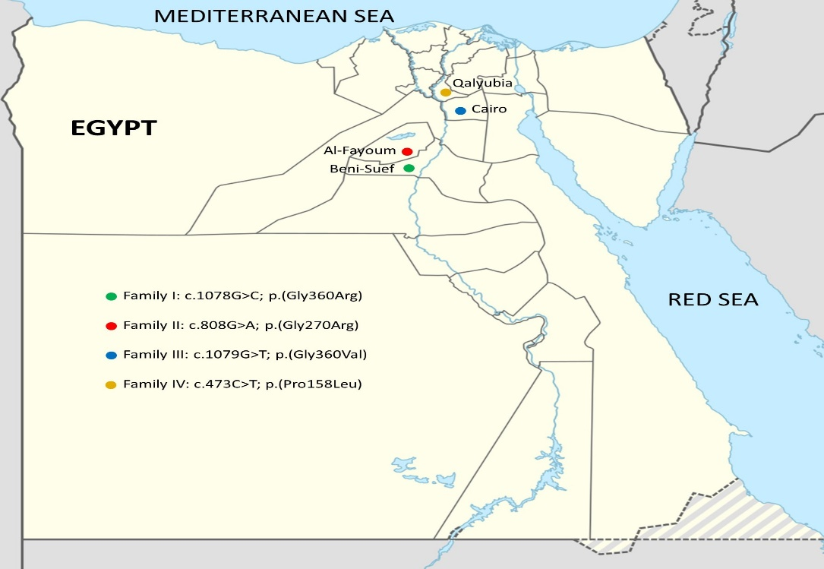

Supplementary Figure 1: Demographic location of reported AKU families within Egypt.

