Supplementary Material
Table S1. The sample size estimation.
Method | Estimating two-sample proportions; Pearson's chi-squared test  - Null hypothesis p₂ = p₁ and  - Alternative hypothesis p₂ ≠ p₁ (two-sided test), p₂ > p₁ or p₂ < p₁ (one-sided test)
Imputed | α = significance level = 0.0500  β = probability of type II error  Power = 0.8000  $n_{1}= m$ = estimated sample size in group 1  $n_{2}=rm$ = estimated sample size in group 2  $$r=ratio of sample size$$  N2/N1 = 4.0000  $P_{1}$= probability of success in group 1 = 0.1556  $P_{2}$= probability of success in group 2 = 0.6852; delta = 0.5296  $$\overline{P}= \frac{\left(P_{1}+ {rP}_{2}\right)}{(r+1)}$$  $$\overline{Q}=1- \overline{P}$$
Required sample size | $$m= \frac{m^{'}}{4}{\left(1+ \sqrt{1+ \frac{2(r+1)}{m^{'}r\left|P_{2}- P_{1}\right|}}\right)}^{2}$$
Result | N1 = 12  N2 = 48  N = 60
References | - STATA Power and Sample Size Reference Manual, StataCorp. 2015. Stata: Release 14. Statistical Software. College Station, TX: StataCorp LP.  - Fleiss, J. L., B. Levin, and M. C. Paik. 2003. Statistical Methods for Rates and Proportions. 3rd ed. New York: Wiley. page 75 -77
Table S2. The complete list of specific treatment protocols.
All participants | Standard of care | Details
All participants | Stroke units | AIS patients were admitted to the acute stroke unit for comprehensive specialized stroke care and incorporated rehabilitation.
All participants | Airway, breathing, oxygenation | - Airway support and ventilatory assistance are given in AIS patients with decreased consciousness or bulbar dysfunction that causes compromise of the airway.  - Supplemental oxygen is provided to maintain an oxygenation saturation of >94%.
All participants | Blood pressure | No early treatment of hypertension unless the following indications have been indicated  - Intravenous thrombolysis candidates with BP >180/105 mmHg  - Acute coronary event, acute heart failure, acute aortic dissection, postfibrinolysis symptomatic intracerebral hemorrhage (sICH)  - SBP >220 mmHg and/or DBP 121-140 mmHg  - DBP >140 mmHg
All participants | Temperature | Identified and treatment of hyperthermia (BT >38 ºC)
All participants | Blood glucose | - Treatment of hypoglycemia when blood glucose <60 mg/dL  - Treatment of hyperglycemia to maintain blood glucose in a range of 140-180 mg/dL
All participants | IV fluid | Isotonic solution (0.9% NaCl) is recommended in AIS patients within 72 hours and maintains euvolemic status.
All participants | Antiplatelet treatment | Antiplatelet agents are administered in noncardioembolic AIS.
All participants | Anticoagulants | Anticoagulants (vitamin K antagonist: VKA or direct oral anticoagulants: DOAC) are recommended in cardioembolic AIS.
All participants | Treatment of hyperlipidemia | Lipid-lowering therapy with high-intensity statin therapy (atorvastatin 40-80 mg/day) is started in most AIS patients.
All participants | Rehabilitation | Early rehabilitation is recommended in AIS without contraindications.
All participants | DVT prophylaxis | Intermittent pneumatic compression (IPC) was applied in immobile stroke patients without contraindications.
Treatment according to TOAST classification
LAA | CE | SVO | OD | UD
- Aspirin 160-300 mg/day within 48 hours after onset  - DAPT: clopidogrel 300 mg loading dose, 75 mg/day + aspirin 81 mg/day x 21 days in TIA high-risk (ABCD₂ ≥4) or minor nonce stroke within 24 hours after onset | - VKA, INR 2-3 (2.5-3.5 in mechanical heart valves)  - DOACs, unless AF with mechanical heart valves or moderate-severe mitral stenosis | Antiplatelet agents | According to the cause identified  - Steroids (vasculitis)  - Anticoagulants (extracranial arterial dissection) | Antiplatelet agents
Abbreviations: AF, atrial fibrillation; AIS, acute ischemic stroke; BT, body temperature; CE, cardioembolism; DAPT, dual antiplatelet therapy; DBP, diastolic blood pressure; DVT, deep vein thrombosis; INR, international normalized ratio; IV, intravenous; LAA, large-artery atherosclerosis; OD, stroke of other determined etiology; SBP, systolic blood pressure; SVO, small-vessel occlusion; TIA, transient ischemic attack; UD, stroke of undetermined etiology.

Table S3. Cutpoint of NT-proBNP with sensitivity and specificity.
 | NT-proBNP (pg/mL) | AUC at a cutpoint | Sensitivity | Specificity
Cutpoint | 476 | 0.68 | 74% | 63%
Abbreviations: AUC, area under the curve; NT-proBNP, N-terminal fragment B-type natriuretic peptide.

Table S4. Univariable analysis.
Characteristics | OR | 95% CI | P-value
NT-proBNP, pg/mL
<476 (n=33) | 1.00 | Reference | Reference
≥476 (n=33) | 4.80 | 1.56-14.62 | 0.006
Age | 1.03 | 0.10-1.80 | 0.09
Male sex | 1.23 | 0.44-3.45 | 0.69
Smoking | 1.12 | 0.32-3.92 | 0.87
Alcohol | 0.55 | 0.16-1.86 | 0.34
Hypertension | 2.35 | 0.73-7.54 | 0.15
Diabetes mellitus | 0.91 | 0.30-2.86 | 0.87
Dyslipidemia | 0.74 | 0.26-2.12 | 0.58
Atrial fibrillation | 2.00 | 0.37-10.82 | 0.42
Prior stroke/TIA | 2.11 | 0.54-8.23 | 0.28
Chronic kidney disease | 0.25 | 0.01-5.00 | 0.36
Antiplatelet therapy | 0.50 | 0.16-1.54 | 0.22
Lipid-lowering drugs | 0.20 | 0.01-4.41 | 0.30
Antihypertensive drugs | 2.82 | 1.00-8.10 | 0.05
SBP | 1.01 | 1.00-1.24 | 0.34
Heart rate | 1.00 | 1.00-1.03 | 0.83
Time from stroke onset to serum NT-proBNP | 1.00 | 1.00-1.01 | 0.63
Creatinine | 1.00 | 0.30-3.42 | 1.00
HDL | 1.00 | 0.95-1.01 | 0.28
LDL | 1.00 | 1.00-1.02 | 0.16
TOAST | 0.63 | 0.39-1.03 | 0.07
OSCP | 0.30 | 0.12-0.64 | 0.003
Admission NIHSS score | 2.04 | 1.40-3.00 | <0.001
Admission mRS | 30.0 | 6.50-133.30 | <0.001
LAE | 2.05 | 0.50-9.11 | 0.34
LVH | 1.10 | 0.30-4.20 | 1.00
LADM | 1.50 | 0.61-3.61 | 0.38
HMCAS | 5.83 | 1.34-25.41 | 0.02
Anterior ASPECTS | 0.60 | 0.42-0.84 | 0.003
Posterior ASPECTS | 1.40 | 0.71-2.65 | 0.35
Large infarction | 5.20 | 1.36-19.90 | 0.02
NDAF | 2.74 | 0.84-8.92 | 0.09
Abbreviations: ASPECTS, The Alberta Stroke Program Early CT Score; BMI, body mass index; CE, cardioembolism; CI, confidence interval; HDL, high-density lipoprotein; HMCAS, hyperdense middle cerebral artery sign; LADM, left atrium diameter; LAE, left atrial enlargement; LDL, low-density lipoprotein; LVH, left ventricular hypertrophy; NDAF, newly diagnosed atrial fibrillation; NT-proBNP, N-terminal fragment B-type natriuretic peptide; OCSP, the Oxfordshire Community Stroke Project Classification; OR, Odds ratio; SBP, systolic blood pressure; TIA, transient ischemic attack; TOAST, the Trial of Org 10172 in Acute Stroke Treatment.

Table S5. 90-day functional outcomes according to NT-proBNP levels among acute ischemic stroke patients.
 | NT-proBNP, pg/mL
 | <100  (n=10) | 100-750  (n=30) | >750  (n=27) | P-value
Unfavorable functional outcome: mRS ≥3
Events – No. (%) | 2 (20.0) | 9 (30.0) | 12 (44.4)
OR (95% CI)
Unadjusted | 1 | 1.71 (0.30-9.72) | 3.43 (0.61-19.35) | 0.54
Multivariable model 1 | 1 | 1.68 (0.28-9.87) | 2.68 (0.41-17.57) | 0.57
Multivariable model 2 | 1 | 2.02 (0.32-12.74) | 1.72 (0.19-15.65) | 0.46
Multivariable model 3 | 1 | 1.36 (0.13-14.29) | 1.49 (0.09-25.01) | 0.78
Abbreviations: CI, confident interval; mRS, modified Rankin Scale; NT-proBNP, N-terminal fragment B-type natriuretic peptide; OR, Odds ratio.
Multivariable model 1: adjusted for age, sex, and body mass index.
Multivariable model 2: model 1 plus serum creatinine, atrial fibrillation, newly diagnosed atrial fibrillation, prior stroke or transient ischemic attack, and left atrial enlargement.
Multivariable model 3: model 2 plus Oxfordshire Community Stroke Project Classification (partial anterior circulation infarcts).

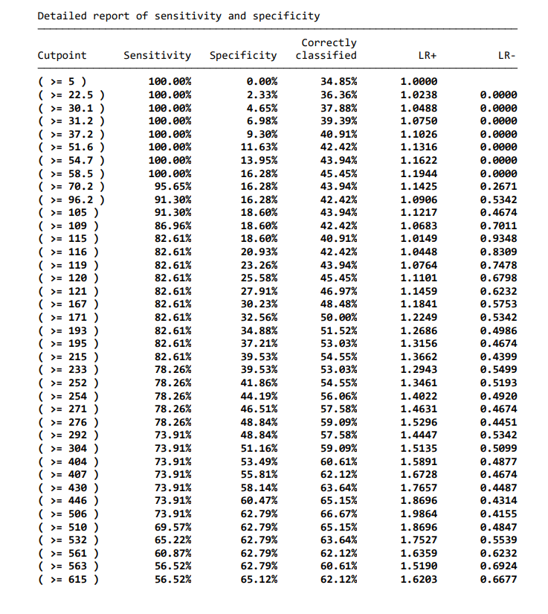
Figure S1. Sensitivity, specificity, and likelihood ratio for a positive and negative test of each NT-proBNP cutpoint.

