Supplementary figure1

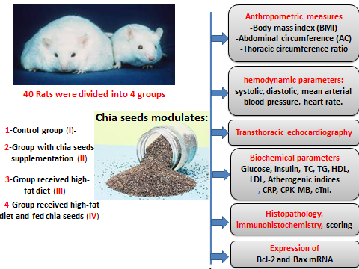

Figure legand for the supplementary figure1 illustrates the experimental design and the efficacy of chia seeds on cardiovascular health

