Supplementary Material for
Beyond the effects of HIV infection and integrase strand transfer inhibitors-based therapies on the oral bacteriome
Villoslada-Blanco Pablo¹, Pérez-Matute Patricia¹*, Recio-Fernández Emma¹, Íñiguez María¹, Blanco-Navarrete Pilar², Metola Luis³, Ibarra Valvanera³, Alba Jorge³, de Toro María⁴, Oteo José A^{1,3}.

¹Infectous Diseases, Microbiota and Metabolism Unit. Infectious Diseases Department. Center for Biomedical Research of La Rioja (CIBIR), Logroño, La Rioja, Spain.
²Centro de Salud Siete Infantes de Lara, Logroño, La Rioja, Spain.
³Infectious Diseases Department. Hospital Universitario San Pedro, Logroño, La Rioja, Spain.
⁴Genomics and Bioinformatics Platform. Center for Biomedical Research of La Rioja (CIBIR), Logroño, La Rioja, Spain.

§Corresponding author: Patricia Pérez-Matute
Infectious Diseases, Microbiota and Metabolism Unit. Infectious Diseases Department, Center for Biomedical Research of La Rioja (CIBIR), Logroño, La Rioja, Spain.
C/Piqueras 98
CIBIR building, third floor
26006 Logroño (La Rioja)
cpperez@riojasalud.es
Supplementary Table 1
Supplementary Table 2
Supplementary Figure 1
Supplementary Figure 2
Supplementary Figure 3
Supplementary Figure 4
Supplementary Figure 5
Supplementary Figure 6
Supplementary Figure 7
Supplementary Figure 8
Supplementary Figure 9

Supplementary Table 1. Characteristics of healthy uninfected controls and HIV-infected patients (naive and under INSTIs).
 | Control | Naive | INSTIs-treated | p value
Number of patients | 26 | 15 | 15 | -
Gender (men) | 9/26 (34.62%) | 13/15 (86.67%) ** | 12/15 (80.00%) ** | 0.002
Age (years) | 43.58±2.31 | 33.87±2.85 * | 43.67±3.39 | 0.033
BMI (kg/m²) | 24.30±0.69 | 23.23±1.05 | 23.51±0.85 | 0.616
Waist circumference (cm) | 85.35±2.55 | 83.83±2.86 | 85.13±2.15 | 0.916
Systolic blood pressure (mmHg) | 120.58±2.76 | 135.67±5.67 * | 129.73±6.02 | 0.050
Diastolic blood pressure (mmHg) | 72.19±1.94 | 81.87±3.31 * | 77.80±3.24 | 0.035
Alcohol active | 3/26 (11.54%) | 0/15 (0.00%) | 1/15 (6.67%) | 0.578
Smoking active | 3/26 (11.54%) | 7/15 (46.67%) * | 10/15 (66.67%) *** | 0.001
Qualitative variables are represented in percentage while quantitative variables are represented as mean ± standard error mean. P value refers to the comparation between two (naive vs. INSTIs) or three (control vs. naive vs. INSTIs) groups, as appropriate. Statistically significant p values are in bold. Asterisks indicate statistically significant differences with respect to control group (*p<0.05, **p<0.01 and ***p<0.001). BMI (body mass index), INSTIs (integrase strand transfer inhibitors-based treatment).

Supplementary Table 2. Characteristics of HIV-infected patients (naive and under INSTIs).

 | Naive | INSTIs-treated | p value
Basal CD4 (cells/µl) | 464.07±76.46 | 850.53±101.68 | 0.006
Nadir CD4 (cells/ µl) | 464.07±76.46 | 526.53 ± 56.30 | 0.517
CD4/CD8 ratio | 0.53±0.13 | 0.84±0.10 | 0.027
Mode of transmission | HS: 6/15 (40.00%) | HS: 7/15 (46.67%) | 0.716
Mode of transmission | MSM: 9/15 (60.00%) | MSM: 7/15 (46.67%) | 0.716
Mode of transmission | Parenteral: 0/15 (0.00%) | Parenteral: 1/15 (6.66%) | 0.716
AIDS | 1/15 (6.67%) | 0/15 (0.00%) | 1
Coinfection with hepatitis C virus | 0/15 (0.00%) | 2/15 (13.33%) | 0.483
Coinfection with hepatitis B virus | 0/15 (0.00%) | 0/15 (0.00%) | 1
Qualitative variables are represented in percentage while quantitative variables are represented as mean ± standard error mean. P value refers to the comparation between naive and INSTIs groups. Statistically significant p values are in bold. AIDS (acquired immunodeficiency syndrome), HS (heterosexual), INSTIs (integrase strand transfer inhibitors-based treatment), MSM (men who have sex with men).
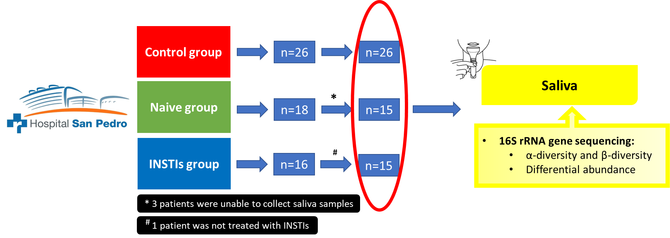
Supplementary Figure 1. Flowchart of patient recruitment. INSTIs (integrase strand transfer inhibitors-based treatment).
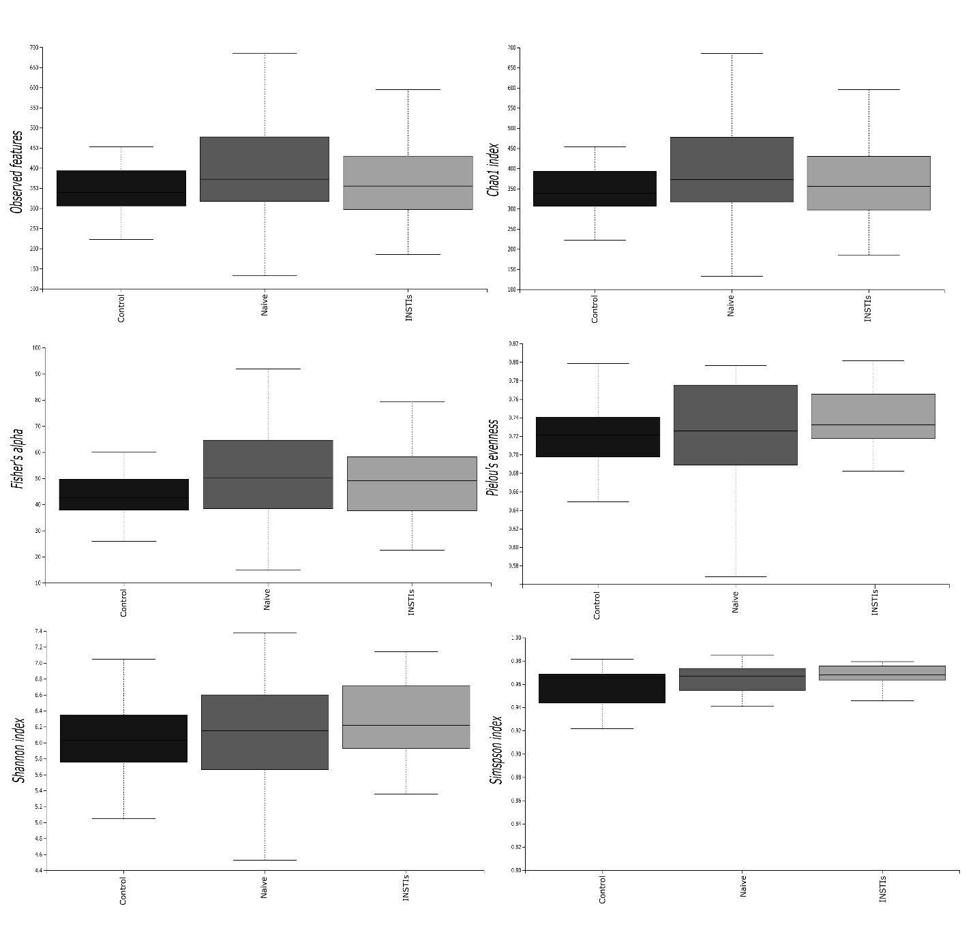
Supplementary Figure 2. Different indexes of α-diversity from bacteria in salivary samples of the studied population. INSTIs (integrase strand transfer inhibitors-based treatments).
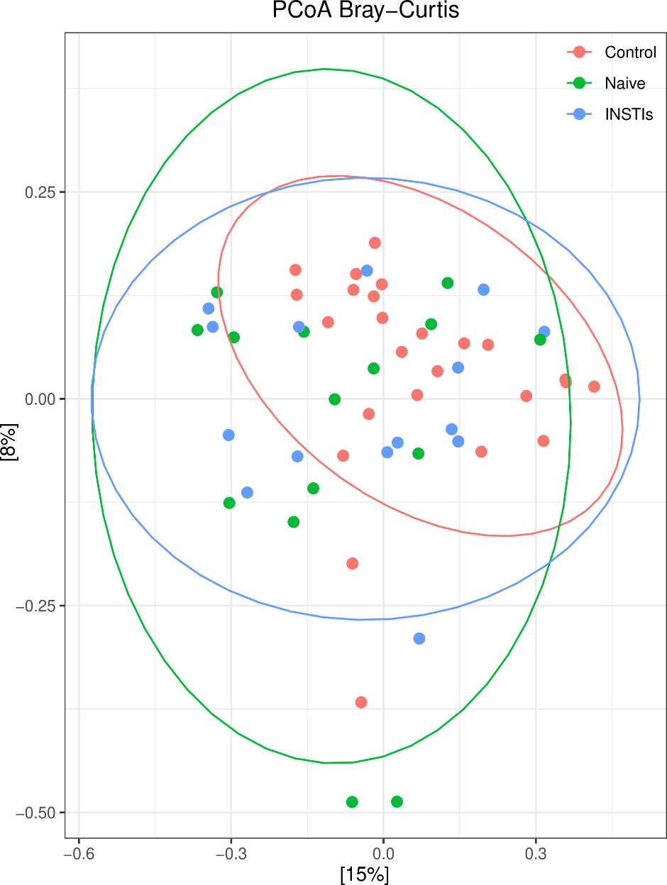
Supplementary Figure 3. PCoAs from bacteria in salivary samples from the studied population (accounting for 23% of the total variation [Component 1 = 15% and Component 2 = 8%]). Results are plotted according to the first two principal components. Each circle represents a sample: red circles represent the uninfected volunteers, green circles represent the naive group and blue circles represent the INSTIs-treated group. The clustering of samples is represented by their respective 95% confidence interval ellipse. INSTIs (integrase strand transfer inhibitors-based treatments).
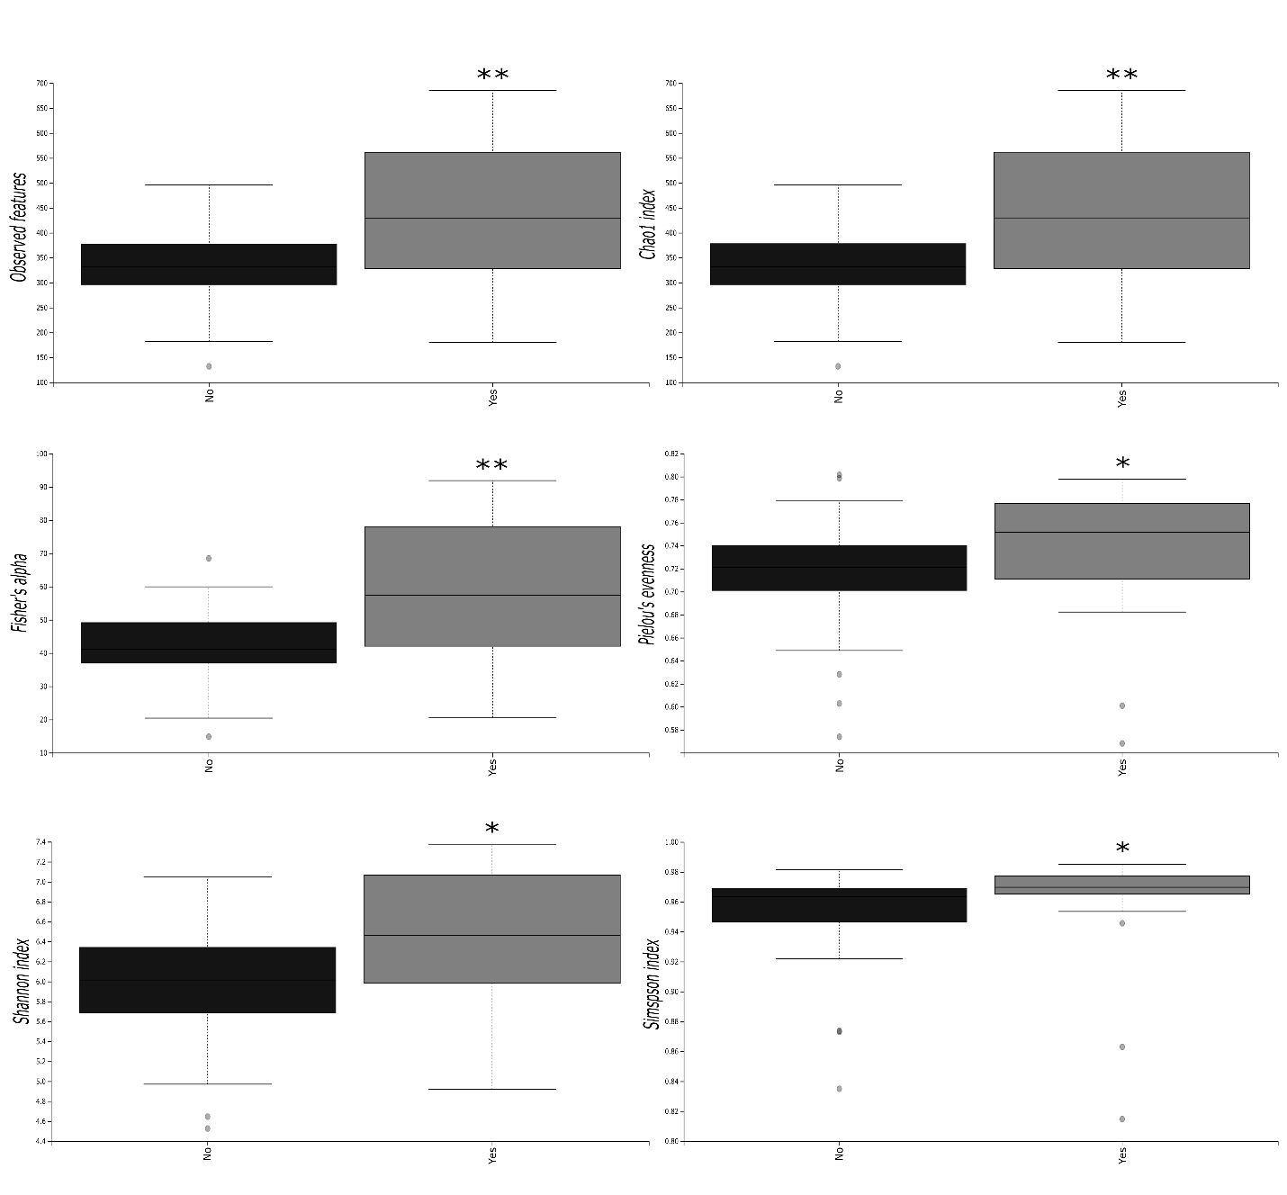
Supplementary Figure 4. Different indexes of α-diversity from bacteria in salivary samples of the studied population regarding smoking habit. *p<0.05 and **p<0.01 vs. non-smokers.
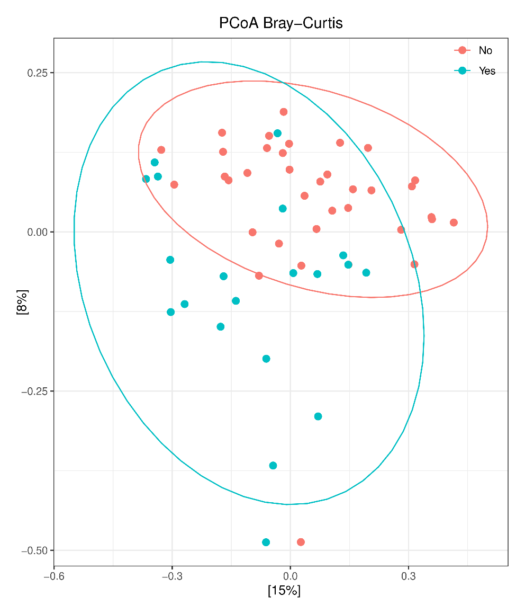
Supplementary Figure 5. PCoAs from bacteria in salivary samples from the studied population regarding smoking habit (accounting for 23% of the total variation [Component 1 = 15% and Component 2 = 8%]). Results are plotted according to the first two principal components. Each circle represents a sample: red circles represent the non-smoking individuals and blue circles represent the smoking individuals. The clustering of samples is represented by their respective 95% confidence interval ellipse. *p<0.001 smokers vs. non-smokers.
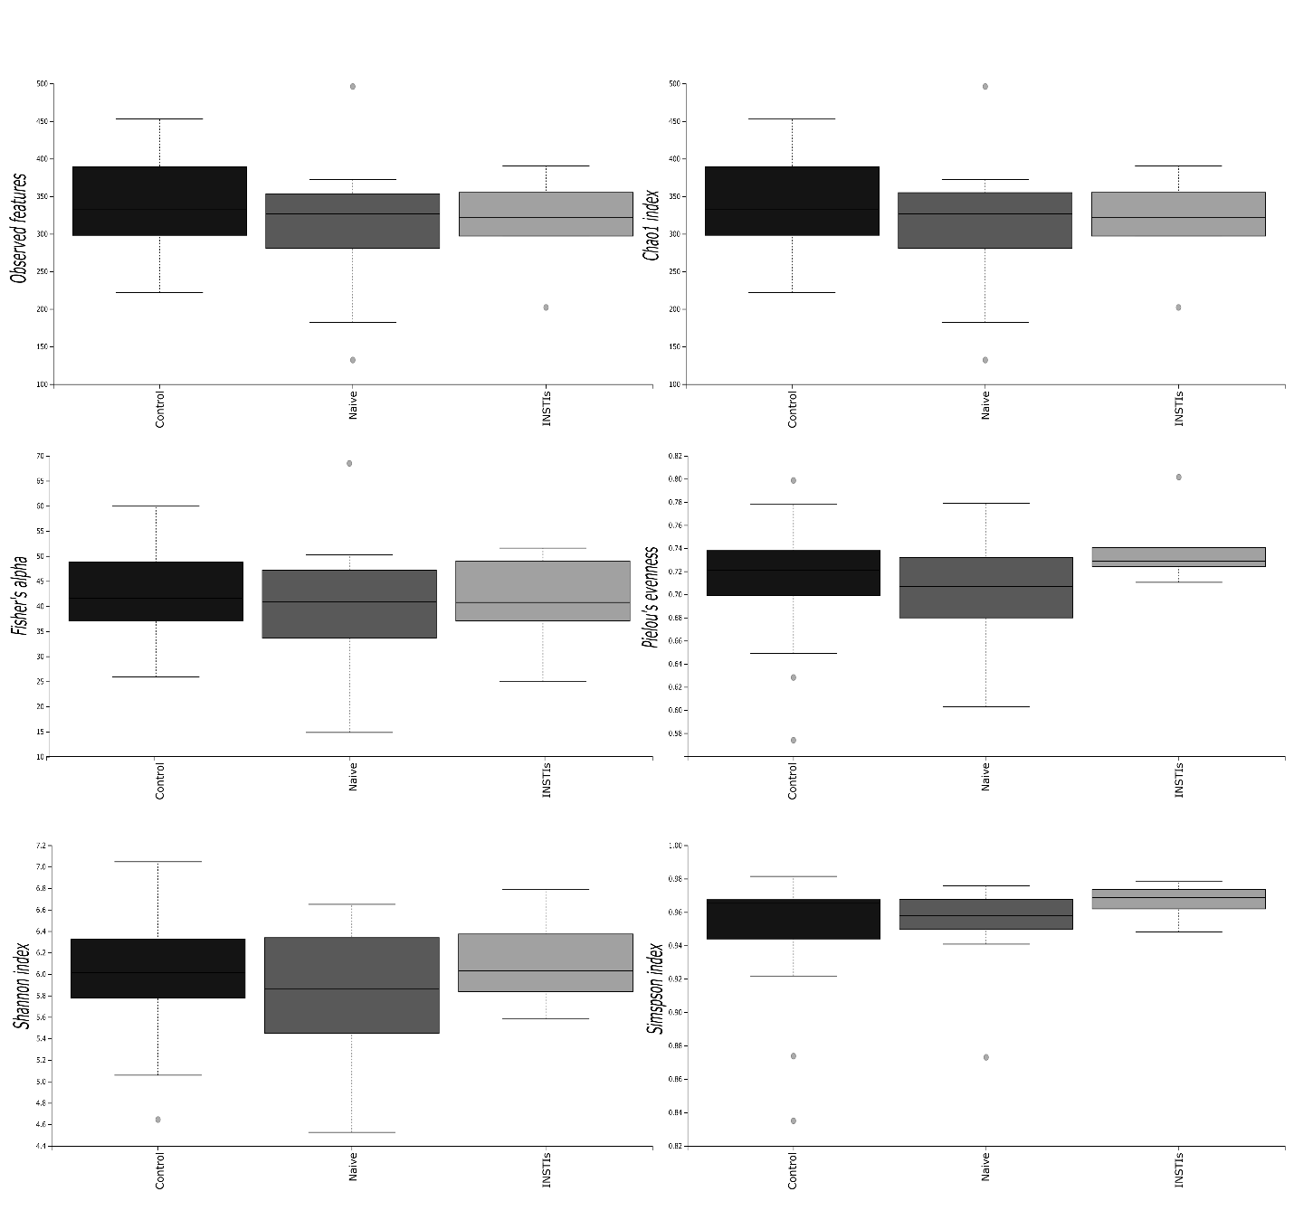
Supplementary Figure 6. Different indexes of α-diversity from bacteria in salivary samples of the non-smoking population. INSTIs (integrase strand transfer inhibitors-based treatment).
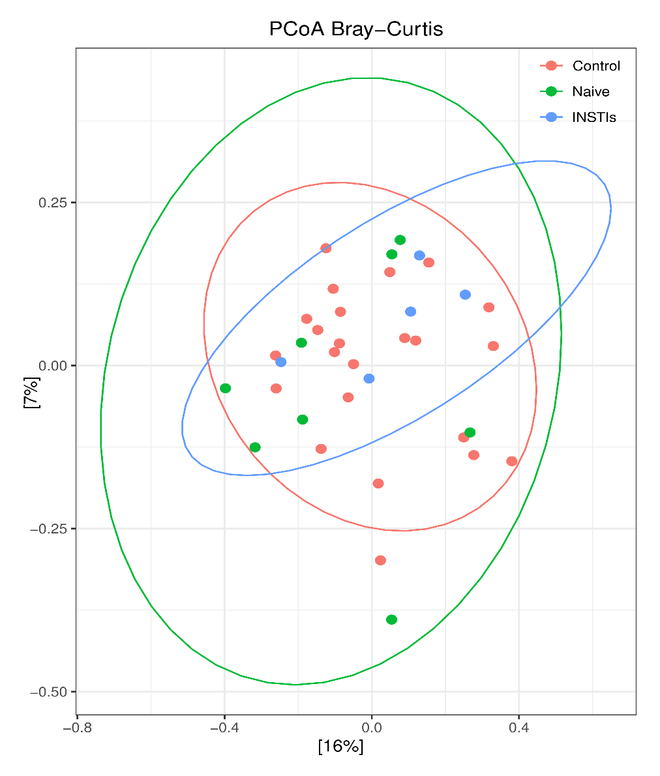
Supplementary Figure 7. PCoAs from bacteria in salivary samples from the non-smoking population (accounting for 23% of the total variation [Component 1 = 16% and Component 2 = 7%]). Results are plotted according to the first two principal components. Each circle represents a sample: red circles represent the uninfected volunteers, green circles represent the naive group and blue circles represent the INSTIs-treated group. The clustering of samples is represented by their respective 95% confidence interval ellipse. INSTIs (integrase strand transfer inhibitors-based treatments).
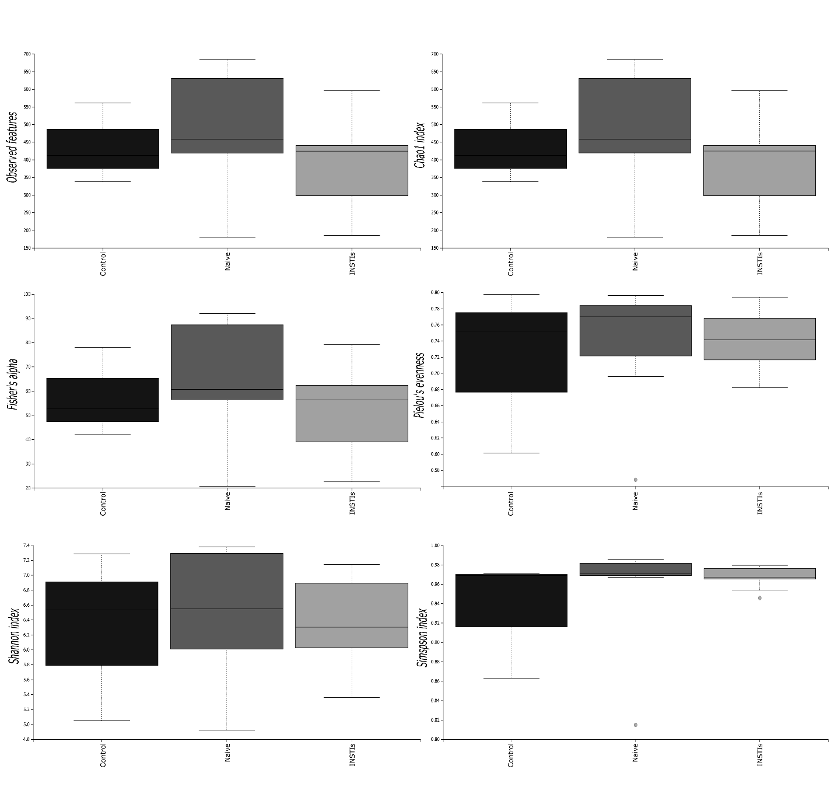
Supplementary Figure 8. Different indexes of α-diversity from bacteria in salivary samples of the smoking population. INSTIs (integrase strand transfer inhibitors-based treatment).
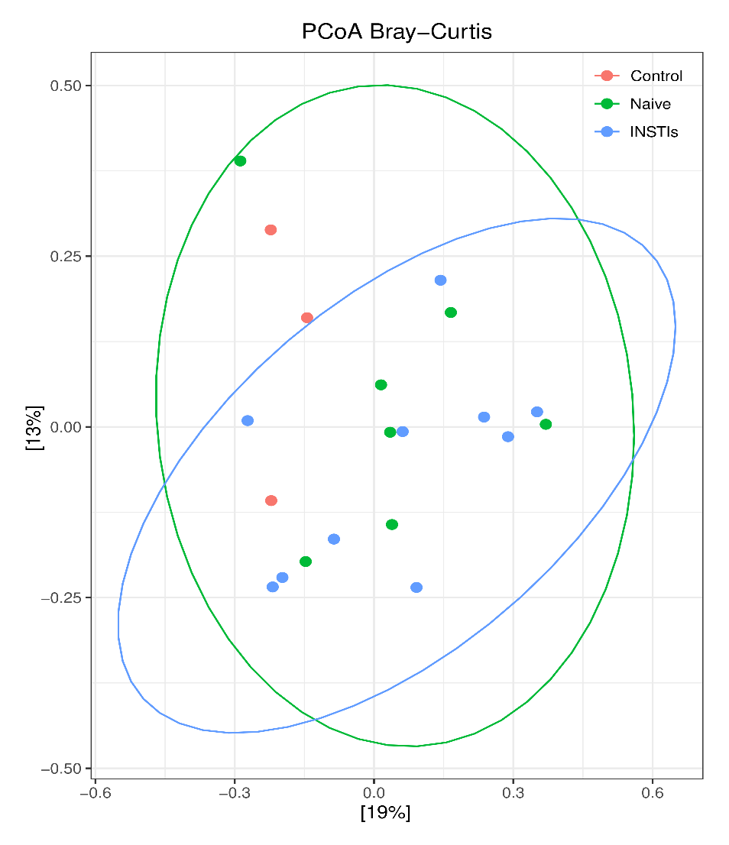
Supplementary Figure 9. PCoAs from bacteria in salivary samples from the smoking population (accounting for 32% of the total variation [Component 1 = 19% and Component 2 = 13%]). Results are plotted according to the first two principal components. Each circle represents a sample: red circles represent the uninfected volunteers, green circles represent the naive group and blue circles represent the INSTIs-treated group. The clustering of samples is represented by their respective 95% confidence interval ellipse. INSTIs (integrase strand transfer inhibitors-based treatments).

