Laser melting manufacturing of large elements of lunar regolith simulant for paving on the Moon
Juan-Carlos Ginés-Palomares¹*, Miranda Fateri¹*, Eckehard Kalhöfer¹, Tim Schubert², Lena Meyer³, Nico Kolsch³, Monika Brandić Lipińska⁴, Robert Davenport⁴, Barbara Imhof⁴, René Waclavicek⁴, Matthias Sperl⁵, Advenit Makaya⁶, Jens Günster^{3,7}*

¹Faculty of Mechanical Engineering and Materials Science, Aalen University, Beethovenstraße. 1, 73430 Aalen, Germany.
²Materials Research Institute Aalen, Aalen University, Beethovenstraße. 1, 73430 Aalen, Germany.
³Federal Institute of Materials Research and Testing (BAM), Unter den Eichen 87, 12205 Berlin, Germany
⁴LIQUIFER Systems Group GmbH, Obere Donaustraße 97/1/62, 1020 Vienna, Austria
⁵Institut für Materialphysik im Weltraum, Deutsches Zentrum für Luft- und Raumfahrt (DLR), 51170 Cologne, Germany
⁶European Space Agency, ESTEC, Keplerlaan 1 - PO Box 299, 2200 AG Noordwijk-ZH, The Netherlands
⁷Clausthal University of Technology, Institute of Non-Metallic Materials, Clausthal-Zellerfeld, Germany

Supplementary information
Manufacturing of paving elements

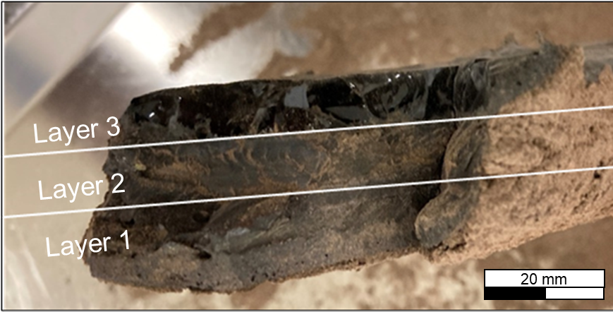
Supplementary Figure S1. Cross section of a part made by depositing two additional layers (15 mm thickness) on top of the initial structure in the powder bed.

Computed Micro-Tomography
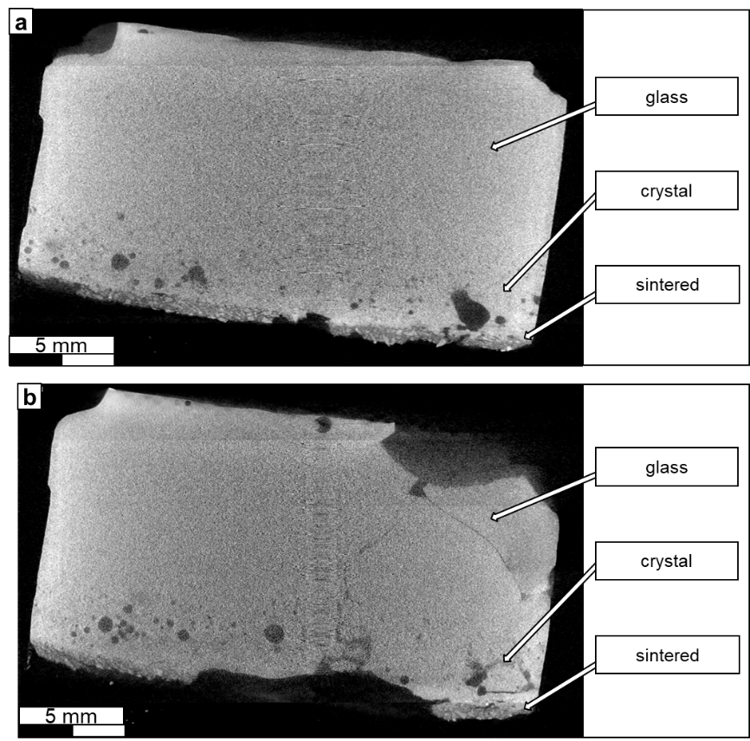
Supplementary Figure S2. (a,b) Images of the Micro-tomography of a laser melted sample.

Density
In Supplementary Table S1, the mass of the samples, the edge parameters (a, b, c), volume and value of the obtained density are listed. The average density of the samples is 2,76 g/cm³ (0,054 g/cm³ standard deviation).
Supplementary Table S1. Parameters and density values of the samples.
 | Sample 1 | Sample 2 | Sample 3 | Sample 4
m (g) | 2,51 | 3,047 | 2,89 | 2,42
a (mm) | 9,74 | 9,71 | 10,69 | 10,04
b (mm) | 10,24 | 11,23 | 10 | 9,58
c (mm) | 9,32 | 10,21 | 9,69 | 8,9
V (mm³) | 929,5 | 1113,3 | 1035,9 | 856,03
d (g/cm³) | 2,70 | 2,74 | 2,79 | 2,82

Energy Disperse X-ray (EDX)
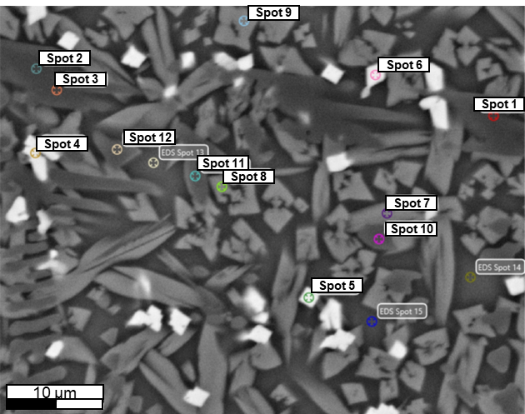
Supplementary Figure S3. Image of the spots analysed in the crystalline region.
Crystalline region analysis. Spots in Supplementary Figure S3. Image of the spots analysed in the crystalline region.
Spot1, spot2, Spot3, Spot10, spot11 and spot12: Forsterite.
Spot4, spot5 and spot6: Iron rich.
Spot7, spot8 and spot9: Augite.
The minerals of other spots analyzed in this region could not be identified.
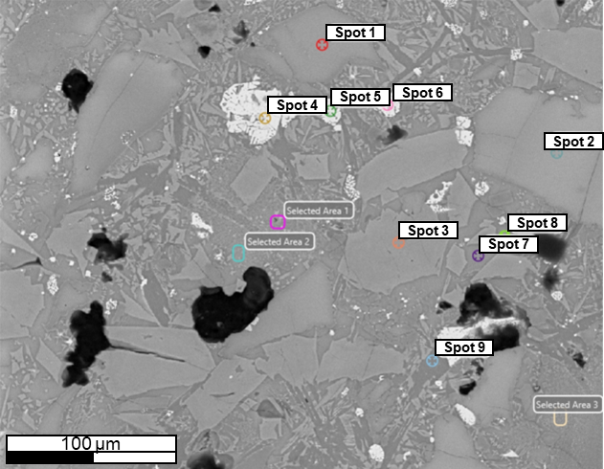
Supplementary Figure S4. Image of the spots analysed in the sintered region.
Sintered region analysis. Spots in Supplementary Figure S4
Area1, area2 and area3: Augite.
Spot4, spot5 and spot6: Iron rich
Spot7, spot8 and spot9: Anorthite.
The “Selected areas” shown in Supplementary Figure S4 were not considered as regions of interest in this analysis.

