Appendix
A1.
Here, we derive the basic reproductive number $R(t)$ – the number of new dengue cases that an infected individual would cause in a community of humans that are entirely susceptible, by using the next generation method and calculating its spectral radius [1]. At the dengue infection-free steady state, $E_{h_{I}}=E_{h_{L}}=I_{h_{I}}=I_{h_{L}}=R_{h}=0, E_{u}=I_{u}=0, E_{w}=I_{w}=0.$ Therefore, $N_{h}=S_{h}$. To compute $R(t)$ with or without Wolbachia-infected mosquitoes, we divide the Exposed and Infected local humans and vector compartments into the appearance rate of new dengue infections$, f$, and progression rates from exposed to infectious compartments and death rates, $v$.
Let $F_{ij}=\frac{∂f_{i}}{∂x_{j}}$ and $V_{ij}=\frac{∂v_{i}}{∂x_{j}}$ where $x_{j}'s$ are the exposed and infected compartments respectively. Therefore,
$F= \left(\begin{matrix}0 & 0 & 0 & Lb_{u}α_{u} & 0 & {Lb}_{w}α_{wh} \\ 0 & 0 & 0 & 0 & 0 & 0 \\ 0 & b_{u}S_{u}α_{u} & 0 & 0 & 0 & 0 \\ 0 & 0 & 0 & 0 & 0 & 0 \\ 0 & b_{w}S_{w}α_{w} & 0 & 0 & 0 & 0 \\ 0 & 0 & 0 & 0 & 0 & 0\end{matrix}\right)$ and
$V= \left(\begin{matrix}{μ+ψ}_{h} & 0 & 0 & 0 & 0 & 0 \\ -ψ_{h} & μ+δ_{h} & 0 & 0 & 0 & 0 \\ 0 & 0 & μ_{u}+ψ_{u} & 0 & 0 & 0 \\ 0 & 0 & -ψ_{u} & μ_{u} & 0 & 0 \\ 0 & 0 & 0 & 0 & μ_{w}+ψ_{w} & 0 \\ 0 & 0 & 0 & 0 & -ψ_{w} & μ_{w}\end{matrix}\right)$.
Hence the reproductive number in the presence of Wolbachia-infected mosquitoes ($R_{0}$) is given as:
$R(t) =\sqrt{{R_{u}}^{2}+{R_{w}}^{2}}$, where,
$R_{u}(t)=\sqrt{\frac{b_{u}^{2}α_{u}^{2}ψ_{u}ψ_{h}S_{u}(t)}{\left(μ_{u}+ψ_{u}\right){{ (μ+δ}_{h}) (μ+ψ_{h})μ}_{u}N_{H}}}$ and $R_{w}(t)=\sqrt{\frac{b_{w}^{2}α_{wh}α_{u}ψ_{w}ψ_{h}S_{w}(t)}{\left(μ_{w}+ψ_{w}\right){ (μ+δ}_{h}) (μ+ψ_{h}) μ_{w}N_{H}}}$,
while in the absence of Wolbachia-infected mosquitoes, $R(t)=R_{u}(t)$.

A2
To account for $R(t)$ with respect to the proportion of Wolbachia-infected mosquitoes $η$, we have that
$$R\left(t\right)=\sqrt{χ\left(S_{u}\left(t\right)+σS_{w}\left(t\right)\right)}$$
where
$$χ=\frac{b_{u}^{2}α_{u}^{2}ψ_{u}ψ_{h}}{\left(μ_{u}+ψ_{u}\right){{ (μ+δ}_{h}) (μ+ψ_{h})μ}_{u}N_{H}}$$
$$σ=\frac{\frac{b_{w}^{2}α_{wh}ψ_{w}}{\left(μ_{w}+ψ_{w}\right) μ_{w}}}{\frac{b_{u}^{2}α_{u}ψ_{u}}{\left(μ_{u}+ψ_{u}\right)μ_{u}}}$$
The independent variable $η$, which is the Wolbachia-infected mosquitoes’ fraction is given as:
$$η=\frac{S_{w}\left(t\right)}{S_{u}\left(t\right)+S_{w}(t)}$$
Assume that $S_{u}+S_{w}=C$ is constant,
$$η=\frac{S_{w}}{C}→S_{w}=ηC$$
$$1-η=\frac{S_{u}}{C}→S_{u}=\left(1-η\right)C$$
We then have
$$R(η)=\sqrt{χC\left(\left(1-η\right)+ση\right)}$$
$$R\left(0\right)=\sqrt{χC}$$
$$\frac{R\left(η\right)}{R\left(0\right)}=\sqrt{\left(1-η\right)+ση}$$
If $η=1$, that is, if all wild-type mosquitoes are replaced by Wolbachia-infected mosquitoes,
$$\frac{R\left(η\right)}{R\left(0\right)}=\sqrt{σ}$$

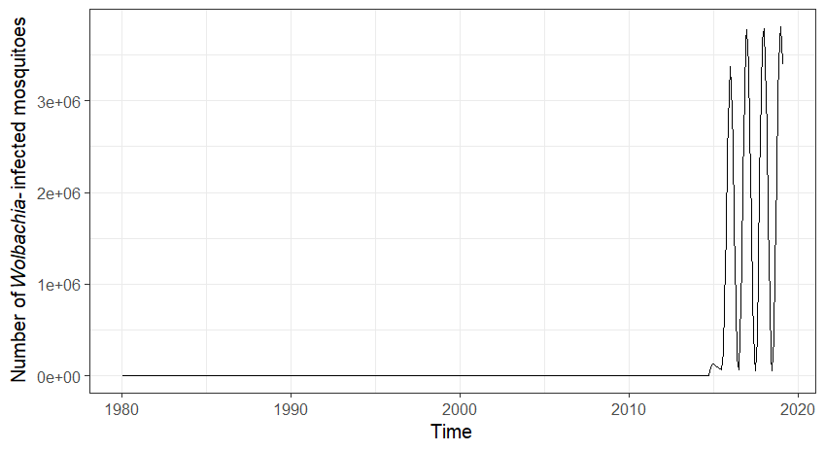
Figure A1: Graph showing the number of Wolbachia-infected mosquitoes over time.
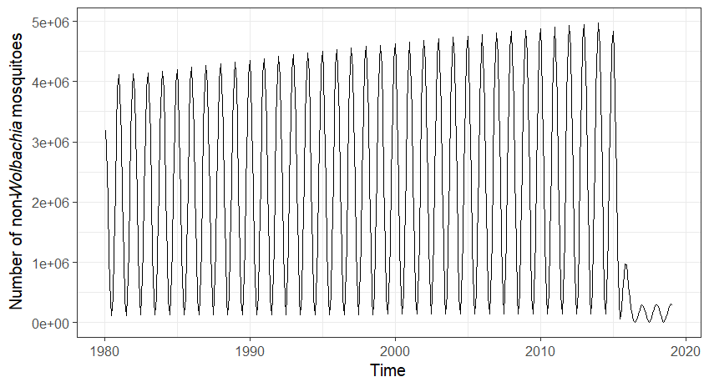
Figure A2: Graph showing the number of uninfected mosquitoes over time.

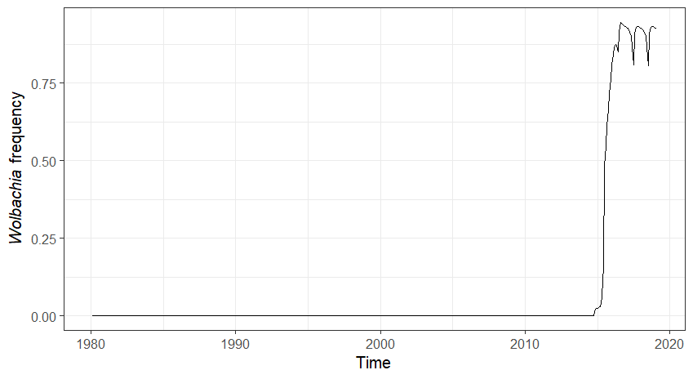
Figure A3: Graph showing the Wolbachia frequency over time.

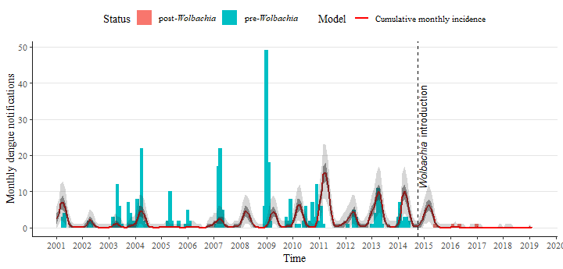
Figure A4: Plot of the data fitting of the number of Townsville locally acquired dengue cases in the presence of Wolbachia mosquitoes from 2001-2019 using the model (1) with 50% (dark grey) and 95% (light grey) confidence interval.

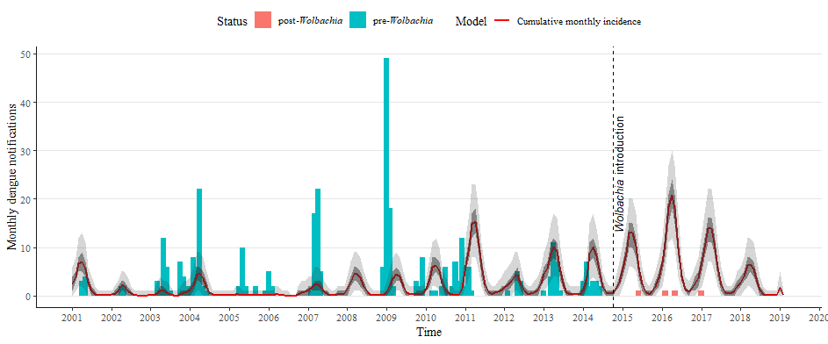
Figure A5: Plot of the data fitting of the number of Townsville locally acquired dengue cases in the absence of Wolbachia mosquitoes from 2001-2019 using the model (1) with 50% (dark grey) and 95% (light grey) confidence interval.

1. van den Driessche, P. and J. Watmough, Reproduction numbers and sub-threshold endemic equilibria for compartmental models of disease transmission. Math Biosci, 2002. 180: p. 29-48.

