A new discovery of the bioluminescent terrestrial snail genus Phuphania (Gastropoda: Dyakiidae)

Arthit Pholyotha¹, Daichi Yano¹, Gaku Mizuno², Chirasak Sutcharit¹, Piyoros Tongkerd¹, Yuichi Oba² & Somsak Panha^{1,3}

¹Animal Systematics Research Unit, Department of Biology, Faculty of Science, Chulalongkorn University, Bangkok 10330, Thailand. ²Department of Environmental Biology, Chubu University, Kasugai 487‑8501, Japan. ³Academy of Science, The Royal Society of Thailand, Bangkok 10300, Thailand.

Corresponding author. Email: somsak.pan@chula.ac.th (S.P.); yoba@isc.chubu.ac.jp (Y.O.)

Supplementary information

Supplementary Table S1. List of samples shows species names, GenBank accession numbers, and localities. Specimen codes correspond to codes in the molecular phylogenetic tree in Figure 5. Asterisk indicates the type species of its respective genus.

Species | Code | GenBank accession number | Locality | Reference
Phuphania Tumpeesuwan et al., 2007
Phuphania costata  Tumpeesuwan & Tumpeesuwan, 2014 | H67 | MT654625 | Pha Phu, Loei, Thailand | Jirapatrasilp et al., 2021
Phuphania costata  Tumpeesuwan & Tumpeesuwan, 2014 | PLL | MW649825 | Loei, Thailand | Deeprom et al., 2022
Phuphania costata  Tumpeesuwan & Tumpeesuwan, 2014 | NE70 | OR485694 | Mueang, Loei, Thailand | This study
Phuphania carinata  Kongim & Panha, 2013 | H125 | MT803070 | Phu Kiew, Chiayaphum, Thailand | Jirapatrasilp et al., 2021
Phuphania carinata  Kongim & Panha, 2013 | NE71 | OR485695 | Nong Hin, Loei, Thailand | This study
Phuphania crossei (Pfeiffer, 1862) | H5 | MT654626 | Jedkot Waterfall, Saraburi, Thailand | Jirapatrasilp et al., 2021
Phuphania crossei (Pfeiffer, 1862) | C47-1 | OR485696 | Kaeng Khoi, Saraburi, Thailand | This study
Phuphania crossei (Pfeiffer, 1862) | C47-2 | OR485697 | Kaeng Khoi, Saraburi, Thailand | This study
Phuphania crossei (Pfeiffer, 1862) | C64 | OR485698 | Kaeng Khoi, Saraburi, Thailand | This study
Phuphania globosa  Tumpeesuwan et al., 2007* | H12 | MT803073 | Wat Tam Nam Pok, Khon Kaen, Thailand | Jirapatrasilp et al., 2021
Phuphania globosa  Tumpeesuwan et al., 2007* | H42 | MT654624 | Nam Pung Reservoir, Sakon Nakhon, Thailand | Jirapatrasilp et al., 2021
Quantula Baker, 1941
Quantula godwinausteni (Laidlaw, 1931) | H30 | MT803077 | Wat Khao Sukim, Chanthaburi, Thailand | Jirapatrasilp et al., 2021
Quantula striata (Gray, 1834)* | H23 | MT654628 | Singapore Botanic Gardens, Singapore | Jirapatrasilp et al., 2021
Quantula striata (Gray, 1834)* | H26 | MT803078 | Singapore Botanic Gardens, Singapore | Jirapatrasilp et al., 2021
Quantula striata (Gray, 1834)* | H56 | MT803079 | Pulau Tioman, Pahang, Malaysia | Jirapatrasilp et al., 2021
Quantula striata (Gray, 1834)* | - | FJ160693 | Singapore | Liew et al., 2009
Quantula striata (Gray, 1834)* | - | MN564863 | Malaysia | Liew et al., 2020
Quantula weinkauffiana  (Crosse & Fischer, 1863) | H18 | MT803080 | Khao Panom Sawai, Surin, Thailand | Jirapatrasilp et al., 2021
Quantula weinkauffiana  (Crosse & Fischer, 1863) | H52 | MT803081 | Khong Sedon, Salavan, Laos | Jirapatrasilp et al., 2021
Quantula weinkauffiana  (Crosse & Fischer, 1863) | H53 | MT803082 | Tad Pha Suam, Champasak, Laos | Jirapatrasilp et al., 2021
Quantula weinkauffiana  (Crosse & Fischer, 1863) | CA11 | MT803083 | Phnom Kampong Trach Cave Temple, Kampong Trach, Kampot, Cambodia | Jirapatrasilp et al., 2021
Quantula weinkauffiana  (Crosse & Fischer, 1863) | CA13 | MT803084 | Phnom Chhngok Cave, Tuek Chhou, Kampot, Cambodia | Jirapatrasilp et al., 2021
Quantula weinkauffiana  (Crosse & Fischer, 1863) | PSP | MW649818 | Khao Panom Sawai, Surin, Thailand | Deeprom et al., 2022
Quantula weinkauffiana  (Crosse & Fischer, 1863) | E53-1 | OR485699 | Makham, Chanthaburi, Thailand | This study
Quantula weinkauffiana  (Crosse & Fischer, 1863) | E53-3 | OR485700 | Makham, Chanthaburi, Thailand | This study
Quantula doma Deeprom et al., 2022 | PKJ | MW649815 | Phu Jor Kor, Mukdahan, Thailand | Deeprom et al., 2022
Quantula doma Deeprom et al., 2022 | PNY | MW649813 | Pha Nam Yoi, Roi Et, Thailand | Deeprom et al., 2022
Quantula doma Deeprom et al., 2022 | KSH | MW649819 | Khao Sala, Surin, Thailand | Deeprom et al., 2022
Quantula doma Deeprom et al., 2022 | KSL | MW649820 | Khao Sala, Surin, Thailand | Deeprom et al., 2022
Quantula sp. | H122 | MT803085 | Nang Rong Waterfall, Nakhon Nayok, Thailand | Jirapatrasilp et al., 2021
Quantula sp. | H24 | MT803086 | Wang Ta Krai Waterfall, Nakhon Nayok, Thailand | Jirapatrasilp et al., 2021
Quantula sp. | H50 | MT803087 | Khao Ang Rue Nai, Chacheongsao, Thailand | Jirapatrasilp et al., 2021
Quantula sp. | H60 | MT803088 | Wat Khao Sala, Surin, Thailand | Jirapatrasilp et al., 2021
Quantula sp. | H94 | MT803089 | Wang Ta Krai Waterfall, Nakhon Nayok, Thailand | Jirapatrasilp et al., 2021
Quantula sp. | H97 | MT803090 | Khao Ang Rue Nai, Chacheongsao, Thailand | Jirapatrasilp et al., 2021
Quantula sp. | H51 | MT803091 | Kam Hom Waterfall, Sakon Nakhon, Thailand | Jirapatrasilp et al., 2021
Quantula sp. | H124 | MT803092 | Cuc Phuong, Nho Quan, Ninh Binh, Vietnam | Jirapatrasilp et al., 2021
Quantula sp. | QPMM | MW649814 | Roi Et, Thailand | Deeprom et al., 2022
Quantula sp. | QUPP | MW649816 | Sakon Nakhon, Thailand | Deeprom et al., 2022
Quantula sp. | QSPF | MW649817 | Surat Thani, Thailand | Deeprom et al., 2022
Quantula sp. | QPJN | MW649821 | Ubon Ratchathani, Thailand | Deeprom et al., 2022
Everettia Godwin-Austen, 1891
Everettia monticola Liew et al., 2009 | - | FJ160648 | Mount Kinabalu, Sabah, Malaysia | Liew et al., 2009
Everettia planispira Liew et al., 2009 | - | FJ160647 | Tawau Hills Park, Sabah, Malaysia | Liew et al., 2009

References

Deeprom K, Tumpeesuwan C, Tumpeesuwan S (2022) A new species of the genus Quantula Baker, 1941 (Eupulmonata: Dyakiidae) from the southern part of north-eastern Thailand. Raffles Bulletin of Zoology 70: 519–533. https://lkcnhm.nus.edu.sg/wp-content/uploads/sites/10/2022/11/RBZ-2022-0029.pdf
Jirapatrasilp P, Tongkerd P, Jeratthitikul E, Liew T-S, Pholyotha A, Sutcharit C, Panha S (2020) Molecular phylogeny of the limacoid snail family Dyakiidae in Southeast Asia, with the description of a new genus and species. Zoological Journal of the Linnean Society. 193(1): 250–280. https://doi.org/10.1093/zoolinnean/zlaa129
Liew T, Marzuki ME, Schilthuizen M, Chen Y, Vermeulen JJ, Mohd-Azlan J (2020) Molecular phylogenetics and evolutionary history of the endemic land snail genus Everettia in northern Borneo. PeerJ 8:e9416. https://doi.org/10.7717/peerj.9416
Liew T-S, Schilthuizen M, Vermeulen JJ (2009) Systematic revision of the genus Everettia Godwin-Austen, 1891 (Mollusca: Gastropoda: Dyakiidae) in Sabah, northern Borneo. Zoological Journal of the Linnean Society 157(3): 515–550. https://doi.org/10.1111/j.1096-3642.2009.00526.x

Supplementary Figure S1. A non-bioluminescent dyakiid species, Pseudoplecta bijuga (Stoliczka, 1873). (A) Lateral view in visible light. (B, C) Lateral view under UV light (365 nm). (D) Ventral view under UV light.

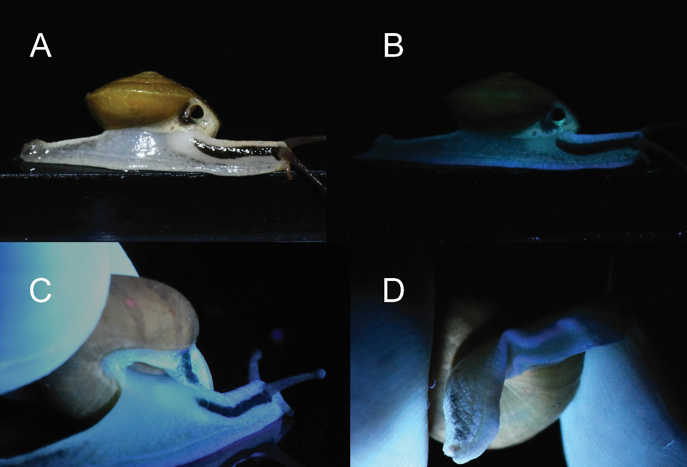

Supplementary Figure S2. Bioluminescent activity of the luminous Phuphania costata (above) and P. crossei (below). Arrows indicate snails with no light emission (pause in bioluminescent activity).

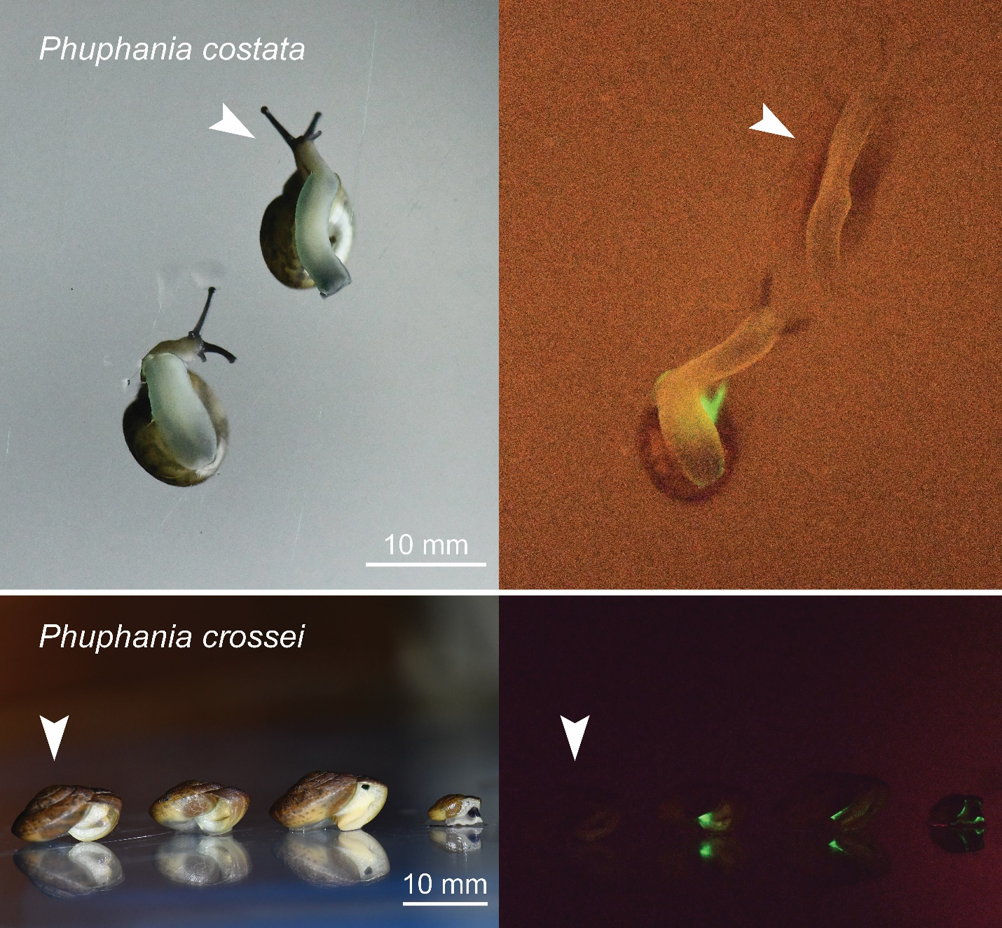

Supplementary Video 1. Continuous luminescence of Phuphania crossei.

Supplementary Video 2. Flashing luminescence of Quantula weinkauffiana.

