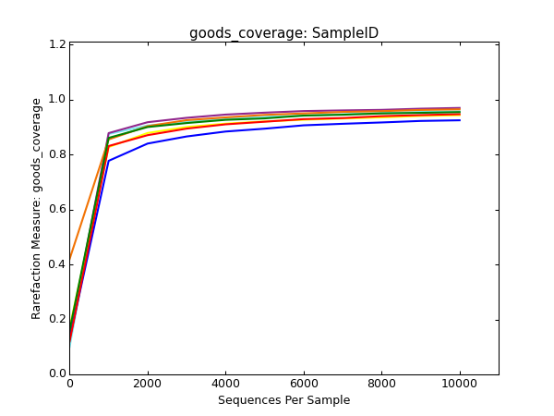
Figure S1. Good’s coverage rarefaction curve in the seven samples. Red= site AF, Blue=Site A, Orange= site B, Green = site C, Purple= site D, yellow= site E, light blue= site F

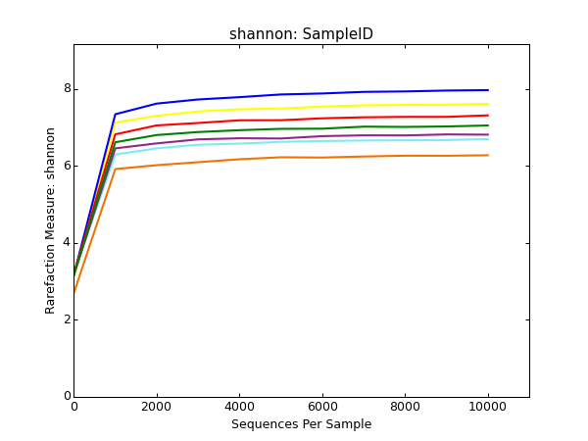
Figure S2. Shannon rarefaction curve in the seven samples. Red= site AF, Blue=Site A, Orange= site B, Green = site C, Purple= site D, yellow= site E, light blue= site F

Numbers | AF | A | B | C | D | E | F
raw reads | 335026 | 430288 | 449824 | 427260 | 396706 | 503036 | 422956
reads after bioinformatic processing | 133422 | 164371 | 194741 | 178019 | 167200 | 205578 | 176453
annotated eukaryotes reads | 123546 | 161488 | 194308 | 177777 | 165950 | 204827 | 174746
annotated eukaryotes beyond D2 level | 107749 | 157442 | 192053 | 176733 | 163428 | 202082 | 170405
Phytoplankton reads | 37650 | 65418 | 64769 | 77565 | 103130 | 93936 | 78730
Phytoplankton OTUs | 496 | 1771 | 898 | 1416 | 909 | 1598 | 958
Table S1. Total number of reads for each sample

