Supplementary Figure S1. Study design. OVX, ovariectomy; Ext., tooth extraction; ZA inj., zoledronic acid injection; s-ZA inj., sham zoledronic acid injection; TPD inj., teriparatide injection; s-TPD inj., sham teriparatide injection.
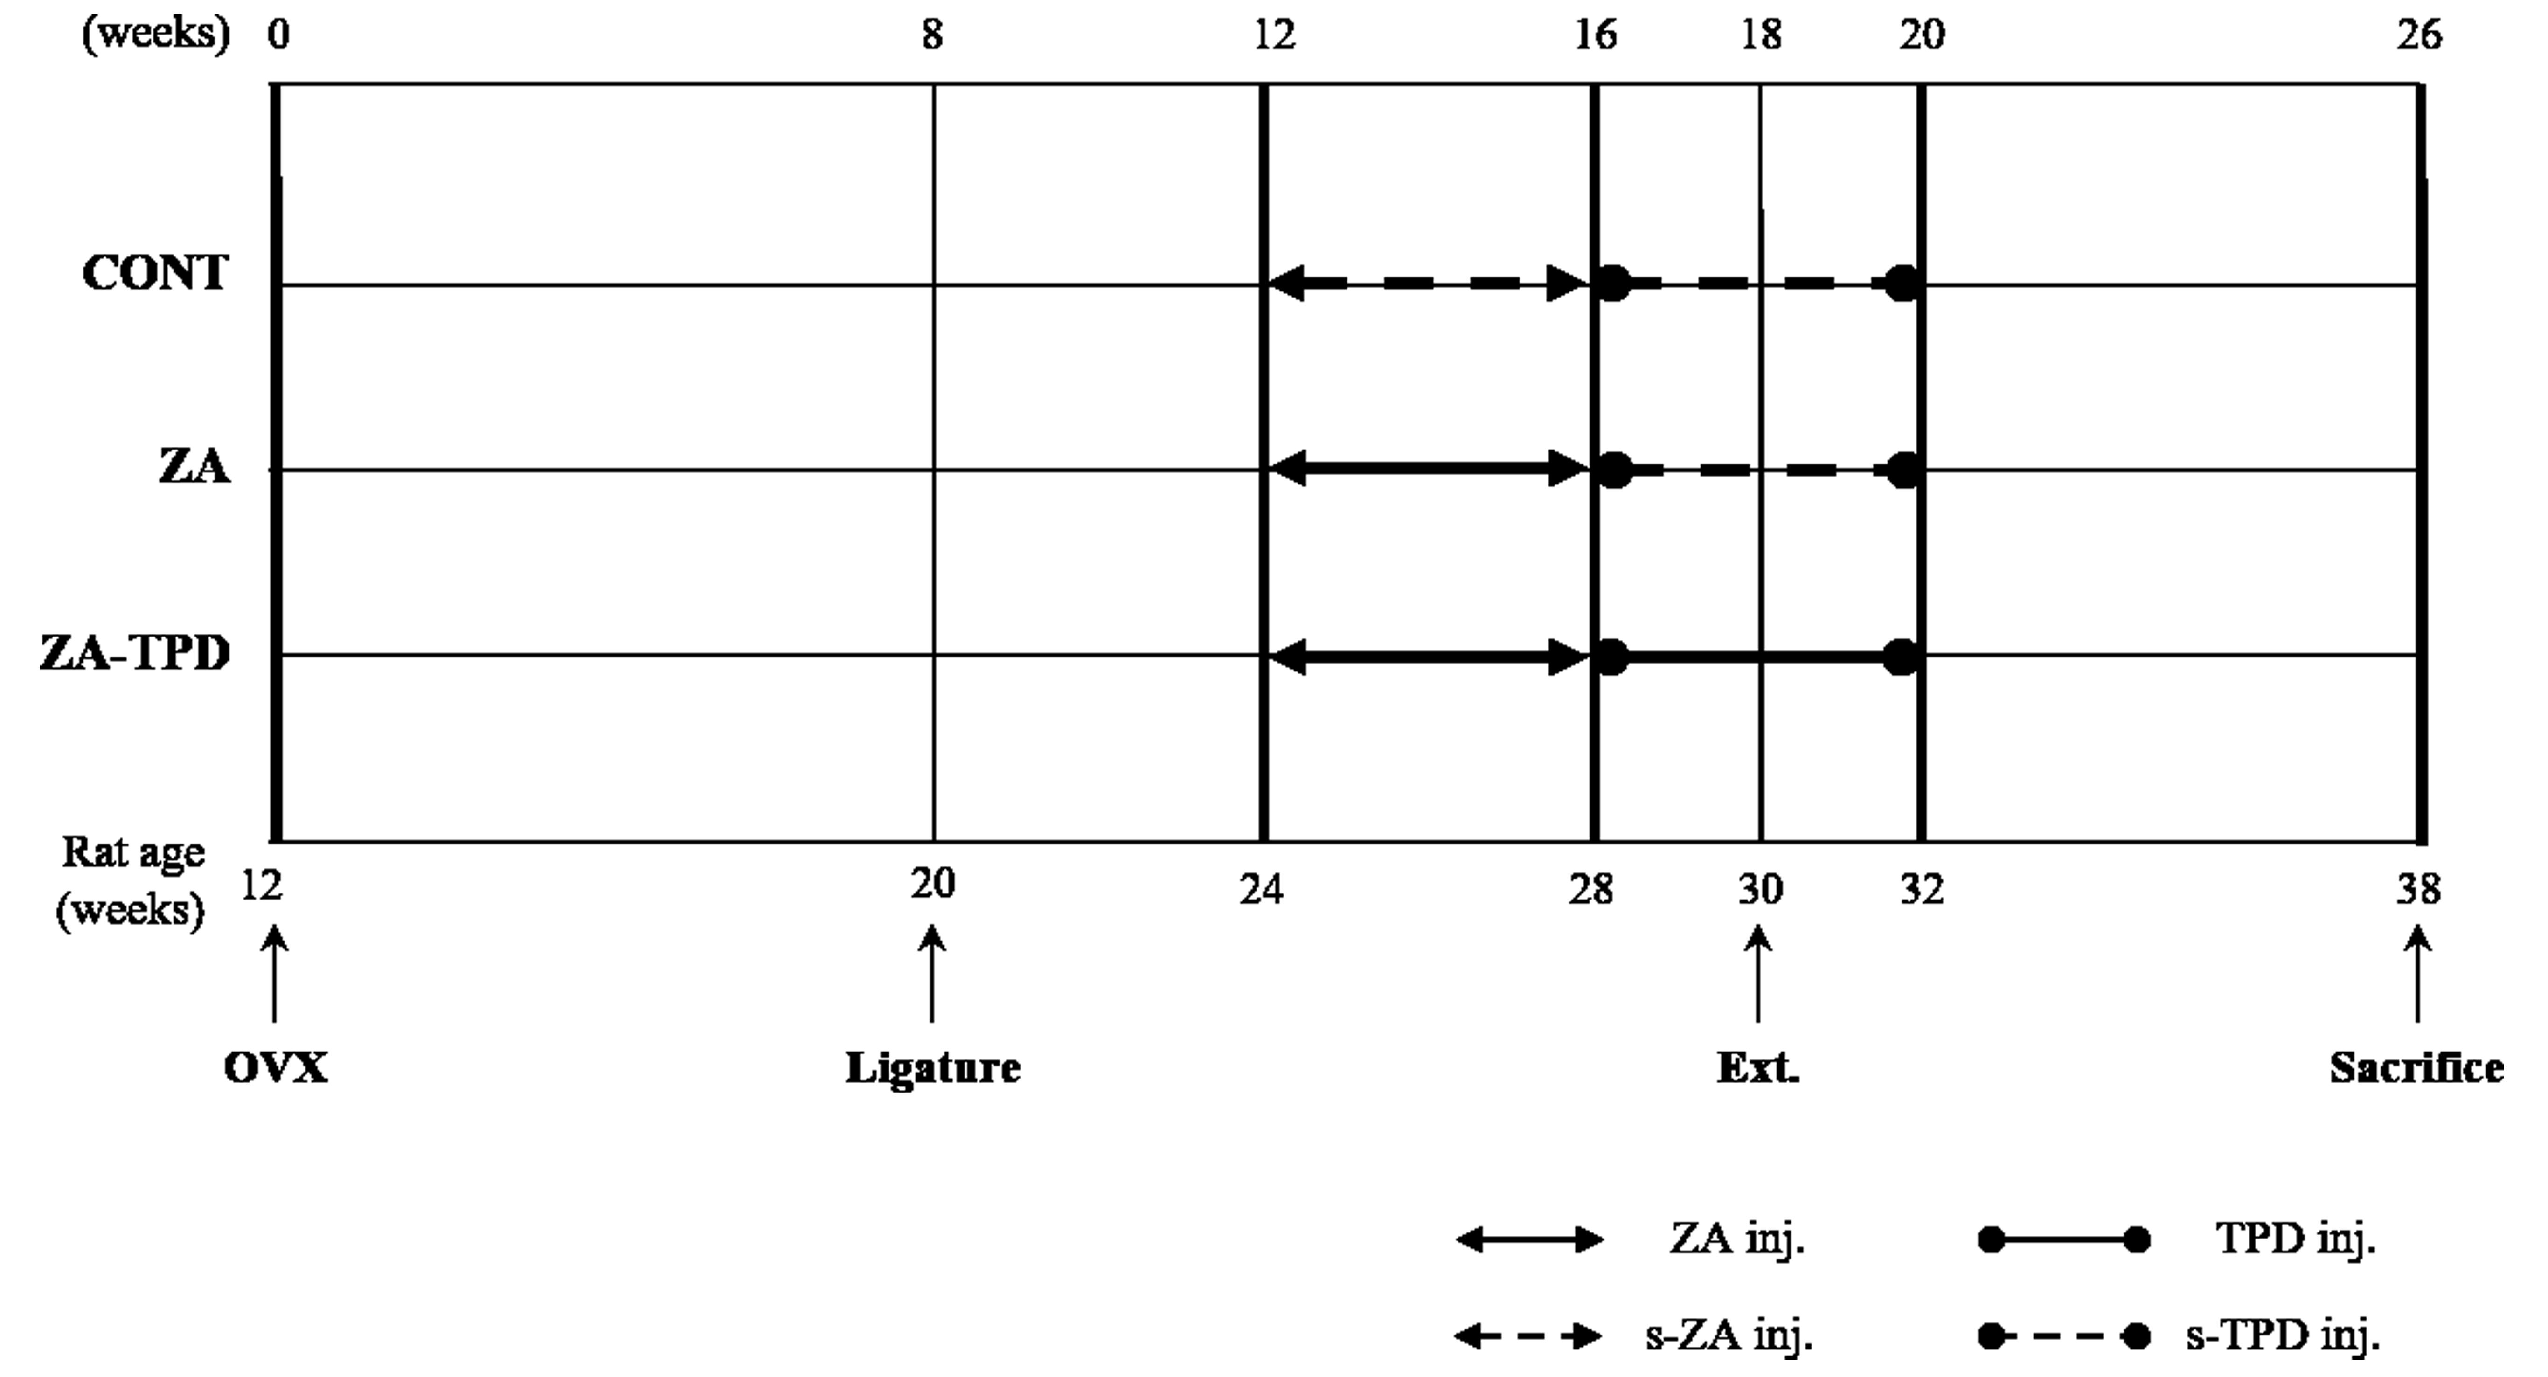
Supplementary Figure S2. The region of interest (ROI) for micro-computed tomography analysis. (A) ROI of the proximal tibia. (B) ROI of the extraction site in the mandible. (a) growth plate. (b) mandibular canal. (c) incisor root.

